South Charnwood High School
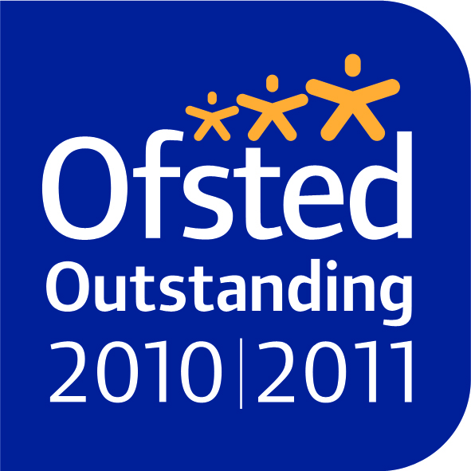
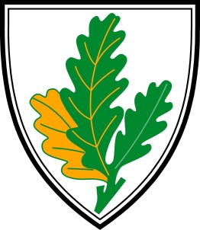
‘encouraging excellence, valuing people’

Headteacher: Andrew Morris:
Deputy Headteachers: Simon Andrews, Tina Corker
Assistant Headteacher: Kathryn Juszkiewicz
Business Manager: Angela Preston

May 2017

Dear Sir/Madam

Teacher of French – MPS/UPS Part Time (90% approx) to cover maternity leave

Thank you for your interest in the above post which is offered from the 24th August 2017.

Please see separate attachments for general details of the school; a description of the post offered, a personnel specification and an application form. Our latest Ofsted report, which judged the school as outstanding, is accessible via the school website at www.southcharnwood.leics.sch.uk. If you wish to proceed, please complete the application form and return it to me.

Please note the application form must be completed in full before it will be considered. South Charnwood High School implements a rigorous and robust recruitment process that gathers evidence about candidates’ suitability to work with children, as well as their suitability for the post in question, and has pro-active safeguarding procedures in place to address inappropriate behaviour, which includes a DBS check.

The deadline for the return of your application is 12 noon Friday 19th May 2017. We hope to arrange interviews week beginning Monday 22nd May 2017. Should you have not heard from us by Friday 26th May 2017, then please assume that on this occasion your application has not been successful.

If you have any particular questions concerning the post, please do not hesitate to get in touch with me personally. Thank you for the time and effort you have already spent finding out about South Charnwood High School. I look forward to receiving your application to join our successful team.

Yours sincerely
ANDREW MORRIS.
Headteacher

