Dear Applicant,

Thank you for your interest in the position of Teacher of Science at Kirkby High School.

We are pleased to offer this exciting opportunity for a suitably qualified, enthusiastic and energetic teacher of science. The successful candidate will be ambitious and have an excellent work ethic.

We are proud of our school’s success and are committed to providing an ambitious and inclusive environment with a strong pastoral care system that values every member of our community.

If your values and ambitions mirror ours and you believe you can deliver that vision, then we would be delighted to receive an application from you.

Completed application forms should be returned Jo Barrett, PA to the Headteacher at the above address or email j.barrett@kirkbyhighschool.net.

We are committed to safeguarding all members of our community. All posts are subject to enhanced disclosure procedures and pre-employment checks.

Closing date for applications – 12 noon Monday 5th February 2018

Yours faithfully,
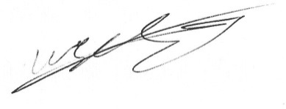

Mr W Leyland
Headteacher

