Dear Prospective Applicant,

On behalf of the Governing Body of New Islington School I would like to thank you for the interest you have shown in applying for the post of Head Teacher.

New Islington School is a very welcoming, friendly and caring school where the governing body, staff, parents, children and the wider community all work together to provide a school that is a safe, caring environment.

It is our aim to provide every child with excellent educational experiences which will maximise progress in an environment where everyone is valued and supported. We are very proud of our school which was graded ‘Outstanding’ at our last Ofsted Inspection in July 2015.

Our school is now a two form entry school with wraparound provision. Our children bring enthusiasm and challenge to school. Our teaching staff are a very keen and enthusiastic team who are ably supported by teaching assistants, administrative, site and lunchtime staff. We also employ sports coaches to support with PE provision and lunchtime activities.

We are looking to appoint a Head Teacher who has the drive, inspiration, vision and commitment to enhance our school’s progress by embracing the challenges of the future. If you are appointed, we will ensure that you are provided with the support necessary for a successful transition.

We hope that you will choose to apply for this position and we encourage you to make an informal visit to the school. This can be arranged by contacting Paula Millward on 0161 273 8007 or email p.millward@newisligntonschool.co.uk.

I look forward to hearing from you.

Yours sincerely

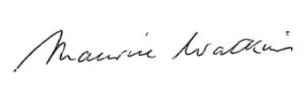

Maurice Watkins CBE
Chair of Governors

