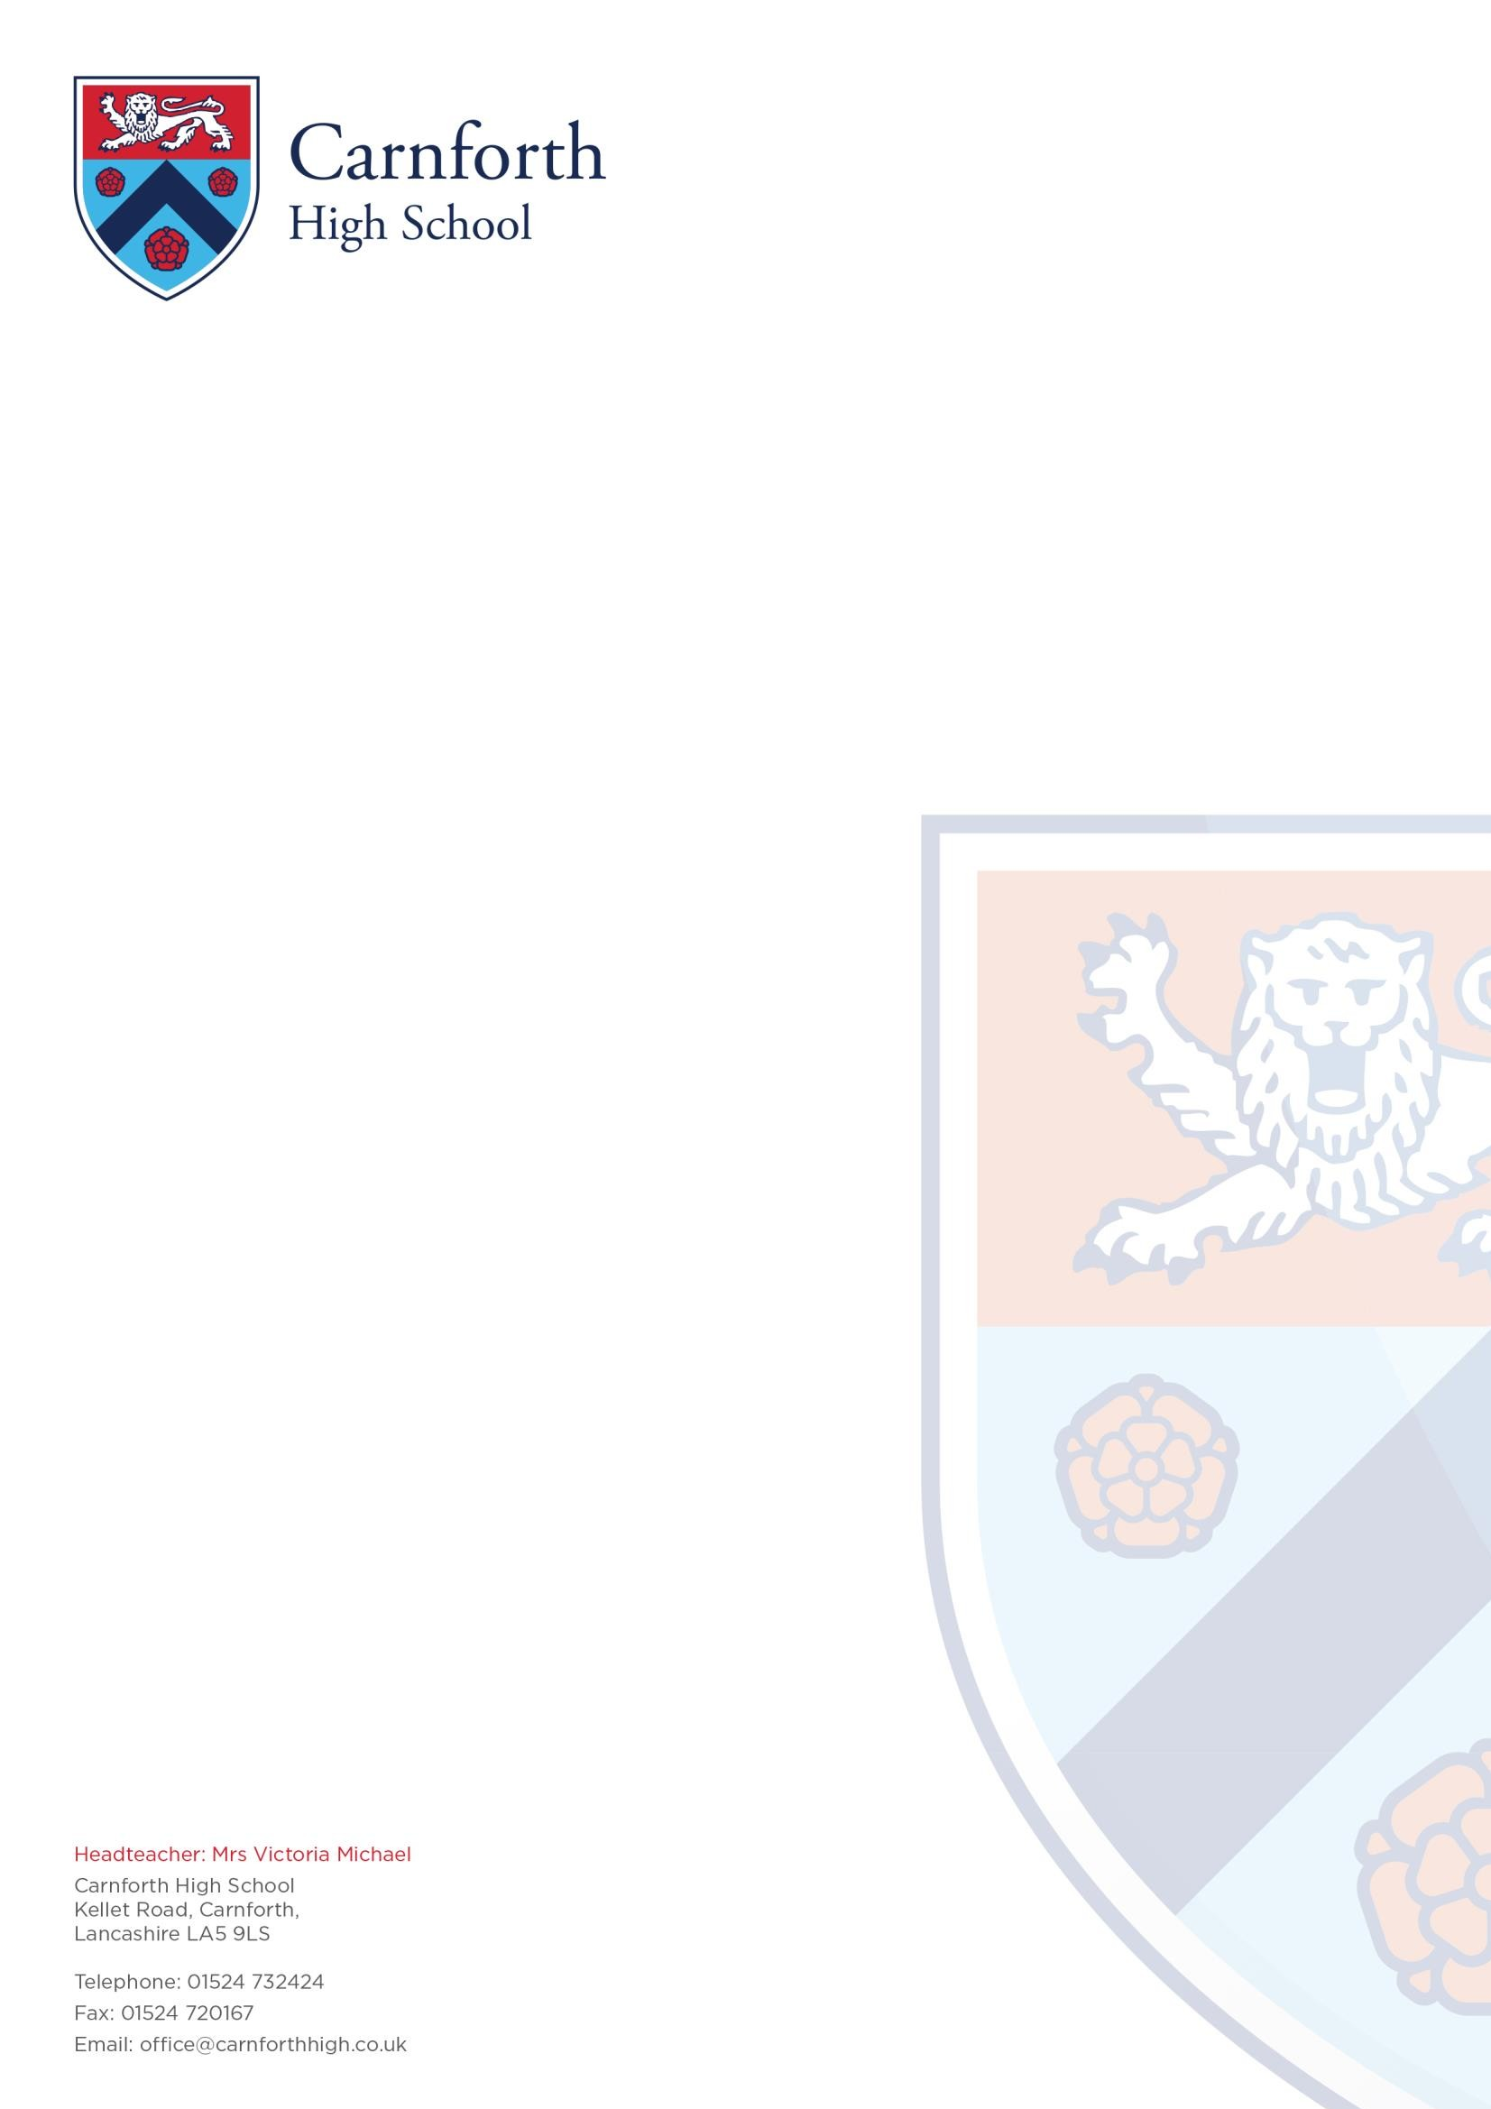

Teacher of MFL (French & Spanish)

Thank you for your interest in joining the community at Carnforth High School. Rated by Ofsted as a ‘good school with outstanding features’, we have very high expectations of all staff and students.
This is a unique opportunity to take part in our journey to ‘outstanding’ and influence the future of our students and make an impact on the community we serve.

As a pivotal player in a small school, the successful candidate will understand the responsibility teachers have to help prepare their students for a bright future. There is plenty of scope for your professional development, as the successful department is extremely popular with students at KS4.

We are seeking to appoint an outstanding teacher who:

- Will raise achievement and deliver excellent academic outcomes
- Can model excellence inside and outside the classroom
- Is flexible and resilient
- Is able to evaluate and improve their impact and effectiveness
- Is able to teach French and Spanish at both KS3 and KS4

This post will mean working alongside high performing and enthusiastic colleagues. All posts are focused on delivering ‘outstanding’ outcomes for all students and realising the highest rigour and standards in pedagogy, learning, behaviour, aspiration, enjoyment and progress.

Our offer to you:
- Excellent CPD opportunities
- Extremely friendly, vibrant staff and students
- A well-resourced department
- A small, warm community school, located in a beautiful part of the world, on the border of the Lake District
- Well-Being & Medical Support

I look forward to receiving your application.

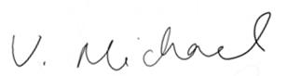

V. Michael Headteacher

