THE GRANGE SCHOOL

Specialising in Business and Enterprise

Teacher of Design and Technology

THE GRANGE SCHOOL

The Grange School is a well established, friendly school, specialising in Enterprise.
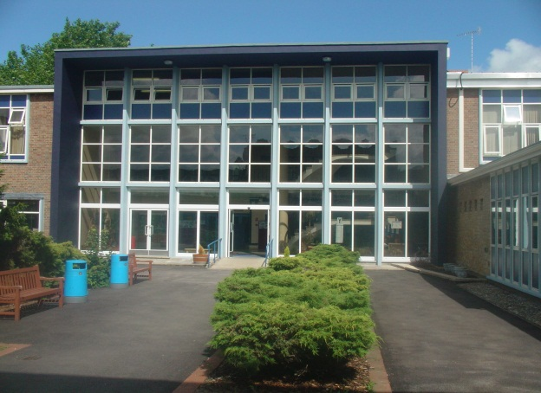
Enterprise is a driving factor throughout learning as evidenced by our Grange Enterprise and Learning Skills (GELS) which are embedded across the curriculum.

We aim to equip all students with the adaptability and flexibility to meet the demands of a rapidly changing world and to promote a sense of responsibility towards others, the school and the wider community. The support and guidance of students is based on a Year system and aims to develop co-operation, involvement and respect in all students.

A broad and balanced curriculum is provided for Years 7 to 9. In Years 10 and 11 all students will study English, Mathematics, Science, PE, RE, ICT/Computing and PSHCE (Personal, Social and Health and Citizenship Education). Students can then choose from a range of additional GCSE, BTEC and vocational courses. We offer a range of traditional and vocational courses at Key Stage 5. The curriculum in all Key Stages is further enhanced through wide ranging extra curricular experiences.

We aim to attract energetic and conscientious staff who have a commitment to the education of our students. The professional development of all staff is an important focus for the school. We strive to create a learning environment which serves the needs of all the members of our diverse and vibrant community.

THE GRANGE SCHOOL

TEACHER OF DESGIN AND TECHNOLOGY

JOB PROFILE

- To raise the level of achievement of all students.

- To be part of a team which will have an impact on students’ levels of literacy and numeracy, empowering them both within the curriculum and in their lives beyond school.

- To contribute to the team’s development of an exciting and dynamic curriculum, which will challenge and motivate all students.

- To have a commitment to an extra-curricular programme, which supports both the academic and cultural life of the school.

- To work within a strong and supportive team that is based on excellent communication and shared good practice.

- To foster good relationships with students and with home, including attendance at parent-teacher consultations.

- To support students’ learning by the use of the school’s policies of marking, assessment, record-keeping, reporting and target-setting.

THE GRANGE SCHOOL

THE DESIGN AND TECHNOLOGY DEPARTMENT

Staff and Structure

The department currently consists of five full time teachers and one part time teacher, supported by one full time and one part time technician. Together, we form an enthusiastic and dedicated team who work in a supportive and friendly atmosphere.

At Key Stage 3, students enjoy a full range of Design and Technology subject areas. Design and Technology is a popular option at Key Stage 4.

We are looking for an enthusiastic and positive teacher, who will be able to teach across the Key Stages and be prepared to embrace all aspects of Design and Technology

The Design and Technology Department Facilities

The department has two specialist Food Technology rooms and a self-contained Textiles Technology facility. The Technology Block, which is situated further away, has three spacious, well equipped Resistant Materials workshops, an Electronics room and two design suites. Our design suites contain computers offering access to a range of 2D and 3D modelling software. The department also has a good range of CAM equipment including 3D printers.

Extra Curricular

The school recognises and values the Design and Technology Department, both within the curriculum and through its extra-curricular contributions.

The Design and Technology Department takes part in a variety of extra-curricular events, adding to the life of the school as a whole. These events range from students participating in local and national technology challenge and STEM competitions, to making scenery and displays for school productions.

Candidates are invited to visit the school prior to interview.
Please contact Jenny Bell to make an appointment.
The Grange School, Wendover Way, Aylesbury, Bucks, HP21 7NH
Tel: 01296 390900
Fax: 01296 390991
E-mail: office@grange.bucks.sch.uk
www.grange.bucks.sch.uk

