

Headteacher Pack
Marner Primary School
Devas Street, Bow, E3 3LL
January 2022

0207 987 2938 www.marnerprimary.com

Contents

Welcome from the Chair of Governors 3
Recruitment Process Details 5
About the School – The Story of Us 6
We are a UNICEF Rights Respecting School 7
Teaching, Learning and the Curriculum 8
English 8
Maths 9
Learning outside the classroom 10
Inclusion & SEND 10
Safeguarding 11
Extended School Provision 11
Shine at Marner – Our Saturday School 12
Partnership working 13
Governors 14
Staffing – Senior Leadership Team 14
Pupil Outcomes 15
Ofsted 16
School Improvement Priorities 17
Recovery Funding Grants 17
Financial Statement 18
Premises 18
Headteacher Job Description 19
Person Specification 23

Welcome from the Chair of Governors

Dear Candidate

The Governors at Marner Primary School would like to thank you for your interest in applying to become our next Head Teacher.

Marner is a large, inclusive, three-form entry primary school and nursery, with over 600 children. Our children generally live locally and come from a wide variety of backgrounds, reflecting the borough’s cultural and economic diversity.
We are a rights-respecting “Good” school with a focus on ensuring we are supporting not just all children but also the whole child, both in curriculum learning and in non-academic aspects around wellbeing and parent engagement. We recognise that great teaching is the most important lever schools have to improve pupil attainment and we are focused on providing the best teaching that we can and supporting staff to attain this highest standard. Our teaching staff at Marner are an experienced group with a culture of sharing learning: bringing curriculum and pedagogy together to deliver improved outcomes for our children. I am sure that any successful applicant will find them wonderful colleagues to work with.
The curriculum is broad with an increasing focus on the richness of outdoor learning. It provides both personalised and creative content in addressing the core subjects and we are keen to continue empowering teachers to pursue new, fun and innovative ways to help our children to love learning and enjoy their time at Marner Primary School.

The school and all its staff are outward facing and are engaged in key partnerships such as the Poplar Partnership and Tower Hamlets Education Partnership. We are proud of our SHINE on Saturday school programme, providing 100 hours of additional and creative learning to 50 students every year. The school also hosts a satellite autism/speech and language provision, with children attending on-site from Phoenix Special School, a collaboration which shows our commitment to a learning model for social inclusion.

The children here come from diverse backgrounds, and we have always found them to be respectful and well behaved, but also curious and, as with all children, to have a sense of fun – qualities that we are keen to foster in their ongoing learning. There is a very strong sense of community at Marner - amongst parents, staff and children - that plays a huge part in its success and that we are keen to continue to nurture. As an example, during the lockdowns the school ran a food bank to assist those families most in need.

If successful, you will be taking on the post of Head Teacher – a role which will become vacant from September 2022. The current Acting Headteacher, Janice Long, will not be applying for the role. In January 2020 the school suffered the sudden and tragic loss of the then Head Teacher of 6 years, Nicholas Hague, and Janice (then Deputy Head) has ably stepped in and has done an exceptional job of steadying the ship and ensuring that the school continues to flourish.

We are looking for a new Head Teacher who will maintain the character of our diverse, inclusive, friendly and community-based school, while continuing to raise standards for all children. Our new Head Teacher will build on the recent successes of the school. They will enjoy working with a committed team of staff and will love working with our children who make the job worthwhile and fun! The new Head will have the support of an active Governing Body and the Local Authority.
The Governors believe the chance to lead our school is a brilliant opportunity for a Head Teacher who is passionate about education, keen to innovate and who can play a critical role in the next step in Marner’s Story of Us: building an ambitious vision and strategy for the future. We look forward to working together with the successful candidate to achieve Marner’s goal to enable all children to become resilient, lifelong thinkers and learners. While we recognise the value of previous experience, we are open minded about who our new Head Teacher will be and are eager to find somebody with exceptional leadership skills, energy and commitment.

We think it is important to offer candidates the opportunity to visit the school and we propose to facilitate this by offering appointments to come to the school. If you would like to apply, please do come and visit us. We are in walking distance of Bromley-by-Bow Underground station and Devons Road DLR Station. The current Head Teacher will be happy to show you around and answer questions, though Andrew Best, our Recruitment Adviser, is available to speak to if you have further questions.

We look forward to receiving your application.

Henry Waite
Chair of Governors

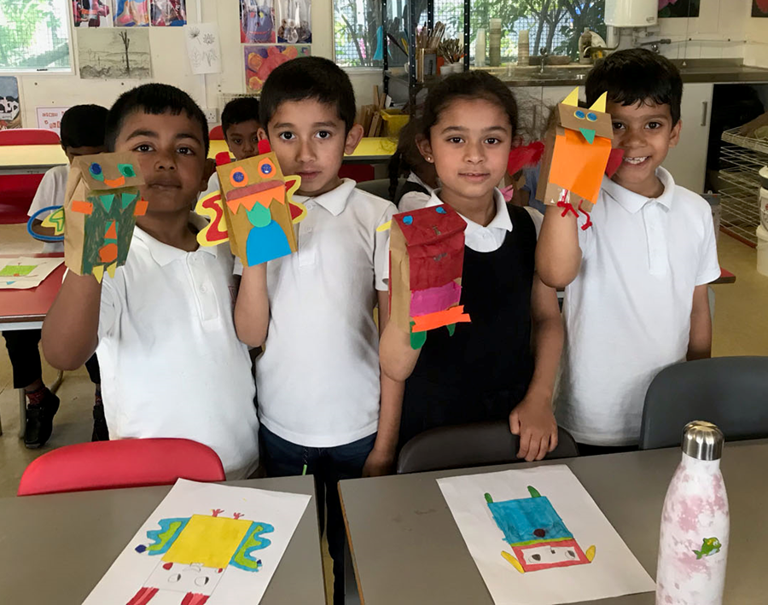

Recruitment Process Details

To start: September 2022

Salary range: L24-L30 (£82,277 - £94,039)

No of Pupils on Role: 670

Closing date for applications: 12 noon on 24th January 2022

Interview dates: 31st January & 1st February 2022
(Candidates to be notified of attendance by 28th January 2022)

A visit is essential and can be booked by contacting:
Jackie O’Hara or Nadia Kalam via email at admin.marner.towerhamlets.sch.uk or by calling on 0207 987 2938.

The Headteacher Job Description and Person Specification can be found at the back of this pack.
To apply for this role please complete the Tower Hamlets application form.
In addition to the application form you are required to respond to the Person Specification requirements for this role with evidence and examples of your experience. You are not at this stage expected to respond to all points as many can only be established at interview. Your response to this should be no longer than 2 A4 sheets in Ariel 11 font.
You are also required to provide a Personal Statement with the reasons why you would like to be the new Headteacher of our school. Your Personal Statement should be no longer than one A4 sheet in Ariel 11 font.
If you have any questions about the role or the process of application, please call Andrew Best on 07917 080201.
We are committed to ensuring equality and diversity is central to the operation of our school through the staff we employ and the provision that we make.
We are committed to safeguarding and promoting the welfare of children and young people, and expect all staff to share this commitment. An enhanced DBS check is required for all successful applicants.

About the School – The Story of Us
Marner Primary School is a large three-form entry primary school, with a nursery, based in Tower Hamlets in the East End of London. We are a local authority community school admitting children from the ages of 3-11. The school hosts a satellite autism provision, with children attending on-site from Phoenix Special School, demonstrating our commitment to a learning model for social inclusion; we strongly believe benefits all our pupils.
We are a happy school and the “The Story of Us” is about the pupils, the staff and the whole community that surrounds our school. We are a diverse community and value every child as an individual. It is our responsibility to ensure our children enjoy coming to school and that we build their enthusiasm and passion for learning. Our staff team care for and nurture these young minds, in a strong partnership with the parents who take an active part in their child’s school life.
Our Vision is that in working together we will enable all our children to become resilient, lifelong thinkers and learners based on the values of:
- Respect
- Happiness
- Growth
- Hope
- Motivation
Visit our website for videos and more information about who we are.


We are a UNICEF Rights Respecting School
Marner Primary School is a rights respecting school. Our school is made up of many different families from a range of different backgrounds, contexts, faiths, beliefs and cultures. Members of our school community speak a range of languages and we take a child-centred approach where every child is valued as an individual.
Whilst we are learning about all the articles in the UNCRC, as a school we are focussing on the following articles as we work towards Silver Accreditation:
- Article 2 - All children have these rights no matter what!
- Article 12 (respect views of child) - You have the right to say what you think should happen and be listened to.
- Article 19 (safe) - You should not be harmed and should be looked after and kept safe.
- Article 6 - You have the right to life and be healthy.
- Article 24 (food, water and safe environment) - You have the right to good food and water and to see a doctor when you are ill.
- Article 29 (goals of education) - Your right to become the best that you can be.
- Article 31 (leisure, play and culture) - You have the right to relax and play.
The RRSA encompasses all that we do as a school to allow our children to flourish into kind and respectful lifelong learners who advocate the rights of every child everywhere and make a positive contribution to society. By learning about their rights, our children also learn about the importance of respecting the rights of others.
The UNCRC is at the heart of teaching and learning in Marner Primary School and is embedded within our school goals, ethos and practice. Children learn about their rights across the curriculum, children learn to respect each other’s rights:
- in the classroom (Article 28: the right to an education),
- in the dining hall (Article 24: the right to nutritious food and clean water),
- in the playground, (Article 31: the right to relax, play and take part in a wide range of cultural and artistic activities),
- in the local community (Article 2: child rights apply to every child without discrimination, whatever their ethnicity, gender, religion, language, abilities or any other status, whatever they think or say, whatever their family background.),
- and as a global citizen (Article 4: implementation of the Convention) Governments must do all they can to make sure every child can enjoy their rights by creating systems and passing laws that promote and protect children’s rights.)

Teaching, Learning and the Curriculum
At Marner Primary, we believe that high-quality teaching, targeted academic support and our wider school strategies, which address the non-academic barriers to success in school, enacted with skill and determination, will enable all children to come back stronger and go onto succeed in this academic year and the years, which follow.
We know that primary school is one stage in our children’s learning journey and we want our children to have the knowledge and skills they need to succeed – to take advantage of opportunities, responsibilities and experiences as they move through our school, onto secondary school, through further education and into the wider world.
With this in mind, we continue to develop our curriculum. We think carefully about the knowledge and skills we want our children to learn. Knowledge brings more knowledge – the more you know, the easier it is to learn new things and we are determined that the knowledge our children build at Marner is powerful: our children acquire knowledge that takes them beyond their own experiences whilst still making sense to them and who they are. In a knowledge-rich curriculum, skills and understanding are seen as forms of knowledge to be taught within subject specific contexts. At Marner, vocabulary development is a priority – we know that by developing our children’s critical and creative thinking skills, collaboration and oracy skills, we support our children to successfully use the vocabularies we work so hard with them to build.
Please visit the Learning section on our school website, where you will be able to see the Approach to Teaching and Learning document at Marner.

English
At Marner, we are committed to ensuring our children leave us as confident readers, writers and communicators. We use a range of strategies to teach our children the necessary skills to succeed in the English Language, and the wider world.
When children enter our school, they begin to progress through our systematic phonics programme. Children who struggle with this programme are identified quickly and support in the form of interventions is put in place. We follow the THEP phonics scheme.
Alongside the phonics teaching, we start to develop a love of reading from an early age. We know the biggest influencers on children's desire to read are parents and other role models in the family home. To enable our families to support this, we hold parent workshops, use a robust home reading strategy and work in conjunction with Book Trust to provide books in the home.
Reading is encouraged and celebrated throughout children's school life, in classrooms, at home and in our school library. Writing is the next step for our children as they become more confident readers and speakers. We are a Storytelling school, and this approach is used throughout our curriculum.
Our English texts are chosen carefully to either correspond with children's learning across the curriculum or inspire their imaginations. At Marner, we are committed to an Anti-Racist approach to our curriculum, and as such we ensure we are exposing children to a wide range of diverse authors and ideas.

Maths
At Marner we love maths! We believe that all children can be successful in maths and Marner is full of enthusiastic mathematicians.
Marner Mathematicians:
- Use concrete hands-on resources to build understanding
- Practise their number facts
- Draw, talk and do whatever they need to do to make sense of their learning
- Talk about their maths and enjoy proving why their answer is correct
- Make mistakes and learn from those mistakes.
And they’re resilient – they think:
- This is hard!
- What do I already know?
- Now, how am I going to use it to help me work this question out?
We follow the White Rose Maths Scheme of Learning. The curriculum is broken down into a series of ‘blocks’ with each ‘block’ broken down into a series of sequenced ‘small steps’. Each step builds carefully from the previous step, building on pupils’ prior knowledge to develop new skills. It is a cumulative curriculum so once a topic is covered, it is met many times again in other contexts.
Further detail on our curriculum can be found on our website.
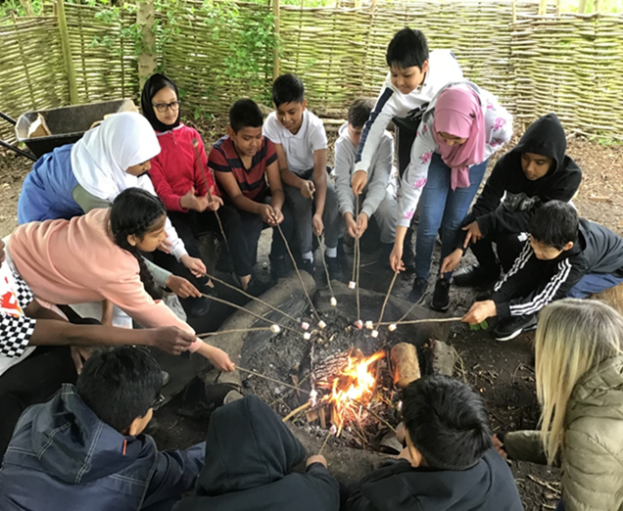

Learning outside the classroom
‘Forest School is an inspirational process, which offers all learners regular opportunities to achieve and develop confidence and self-esteem through hands-on learning experiences in a woodland or natural environment with trees.’

Marner Forest School is within the school grounds in the school garden. The entrance is through the edible garden alongside the sports pitch. We have two staff members trained as Forest School Leads and we work in partnership with a local Woodlands based Forest School.
The Forest School ethos has roots reaching back to early years pioneers in education and the Scandinavian culture known as ‘fruitsliv’ meaning ‘free open-air life’.
Within our Forest School we follow the principles defined by the Forest School Association.
We aim to:
- Support the holistic development of all participants. Our objective is to nurture and support the whole person including their physical, emotional, social and cognitive needs.
- Encourage a connection between nature and the participants. As our natural environment continues to be under threat it is vital that we learn about, experience its value for us, and understand the necessity to conserve and regenerate it. This is particularly important due to our location within a very built-up, urban area of London.
- Provide regular sessions led by trained practitioners, which build upon the interests and needs of participants.
- Provide the opportunity for participants to take supported risks appropriate to the environment and to themselves.
- Provide opportunities and activities to support and enable different kinds of play and learning styles. Learning is most effective and memorable when we are having fun!

This along with our Edible Garden, where each year group has raised beds to plant and grow seasonal produce, provides our children with many opportunities they would not have growing up in inner city London.

Our children are passionate about a Greener Marner. This year we achieved GOLD STARS Accreditation a scheme that inspires young Londoners to think differently about travel and its impact on their health, wellbeing and the environment

Inclusion & SEND
At Marner, all children are valued and respected. We recognise that each child has a variety of abilities and that a child with Special Educational Needs and/or Disabilities (SEND) will require additional support, over and above the usual differentiated activities to enable them to access a broad and balanced curriculum. At Marner, our commitment to children with a special educational need or disability is reflected in our whole school policy.
We believe that each child should participate in the everyday life of the School. We aim to respond with sensitivity to the needs of the individual and to work in partnership with parents and outside professionals to create the best possible learning path for their child. We know that at times this can feel stressful for parents, as they navigate the best options for their child. We strongly encourage parents to talk with us if they are worried about their child or need sign posting to wider services for support.
Please see the video on our website, found under the Inclusion tab, which explains the excellent collaborative work between Phoenix Special School and Marner Primary, demonstrating our joint commitment to a learning model for social inclusion; we strongly believe benefits all our pupils.

Safeguarding
At Marner Primary School our core responsibility is for the safety and well-being of the children in our care. As such we take our responsibility for safeguarding, including our statutory responsibilities, very seriously. Only if children are safe and happy are they able to fulfil their potential in their learning.
We achieve this objective by:
- Establishing a safe environment in which children can learn and develop.
- Supporting pupils who have been abused in accordance with his/her agreed child protection plan.
- Raising awareness of child protection issues and equipping children with the skills needed to keep them safe. Pupils are taught about safeguarding as a part of the national curriculum through PSHE, RSE and Religious Education.
- Developing and then implementing procedures for identifying and reporting cases, or suspected cases, of abuse.
- Ensuring we practise safer recruitment in checking the suitability of staff and volunteers to work with children.
- Staff development and learning to recognise children in need of protection.
We have a team of Safeguarding Leads, who work in partnership with the School Social Worker, Attendance Officer and the Pastoral Team, made up of a Parent Liaison worker and Learning Mentors.

Extended School Provision
Breakfast club runs every day between 8am and 8.45am in the main hall with the last breakfast serving at 8.30am. Healthy breakfast food is provided by The Magic Breakfast charity. The children have the opportunity to take part in a number of activities including sport, arts and crafts and computing.
A rich programme of After School Clubs run each term for each year group. Children enjoy these opportunities and clubs are well attended.
Through after school clubs and PE lessons, the school has built up a strong sporting reputation which we are proud of, achieving Gold School Sports Accreditation. We are committed to ensuring we provide opportunities and pathways for children to participate in in a range of team sports such as: Cricket, football, hockey, athletics and boccia to name just a few. All our children leave us having had access to rock climbing and abseiling on our very impressive indoor climbing wall!
Our children are regularly congratulated on their sporting values, demonstrating they are able to represent themselves well in the community, in the ways our Rights Respecting School charters expect of them.
A list of all the clubs offered can be found on our school website along with many photographs of sporting moments in the highlights section.

Shine at Marner – Our Saturday School
Shine at Marner, which runs on a Saturday, provides 100 hours of additional and creative learning every year, designed to boost achievement levels. The project runs for 20 Saturdays a year, working with 50 students from KS2.
- It exists for students to achieve more and enhance their learning.
- It is designed to be distinctive from, but complementary to, the school week
- We have students and tutors (instead of pupils and teachers), with small classes of mixed ages and mixed abilities.
- We have older students to act as peer mentors from local Secondary Schools
- We have Queen Mary University undergraduates working as mentor volunteers.
- It emphasises excitement, enrichment and activity-based learning - each term has a main theme, supported by investigative learning in literacy, mathematics, science and technology
- It has an absolute commitment to raising expectations, attaining high standards and demonstrating improved performance
- To promote the development of the children in a safe, secure and happy environment.
- Shine on Saturday has well established monitoring procedures to evaluate the impact of each project.
- Expected outcomes include: high attendance; raised achievement in core academic subjects, increased confidence, improved attitudes to learning and higher aspirations.
- Shine on Saturday is about helping students to foster a love of learning!
Please visit our website for further information and to watch a video all about life at Shine School.

Partnership working
The school is a member of the Poplar Partnership which is a group of schools in and around Poplar who have worked together for several years to help to improve the lives of families in our local community. The partnership has charity status which enables us to fund collaborative projects for the benefit of the community. The partnership provides a strong professional support network for the Headteachers and subject leaders, which make up the Poplar Partnership Schools.
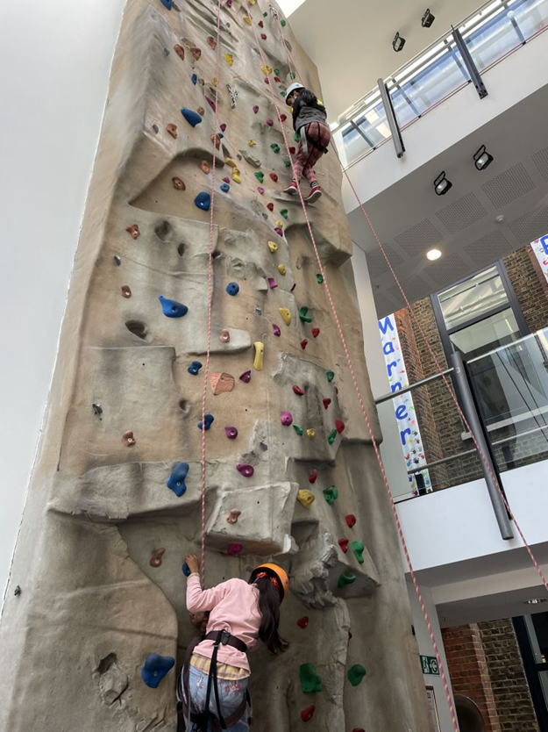

Governors
The Governing Body is made up from parents, people from the community, staff members and from the Local Education Authority (LEA).
Marner's Governors
Chair of Governors: Mr Henry Waite (Co-opted Governor)
Vice-Chair of Governors: Mr Mark Campbell (Co-opted Governor)
Acting Headteacher: Ms Janice Long
Parent Governors: Mr Abdul Miah, Mrs Nasrin Sardar (Two vacancies advertised.)
Staff Governor: Mr Stuart Seamark
Local Authority Governor: Ms Premalatha
Co-opted Governors: Mrs Helen Witty, Ms Rita Newland, Mr Nizam Miah

Staffing – Senior Leadership Team
The school leadership team is made up of the Headteacher, Deputy Headteacher, four Assistant Headteachers and the Inclusion and Transition Leader (SENDCO). There is also a team of experienced Middle Leaders.

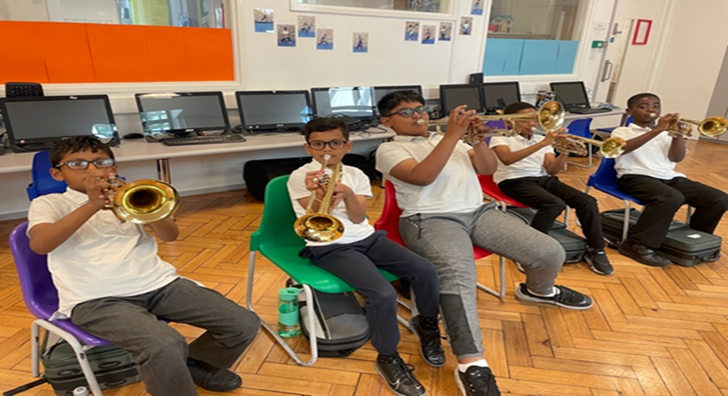

Pupil Outcomes
EYFS Results
Subject/Aspect | School Results 2019 | National Results 2019
Good level of development | 69% | 72%
Year 1 Phonics Check Results
Subject/Aspect | 2019 School Results | National Results 2019
Overall | 91% | 82%
KS1 Results
Subject/Aspect | 2019 School Results | National Results 2019
Reading % ARE + | 77% | 75%
Reading % greater depth | 12% | 25%
Writing % ARE + | 73% | 69%
Writing % greater depth | 4% | 15%
Mathematics % ARE + | 74% | 76%
Mathematics % greater depth | 9% | 22%
KS2 Results 2018
Subject/Aspect | 2019 School Results | National Results 2019 | School Progress Score
Reading % ARE + | 77% | 73% | +3.4
Reading % greater depth | 30% | 27%
Average scaled score in reading | 106 | 104
SPaG % ARE + | 88% | 78%
SPaG % greater depth | 50% | 36%
Writing % ARE + | 79% | 78% | +2.0
Writing % greater depth | 17% | 20%
Mathematics % ARE + | 86% | 79% | +2.3
Mathematics % greater depth | 27% | 27%
Average scaled score in maths | 106 | 105
R, W&M % ARE + | 67% | 65%
R, W&M % greater depth | 8% | 11%

Ofsted
Short Inspection – 22 February 2017
Main Finding – This school continues to be Good. Safeguarding is effective.
Inspection findings:
- Good attendance is strongly promoted and the school has worked effectively to ensure that pupils, and their parents, know why it is so important to attend school regularly.
- As a result of action taken, attendance has improved since the previous inspection and the amount of persistent absence has reduced. The school can demonstrate that the improvement in attendance has led to better attainment and progress, both for individual pupils and in the school as a whole.
- The rate of improvement in attendance has not been as fast as the school would like. Leaders understand that they need to be more rigorous in their approach and implement the changes they propose more rapidly if they are to ensure that attendance is at least in line with the national average.
- You made improving the provision for pupils who have special educational needs and/or disabilities a high priority because over time, these pupils were not making as much progress as others. The recent review identified several key areas for improvement. You have already improved the quality of the additional support, with the result that pupils are making better progress than before.
- In reading and mathematics, current pupils who have special educational needs and/or disabilities make rapid progress. Teaching is well matched to their needs and additional adults give them good support in class. Progress in writing has not been as rapid because teachers’ expectations have not been as consistently high.
- Senior staff are leading a drive to improve the quality of writing across the school and in all subjects. Teachers give pupils better guidance on what is expected when writing for different purposes.
- The impact of this is seen in the planning of tasks that interest pupils and encourage them to want to write. In key stage 1, teachers’ strong emphasis on extending pupils’ vocabulary and oral skills is helping pupils to become more confident writers.
- Although progress is evident, initiatives have not had enough time to show that they can fully deliver the improvements expected. In some classes, pupils have good opportunities to practise their skills and to write in greater depth in other curriculum subjects, but this is not happening consistently in all classes.
- Standards in reading have improved over the last year and it is clear from discussions with pupils that most of them enjoy reading. Younger as well as older pupils could talk knowledgeably about the books they had read and why they liked them.
- Children in the early years and pupils in key stage 1 receive a good grounding in phonics. This enables them to read unfamiliar words accurately, but some, particularly younger boys, do not always fully understand what they are reading. Staff have been focusing on developing pupils’ comprehension skills so that they read with greater understanding. So far, the evidence shows that this is working well.
Next steps for the school
Leaders and those responsible for governance should ensure that:
- they improve attendance further by rapidly implementing the school’s plans
- pupils have more opportunities to apply and develop their writing skills in greater depth in subjects other than English.

School Improvement Priorities
Overview of School Improvement Objectives.
- A tiered approach
- High quality teaching to improve attainment for all pupils.
- Targeted academic support across spectrum of achievement.
- Wider strategies; non-academic barriers to success in school
- Whole school approach to Teaching & Learning at Marner
- As a school we want to be evidence informed.
- Evidence based practice – integrating professional expertise with the best external evidence from research to improve the quality of practice.
- Establish a Marner shared framework for thinking and talking about teaching and learning (Policy).
- Achieving the best possible outcomes for all pupils, particularly the most disadvantaged among them. (Recovery, Intervention and a curriculum for the future.)
- To further develop learning in the outdoors improving problem solving, team work, creativity, wellbeing and physical health.

Recovery Funding Grants
High quality teaching for all.
School-Led tutoring programme – Mathsucan run by two specialist maths teachers.
Training of intervention staff – Year 1 to Year 4.
Diagnostic reading analysis, Lexplore. Accelerated reader and Bug Club to further support.
Tuition classes after school focusing on reading and maths intervention.
Mental Health and Wellbeing App, alongside Team Around the Child/family meetings.
External professionals e.g. Speech & Language team, ASD outreach team, Educational Psychologists, parent liaison workers and social workers.

Financial Statement
The School has a good record of careful budget management. The school completed a process of restructure during 2019/2020. Despite the challenges presented by the Covid-19 pandemic; the school has no financial concerns and works effectively with the School Governing Body to make sound financial decisions. The school is aware that in the years ahead, finances for schools will remain a key priority and area of challenge.

Premises
There are no significant premises concerns. There is one planned construction project to build a new front reception area and access point for the school. This is due to be completed by the start of the new academic year.



Headteacher Job Description
Salary:
L24 – L30 (£82,277 - £94,039)
Qualities:
Our new Headteacher will be passionate about achieving the best possible outcomes for our children. They will care about the whole family: parents, carers and children and will value our staff and the contribution they make. They will be welcoming, genuinely friendly and visible to parents. Our Headteacher will enjoy celebrating success, in all its forms, and expect our children to leave our school with a life-long love of learning and well prepared for the challenges ahead.
Their style of leadership will be calm, considered, inclusive and they will use distributed leadership to facilitate decision making and manage change. They will deliver strategies designed to help all our children to become resilient and confident learners, who are excited by their learning experiences and who expect, and are encouraged, to do their very best.
They will understand our changing and evolving community, and will have the ability to build and maintain a sense of togetherness and common purpose. Motivating staff, with a focus on their development, will be a key part of our Headteacher’s day to day activities. They will be outward facing, collaborating with other schools, the Local Authority and other organisations for the benefit of our pupils and their families.
Duties, ethics and professional conduct:
This job description is subject to the general conditions of service for a Headteacher as set out in the current School Teachers Pay and Conditions Document. This job description is aligned to the Headteacher Standards – October 2020. Our Headteacher is expected to demonstrate consistently high standards of principled and professional conduct (see Headteacher Standards – section 1). They are expected to meet the teachers’ standards and be responsible for providing the conditions in which teachers can fulfil them. Our Headteacher will uphold and demonstrate the Seven Principles of Public Life (the Nolan principles) at all times.
Main Purpose:
The Headteacher will, through their own actions and working with the Senior Leadership Team (SLT), provide professional leadership, vision and strategic direction for our school in order to ensure the highest quality of education and a positive and enriching experience for all our pupils.

Our Headteacher will:
School Leadership & Culture
- establish and sustain our school’s ethos and strategic direction in partnership with those responsible for governance and through consultation with the school community
- create a culture where our pupils experience a positive and enriching school life
- uphold ambitious educational standards which prepare pupils from all backgrounds for their next phase of education and life
- develop leadership capacity and teamworking across the staff team
- promote positive and respectful relationships across the school community and a safe, orderly and inclusive environment
- ensure a culture of high staff professionalism
Teaching and Learning
- establish and sustain high-quality, expert teaching across all subjects and phases, built on an evidence-informed understanding of effective teaching and how pupils learn
- ensure teaching is underpinned by high levels of subject expertise and approaches which respect the distinct nature of subject disciplines or specialist domains
- promote a positive learning culture that will enable pupils to become effective, enthusiastic, independent learners committed to life-long learning
- ensure effective use is made of formative assessment
Curriculum and Assessment
- ensure a broad, structured, creative and coherent curriculum entitlement which sets out the knowledge, skills and values that will be taught
- establish effective curricular leadership, developing subject leaders with high levels of relevant expertise with access to professional networks and communities
- ensure that all pupils are taught to read through the provision of evidence-informed approaches to reading, particularly the use of systematic synthetic phonics in early reading
- ensure valid, reliable and proportionate approaches are used when assessing pupils’ knowledge and understanding of the curriculum
Behaviour and Attitudes
- establish and sustain high expectations of behaviour, punctuality and attendance for all pupils, built upon relationships, rules and routines, which are understood clearly by all staff, parents and pupils
- ensure high standards of pupil behaviour and courteous conduct in accordance with the school’s behaviour policy
- implement consistent, fair and respectful approaches to managing behaviour
- ensure that adults within our school model and teach the behaviour of a good citizen
Additional and Special Educational Needs and Disabilities
- ensure our school holds ambitious expectations for all pupils with additional and special educational needs and disabilities
- establish and sustain culture and practices that enable pupils to access the curriculum and learn effectively
- ensure our school works effectively in partnership with parents, carers and professionals, to identify the additional needs and special educational needs and disabilities of pupils, providing support and adaptation where appropriate
- ensure our school fulfils its statutory duties with regard to the SEND code of practice
Professional Development
- ensure staff have access to high-quality, sustained professional development opportunities, aligned to balance the priorities of whole-school improvement, team and individual needs
- prioritise the professional development of staff, ensuring effective planning, delivery and evaluation which is consistent with the approaches laid out in the standard for teachers’ professional development
- ensure that professional development opportunities draw on expert provision from beyond the school, as well as within it, including nationally recognised career and professional frameworks and programmes to build capacity and support succession planning
Organisational Management
- ensure the protection and safety of pupils and staff through effective approaches to safeguarding, as part of the duty of care
- promote the welfare and wellbeing of pupils and staff through effective training and management
- prioritise and allocate financial resources appropriately, ensuring efficiency, effectiveness and probity in the use of public funds
- ensure staff are recruited, deployed and managed well with due attention paid to workload
- establish and oversee systems, processes and policies that enable our school to operate effectively and efficiently
- maximise the benefit to be gained from ICT in learning and operating our school
- ensure rigorous approaches to identifying, managing and mitigating risk
- maintain a safe and healthy environment in school that complies with our school policies and statutory requirements

Continuous School Improvement
- make use of effective and proportional processes of evaluation to identify and analyse complex or persistent problems and barriers which limit school effectiveness, and identify priority areas for improvement
- develop appropriate evidence-informed strategies for improvement as part of well-targeted plans which are realistic, timely, appropriately sequenced and suited to our school’s context
- ensure careful and effective implementation of improvement strategies, which lead to sustained school improvement over time
Working in Partnership
- forge constructive relationships beyond our school, working in partnership with parents, carers and the local community
- commit our school to work successfully with other schools and organisations in a climate of mutual challenge and support
- establish and maintain working relationships with fellow professionals and colleagues across other public services to improve educational outcomes for all pupils
Governance and Accountability
- understand and welcome the role of effective governance, upholding their obligation to give account and accept responsibility
- establish and sustain professional working relationship with those responsible for governance
- ensure that staff know and understand their professional responsibilities and are held to account
- ensure the school effectively and efficiently operates within the required regulatory frameworks and meets all statutory duties
This Job Description forms part of the contract of employment of the person appointed to this post.
Marner Primary School is committed to safeguarding and promoting the welfare of children and young people, and expects all staff to share this commitment. An enhanced DBS check is required for all successful applicants.

Person Specification
 | Criteria
Qualifications | Qualified Teacher status | E
Qualifications | Graduate level qualification | E
Qualifications | Completed NPQH (except substantive Headteachers in post before April 2004) | D
Qualifications | A record of recent and relevant in-service training | E
Experience | Proven successful leadership at senior level in a primary school as a Head Teacher or Deputy Head or equivalent. | E
Experience | Experience of working in an urban setting (inner-city). | D
Experience | Experience of working in a culturally diverse community. | D
Experience | Experience of working effectively with the school community and external partners. | E
Experience | Experience of developing a differentiated and creative curriculum to pupils with a diverse range of social, emotional, cultural, intellectual and physical needs. | E
School Leadership & Culture | Ability to strategically develop and lead a school in partnership with governors and in consultation with the school community. | E
School Leadership & Culture | Proven track record of the ability to raise significantly the academic and personal achievement of all pupils. | E
School Leadership & Culture | Have the intellectual understanding and emotional intelligence to manage the wellbeing and development of pupils and staff. As a result enhance leadership capacity and teamworking. | E
School Leadership & Culture | Ability to innovate and find creative solutions to a wide range of issues. | E
School Leadership & Culture | Excellent interpersonal and communication skills, both oral and written, to communicate a vision and inspire and motivate the whole school community. | E
School Leadership & Culture | Evidence of the ability to promote positive and respectful relationships to create a safe and inclusive school environment. | E
Teaching and Learning | Ability to identify and develop high-quality teaching. | E
Teaching and Learning | Able to create the conditions for a positive learning environment that enables pupils to become life-long learners. | E
Curriculum and Assessment | Know how to develop and maintain a broad, structured, creative and coherent curriculum which clearly sets out the knowledge, skills and values that will be taught. | E
Curriculum and Assessment | Ability to use, analyse and monitor pupil assessment data to identify needs and trends to promote an appropriate level of challenge to all pupils. | E
Behaviour and Attitudes | Proven skills to establish consistent systems and procedures which bring about effective behaviour management, punctuality and good attendance. | E
Additional and Special Educational Needs and Disabilities | Evidence of a commitment to an inclusive education which addresses the needs of all learners in a diverse community. | E
Professional Development | Evidence of a commitment to the continuing professional development of self and other members of staff. | E
Organisational Management | Knowledge and understanding of how to sustain a safe, secure and healthy school environment, in accordance with Child Protection and safeguarding legislation. | E
Organisational Management | Knowledge of legal issues relating to managing a school including health and safety, equal opportunities, race relations, disability, human rights and employment legislation. | E
Organisational Management | Experience and understanding of managing financial resources appropriately, ensuring efficiency, effectiveness and probity in the use of public funds. | D
Organisational Management | Experience of recruitment and management of staff and their workloads. | E
Organisational Management | The ability to prioritise tasks, make informed decisions and implement them in a flexible manner. | E
Organisational Management | An understanding of technology and its role within the classroom and in the running of the school. | E
Organisational Management | Experience of identifying, managing and mitigating risks. | D
Continuous School Improvement | Evidence of the ability to establish robust systems of quality assurance, develop effective improvement plans and to ensure their consistent implementation and impact. | E
Working in Partnership | Ability to work constructively and effectively with parents, carers and the local community. | E
Working in Partnership | Evidence of willingness to work in a collegiate way with colleagues, other local schools and the Local Authority/THEP | E
Governance and Accountability | Knowledge and experience of governance and external accountability. | E
Governance and Accountability | The ability to use performance management and line management to secure accountability and improve performance. | E
E- Essential, D Desirable
Appointment to this post is subject to a satisfactory enhanced DBS check. This post is exempt from section 4(2) of the Rehabilitation of Offenders Act, 1974, as the duties give you access to persons who are under the age of 18. Applicants are not entitled to withhold information about convictions which would be regarded as spent for other purposes.

