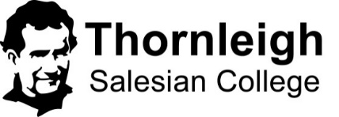

Job Vacancy
Student Progress Coordinator

Grade F approx. (£24,920–£28,227) - pro rata
37 Hours per week, term time only - plus 5 days
Permanent
Required from September 2022

Applications are invited from suitably qualified and experienced candidates for the above post. The successful candidate will take a lead role within school, in a particular year group, to secure high quality standards of behaviour, attendance, punctuality, care and guidance to enable every student to make good academic progress.

Our identity as a Catholic Salesian school and the inspiration we receive from the life of St John Bosco shapes our ethos and spirit, placing the developing child at the centre of everything we do.

If you are a successful motivator of young people, keen to help students achieve their potential by overcoming barriers to learning – we would like to hear from you.
As a school we welcome visits to any prospective candidate, please contact the Headteachers PA.

Closing date: 12 noon Monday 18th July 2022
Interview date: Wednesday 20th July 2022

Application packs can be downloaded from the school website www.thornleigh.bolton.sch.uk
Please send completed application forms to recruitment@thornleigh.bolton.sch.uk

This school is committed to safeguarding and promoting the welfare of children and young people
and expects all staff and volunteers to share this commitment.
The successful applicant will be required to complete an enhanced DBS check.

