
Interview date: Wednesday 20th July 2022
Closing date for applications: 12:00 noon Monday 18th July 2022
Student Progress Coordinator
Thornleigh Salesian College
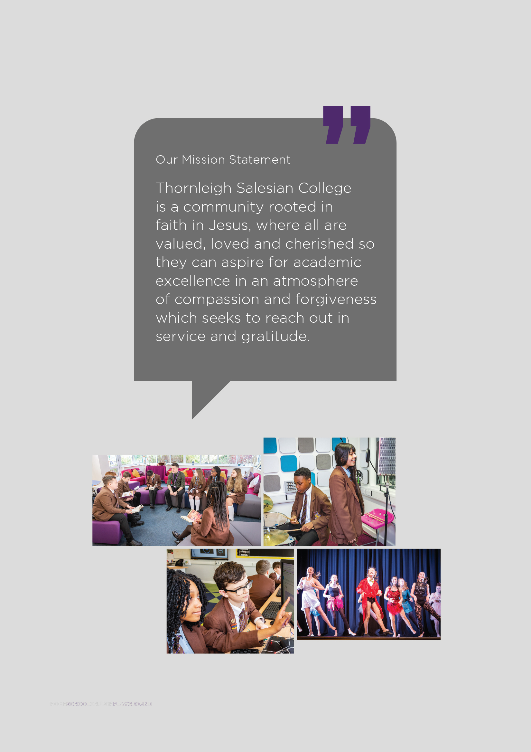
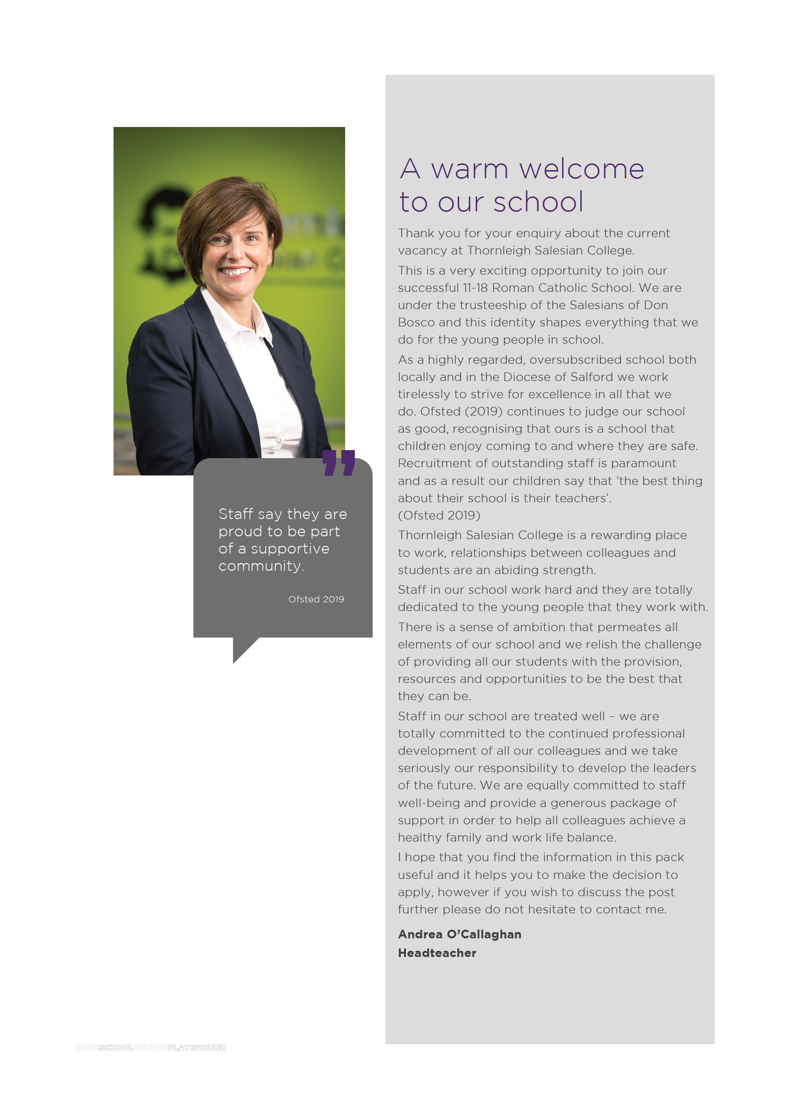


Student Progress Coordinator

Grade F approx. (£24,920–£28,227) - pro rata
37 Hours per week, term time only - plus 5 days
Permanent
Required from September 2022

Applications are invited from suitably qualified and experienced candidates for the above post. The successful candidate will take a lead role within school, in a particular year group, to secure high quality standards of behaviour, attendance, punctuality, care and guidance to enable every student to make good academic progress.

Our identity as a Catholic Salesian school and the inspiration we receive from the life of St John Bosco shapes our ethos and spirit, placing the developing child at the centre of everything we do.

If you are a successful motivator of young people, keen to help students achieve their potential by overcoming barriers to learning – we would like to hear from you.
As a school we welcome visits to any prospective candidate, please contact the Headteachers PA.

Closing date: 12 noon Monday 18th July 2022
Interview date: Wednesday 20th July 2022

Application packs can be downloaded from the school website www.thornleigh.bolton.sch.uk
Please send completed application forms to recruitment@thornleigh.bolton.sch.uk

This school is committed to safeguarding and promoting the welfare of children and young people
and expects all staff and volunteers to share this commitment.
The successful applicant will be required to complete an enhanced DBS check.

Job Description
Every member of staff at Thornleigh Salesian College is expected to endeavour to maintain and develop the Catholic and Salesian character of the school, and to support and promote the aims and mission of the school in and through the exercise of all contractual duties and any voluntary activities.

Department |  | THORNLEIGH SALESIAN COLLEGE
Post Holder
Job Title |  | Student Progress Co-ordinator
Grade |  | Grade F
Primary Purpose of the Job |  | Under an agreed system of supervision, to take a lead role within school to provide support for students, parents, staff and outside agencies in helping to raise standards of achievement and attainment across year groups and helping individual students to overcome any barriers to learning both inside and outside of school in order for them to achieve their full potential.
Responsible to |  | Relevant Senior Leadership Team member
Responsible for |  | n/a
Principal Responsibilities |  | To assist in managing a year group to secure high quality standards of behaviour, attendance, punctuality, care and guidance to enable every student to make good academic progress.
MAIN DUTIES
 | Support For Students
 | To take a lead role in the management and delivery of care and support in accordance with the aims of the school and the policies determined by the Governing Body.
 | To raise standards of student attainment and achievement, assess, monitor and evaluate the progress of students and organise and facilitate programmes of support for individual students.
 | Undertake and participate in the comprehensive assessment of selected students, identifying and assessing those who need extra help to overcome barriers to learning inside and outside the school and developing strategies/initiatives of support
 | To arrange and develop 1:1 and small group mentoring and relationships with young people needing particular support to achieve goals defined in the action plan and to take a lead in drawing up an action for individual children.
 | To act as a point of reference for information relating to mentoring and additional support.
 | To maintain regular contact with families/carers of children in need of extra support, to keep them informed of the child’s needs and progress, and to secure positive family support and involvement.
 | To take a lead role in managing the speedy/effective transition of students across phases/integration of those who have been absent.
 | To promote the speedy and effective transfer of information on targeted pupils and to assist in the arrangements for those moving to other schools and to ensure that this is managed efficiently and effectively.
 | To promote outstanding behaviour and attitude to learning for all students.
 | To have knowledge and appreciation of the range of activities, courses, opportunities, organisations and individuals that could be drawn upon to provide extra support for young people.
 | To monitor attendance within the year group, ensuring consistently good attendance for all students and identified cohorts.
 | To establish constructive relationships with parents/carers, exchanging information, facilitating their support for their child’s attendance, access to learning and supporting home to school and community links.
 | To actively seek information regarding (and utilise), the range of activities, courses, organisations and individuals to provide support for students to broaden and enrich their learning.
 | To challenge and motivate students, promote and reinforce self-esteem.
 | To work on the implementation of the SDP/SIP as it relates to students across year groups.
 | To assist in the collection and coordination of pastoral information (including interviewing students) following referrals relating to school work, behaviour, bullying or other personal issues which may impact on progress or well-being.
 | To liaise with relevant external agencies when appropriate.
 | To be available to students at lunch and break times to discuss pastoral issues or concerns.
 | Support for Teachers
 | To work alongside teaching and other staff to promote academic and personal, social and emotional achievement with students. Provide feedback to students in relation to progress, achievement, behaviour, attendance etc
 | To monitor and evaluate students’ responses and progress against action plans through observation and planned recording.
 | To manage record keeping systems and processes.
 | Work as part of the team by co-operating and communicating and sharing resources and expertise with other Student Progress Co-ordinators
 | To provide objective and accurate feedback and reports as required, to other staff on student achievement, progress and other matters, ensuing the availability of appropriate evidence.
 | Administrative support e.g. dealing with correspondence, compilation/analysis/reporting on attendance, exclusions etc., phone calls etc.
 | To facilitate the sharing of relevant information between local agencies and school and be a point of contact for accessing a range of community and specialist support services for example, Social Services.
 | To work alongside other members of the Pastoral Team in the delivery of guidance, support and intervention in order to address the welfare needs of individual students and resolve related issues.
 | To analyse behaviour data and information from incident referrals and suggest strategies for dealing with students exhibiting behaviour problems.
 | To oversee and monitor student report cards and review progress towards agreed targets.
 | To oversee the writing and implementation of Individual Behaviour Plans (IBPs), Pastoral Support Plans (PSPs) and Early Help Assessment forms (EHA’s) and to liaise with parents and other key workers in their preparation and review.
 | Support for School
 | Be aware of and comply with policies and procedures relating to child protection, health and safety, security and confidentiality, reporting all concerns to an appropriate person.
 | Contribute to the overall ethos/work/aims of the school.
 | Attend and participate in regular meetings as required
 | To ensure good communication and liaison with parents and staff relating to pastoral issues.
 | To support the delivery of intervention work as part of the schools approach to the personalisation of learning.
 | Participate in training and other learning activities and personal development as required.
 | Recognise own strengths and areas of expertise and use these to advise and support others.
 | Implement planned supervision of students out of lesson times e.g. Homework clubs / extra-curricular activities
 | To contribute to the management of the school rewards systems and procedures.
 | To ensure that relevant student records are kept up-to-date.
 | The post holder may reasonably be expected to undertake other duties commensurate with the level of responsibility that may be allocated from time to time.

Date Job Description prepared/updated | July 2022
Job Description prepared by | A O’Callaghan

Person Specification
STAGE ONE | Disabled Candidates are guaranteed an interview if they meet the essential criteria

MINIMUM ESSENTIAL REQUIREMENTS |  |  | METHOD OF ASSESSMENT
1. Skills and Knowledge
1.1 | Ability to work effectively within a team environment, understanding classroom roles and responsibilities |  | Application Form/Interview
1.2 | Ability to build effective working relationships with all students and colleagues |  | Application Form/Interview
1.3 | Ability to work within a team of staff, ensuring effective communication and deployment |  | Application Form/Interview
1.4 | Ability to promote a positive ethos and role model positive attributes |  | Application Form/Interview
1.5 | Ability to adapt own approach in accordance with student needs |  | Application Form/Interview
1.6 | Ability to work with children at all levels regardless of specific individual need and identify learning styles as appropriate |  | Application Form/Interview
1.7 | Ability to continually develop and extend own working practices |  | Application Form/Interview
1.8 | Excellent numeracy and literacy skills |  | Application Form/Interview
1.9 | Understanding of principles of child development, learning styles and independent learning |  | Application Form/Interview
1.10 | Considerable experience of working with young people in an educational setting (within specified age range/subject area) |  | Application Form
1.11 | Working knowledge of relevant policies/codes of practice/legislation |  | Application Form/Interview
1.12 | Understanding of inclusion, especially within a school setting |  | Application Form/Interview
1.13 | Experience of resources preparation to support learning programmes |  | Application Form/Interview
1.14 | Effective use of ICT to support learning |  | Application Form/Interview
1.15 | Customer Care - Listen and respond to customer needs, seek out innovative ways of consulting service users and engaging partners. Network with others to develop services for the benefit of the service users. |  | Application Form/Interview
1.16 | Valuing Diversity - Listen, support and monitor the diverse contributions made to service development without prejudice. Challenge behaviours and processes which do not positively advance the diversity agenda whilst being prepared to accept feedback about own behaviour. Recognise people’s strengths, aspirations and abilities and help to develop their potential. Understand how Valuing Diversity can improve our ability to deliver better services and reduce disadvantage. |  | Application Form/Interview
1.17 | Developing Self and Others - Ability to question, and request right training and development that links to the post, to seek opportunities that add to skills and knowledge, to respond positively to opportunities that arise. To support the learning of others and share learning with others |  | Application Form/Interview
2. Experience/Qualifications/Training etc
2.1 | Teaching Degree, HLTA or required to work towards the HLTA qualification |  | Application Form
3. Work Related Circumstances – Professional Values & Practices
3.1 | High expectations of all students; respect for their social, cultural, linguistic, religious and ethnic background and a commitment to raising their educational achievements |  | Application Form & Interview
3.2 | Ability to build and maintain successful relationships with students, treat them consistently, with respect and consideration and demonstrate concern for their development as learners |  | Application Form & Interview
3.3 | Demonstrate and promote the positive values, attitudes and behaviour they expect from the students with whom they work |  | Application Form & Interview
3.4 | Ability to work collaboratively with colleagues and carry out role effectively, knowing when to seek help and advice |  | Application Form & Interview
3.5 | Able to liaise sensitively and effectively with parents and carers recognising their role in student learning |  | Application Form & Interview
3.6 | Able to improve their own practice through observations, evaluations and discussion with colleagues. |  | Application Form & Interview
STAGE TWO |  | Will only be used in the event of a large number of applicants meeting the minimum essential requirements
ADDITIONAL REQUIREMENTS |  |  | METHOD OF ASSESSMENT
1. Skills and Knowledge
1.1 | Previous experience of working within a school / educational environment in a similar capacity. |  | Application Form
1.2 | Previous extensive experience of use and development of SIMS packages. |  | Application Form

2. Experience/Qualifications/Training etc
2.1 | Training in additional needs strategies / interventions. | Application Form
2.2 | Willingness to undertake appointed person certificate in First Aid | Application Form/Interview
Note to Applicants: Please try to show in your application form, how best you meet these requirements

Date Person Specification prepared/updated | July 2022
Person Specification prepared by | A O’Callaghan

