

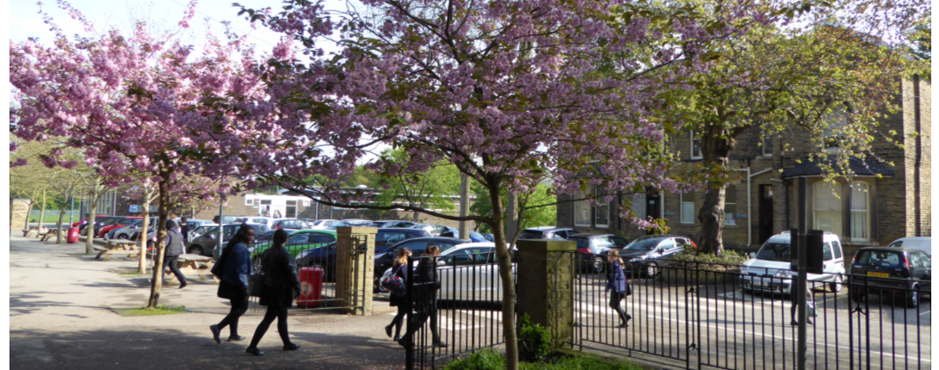



Applicant Information
Behaviour Support Assistant (Beacon 1)
37 hours per week 08.30 to 4.30 Mon to Thurs and 08.30 to 4.00 on Fridays
Term time only plus two days
NJC points 5 – 6 £18274 to £18936 (actual) dependent on experience
Required as soon as possible. Closing date Thursday 28th September at noon

Be

CONTENTS

Letter from the Headteacher Page 3

Our College and our Mission Page 4

Role Profile Page 5

The Candidate Page 6

Advert Page 7

Dear Colleague
Welcome to the exciting opportunities offered by working with us as a Behaviour Support Assistant (Beacon 1) at St Bede’s and St Joseph’s Catholic College.

Working with the Radiate team, and as part of the wider Inclusion provision, the role is to support students to achieve the highest standards of behaviour across the College through one to one and small group mentoring, assuming appropriate supervisory duties and providing the necessary administrative assistance to enable the effective day to day operations contained within the College Behaviour policy. You will also be required to be a House Tutor and support our students during House Welcome Time and House Development Time.
The College is a unique learning community, with a distinct ethos. It is filled with talented and creative staff, led by an ambitious and forward-thinking leadership team, all of whom share the same vision: “to provide a thorough training in the knowledge and principles of the Catholic faith combined with a secular education equal in every respect to the best public schools in England.”

It is important to us that we appoint the right person and if that is you, you will be hardworking, have very high expectations and have a clear commitment to our role.

In return, you will be nurtured and supported as a member of our support staff so that you are perfectly placed to develop your career.

I look forward to meeting you at interview.


Lawrence Bentley,
Headteacher

Our College and Our Mission
St Bede’s and St Joseph’s Catholic College is a highly aspirational learning community, striving to provide an outstanding 21st century education for all learners in a learning environment of the highest possible quality. We work constantly to promote a passion for learning, to create innovative ways of working and to nurture the talents and ambitions of all our students and staff.

The College operates across the impressive former sites of its two foundation schools, St Joseph’s Catholic College and St Bede’s Grammar School – now known respectively as “Ignis” for Years 7–9 and “Ardor” for Years 10-13 – approximately one mile apart. The rich history and tradition of the two foundation schools stretches back over 100 years, with the originally stated mission to provide,

“a thorough training in the knowledge and principles of the Catholic faith combined with a secular education equal in every respect to the best public schools in England.”
This is an exciting time to join the College as we continue to develop this mission and build on our tradition, with a determined focus on strong teaching, and wide-ranging co-curricular and extra-curricular activities. Our mission inspires the three elements of our College Diploma – Scholastica, academic achievement, Ecclesia, contribution to the Catholic life of the College, and Olympia, participation in activities outside the classroom. These elements of the College Diploma also form the foundation of our House system, with our 1500 lower school students divided into five Houses, each with three leaders who are responsible for the achievement, personal growth and well-being of students within their House. Each House is supported by a Junior and Senior House Manager who uphold standards and expectations within the House, as well as playing a major role in clerical and administrative organisation to support students.

The College motto, Christus Lumen Gentium, Christ, Light of Nations, inspires the organisation of our subject areas into five Learning Divisions, again, each with three leaders: Ignite, the Division Leader, responsible for overall performance, Illuminate, responsible for quality of teaching and professional learning, and Shine, responsible for tracking student progress and organising intervention and support. Each Learning Division is complemented by a Division Manager who provides efficient and effective clerical and administrative support for teachers. As need arises, we also make temporary, fixed term appointments on TLR3 to enhance the professional development within specific Learning Divisions, to develop future leaders and to continue to improve attainment at GCSE.

After GCSE, the majority of students continue with us into St Benedict’s Sixth Form, our very successful Post-16 provision, where approximately 350 students enjoy fantastic study and social facilities and achieve excellent results. Ofsted concludes,

“As a result of strong leadership and consistently good teaching, achievement in the sixth form is good. Leaders know the priorities for improvement and take effective action to further improve students’ opportunities.”
We make every effort to secure and enhance the success of our sixth form students, through work experience, academic and pastoral support and an intensive focus on careers advice and guidance to steer them to the most appropriate Post-18 choices.

Our Houses and Learning Divisions and our high-performing sixth form reflect our passion to achieve success for all and we want to appoint staff who share this passion and are committed to supporting the development of our mission. For every post, we seek staff who can inspire, have high expectations and raise the aspirations of young people. If this is you, we look forward to reading your application and welcoming you as a member of our community.

Role Profile
Post Title: | Behaviour Support Assistant (Beacon 1)
Grade: | Scale points 5 to 6
Responsible to: | Radiate Manager
Responsible for: | No supervisory responsibilities

Role Overview
Working with the Radiate team, and as part of the wider Inclusion provision, the role is to support students to achieve the highest standards of behaviour across the College through one to one and small group mentoring, assuming appropriate supervisory duties and providing the necessary administrative assistance to enable the effective day to day operations contained within the College Behaviour policy. You will also be required to be a House Tutor and support our students during House Welcome Time and House Development Time.

Key Responsibilities:

- Work alongside colleagues in the SIP (School Inclusion Provision) to support the inclusion of all students
- Prepare, create and maintain a purposeful, orderly and supportive learning environment
- Deliver learning activities and interventions and monitor student progress as instructed
- Set challenging and demanding expectations of all students, promoting positive values, attitudes and good behaviour
- Assist with the development, implementation and monitoring of Individual Education Plans and Personal Care Programmes
- Supervise internally excluded students
- Assist with the supervision of students out of lesson times
- Take responsibility for the care, preparation, maintenance and use of relevant equipment
- Support the administration of alternative curriculum courses within the SIP
- Administer routine tests, invigilate exams and undertake marking of students’ work when necessary
- Provide accurate, constructive and detailed feedback to teachers and students, as required
- Liaise with parents, when necessary
- Conduct investigations into breaches of the Radiate Behaviour Policy by students collating statements and making recommendations
- Provide first aid and attend appropriate training as necessary
- Lead a House Tutor Group

All support staff are required to support the College aims and to play a full part in the pastoral, cultural and sporting aspects of College life. The majority of full-time staff are House Tutors and are connected to one of the five Houses in the College.

St Bede’s and St Joseph’s Catholic College is a two site College – role holder should be aware that you may be asked to work on either site.



THE CANDIDATE



PERSONAL CHARACTERISTICS  Our ideal candidate will combine positivity, helpfulness and courtesy with a rigorous work ethic, stamina and a good sense of humour. Strong administrative and organisational skills will come as standard, along with a willingness to embrace change and be able to demonstrate commitment, flexibility and integrity. They will also be an excellent communicator, with the ability to listen to all stakeholders with emotional intelligence. We are looking for a strong team player with the attention to fine detail, as well as the ‘big picture’, who is quick-thinking and can find solutions to problems as they arise. | VALUES  The successful candidate will be sympathetic to and supportive of our Catholic ethos, holding values which enable them to act as a positive role model in our community. They will be aligned to all College policies, processes and procedures, and willing to contribute to all College initiatives. They will promote the view that all learners should be inquirers, knowledgeable, thinkers, communicators, principled, open-minded, caring, risk-takers, balanced and reflective. They will thrive on the experience of working in a multi-ethnic and multi-lingual community, where students have a wide range of skills and abilities.
ACADEMIC  We will appoint a colleague who is qualified to NQF Level 2, e.g. Health/Childcare/Youth Work/ Community Language or Equivalent experience. The successful candidate will also have gained passes in GCSE English and Maths (at least Grade C/4) and be able to demonstrate further training and/or development. In addition, they will be computer literate and willing to undertake training for a First Aid qualification. | INTERESTS  We look forward to working with colleagues who have wide and varied interests and are able and willing to be involved in the extra-curricular life of our busy and vibrant College. They will be able to contribute to many areas of College life and appreciate, value and promote the diverse skills and talents of all our students. They will recognise, understand and be keen to act upon the idea that students have a greater chance to achieve their full academic potential when they are happy, successful and active participants in the life of the College.
PASTORAL
We are looking for a colleague who shows a strong interest in students and is passionate about guiding them to success in their College life. They will have effective mentoring skills, a high level of resilience to provide support for a wide range of student need and be committed to the principle of inclusion for all. They will combine high expectations with the ability to foster a unified community and a strong sense of belonging.

Behaviour Support Assistant (Beacon 1)

 | St St Bede’s and St Joseph’s Catholic College, Bradford, West Yorkshire
Start date: As soon as possible
Contract type: Full Time 37 hours per week TTO plus 2 days
Salary: Spine points 5 to 6
£18274 to £18936 (actual) dependent on experience
Contract Term: Permanent
Closing date: Thursday 28th September 2023 at 12 noon

St Bede’s and St Joseph’s Catholic College are seeking to employ a Behaviour Support Assistant (Beacon 1) Working within the Inclusion Team.
Working with the Radiate team, and as part of the wider Inclusion provision, the role is to support students to achieve the highest standards of behaviour across the College through one to one and small group mentoring, assuming appropriate supervisory duties and providing the necessary administrative assistance to enable the effective day to day operations contained within the College Behaviour policy. You will also be required to be a House Tutor and support our students during House Welcome Time and House Development Time.

To apply: control click this link http://sbsj.co.uk/job-opportunities

For further details or to arrange a visit, please email: personnel@sbsj.co.uk
or contact Ruth Jackson 01274 941941

Committed to equality of opportunity. Committed to safeguarding young people; enhanced DBS and social media checks required along with full satisfactory references.

