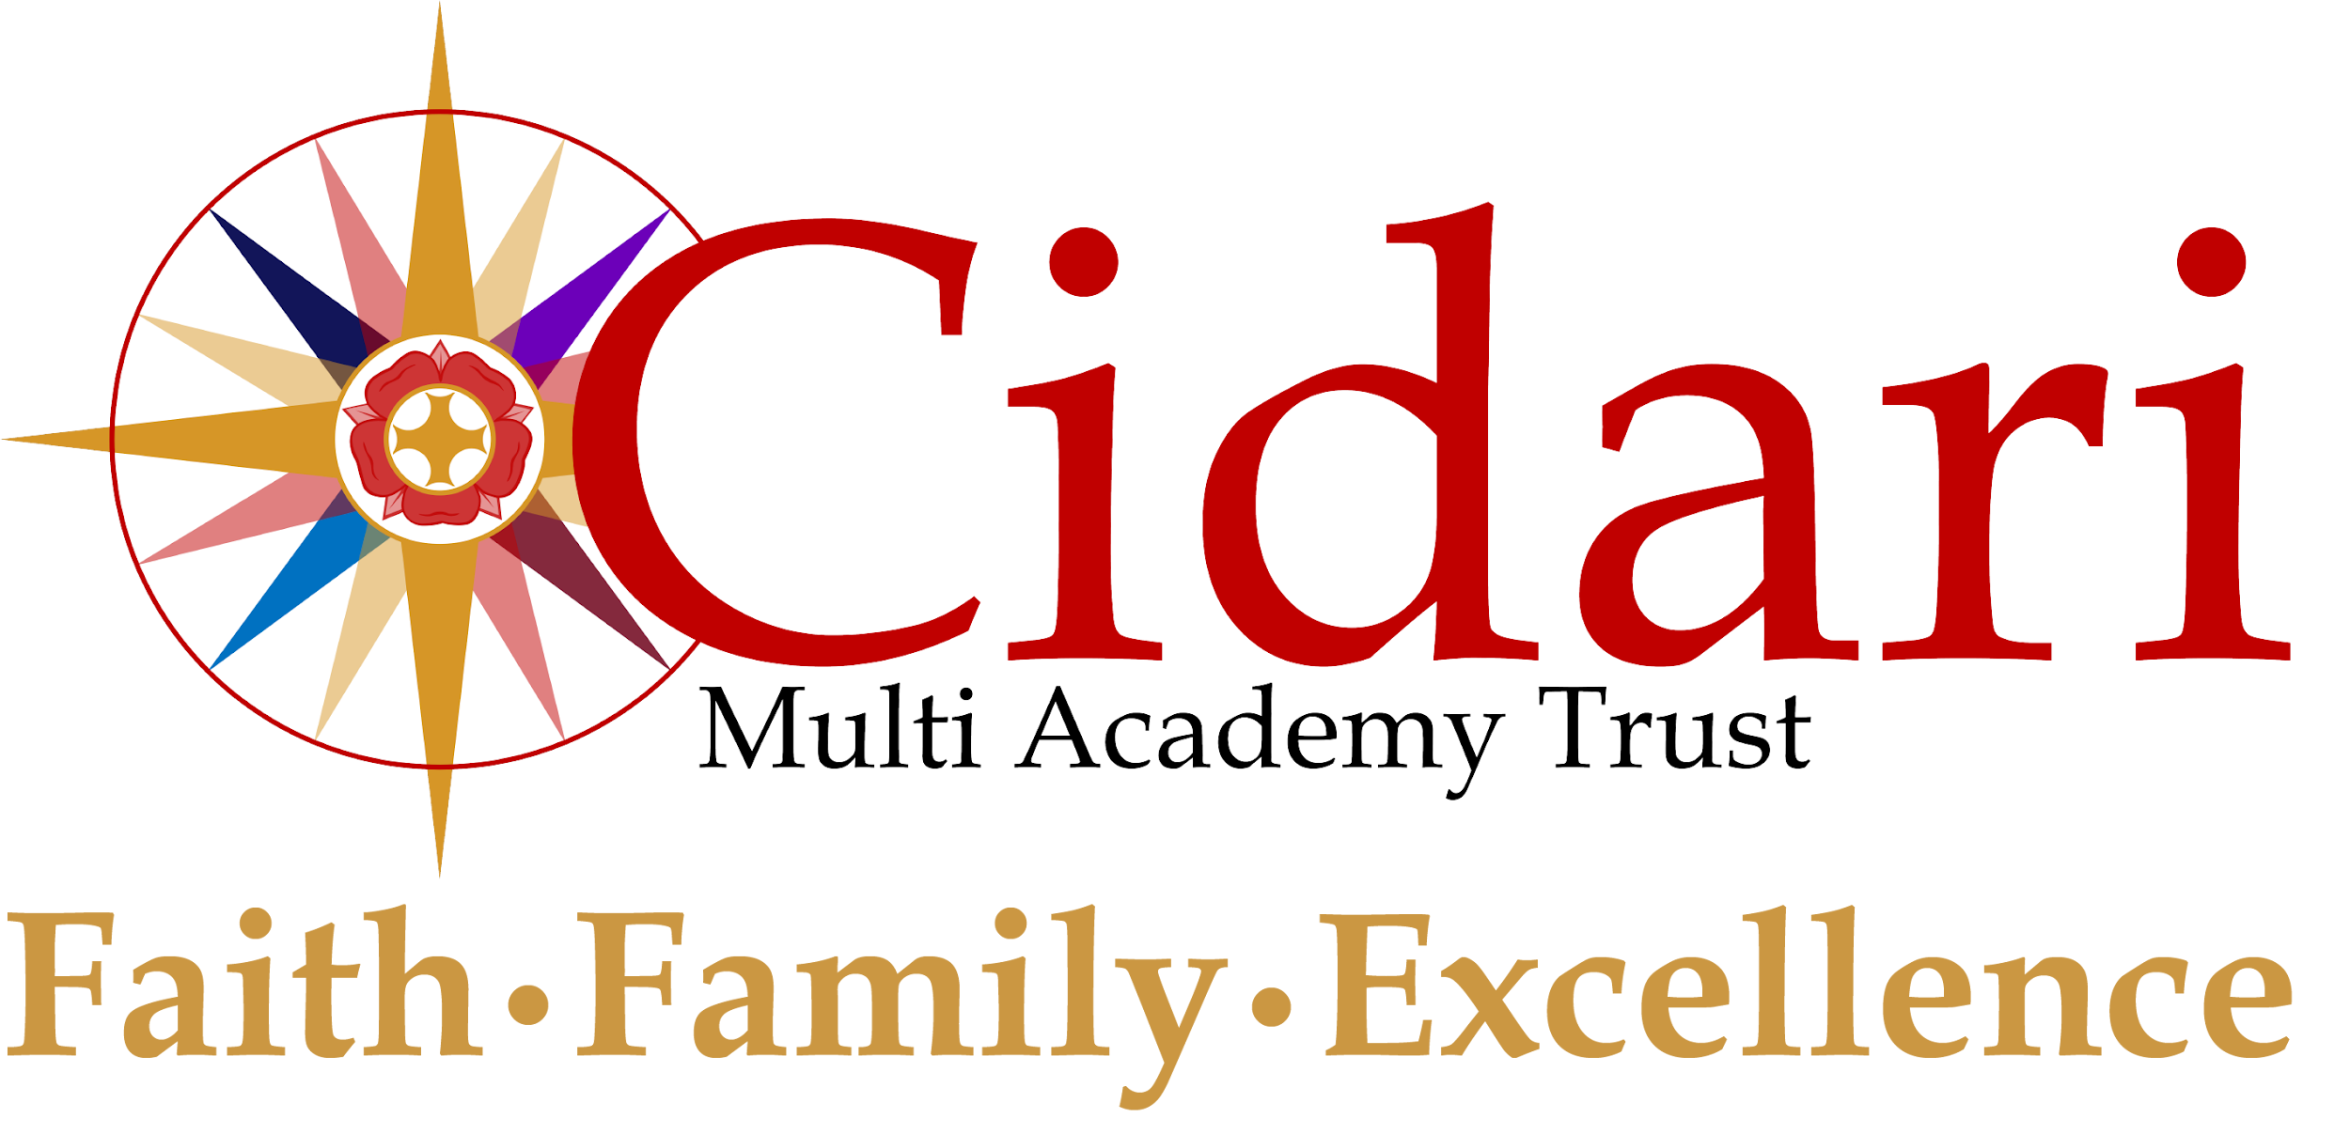

Role Profile
Senior Site Supervisor
Scale
NJC Grade E Scale 12-17
Based at
St George’s Church of England Academy
Purpose of the role (job statement)
To be accountable to the Senior Leadership Team for ensuring the quality of the security, premises related health and safety maintenance and cleaning within the academy.
The Senior Site Supervisor will manage the day to day, medium and long term maintenance of the academy, ensuring that they provide an appropriate safe and secure environment for the education of students, staff, contractors and other visitors.
Key Responsibilities
Health and Safety
To support Health and Safety across the site, leading the site team in areas including, but not limited to:
Key duties:
- Be responsible for ensuring the security of school buildings and site
- Act as a designated key holder, providing out of hours and emergency access to the academy site
- Ensure that all statutory and non statutory maintenance checks are undertaken on an annual basis
- Undertake regular inspections of the building, grounds, furniture, and equipment to identify damage, vandalism, wear and tear to ensure repairs are carried out promptly and efficiently, taking a hands on approach where required
- Responsible for regular health and safety checks of buildings, grounds, fixtures and fittings, (including compliance with fire safety regulations) and equipment
- Undertake minor repairs (i.e. not requiring qualified craftsperson) and maintenance of the buildings and site
- Undertake cleaning as required
- Undertake general portage duties, including moving furniture and equipment within the academy
- Provide a degree of analysis and planning to ascertain the nature and extent of repairs and maintenance and procure contractors
- Responsible for contractors whilst on site and ensure work is completed to the required standard
- Purchase premises related equipment and supplies within agreed budget
- Responsible for the regular checking of systems such as heating, cooling, lighting and security (including CCTV and alarms)
- Operate the heating plant, cooling and lighting systems
- Supervise and provide training to other site staff.
- Undertake risk assessments, ensure compliance within the school with all health and safety COSHH regulations
- Reporting half termly H&S and statutory concerns to the Trust Business Leader on premises related compliance and risk, as well as updates on any changes to current legislation
- To apply a philosophy of sustainability and environmental awareness to management of the estate, identifying opportunities to reduce our carbon footprint and wider environmental impact.
The regular review of and responsibility of fire regulations, including but not limited to:
- Ensuring the maintenance and documenting regulatory compliance of all fire systems and equipment in line with current legislation, ensuring all servicing and test reports are available for inspection
- Ensure that adequate out of hours cover is in place that will ensure the academy alarms are responded to
- Ensure that all fire notices, signage, and exits are clearly marked and are unobstructed together with the effective communication of the academy’s evacuation procedures.
- Facilitate, with the Headteacher and School Admin Manager the fire evacuation processes to ensure that all premises related areas are working correctly and documented, i.e., fire panels, emergency exits, break glasses, extinguishers
- Undertake regular risk assessments in line with good practice for the Academy and record findings.
Community Support
Leading on health and safety for lettings and out of school activities.
- Ensure the buildings, site and facilities are available for Academy use and other users, whenever they are needed
- Engage with the appropriate lead to ensure the smooth operation of lettings
- Liaise with event organisers regarding requirements and organise premises services effectively to ensure Academy events are set up and cleaned ready for the required time, and then areas are returned to normal operating arrangements in preparation for the next academy day

Individuals in this role may also:

Monitor the performance of the cleaning contract
- To ensure high standards of cleanliness are maintained throughout the Academy and that poor performance is highlighted in termly meetings with the premises manager/contractor
Lead on transport including but not limited to:
- Arranging, via the finance team, insurance of academy vehicles
- Maintenance of all records for the Academy owned/leased mini buses, i.e. fuel logs, vehicle checklists
- Maintenance of the vehicles, ensuring that each vehicle is kept clean and tidy both inside and out
- That regular routine compliance checks have been carried out and logged, i.e. oil levels, tyre pressures, working lights etc.
- Support the Trust Central Team to maintain and update Health and Safety and driving policies in line with current DVLA legislation, Ofsted requirements and good practice
Common Core of Skills and Knowledge for the Children’s Workforce
The common core covers six themes:
- 1. Effective communication and engagement with children, young people, parents and carers
- 2. Child and young person development
- 3. Safeguarding and promoting the welfare of the child
- 4. Supporting transitions
- 5. Multi-agency working
- 6. Sharing information
This Job Description forms part of the contract of employment of the person appointed to this post. It reflects the position at the present time only and may be changed at management’s discretion in the future.

