HMC BOARDING AND DAY
839 Boys; 277 Sixth Form

Head of Economics & Business

Bedford School
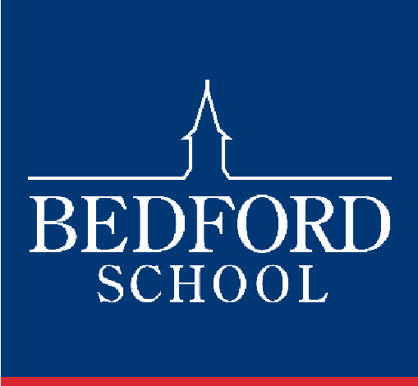

Situated just 35 minutes on the train from London St Pancras, and half way between Oxford and Cambridge, Bedford School is one of the region’s leading boarding and day schools, educating boys from the ages of 7 to 18. Part of The Harpur Trust, Bedford’s leading educational and social welfare charity, we’re a vibrant school with a very strong sense of community, set in a beautiful 50-acre estate in the heart of the town.

There are approximately 700 pupils in the Upper School aged 13 to 18, with roughly 280 in the Sixth Form. 35% of the boys are boarders in our six Boarding Houses, each of which is “twinned” with a Day House. Our Prep School with 400 boys caters for the 7-13 age range on the same campus, and has its own junior Boarding House.

Academic excellence is central to life at Bedford School, and we encourage boys to aspire to the highest possible standards and to exceed their expectations. Our success is demonstrated by a long history of impressive exam results at GCSE, A level, and in the International Baccalaureate Diploma. The vast majority of our leavers go on to Higher Education, and 83% of our Upper Sixth boys accepted places at either Russell Group or Times Top 30 universities in 2019, to specialise in particular areas of expertise. We are seeing our boys diversify their applications, with more expressing an interest in degree-level apprenticeships and universities in the USA and Europe. Typically, between five and ten boys take up places at Oxbridge each year.

The School was inspected in November 2016, and we are particularly proud of the fact that ISI (Independent Schools Inspectorate) gave us the top ratings possible. Full details, including a copy of the inspection report can be found here: http://www.bedfordschool.org.uk/Inspection-Report

The school adopts a selective entry policy without being ruthless and seeks to provide an environment where all boys will thrive academically. It emphasises continuity of education at 13+ and 16+ so that, although there are academic entry requirements at each point, they are geared to whether boys are suitable to move to the next stage rather than over-formulaic targets. We believe in an all-round education that exposes all boys to a wide range of experiences and opportunities.

We place great emphasis on the value of Sport, Music and the Arts for the camaraderie, teamwork and self-motivation they instil, and encourage boys to explore their individual talents. Our extensive programme of extracurricular activities is wide-ranging and offers boys the opportunity to learn new skills and discover new interests outside the classroom. Boarding is at the heart of the school and all full-time members of staff are expected to contribute to the wider life of the school through involvement in the tutoring system and in activities outside the classroom.

The school’s ongoing development programme has included the construction of a new Library (2003), Observatory & Planetarium (2003), a new Music School (2006) and a wonderful new theatre in St Luke’s Church, on the edge of the estate (2015). Other developments have included renovation of the school dining halls and kitchens (2009), fitness suite (2010), staff common room (2011), sports pavilion (2012) and science department (2015).

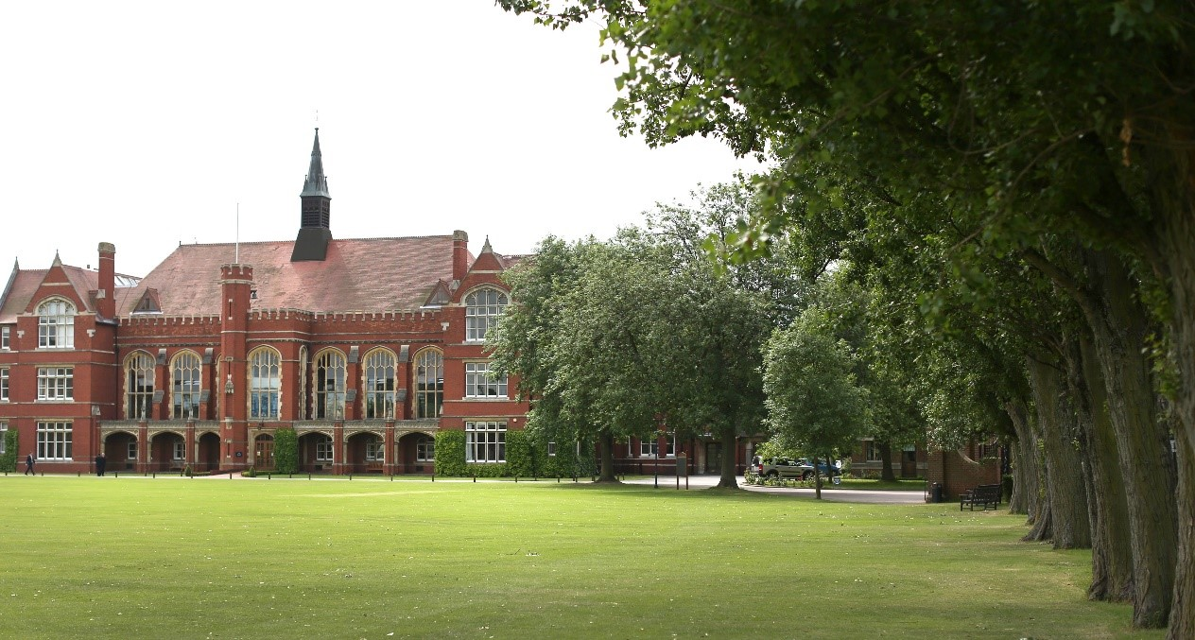

The Economics & Business Studies Department

Despite being the only Sixth Form-only department in the School, the Economics and Business Department teaches over 200 boys and has built an excellent reputation within the School. Currently, the Department has five full-time and one part-time member of staff. The Department is situated within the main school building, with six teaching rooms all equipped with interactive whiteboards. The Department also boasts a small study room, equipped with computers, which is ideal for research-based lessons.

We offer A Level Business (AQA), A Level Economics (AQA) and IB Economics. All courses have a dedicated area on the School’s VLE (FireFly), including up-to-date notes, presentations, prep schedules, revision notes and past papers. The site also has an area dedicated to UCAS, enrichment and Oxbridge. The boys learning is fully supported with a weekly Academic Clinic and a “9th lesson” for Sixth Form boys, which is a dedicated workshop lesson to support the individual learning needs of the boys.

The department is particularly proud of their excellent retention rates from Lower Sixth to Upper Sixth, and the fact that many boys within the Department develop a genuine interest in their subject, often taking this interest onto University with a Business or Economics-related degrees. Each year students apply successfully for courses at the most competitive universities, including Oxbridge and LSE. The department, in conjunction with the wider Humanities Society, has hosted many lectures, particularly from Old Bedfordians working in related fields of work. The Department also enters the Bank of England Target 2.0%, BASE Business Competition and IFS Investor Challenge on an annual basis.

Qualification results for the previous four years are as follows;

Subject | 2020 | 2019 | 2018 | 2017
Economics % A*-B | 85 | 72 | 72 | 71
Business % A*-B | 87 | 47 | 70 | 79
IB Economics % 7-6 | 67 | 75 | 80 | 80

The Role

We wish to appoint a Head of Economics and Business for September 2021, who is enthusiastic and well qualified, to lead a highly successful department offering A Level and IB courses. The successful candidate will have a genuine passion for Economics and Business, a desire to inspire this in others and will be eager to develop their own teaching skills and those of their team. The successful candidate is also likely to contribute to the development of our boys’ entrepreneurial thinking.

Benefits of Service

Bedford School has high expectations of its staff and therefore looks to reward them with generous salary scale increments and beneficial conditions of service. All teachers are offered membership of the Teachers’ Pension Scheme and have longer holidays than the maintained sector. Class sizes are small (typically a maximum of 14 at Sixth Form and 24 at GCSE).

We believe we have a responsibility to keenly and pro-actively support all of our staff in their development and to make this an outstanding place to work. Each member of staff has a voice on professional matters via the Common Room Chair and a variety of staff run initiatives, and The Head Master has weekly open-door sessions for staff (and pupils). A wide range of opportunities for professional development exist and staff are encouraged to further their skills and consider career options at all levels. There is a generous budget to support continued development and learning for our teachers. The Teaching and Learning Group host meetings and dinners throughout the year and staff run training sessions for one another in order to share best practice. The school recently hosted a TeachMeet evening for those who work across the schools of the Harpur Trust. There are also bursaries available for staff who wish to travel in order to develop their subject specific knowledge or understanding of different educational contexts. We fully fund and support teachers in qualifying through PGCEs and the assessment only route to qualified teacher status. In a recent quality assurance visit, we were considered to be a school offering best practice induction to newly qualified teachers (NQTs). There is ample opportunity to take on additional responsibilities here at Bedford School.

The school is set in beautiful grounds within a 50-acre site on the edge of a busy town centre that is well connected to London, Milton Keynes and Cambridge in particular. Staff are welcome to make use of the extensive leisure and sporting facilities on the site (which includes gym, swimming pool, tennis courts, squash courts etc.) for themselves and their immediate family.

The school has an incredibly friendly Common Room that provides support and puts on a variety of social events; most recently, there was a hotly contested staff bake off competition. Weekly football, yoga and mindfulness sessions are complemented by additions such as staff life drawing, a tennis evening, calligraphy club, and regular staff cricket fixtures with local clubs and schools.

Fee concessions are available across the Harpur Trust schools. A private health care scheme is also available for teaching staff. Our staff all receive free lunches, which are provided by our national award-winning catering team, and all staff can expect free on-site parking.

Bedford is a dynamic and incredibly rewarding place to work with a strong sense of community. We very much hope that you will want to come and find out more about us.

General Information

Full-time teachers at Bedford are expected to:
- Play a full part in the extensive games and activities programme
- Be a Tutor attached to a boarding or day house

Bedford School is committed to safeguarding and promoting the welfare of children and young people and expects all staff to share this commitment. Offers of appointment are subject to satisfactory references and DBS clearance.

Staff are normally expected to find their own accommodation, although there may be some school accommodation available in certain circumstances.

Application Process

Applicants are asked to complete the School Application Form; CVs in place of an Application Form cannot be accepted.

Short-listed candidates will be invited to the School for interview on the advertised date. The selection process will involve a lesson observation and several interviews.

The Department is a lively and friendly one, with a considerable amount of experience and expertise. The Head of Department, Mr Phil Waterhouse, would be happy to talk to prospective applicants; he can be contacted through the School Reception on 01234 362200 or by email pwaterhouse@bedfordschool.org.uk

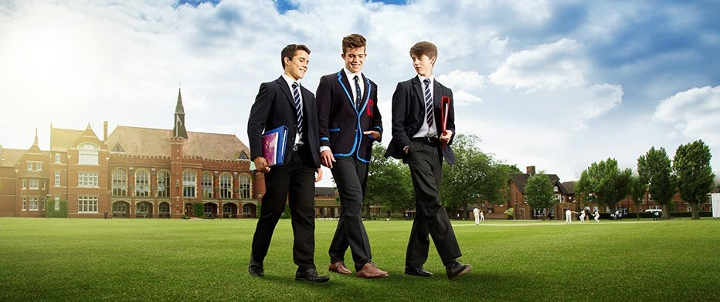

Bedford School is part of The Harpur Trust
