
Teacher of English

Information Pack

Dear Candidate,

Thank you for taking the time to consider joining the talented staff team here at Redden Court School and The Success for All Educational Trust. I am very proud to be the Headteacher of Redden Court, a school that is committed to the success of all students in our care.

Notable Achievements in recent years:
- In 2020 we were awarded the SSAT award for exceptional outcomes for our SEND Students
- We have recently been re-accredited as a Thinking School by the CEDU at the University of Exeter
- In 2019 we were awarded the ‘Quality in Careers’ standard for our work in this area
- The school received 2 awards from SSAT for the Progress and Attainment of students in 2016 and 2 awards in the same categories for 2017
- In the Havering Learning Partnership Awards 2019 we received the award for Wellbeing and in 2018 we received awards for Best Progress in the “Open” Subjects and an Enrichment Award for Most Innovative Technology Project. In 2017 we received awards for Best Progress Overall, Best Progress Made by Disadvantaged Students, Best Progress Made by More Able Students, Best Progress for “Open” Subjects, Best Progress in Mathematics, Best Progress in Humanities, Most Improved Attainment in the EBacc 2016
- In 2016, Ofsted recognised the progress made by the school and the fact that we have created an inclusive community where we focus on working with families to raise aspirations

We pride ourselves on being a fully comprehensive school placed at the heart of the community. We want all of our students to be happy, ambitious and to achieve results that reflect their true potential.

Our school has served the local community of Harold Wood for many years, providing a high quality education to the students of this area.

Our vision is focused on a ‘Commitment to Success for All’ and high levels of aspiration for every member of our community. The school is forward thinking and progressive. We seek to achieve the very best for all of our students through the use of a rich variety of educational approaches. We have caring staff who are dedicated to ensuring the students are successful in every aspect of their learning.

Redden Court is the founding school in the Success for All Educational Trust and is recognised as one of the highest performing mixed comprehensive schools in Havering. The SFAET will expand over the next few years to incorporate both local Secondary and Primary Schools and currently includes 3 Secondary Schools.

We are an accredited ‘Thinking School’ and have very close links with the Cognitive Education Development Unit at the University of Exeter. Metacognition and the development of thinking skills is at the heart of our teaching and learning in the school as we believe it plays an important part in developing resilient and independent learners.

We also have very strong links with the Havering Teacher Training Programme, we are a senior partner in the Empower Teaching Alliance and we are recognised as a Leading Edge School by the SSAT. The school has also been accredited with All Together (Anti Bullying), Place2Be (Student Mental Health), SEND Exceptional Outcomes Award, The Quality in Careers Standards, Healthy Schools Gold Award and Gold Travel Ambassadors Award.

We are a growing community Trust with inclusion at the heart of our ethos and require leaders who will bring this vision to life.

These are exciting times for Redden Court School with so much change and challenge in the future.

Perceptions play a major part in your decision when choosing the right school for you to lead and build a successful career. We strongly urge you to come and visit the school prior to application.


Mr Anthony Henry
Headteacher of Redden Court School

Teacher of English
Salary Scale: Teacher Mainscale Outer London
Start date: September 2021

Redden Court School, a place where “Pupils are enthusiastic about
coming to school to learn.” (OFSTED SEPTEMBER 2016)

Would you like to move your career forward in a friendly environment with eager students and support from an experienced leadership team, in one of the best mixed comprehensive schools for 11-16 in our Local Authority. We are oversubscribed, serve Harold Wood well and we are only twenty minutes from the heart of London.

We invest in our staff to help them to become the best possible teachers they can be. There are excellent opportunities for people who work hard. Effort is often recognised in career development. Many who came to us as NQTs now have substantial leadership roles. Our CPD programme and collegiate approach are highly effective. Staff morale is high and so is that of our students and their community.

Redden Court’s most recent results place us in the
top 20% nationally for progress, the top 10% in English and Maths for Progress 8.

Our school mantra is "Committed to Success for All." That includes our staff and we want the very best for our students. Less than a year ago OFSTED said we “have created an inclusive community where pupils and staff relate well to each other. The school is focused on working with families to raise aspirations for pupils.”

If you are an inspiring, enthusiastic Teacher of English who recognises that the best practitioners always want to improve, we would like to talk to you. This is an exciting opportunity to be part of a forward thinking school. This position would be suitable for an experienced teacher seeking a new challenge or a Newly Qualified Teacher looking for their first position.

The successful candidate will be committed to our vision, our values and ethos, and have the interpersonal skills and ability to lead staff and students to achieve all they can. If you would like to speak to the Head of English Faculty, Mrs L Campbell, please feel free to telephone the school or email her at lcampbell@reddencourtcloud.co.uk.

We are committed to safeguarding and promoting the welfare of children and young people and we expect all staff to share this commitment. We require the successful candidate to undertake an enhanced criminal records check via the Disclosure and Barring Service.

We welcome enquiries from everyone and value diversity in our workforce. Applications are welcome from all sections of the community regardless of gender, gender identity, ethnic origin, disability, age or sexual orientation.

References from 2 previous employers will be sought prior to interview.

For details on how to apply, please visit our website: https://www.reddencourtcloud.co.uk/about-redden-court/work-with-us

Please email cmorris@reddencourtcloud.co.uk to arrange a tour of the school.

Closing date: Thursday, 10th June at 12pm

Interviews will take place week commencing Monday, 14th June 2021

Redden Court School is a member of the Success for All Educational Trust.
Cotswold Road, Harold Wood, Romford, Essex, RM3 0TS Tel: 01708 342293



Job Profile

Teacher of English

Pay scale: Teacher Mainscale Outer London
Reports to: Head of English Faculty

Principal duties and responsibilities

1. To strive for excellence in teaching and learning in the classroom.

2. To ensure that agreed school and faculty policies are adhered to in all
teaching and administrative activities.

3. To liaise with parents / carers on student progress and attend consultation
evenings / progress review days as specified in the school calendar.

4. To assess and report on students at all levels, including those with special
educational needs and disabilities.

5. To ensure that there is a sharing of information regarding the progress of individual students with relevant Tutors, Pastoral Heads and the SENCO.

6. To support the development of the subject through attendance and
discussions at regular calendared faculty meetings.

7. To assist with curriculum planning in order to ensure that the curriculum on offer to students is appropriate to the needs of all and ensures equal access.

8. To support enrichment activities for students as directed by the Head of Faculty.

9. To be responsible for the teaching of Key Stage 3 and Key Stage 4 groups and their progress against school targets.

10. To participate in relevant staff development programmes within the school.

11. To participate in the pastoral care structure of the school as a Form Tutor or member of the support team.

12. To undertake any reasonable duties at the direction of the Headteacher which are appropriate to the needs of the school.

Mr A Henry
Headteacher
Deputy Headteacher of Student Achievement
PA to Headteacher

Head of English Faculty (x2)
English Teacher
(x7)
Lead Practitioner

Google Education

Google Education is an exciting and innovative way of learning, introducing easy tools to engage students whenever, wherever on any device!

In summer 2012, Redden Court School adopted G Suite for Education, the free web-based communication and collaboration suite available to education establishments.

With products including Gmail, Google Calendar, Google Drive, Google Sites and Google Classroom, Redden Court School recognised the potential it would bring to classroom learning, knowledge sharing across the academies, improvements in administrative efficiency and providing access from home for all.

This enables all our students and staff to have access to the most up-to–date technology. Our academies have also rolled out many class sets of Google Chromebooks, affordable browser-based laptops that provide quick, simple access to the web!


Continued Professional Development

Redden Court School believes that all staff should be involved in a continuing process of improvement. The school is committed to fostering a positive ethos of continuous learning. Continuing Professional Development (CPD) is the means by which the school is able to motivate and develop its staff community. This development takes place at a number of levels: individual, team, whole school and through wider networks. CPD supports and reflects the ethos, values and vision of the school.

All forms of professional development are based on the following principles:
• all staff should be encouraged to develop their knowledge, skills, understanding and attitudes to enhance their professional work;
• all staff will have regular opportunities to discuss their development needs and professional aspirations through our appraisal process;
• all staff have a responsibility to participate in school focused CPD and personal career development.

Our annual CPD programme consists of a number of compulsory Twilight training sessions, these are targeted around Safeguarding and Teaching and Learning Priorities. It is expected that staff join a Focus Group which collaborates on action research based on one of our whole school priorities. In addition, all teachers should actively participate in Faculty training led by team leaders.

To supplement our compulsory provision, we offer a range of additional, voluntary CPD approaches for all staff. These include:
• attendance at a course or conference;
• in-school training using the expertise available within the school, e.g. team teaching, coaching/mentoring, skills in classroom observation, sharing existing expertise;
• school-based work through accessing an external consultant/adviser or relevant expert such as an advanced skills/SLE or lead teacher;
• school visit to observe or participate in good and successful practice, e.g. visit to a school or subject area with similar circumstances, a teaching school;
• secondments, e.g. with another teacher, school;
• shadowing opportunities to observe experienced colleagues in another setting;
• opportunities to participate in award bearing work from higher education or other providers such as the National College for the Leadership of Schools and Children’s Centre e.g. NPQML and NPQH;
• research opportunities;
• distance learning, e.g. relevant resources, training videos, reflection, simulation;
• practical experience, e.g. national test or exam marking experience, opportunities to present a paper, contribute to a training programme;
• job enrichment/enlargement, e.g. a higher level of responsibility; front lining working in someone else’s job, job sharing, acting roles, job rotation, shadowing.

Where possible, we try to offer a bespoke training programme for all our employees.
EXTRA-CURRICULAR TIMETABLE

There is a multitude of extra-curricular opportunity at Redden Court and we encourage all students to attend clubs weekly and be involved in what’s on offer. Enrichment is an important part of school life and essential to the development of individual character and cultural capital.

The Extra-Curricular Timetable outlines what’s available both before and after school and at lunchtimes.

WEEKS A AND B | MONDAY | TUESDAY | WEDNESDAY | THURSDAY | FRIDAY
BEFORE  SCHOOL | THE AM NEWS CLUB | THE AM NEWS CLUB | THE AM ANEWS CLUB | THE AM NEWS CLUB | THE AM NEWS CLUB
BEFORE  SCHOOL | FUTSAL - WEEK A & B ROTATION | INDOOR ATHLETICS | Y10 FOOTBALL | Y9 FOOTBALL | ALL YEARS - GIRLS NETBALL
BEFORE  SCHOOL |  |  | Y7 & 8 GIRLS FOOTBALL | Y8 FOOTBALL | Y7 RUGBY
BEFORE  SCHOOL |  |  | SPORTS ACADEMY |  | LATIN CLUB
LUNCHTIME | MATHS PUZZLE / CHESS | DANCE | PRINTMAKING WORKSHOPS | FIIIT CLUB | POLITICS CLUB
LUNCHTIME | Y9 TABLE TENNIS | MAD SCIENTISTS | CREATIVE WRITING | Y7 TABLE TENNIS | MUSIC CLUB
LUNCHTIME | WORLD CHALLENGE | DEBATE CLUB | STUDENT NEWSLETTER | WORLD CULTURE CLUB | TEXTILES CLUB
LUNCHTIME | DIGITAL LEADERS CLUB | LITERACY QUOTES | Y10 & 11 TABLE TENNIS | HISTORY ART CLUB | GCSE TABLE TENNIS
LUNCHTIME |  | Y8 TABLE TENNIS | CHALLENGE FRENCH | GEOGRAPHY CLUB | ANTI BULLYING CLUB
LUNCHTIME |  | DUKE OF EDINBURGH |  | KS3 DRAMA CLUB
LUNCHTIME |  |  |  | JLT MEETINGS
AFTER  SCHOOL | Y7 NETBALL | ART CLUB | GYMNASTICS | BOCCIA | Y9 RUGBY
AFTER  SCHOOL | Y9 & 10 GIRLS FOOTBALL | CREATIVE WRITING | ARTS AND CRAFTS | GIRLS WHO CODE | YEAR 10 RUGBY
AFTER  SCHOOL | Y7 BOYS RUGBY - INVITE PRACTISE | KS4 GIRLS NETBALL | THE CREST AWARD | SPANISH CLUB | Y8 GIRLS NETBALL
AFTER  SCHOOL |  |  | MUSICAL THEATRE
AFTER  SCHOOL |  |  | STEM CLUB

Results 2020

Results 2020 | Redden Court School
Progress 8 | +0.49
Attainment 8 | 55.07 | +5.03
Basic English & Maths (strong) | 69.80% | +9.05%
Basic English & Maths (standard) | 84.56% | +11.06%
Ebacc entered | 89.93% | +5.23%
Ebacc APS | 5.19 | +21.21%

Staff Benefits

Career Development:

- Apprenticeships
- Support towards achieving further qualifications
- Leadership programmes
- Progression opportunities
- Teacher Training Programme

Family Friendly:

- Childcare vouchers – if you are using registered or approved childcare, you can choose to take part of your salary in childcare vouchers to pay for it which are Tax and National Insurance free. This means you get extra value from your pay packet each month.

Financial:

- Pension – teaching staff access Teacher Pension Scheme and Associate Staff access Local Government Pension Scheme
- All teaching staff are allocated a Chromebook

Health and Wellbeing:

- Schools Advisory Service offering:
  - Access 24 hours a day to a GP Helpline where you can have a telephone consultation for you and close relatives.
  - Access to Physiotherapy
  - Access to a counselling service
  - Free 12 week Weight Management Programme
  - Support for stress management
  - Lifestyle Screening
  - Relationship Counselling
  - Long Term Condition support - Support for you and family members where you or a member of your family is suffering from a long term condition such as cancer, Multiple Sclerosis or Motor Neurones Disease. This list is not exhaustive.
  - Private Medical Service
  - Stress Counselling

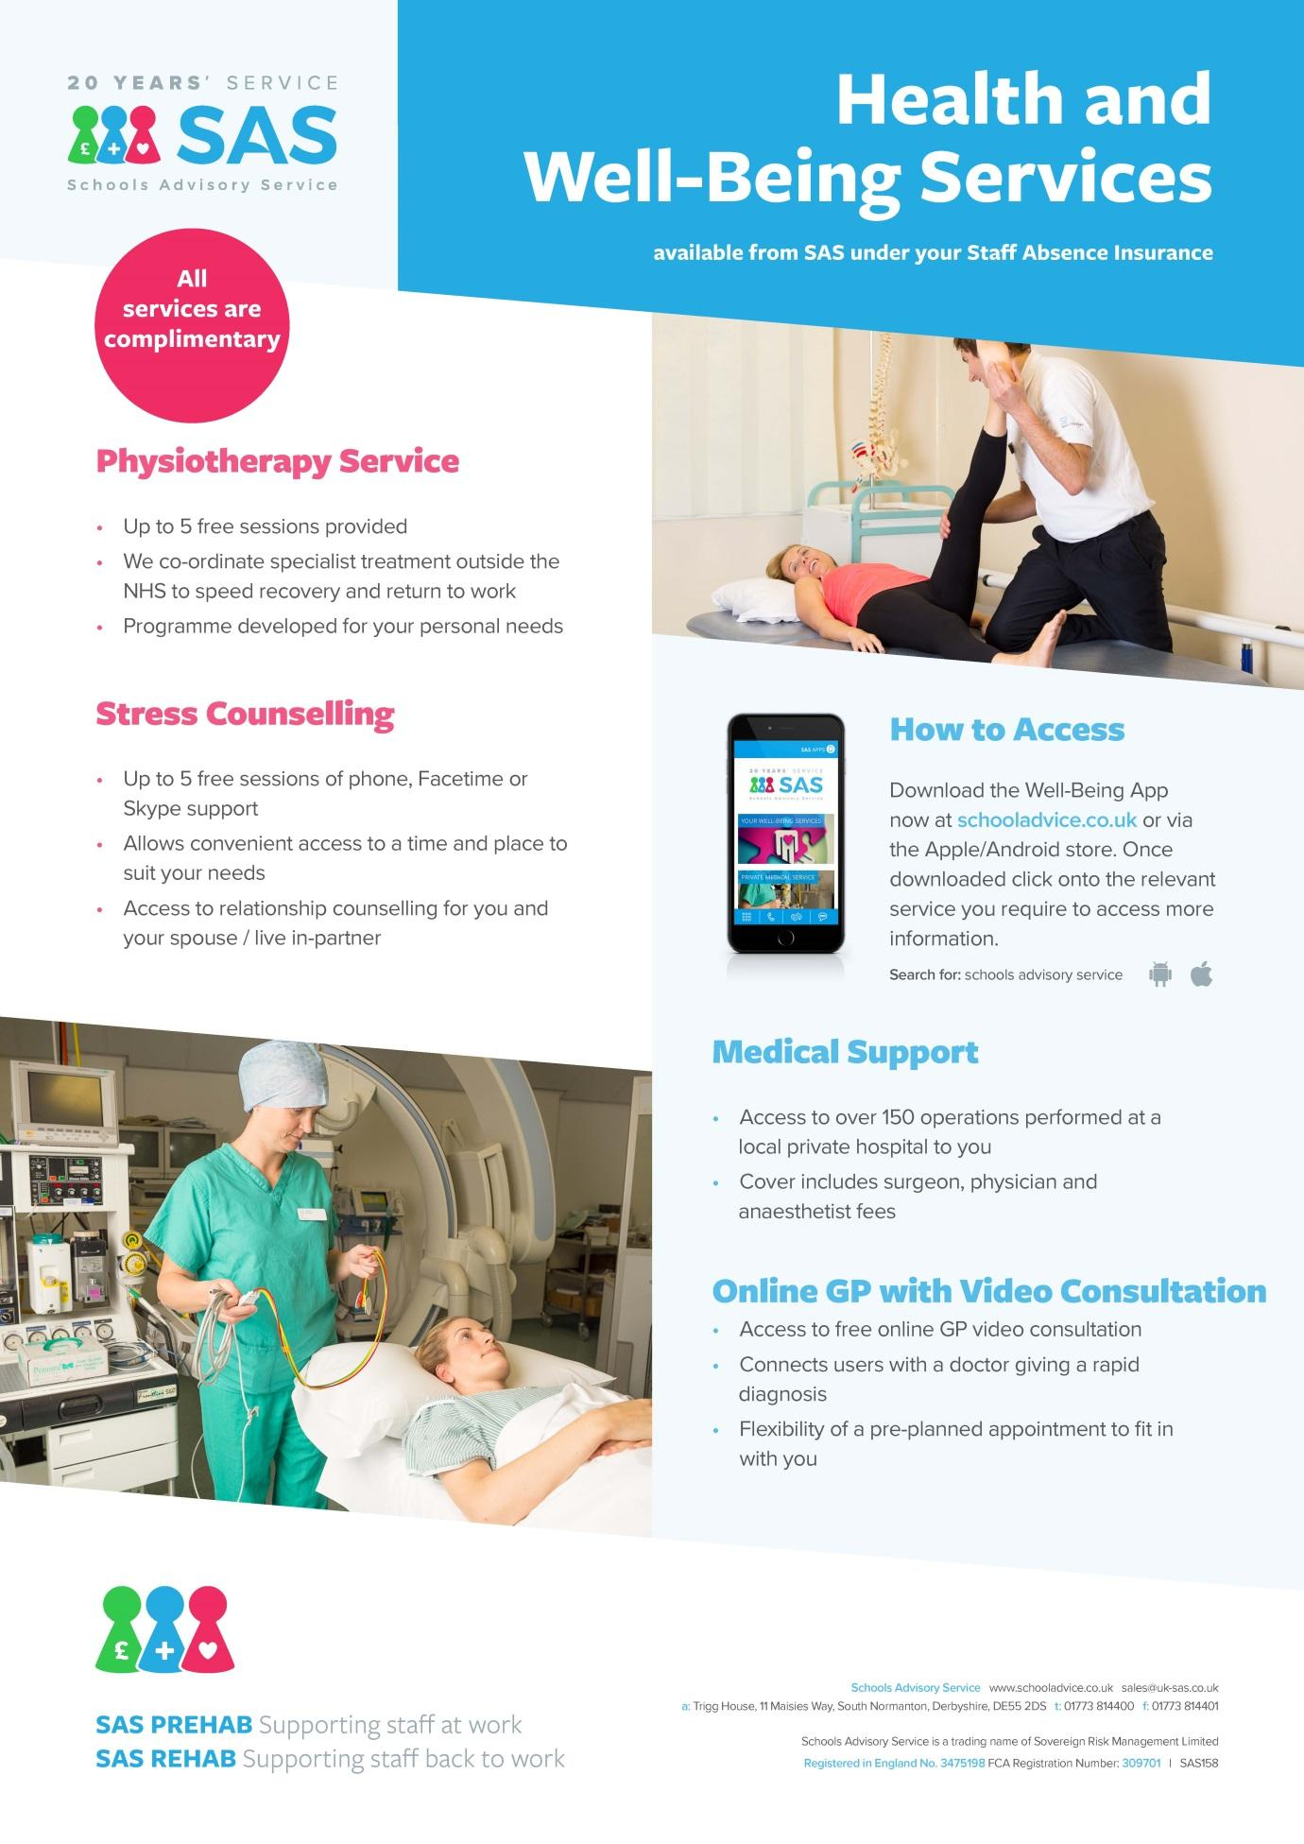

VALUES AND ETHOS STATEMENT

At Redden Court, our Mission Statement has been formulated as a result of the collective input of all stakeholders in our community, parents, staff, governors and particularly our students. We have chosen to express our mission through our ASPIRE logo:



and our ASPIRE ethos:


Achieve and Accomplish

“At Redden Court we support and challenge each other to achieve and accomplish”. Connor H
“I want to be successful in everything I do. For me it is not enough to just become okay at something. I like to know that I have not only achieved but that I have become accomplished.” Lucy E





Share and Support

“Sharing is something I value – for me, sharing is caring. I value other people’s opinion as they help me to build my own ideas.” Olivia W
“From as soon as I started at Redden Court it was clear that everyone was happy to listen to my ideas and give me help when I needed it.” Daniel O

Pursue and Persist

“Being knocked down doesn’t mean you just give up, it means you get back up and try even harder. It’s the world telling you to just give that little bit more.” Scarlet J
“When I have my eye on something, whether it’s an ‘A’ in a science test, or a game winning try in rugby, I practise, practise, practise. If I keep improving, eventually I will reach my goal.” Luyi G

Innovate and Inspire

“At Redden Court I am inspired to innovate and to think outside the box. I am encouraged to expand my knowledge and to ask myself, “what if” and “why”. Megan C
“I think it is as important to inspire as it is to find inspiration. I am a reading mentor and hope to inspire those that I support.” Thomas B


Reflect and Refine

“In lessons, we are encouraged to think deeply about our work, recognise what we have done well and see how we can develop it. Sometimes it is hard, to be honest, but I know it will help me to succeed.” Katie C
“Reflecting and refining means to a lot – I’m not scared to learn from my mistakes. I am able to go back to my previous work and pick out the points I can improve.” Laura Y


Engage and Excel

“I want to surpass the expectations others have of me and know that I will need to work hard at everything - even the little things – that I need to do.” Kim D
“I have high expectations for myself, but I know that success doesn’t come without hard work.” Jed R
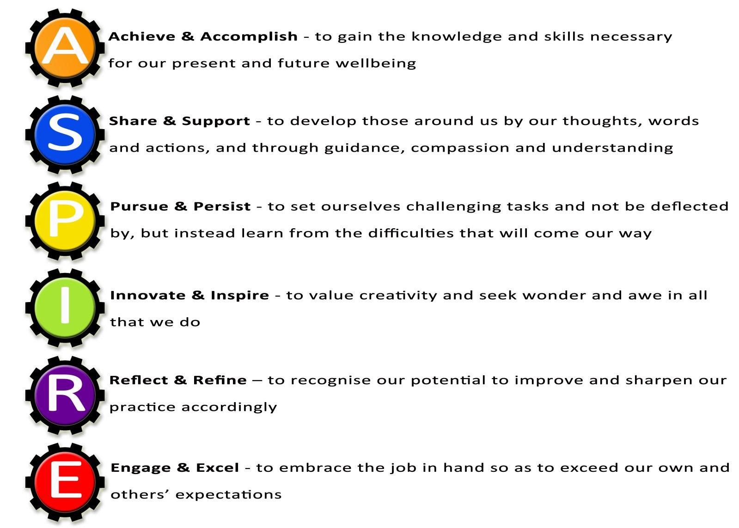



We believe that all members of our community should be aspirational, supportive of each other, persistent, innovative, reflective and willing to engage at all times.

Our aspirational values will ensure that everyone in our community is committed to success for all.

Staff Stories
  Mr Carrington, Deputy Head | Redden Court recognises and rewards hard work, enthusiasm and commitment to success. I have been given the opportunity to progress from an NQT to Head of Faculty, SLT and now my current role as Deputy Headteacher within 10 years. I have been encouraged to introduce new technology to the school and work on a variety of interesting projects. The students and staff are a pleasure to work with and our team ethic is impacting positively on the progress of our students. Our reputation has been transformed in the past decade and the future is bright as we have vibrant leadership in place at all levels, quality teachers and a fantastic support network of staff who are dedicated to the needs of all students. We work closely with the other schools in our Multi-Academy Trust and continue to expand our own vision and ethos with plenty of opportunities for career development.
  Miss Todd, SFAET Maths Lead Practitioner | Redden Court is a wonderful school and has supported me over the years with each stage of my professional progression. I started my training here as GTP in 2007, became leader of the house system, second in Maths and then Head of Faculty in January 2014. More recently, I have gained Lead Practitioner accreditation and when I returned to work after having my son, I was promoted to Lead Practitioner for Maths across the Success for All Educational Trust. I have been given huge opportunities and been supported each step of the way.  Redden Court is a wonderful teaching environment, with excellent resources and students who make you love the job! If you are a good teacher, with great ambition and enthusiasm you will be supported and encouraged to go on and achieve fantastic things in your career at Redden Court.
  Miss Morris, PA to EHT and HT | When I joined RCS over 11 years ago, I was job sharing the role of PA to the Headteacher. Now I work full time as the PA to the Executive Headteacher of the Success for All Educational Trust and the Headteacher at Redden Court School.  I have always felt supported and empowered to excel in my performance and development and am considered a valuable member of the Trust and Redden Court School team.

  Mr Pendred, Head of Technology Faculty | I arrived at Redden Court School as an NQT, and at the time I never thought I would progress as quickly as I have. This is a school that really recognise and reward hard-work. From the very start I had the responsibility of being a subject leader in Product Design, then after only two years I progressed to Head of Department in Design and Technology, and in my fifth year at the school I was made Head of the Technology Faculty. I have had a key involvement in much of the school signage and have had opportunities to run school trips and lead a STEM club. This is an ambitious and supportive school full of great staff, and in my opinion there is no better place to pursue a career in teaching.
  Mr Barrett, Business Manager | I joined Redden Court in 2012 shortly after the school converted to Academy Status in January 2012. From that time I have learned something new every day. Little did I know the range of experiences I would have within the school. I have enjoyed every single day I have worked in the school and am extremely proud of the outcomes the students achieve and the part that I play in that. We are about to encounter an exciting time at the school with the formation of the Multi Academy Trust and building works through the Priority Schools Building Programme that will enhance the quality of provision for our students.  Redden Court is a school where I want to come to work with enthusiasm each day and I am empowered by an amazing leadership team.
  Mr Sims, Learning for Behaviour Mentor | I joined Redden Court School as a Learning Facilitator in 2016. I was immediately impressed (and inspired) by the dedication of the staff and the attitudes the students had towards learning. It is clearly evident that the school acknowledges the all round importance of the students wellbeing. I quickly became involved in the Futsal team and have managed them in competitions at the Copperbox in London. I also co-founded the Sports for Confidence team which has participated in various tournaments and competitions around the Greater London area. Redden Court School has afforded me the opportunity to advance in my career. As a result of that I have become the schools Learning for Behaviour Mentor. It is a privilege to be part of a team that truly reflects its ethos of "Success for All".

