Headteacher Recruitment – Application Pack

St Patrick’s Catholic
Primary School
Nova Lane, Birstall, WF17 9LQ

- 01924 423220
office.stpatricksbirstall@kirkleeseducation.uk
www.stpatricksbirstall.co.uk

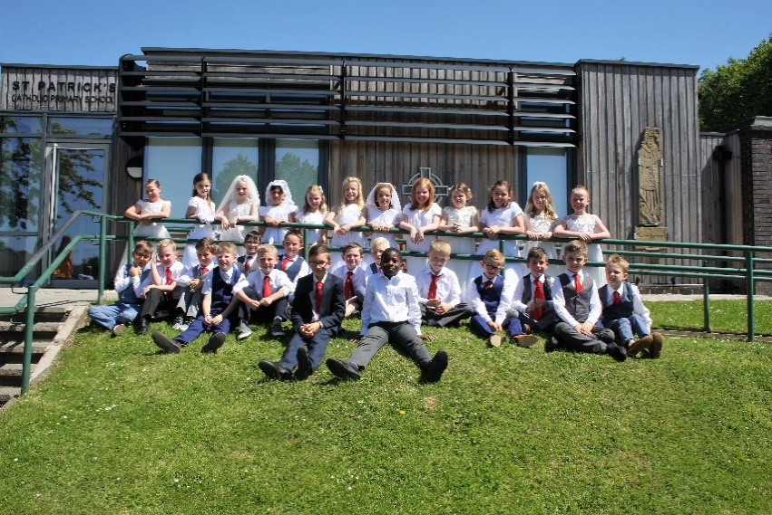
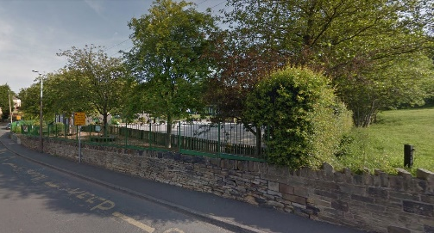

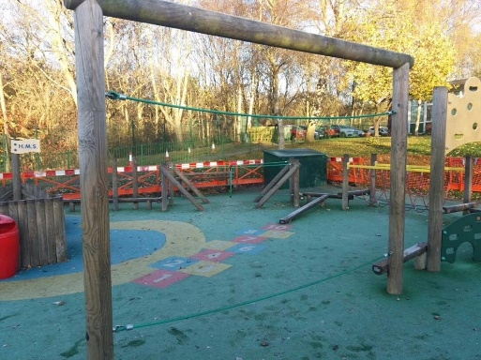

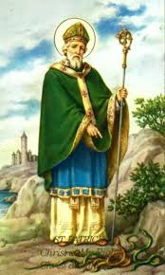

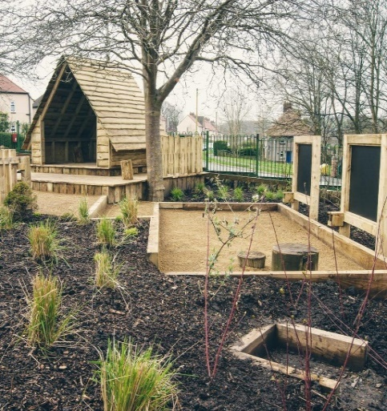

Chair of Governors’ Letter
Dear Applicant,
Thank you for the interest you have shown in the position of Headteacher at our school. I hope that you find the following details informative and that they help you decide that St Patrick’s Catholic Primary School is the school in which you would be happy and able to make a positive contribution. We also recommend that you visit in person – you will be warmly welcomed and have the opportunity to discover for yourself our wonderful children, staff and facilities.
At out last Ofsted we were rated Outstanding with numerous positive features, particularly with regard to the behaviour and attitude of our children. The Catholic life of the school was rated as Outstanding by the Diocesan inspection team in June 2018. We are very proud of our achievements in recent years and believe that with the right leadership we will continue to move the school onwards in providing an outstanding learning experience for every child, as well as being a living Christian community.
St Patrick’s, founded in 1877, is an outstanding one-form entry primary school that has a proud tradition of serving the community of Birstall and surrounding areas with many families sending several generations of children to be nurtured and supported by us. Our primary role is the teaching of the Catholic faith and we do this by placing Christ at the centre of everything we do.
We believe that our school is a special place; rooted in the Catholic faith our aim is for each child to thrive, achieving their full potential, academically, emotionally, socially and spiritually. We want all our children to find school life interesting, challenging and enjoyable whilst feeling safe, secure and valued.
We have a strong leadership team and committed and reflective staff keen to learn from one another to consistently deliver excellent teaching. The use of rigorous data analysis and targetted interventions has led to excellent pupil outcomes.
We have an experienced and committed Governing Body with a good range of skills and a deep knowledge of the school. The governors are well aware of the challenges facing the education system in the future, not least financial pressure and will provide the Head with strong support.
I believe this is an exciting opportunity and challenge for an individual to lead this successful school.
Kind regards,
Fr David Bulmer, Chair of Governors

Job Advert

Role: Headteacher

Range: L13 to L19

Salary: Dependent on experience

Start: September 2019

Type: Group 2

On Roll: 259

PAN: 35

The Governors at St Patrick’s wish to appoint a well-qualified and enthusiastic leader to be Headteacher of this outstanding and happy school on the retirement of their successful and valued Headteacher. The school was judged as outstanding in its last OFSTED inspection, in June 2018 was graded outstanding in its Section 48 inspection and has just been announced as the best performing primary school in Kirklees.

We welcome applications from practising Catholic’s who are either current Head Teachers looking for a change of school or an experienced Deputy Headteacher ready to take the next step into Headship.

The successful candidate will be:

- Committed to the Catholic ethos of the school and someone who tries to live the values of the Gospel every day.
- A highly effective and successful leader able to inspire our leadership team.
- A strategic thinker able to achieve targets by having a clear vision and direction for the school.
- Have the skills to lead, motivate and inspire pupils, staff, parents and governors to build further sustainable success.
- Passionate about pastoral care, developing the whole child and embracing the school’s ethos and values.

In return, St. Patrick’s offers:

- Happy and well-motivated children who enjoy learning.
- A dedicated and talented staff team who have high expectations of themselves and each other.
- A Governing Body who play an active role in supporting the leadership of the school.
- A close relationship with our parish who play a key role in the life of the school.

This is an exciting opportunity for a committed leader to build on strong established foundations and lead this school to the next level.

“A strong and vibrant sense of family characterises the school and there is a profound feeling of everybody working together, inspired by the Gospel, to achieve a common goal. A strong sense of mission permeates the school, being visible in the environment and tangible in its daily life. It is encapsulated in the school’s mission statement, we live, love, learn and grow in the light of Christ.” (Section 48, June 2018)

Application forms and further details are available from the school website:
www.stpatricksbirstall.co.uk

Closing Date: 28th January 2019
Shortlisting: 30th January 2019
Interview Dates: 14th/15th February 2019

Birstall is a village to the south of Leeds, five minutes from major motorway networks (M62, M1). Visits to the school are warmly welcomed and encouraged. Please contact the school on 01924 423220 to arrange a mutually convenient time to visit.
Our School

We are a voluntary aided mixed primary school providing education to children from ages 3 to 11 in the Diocese of Leeds. There are currently 259 pupils on the roll, of which 96% are baptised Catholics. There is a high demand for places as the school is well regarded in the local community and we are always significantly oversubscribed. Pupils come mainly from the parishes of St Patrick’s Birstall and Our Lady of Unfailing Help & St Paul of the Cross, Cleckheaton.

The school was judged as outstanding in December 2007 and in June 2018 was graded as outstanding in its Section 48 inspection.

Below are our results for 2018 and, as can be seen, the KS2 results based on the new measures were outstanding. Not only were they outstanding, the results meant that our school has been classed as the best performing school in Kirklees.

Key Stage 1

Area | Our School  % Working at Expected and above | National Average % Working at Expected and above | Our School  % Working at Greater Depth | National Average % Working at Greater Depth
Reading | 74% | 75% | 29% | 26%
Writing | 63% | 70% | 11% | 26%
Mathematics | 74% | 76% | 14% | 22%
Combined | 54% | - | 6% | -

Key Stage 2

Area | Our School  % Working at Expected and above | National Average % Working at Expected and above | Our School  % Working at Greater Depth | National Average % Working at Greater Depth | Our School Average Scaled Score | National Average Scaled Score
Reading | 100% | 75% | 70% | 28% | 112 | 105
Writing | 97% | 78% | 30% | 20% | - | -
Mathematics | 94% | 76% | 42% | 24% | 109 | 104
SPAG | 100% | 78% | 82% | 34% | 115 | 106
Combined | 94% | 64% | 24% | 10% | - | -

Our School Life
Our School Mission Statement

"We recognise that every person has a divine origin and an eternal destiny. With this in mind, we at St Patrick's School, aim to provide an education which promotes the development of the whole person. Our children will be encouraged to live the Gospel values through all aspects of the curriculum and the events of their daily lives, leading them to grow, develop and find fulfilment. We seek to foster respect for the unique value and giftedness of each member of the school community and to prepare our children for life in the wider world of diverse faiths and cultures."

St Patrick’s is a happy, inclusive and friendly school where pupils enjoy learning and are cared for by dedicated and enthusiastic staff. We pride ourselves on supporting the development of loving and nurturing relationships within the school community based on Christian care and respect, coupled with high expectations and aspirations for each child. This is clearly reflected in our school mission statement.

At St Patrick’s we endeavour to provide not only outstanding education for our children, but also support in the development of their minds, body and spirit through the provision of a wide range of opportunities for personal growth and challenge. We place great emphasis on delivering a broad curriculum, one that is not just focused on SAT outcomes.

As a school we recognise that each individual member of our community makes their own unique contribution to the school. We believe in the importance of sharing best practice between schools to enrich and professionally develop our staff and in turn our pupils and therefore have great links with other primary schools in our pyramid including St John Fisher’s Catholic Academy, for which we are a main feeder school. We have very well-established links with both our parishes and the parish priest at St Patrick’s attends regularly both to celebrate Mass and visit classes.

We are seeking a Headteacher who will build further sustainable success, who will cherish our caring family ethos and inspire staff to provide the highest learning experience for each and every child at St Patrick’s Catholic Primary School.
‘Teaching is of a very high standard. A high proportion of it is outstanding and none of it is less than good.’ ‘Attainment is excellent, a high percentage of children achieving at or above expected levels by the end of each key stage. Progress is good.’
June 2018 Section 48 R.E Inspection Report

St Patrick’s has a reputation as a caring school that provides support to all its pupils, especially the vulnerable and those with special needs. The school provides a warm, nurturing environment, good resources and a commitment to team work and the professional development of staff. ‘Pupils are full of enthusiasm for their school and are proud to be St Patrick’s pupils. They are highly appreciative of the staff. They are polite and well behaved and their relationships with each other as well as with the adults in school are excellent.’
June 2018 Section 48 R.E Inspection Report

Our Mini Vinnies

Around 12 months ago, pupils and staff formed a Mini Vinnies group (a Children’s St Vincent de Paul Society) and during this time have had a considerable impact in and out of school, sending cards to sick parishioners, and supporting a local drop in centre, for instance. The RE coordinator explained that they consider themselves to be a Mini Vinnies school and the group represents the rest of the pupils.

One of their first and very important roles was in deciding the new child-friendly school motto, which was launched at a Whole School Praise on the 26th January 2018.
“We live, learn, and grow in the light of Christ”

We live the Gospel, love like Jesus, learn the bible as we grow together in faith.

We do all this illuminated in the Light of Christ.

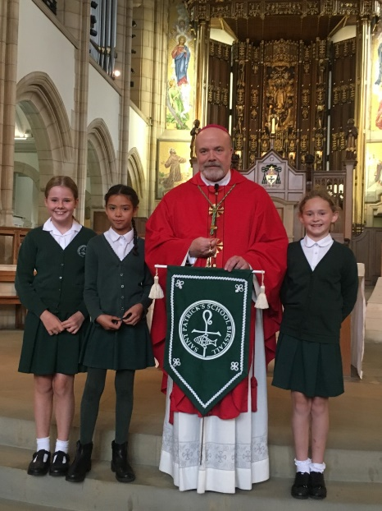

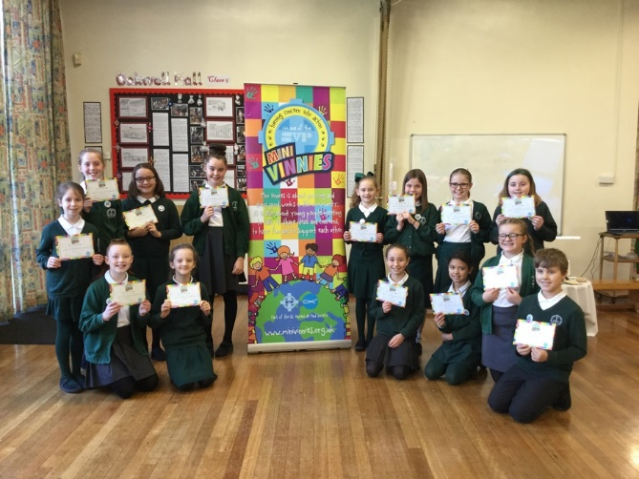

One child said that the best thing about the school was the way that “teachers are gentle and kind and they encourage you to be a better person.”

Another child encapsulated the feeling within the school when she said, “We are learning to build a life of faith. God is our rock.”
Our School PFA

The Parents and Friends of St Patrick’s are very active and supportive, arranging various fund-raising events which provide considerable sums of money, enabling us to enhance our resources and provision in ICT, sports and recreational areas.

The PFA are parents and friends of the school who organise events such as the Christmas Fair and the Easter Trail. The group is open to anyone who is interested in becoming involved and they hold meetings every 4 to 6 weeks during term time.

The main aims of the PFA are to create a friendly community spirit amongst the parents and children of the school, and to help raise funds which can be put to good use throughout the school. The events organised by the PFA have helped, over the years, to fund several items which include Laptops and Smart Boards, Playground and Early Years equipment, and the recent building works at the school.
“One view, which is typical of the majority of parents, is, ‘I feel very privileged that my child attends St Patrick’s– a lovely school where every child is cherished.’ The school is cheerful and welcoming, and many pupils and parents comment positively on the ‘family atmosphere’ and ‘community spirit’.”
Ofsted inspection 2007
Headteacher: Job Description
Introduction
St. Patrick’s Catholic Primary School has been designated a voluntary aided school with a religious character. Its Instrument of Government states that it is part of the Catholic Church and is to be conducted as a Catholic school in accordance with Canon Law, the teachings of the Roman Catholic Church and the Trust Deed of the Diocese of Leeds. At all times the school is to serve as a witness to the Catholic Faith in Our Lord Jesus Christ.
The core purpose of the headteacher of any school is to provide professional leadership and management. In our Catholic school, that professional leadership is provided in the context of a community rooted in the Catholic Faith recognising a joint responsibility across all schools. Thus, it is an essential requirement that applicants have a strong, personal faith and recognise the opportunities and challenges facing Catholic education as a vibrant part of the mission of the Church in education. The governing body and the Diocese acknowledge the importance of the role of the Catholic headteacher and will actively offer long term support, encouragement, affirmation and realistic challenge to the successful candidate.
In a Catholic school, the search for excellence is given expression in learning and teaching which responds to the needs and aspirations of its pupils and acknowledges their individual worth as made in the image and likeness of God. The headteacher shares responsibility for the mission of the school and the wider diocesan educational system and as such is therefore called to work in collaboration with parents, priests, parishioners, diocesan officers and colleague headteachers as well as agencies such as CAFOD, Family Life and Youth Ministry as and when appropriate. In a Catholic school, the role of the headteacher is one of leadership of a learning community rooted in faith. The headteacher’s leadership must take Christ as its inspiration. The headteacher’s management of staff should demonstrate an awareness of their unique contribution as individuals, valued and loved by God. Headteachers lead, by example, the professional conduct and practice of teachers in a way that minimises unnecessary teacher workload and leaves room for high quality continuous professional development for staff. They secure a climate for the exemplary behaviour of pupils. In a Catholic school the headteacher fulfils his or her responsibilities in accordance with the Instrument of Government/ Articles of Association. He/she supports the governing body in fulfilling its responsibilities to the Diocese under Canon Law as well as in accordance with national legislation. The headteacher accounts to the governing body, parents/carers and the school community for the fulfilment of the school’s Catholic mission and its educational success.
The discharge of the role of headteacher requires a significant theological insight and vision of the development of this Catholic school.
National Standards of Excellence for Headteachers
The National Standards of Excellence for Headteachers (2014) define high standards which are applicable to all headteacher roles within a self-improving school system. These standards are designed to inspire public confidence in headteachers, raise aspirations, secure high academic standards in the nation’s schools, and empower the teaching profession. Headteachers occupy an influential position in society and shape the teaching profession. They are lead professionals and significant role models within the communities they serve. The values and ambitions of headteachers determine the achievements of schools. They are accountable for the education of current and future generations of children. Their leadership has a decisive impact on the quality of teaching and pupils’ achievements in the nation’s classrooms. Headteachers lead by example the professional conduct and practice of teachers in a way that minimises unnecessary teacher workload and leaves room for high quality continuous professional development for staff. They secure a climate for the exemplary behaviour of pupils. They set standards and expectations for high academic standards within and beyond their own schools, recognising differences and respecting cultural diversity within contemporary Britain. Headteachers, together with those responsible for governance, are guardians of the nation’s schools.
National Standards of Excellence for Headteachers,
DfE Jan 2015

This appointment is with the governing body of the school under the terms of the Catholic Education Service contract to be signed. The governing body will appoint a practising Catholic who can show by example and from experience that he or she will ensure that the school is distinctively Catholic in all aspects. The appointment is subject to the current conditions of service for headteachers contained in the School Teachers’ Pay and Conditions document and other current education and employment legislation. In carrying out his/her duties the headteacher shall consult, when appropriate; the Diocese, the Local Authority, the staff of the school, the parents of its pupils, the parishes served by the school and other local Catholic schools where necessary.

Excellent headteachers: qualities and knowledge

- Work within the school and with the parish to hold and articulate clear values and moral purpose, which takes account of the school’s Catholic mission focused on providing a world-class education for the pupils they serve.
- Demonstrate optimistic personal behaviour which stems from Christ’s vision for humanity. Promote positive relationships and attitudes towards their pupils, staff, parents, governors and members of the local community recognising their individual worth as made in the image and likeness of God.
- Inspired by Christ, lead by example - with integrity, creativity, resilience, and clarity - drawing on their own scholarship, expertise and skills, and that of those around them.
- Sustain wide, current knowledge and understanding of education and school systems locally, nationally and globally, and pursue continuous professional development.
- Work with political and financial astuteness, within a clear set of principles influenced by the Gospel message and Church teaching, centred on the school’s vision, ably translating local and national policy into the school’s context.
- Communicate compellingly the school’s vision and drive the strategic leadership, empowering all pupils and staff to excel.

Excellent headteachers: pupils and staff

- Demand ambitious standards for all pupils, overcoming disadvantage and advancing equality, instilling a strong sense of accountability in staff for the impact of their work on pupils’ outcomes that reflect the distinctive characteristics of Catholic education.
- Secure excellent teaching through an analytical understanding of how pupils learn and of the core features of successful classroom practice and curriculum design, leading to rich curriculum opportunities and pupils’ well-being. Ensure high quality provision for the academic, spiritual, moral, social, emotional and cultural well-being of all pupils and families.
- Establish an educational culture of ‘open classrooms’ as a basis for sharing best practice within and between schools, drawing on and conducting relevant research and robust data analysis.
- Create an ethos within which all staff are required to treat all people fairly, equitably, and with dignity and respect. Inspire, encourage and support staff to develop their own skills and subject knowledge, and to support each other.
- Identify emerging talents, coaching current and aspiring leaders in a climate where excellence is the standard, leading to clear succession planning.
- Hold all staff to account for their professional conduct and practice, emphasising the distinctive nature of Catholic Education.

Excellent headteachers: systems and process

- Ensure that the school’s systems, organisation and processes are well considered, efficient and fit for purpose, upholding the principles of transparency, integrity and probity reflecting the school’s Gospel values.
- Provide a safe, calm and well-ordered environment for all pupils and staff, focused on safeguarding pupils and developing their exemplary behaviour in school and in the wider community to promote Gospel values which unite society in a commitment to social justice and the common good.
- Establish rigorous, fair and transparent systems and measures for managing the performance of all staff, addressing any under-performance, supporting staff to improve and valuing excellent practice.
- Welcome strong governance, rooted in faithful stewardship of Gospel values, actively supporting the governing board to understand its role and deliver its functions effectively – in particular its functions to set school strategy and hold the headteacher to account for pupil, staff and financial performance.
- Exercise strategic, curriculum-led financial planning to ensure the equitable deployment of budgets and resources, in the best interests of pupils’ achievements and the school’s sustainability.
- Distribute leadership throughout the organisation, forging teams of colleagues who have distinct roles and responsibilities and hold each other to account for their decision making.

Excellent headteachers: the self-improving school system

- Lead outward-facing schools which work with other schools and organisations - in a climate of mutual challenge – where each pupil is championed to ensure they secure their unique potential and achieve excellence
- Develop effective relationships with fellow professionals and colleagues in other public services to improve academic, spiritual, moral, social, emotional and cultural outcomes for all pupils.
- Challenge educational orthodoxies in the best interests of achieving excellence, harnessing the findings of well evidenced research to frame self-regulating and self-improving schools.
- Shape the current and future quality of the teaching profession through high quality training and sustained professional development for all staff.
- Model entrepreneurial and innovative approaches to school improvement, leadership and governance, confident of the vital contribution of internal and external accountability.
- Inspire and influence others - within and beyond schools - to believe in the fundamental importance of Catholic education in young people’s lives and to promote the value of education.

Child Protection

- Ensure that the child protection policies and procedures adopted by the trust board are fully implemented and followed by all staff.
- Ensure that sufficient resources and time are allocated to enable staff to discharge their child protection related responsibilities effectively.
Securing Accountability

In a Catholic school the Headteacher fulfils his or her responsibilities in accordance with the Instrument of Government. The Headteacher supports the Governing Body in fulfilling its responsibilities under Canon Law to the Diocese and in accordance with national legislation. The Headteacher accounts for the efficiency and effectiveness of the school to the Governing Body and wider community of the school.

- To fulfil commitments arising from contractual accountability to the Governing Body.
- To develop a Catholic school ethos which enables everyone to work collaboratively, share knowledge and understanding, celebrate success and accept responsibility for outcomes.
- To ensure individual staff accountabilities are clearly defined, understood and agreed and are subject to rigorous review and evaluation.
- To work with the Governing Body (providing information, objective advice and support) to enable it to meet its responsibilities.
- To develop and present a coherent, understandable and accurate account of the school’s performance to a range of audiences including governors, parent and carers.
- To reflect on personal contribution to school achievements and to take account of feedback from others.
Strengthening Community

In a Catholic school the Headteacher shares responsibility for the mission of the school and the wider Diocesan educational system and as such is therefore called to work in collaboration with parents, priests, parishioners, Diocesan Officers, colleague Headteachers and agencies such as CAFOD, Family Life and Youth Ministry as and when appropriate.
- To build a school culture and curriculum which takes account of the richness and diversity of the school’s communities rooted in the Catholic Christian faith.
- To create and promote positive strategies for challenging racial and other prejudices and dealing with racial harassment.
- To ensure learning experiences for students are linked into and integrated with the wider community.
- To ensure a range of community-based learning experiences.
- To collaborate with other agencies in providing for the academic, spiritual, moral, social, emotional and cultural well-being of pupils and their families.
- To create and maintain an effective partnership with parents and carers to support and improve pupils’ achievement and personal development.
- To seek opportunities to invite parents and carers, community figures, businesses or other organisations into the school to enhance and enrich the school and its value to the wider community.
- To contribute to the development of the education system by sharing effective practice, working in partnership with other schools and promoting innovative initiatives, especially with other Diocesan schools.
- To cooperate and work with relevant agencies to protect children.

Headteacher: Person Specification
This person specification is intended to assist both candidates and governors in the appointment process. It highlights the particular qualities for headteachers of Catholic schools in ensuring that they meet the same expectations of headteachers of all schools while serving the mission of the Church in education.
The core purpose of the headteacher of any school is to provide professional leadership and management. In our Catholic school, that professional leadership is provided in the context of a community rooted in the Catholic faith. Thus, it is an essential requirement that applicants have a strong, personal faith and recognise the opportunities and challenges facing the Catholic school as a vibrant part of the mission of the Church in education.
The governing body and the Diocese acknowledge the importance of the role of the Catholic headteacher and will actively offer long term support, encouragement, affirmation and realistic challenge to the successful candidate.
The governing body acknowledges that the criteria reflect the evolving role of headship in the early 21st Century and that they apply as much to experienced headteachers as they do to aspirant headteachers. The successful candidate will be encouraged to participate in the diocesan induction programme and will be offered an appropriate and experienced Catholic headteacher as a mentor.
If the successful applicant has not completed the CCRS course in Catholic Education or equivalent, an undertaking to successfully complete the course will be expected.

SYSTEMS AND PROCESS | Essential or  Desirable |  | Evidence
Efficient strategic leadership and prudent financial planning | E |  | A/I
Ensure the safety of all staff and pupils at all times | E |  | A/I
Promote excellent behaviour and positive attitudes to school life | E |  | A/I
Systems for performance management to hold staff to account | E |  | A/I
Ability to challenge under-performance | E |  | A/I
Understanding of strong governance to hold the school to account | E |  | A/I
Ensure budgets and resources are deployed in the best interests of pupils | E |  | A/I
Promote distributed leadership throughout the organisation | E |  | A/I
QUALITIES AND KNOWLEDGE | Essential or  Desirable |  | Evidence
Practicing Catholic (see notes for definition) | E |  | A/R
Qualified Teaching Status | E |  | A
Degree | E |  | A
Evidence of Leadership Development | E |  | A
CCRS (Catholic Certificate in Religious Studies) | D |  | A
Recent Senior Leadership experience in a Catholic primary school | E |  | A/I/L
Lead by example and be a positive role model with excellent communication skills | E |  | I/L
Ability to articulate a clear vision and purpose for Catholic education | E |  | A/I
Personal impact and presence | E |  | A/I
Participation in a Parish Community | D |  | A/I/R
Ability to lead the spiritual development of staff and pupils | E |  | A/I
Understanding of current educational provision and the wider school systems | E |  | A/I
Political and financial astuteness | E |  | A
PUPILS AND STAFF | Essential or  Desirable |  | Evidence
Have ambitious standards and high expectations for all pupils | E |  | A/I
Excellent understanding of high quality teaching and learning | E |  | A/I
Promote the development of the whole child | E |  | A/I
Use data analysis to effectively drive whole school improvement | E |  | A/I
Encourage all staff to develop their unique potential | D |  | A/I
Identify emerging talent, develop excellence and clear succession planning | D |  | A/I
SECURING ACCOUNTABILITY | Essential or  Desirable |  | Evidence
Fulfil commitments arising from contractual accountability to the Governing body | E |  | I
Develop a Catholic school ethos | E |  | A/I
Ensure individual staff accountabilities are clear, understood, agreed, reviewed and evaluated | E |  | I
Work with the Governing Body to enable it to meet its responsibilities | D |  | A/I
Develop an accurate and understandable account of the school’s performance for a range of audiences | E |  | A/I
Personally contribute to school achievements taking account of feedback from others | E |  | A/I
STRENGTHENING THE COMMUNITY | Essential or  Desirable |  | Evidence
Build a school culture and curriculum which takes account of the richness and diversity of the community’s Catholic Christian faith | E |  | A/I/R
Create and promote strategies for challenging racial and other prejudices | D |  | A/I
Ensure learning experiences for pupils are linked into and integrated with the wider community | D |  | A/I
Ensure a range of community-based learning experiences | D |  | A/I
Collaborate with agencies in providing for the academic, spiritual, moral, social emotional and cultural well-being of pupils and their families | D |  | A/I
Create and maintain an effective partnership with parents and carers | E |  | A/I
Invite local community into school to enhance and enrich the school | D |  | A/I
Share effective practice working in partnership with other schools | D |  | A/I
CONFIDENTIAL REFERENCES AND REPORTS | Essential or Desirable |  | Evidence
A positive and supportive written faith reference from a priest where the applicant regularly worships. | E |  | R
A positive recommendation from current employer or Headteacher | E |  | R
A second professional reference | E |  | R
APPLICATION FORM AND LETTER | Essential or Desirable | Evidence
Application form to be completed in full and legible | E | A
Supporting statement to be clear, concise and related to the specific post and appointment criteria | E | A
Notes: Definition of Practising Catholic
To objectively define what a ‘practising Catholic’ is when assessing applicants for key leadership posts within a Catholic school, it is necessary to understand that there are general obligations as well as essential components that constitute ‘practice’ of the faith in the teaching of the Catholic Church.
The Church’s general obligations for its members require that they strive to live lives of holiness by being faithful to the teaching of the Gospel, by trying to uphold the values proclaimed in the Beatitudes, by assisting in the Church’s mission to make Christ known to all peoples, by upholding privately and publicly the Church’s moral and social teaching, by endeavouring to follow an informed conscience and by making every effort to keep the precepts of the Church. This is the ‘practice’ of the Catholic faith in its widest and all-encompassing sense. At the heart of these general obligations though, there are essential components for “full communion” with the Catholic Church. These are sacramental initiation (Baptism, Confirmation and the Eucharist) and the bonds of profession of faith, the sacraments and ecclesiastical governance. The preservation of this full communion is not limited to purely religious activity but is to be an integral part of the whole pattern of behaviour of a member of the Church. It is what essentially constitutes being a committed and ‘practising Catholic’.

Working in Leeds Diocese

Thank you for taking the time to find out more about the headship at St Patrick’s Catholic Primary School in the Diocese of Leeds.

The Diocese of Leeds covers a wide geographic area encompassing eight local authorities mainly in West and North Yorkshire well served by a network of rail and motorway links. We have 80 primary schools, 13 high schools, a sixth form college in Leeds and a residential non-maintained school for the deaf. Our smallest school is 20 pupils whilst the largest is 2,300 pupils serving both rural and urban areas. There are good partnerships between schools across the Diocese as well as within local deaneries and further networks with local authority schools. Also, within the Diocesan educational provision is our Catholic university of Leeds Trinity. The primary headteachers from across the Diocese meet regularly and organise retreats both local and to Rome.

The Diocese offers a comprehensive programme of continuing professional development every academic year which is available on the website and open free of charge to all schools giving to the Diocesan school contribution scheme. In future years it is hoped that the teaching schools in the Diocese will also take a role in delivering the programme.

It is an exciting time to join a Diocesan school and I hope that you will take this opportunity to apply to be the new headteacher of St Patrick’s Catholic Primary School, Birstall.

Kind regards
Angela Cox

Director of Education
Diocese of Leeds
www.dioceseofleeds.org.uk/education

Working in Leeds Diocese – Wellbeing Service
What is the Headteacher Wellbeing Service?
The Service:
- Was requested by Headteachers for Headteachers
- Is designed to meet the specific needs of Headteachers in the Leeds Diocese
- Is a confidential service for all Headteachers in Diocesan primary, secondary and special schools
- Offers an opportunity to talk confidentially on a personal and professional basis
- Facilitates links with other professionals
What does the Service Aim to Do?
The Service:
- Promotes the wellbeing of the Catholic Headteachers in the Leeds Diocese
- Provides personal support for individual Headteachers
- Assists Headteachers in resolving issues
- Facilitates support networks
- Enhances relationships between Headteachers, Governors, Diocesan and Local Authority personnel
What is the Role of the Diocese?

- The Diocese is committed to supporting Headteachers in their task and to working in partnership with schools
- The Diocesan Vicariate for Education as the agent in the employment of the Co-ordinator for Headteacher Wellbeing
How is the Service Funded?
- The Headteacher Wellbeing Service is funded through the School Contribution Scheme, which is an annual donation whereby schools support the work of the Diocese in relation to education and school property.
A confidential mobile line is available Monday to Friday during term time. There is a voicemail facility and response will be made within 24 hours
Headteachers and Acting Headteachers can use this service at any time as required

