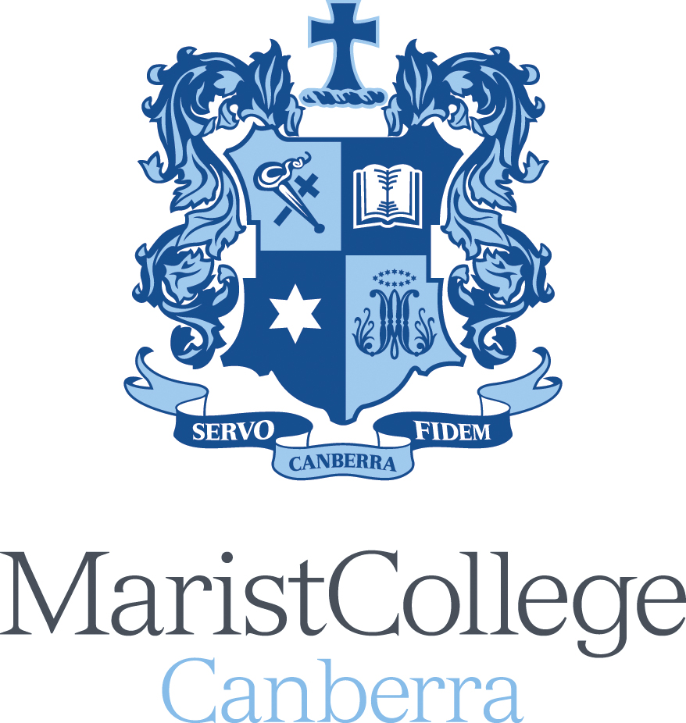

APPLICATION FORM FOR TEACHING POSITIONS – TES Applicants

SUBJECT AREA:

Thank you for your expression of interest in a position at Marist College Canberra. Please complete this form and submit through the TES Portal.

PERSONAL DETAILS
PLEASE PRINT
Surname
Previous Surname (if applicable)
Title (ie Mr/Mrs/Ms/Miss …)
Given Names
Religion
Residential Address - Street
Suburb/ Town
Post Code
Mailing Address if different
Phone Number
Email
- Please attach a curriculum vitae and resume outlining your qualifications, summary of employment history and other personal information.
- Please attach academic transcripts of educational qualifications.
- Early career teachers should include copies of final practical reports.

TEACHER QUALITY INSTITUTE / WORKING WITH VULNERABLE PEOPLE REGISTRATION
All teachers employed in schools in the Australian Capital Territory (Canberra) need to have registration with the ACT Teacher Quality Institute and hold Working with Vulnerable People Registration prior to commencing employment. Whilst you may apply for position without these registrations, if you do have them (or other state registrations), please attach a copy with your application.
TQI Registration Number: |  | Expiry date
Working with Vulnerable  People Registration Number: |  | Expiry date

MANDATORY QUESTIONS

Yes or No
Have you ever been convicted of an offence that would bar you for child-related work?
Are you currently subject to any criminal charges or investigations that may impact your ability to engage in child-related work?
Have you ever been the subject of an allegation regarding harm to a child that resulted in notification to a statutory authority under child protection legislation?
Note: in the ACT this is an allegation of ‘reportable conduct’ as defined in the Ombudsman Act 1989
Are you able to perform the inherent requirements of the position, including without aggravating any illness, injury or condition, either mental and/or physical? If no, please provide details so the College can consider and make reasonable adjustments that may be required.
Details if No:

REFEREES

Please complete these details for three professional referees. Include your current employer who can comment on your professional practice. Any information obtained from your referees will be treated confidentially.

Current Employer: Is your employer aware that you have applied for the position? Yes / No
Name
School or Organisation
Telephone
Email
Previous Employers / Other Referee:
Name
School or Organisation
Telephone
Email

Name
School or Organisation
Work Phone
Email
DECLARATION - Please read carefully and sign.
I declare that the information on this form is complete and correct in every detail and I understand that deliberate inaccuracies or omissions may result in non-acceptance of this application and/or termination of employment.

I am willing to support the Catholic and particular Marist ethos of the College.

I have read Teaching in Catholic Schools – a Statement of Principles, I concur with its content and agree to support the objectives outlined.

I am eligible for child-related employment and consent to a screening check being undertaken.

Signature:_______________________ Date:___________________

JOB INFORMATION COLLECTION NOTICE

The full College Information Collection Notice for Job Applications is available on the College website:
https://www.maristc.act.edu.au/our-college/employment

Marist College Canberra can be contacted about our Privacy Policy or about personal information generally, by:
• Emailing privacy@mcc.act.edu.au • Calling 02 6298 7200
• Writing to our Privacy Officer at PO Box 727, Mawson ACT 2608 or by facsimile at 02 6298 7259

DOCUMENT CHECK
Listed below are the documents required to complete this application.
Originals of documents will be required should you be offered employment.
☐ Current curriculum vitae or resume outlining your qualifications, summary of employment history and other personal information
☐ Final academic transcript for teaching qualification(s) showing eligibility for the award and including front and back of the original transcript for descriptive or explanatory information
☐ Evidence of TQI Registration (or other state equivalent teacher registration)
☐ Evidence of Working with Vulnerable People Registration (or other state equivalent)
☐ Other Degrees, Diplomas or Certificates
☐ Evidence of change of name (if applicable)
☐ Practice Teaching Reports (beginning teachers only)
☐ Passport and Visa for non-Australian residents

TEACHING IN CATHOLIC SCHOOLS – A STATEMENT OF PRINCIPLES
The Catholic Church has established schools to assist in presenting a vision of reality that is found in the Good News preached by Jesus Christ. Marist College Canberra serves a particular Catholic community, providing quality education in the Marist tradition for boys in an environment that reflects Gospel values.
Such an education involves a high level of interpersonal relationship between teacher and pupil.
Pope John Paul II spelt out key implications of this for teachers who work in Catholic schools:
The Church looks upon you as co-workers with an important measure of shared responsibility … To you it is given to create the future and give it direction by offering to your students a set of values with which to assess their newly discovered knowledge …(The changing times) demand that educators be called to bring professional competence and a high standard of excellence to your teaching … But your responsibilities make demands on you that go far beyond the need for professional skills and competence …Through you, as through a clear window on a sunny day, students must come to see and know the richness and the joy of life lived in accordance with Christ’s teaching, in response to his challenging demands. To teach means not only to impart what we know, but also to reveal who we are by living what we believe. It is this latter lesson which tends to last the longest.”
The College is more than an educational institution: it is a key part of the Catholic Church’s mission. A teacher at the College is more than an employee: he or she ministers in the name of the Catholic Church. In addition, all teachers in a Marist school have inherited the traditions and charism of Marcellin Champagnat, the support and transmission of which are part of the apostolate in which all staff members participate.
The Marist Brothers are a worldwide congregation with schools and other educational and social agencies in some 60 countries. Founded in France in 1817 by Father Marcellin Champagnat, they arrived in Australia in 1872, and now conduct schools in all mainland states and territories. The Brothers and the lay staff working together seek to conduct an authentic Catholic school fully in accord with the tradition and practice of the Church. At the same time their schools have a distinctive ethos which may be briefly summarised as follows:
- Emphasis on a family spirit, where each student is loved and valued.
- Inculcation of habits of hard work and unselfish sharing.
- A balance between the religious and the social – we aim to turn out good Christians and good citizens.
- An atmosphere of orderliness, cooperation and encouragement.
One of the aims to be achieved within a reasonable and practicable period of time is that those appointed to positions where teaching of Religious Education is included will have Religious Education qualifications (or will have begun to acquire formal qualifications) and the necessary background, knowledge and professional commitment to the purposes of Catholic Religious Education and the Catholic ethos of the College. While it is acknowledged that teachers of other religious traditions will have a valuable contribution to make from time to time on a particular topic, it is expected that teachers given responsibility for Religious Education classes will be Catholics with a commitment to the practice of Catholicism.
Teachers in the College have an indispensable role to play in supporting and promoting the mission and goals of the College. It is expected, therefore, of all teachers employed in the College that they will:
- see themselves as being in cooperative partnership with parents, pastors and the Marist Catholic community generally, working towards the achievement of the College’s aims;
- strive, by their teaching and personal example, to develop in students an appreciation and acceptance of Catholic teaching and values, and help maintain an atmosphere of charity and justice;
- avoid, whether by word, action or public lifestyle, any influence upon students that is contrary to the teaching and values of the Catholic Church in whose name they act;
- accept, support and espouse the Catholic educational philosophy of the College;
- develop and maintain an adequate understanding of those aspects of Catholic teaching that touch upon their subject areas;
- be suitable, competent, trained teachers committed to the goals of Marist education in the Catholic tradition;
- be committed to regular ongoing professional development;
- actively contribute to the religious and liturgical life of the College and the spiritual formation of the students;
- undertake the various duties normally rostered to school staff as specified in the Staff Handbook;
- assist and participate, from time to time, in school programs outside school hours including parent/teacher interviews;
- be available, from time to time, for professional meetings after school hours, and be committed to ongoing professional development;
- participate, when it is appropriate, in the College’s outdoor education and retreat programs and be involved in a substantive way in other co-curricular activities.

