Information for applicants  School Librarian (Maternity Cover) | 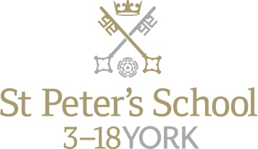
Department: Alcuin Library
Responsible to: Academic Deputy
Hours of work: Term Time only plus 7 weeks during the holidays (to include the week immediately before the start of the Autumn Term)
Term Time hours:
Monday 8.30am – 5.30pm
Tuesday 8.30am – 5.30pm
Wednesday 8.30am – 4.00pm
Thursday 8.30am – 5.30pm
Friday 8.30am – 5.30pm
Saturday 8.30am – 4.00pm
Holiday hours
Monday – Friday 9.00am - 4.30pm
(with one hour unpaid lunch break each day)
Weeks to be worked during the holidays to be agreed with the Academic Deputy
Grade/Salary: Grade 4 (£22,724 - £26,840)

Alcuin – one of the first Head Masters of St Peter’s School – created a world class library. His scholarship and research earned him a reputation across Europe. Charlemagne called him over from York to be his chief scholar.

St Peter’s School lives and grows according to its Seven Aims. The School Librarian will feel a strong commitment to these Seven Aims, in particular Wisdom: “to develop enquiring minds and a lifelong love of learning, and provide the inspiration to achieve.” Twenty First Century learning is putting greater and increasing emphasis on independent study and research skills.

We are looking for a professionally qualified librarian who has exceptional energy and vision to join this vibrant and happy learning community. The post is available from May 2018 and is temporary (initially until Christmas 2018) to cover a period of maternity leave.

Overall purpose of the post:

- To manage the day-to-day running of the library and oversee its development as a key component in the School’s teaching and learning environment.
- To ensure the integration of the library and its services into the life of the whole School.
- To ensure an effective library service to complement the education of pupils.

Key responsibilities:

- To be responsible for the library facility on a daily basis: its service to pupils, its security and health and safety, utilising the appropriate services of other support staff to assist when necessary.
- To contribute to pupils’ learning at the School, working in close partnership with teaching and non-teaching staff and in line with the School’s teaching and learning and literacy strategies.
- To collaborate with Heads of Departments and other colleagues in the design and delivery of literacy programmes and/or resources for specific projects and courses.
- To ensure and promote the proper conduct of pupils using the Library during lessons and at other times.
- To work with pupils individually or in groups, or within the teaching programme, to develop information literacy.
- To inspire a love of literacy, research and independent study.
- To maintain and develop a working knowledge of educational initiatives, information and communications technologies and developments in school librarianship.
- To manage, maintain and record accurately the use of library resources.
- To select, acquire, organise and maintain library resources within budget to cover the full school community.
- To arrange the effective retrieval by systematic indexing, classification and cataloguing of all library resources and disseminating information on those resources to staff and pupils.
- To arrange pupils’ participation in children’s literary events and author visits.
- To provide guidance and assistance to pupils and staff on information retrieval and reading materials.
- To promote the library and its resources both within the library and the whole School and externally, where relevant.
- To attend meetings where appropriate.
- To assist with any other duties to ensure the smooth running of the library, as required by the Academic Deputy.

The School is committed to safeguarding and promoting the welfare of children and young people and expects all staff and volunteers to share this commitment. The successful applicant will be required to undergo checks with the Disclosure and Barring Service.
All staff at St Peter’s School are required to observe all relevant Health and Safety, Equality and Data Protection legislation and procedures.
Note: This job description is not a comprehensive definition of the post and the post holder will be expected to undertake any other tasks commensurate with the duties and responsibilities of the post. The job description will be reviewed as part of the cycle of appraisal, and it may be subject to modification or amendment at any time after consultation with the post holder.

St Peter’s School Person Specification

Criteria | Essential | Desirable | Assessment
Experience | - Substantial experience of working in a busy library | - Experience of working in a similar school environment  - Teaching experience | Application/Interview
Qualifications | - Degree in Library/Information Studies or first degree with postgraduate library qualification in LIS | - Chartered status or approaching chartered status | Application
Specialist Knowledge | - Library management software Information specialist  - Expertise in online searching using the internet and a range of subscription services | - Sound knowledge of and/or interest in literature for young people | Application/Interview/ Reference
Skills and Abilities | - Able to work on own initiative and organise others’ work.  - Able to meet deadlines and work to pre-set timescales.  - Able to both lead and work as a member of a team.  - Enthusiasm and commitment.  - Confidence in working with young people from 13-18 | - Presentation skills | Application/Interview/ Reference
Personal Attributes/  Competencies | - Passion for promoting literacy with excellent people skills with the ability to engage with staff, parents and pupils  - Effective communicator both verbally and in writing  - Ability to work with teaching colleagues  - A commitment to safeguarding and protecting children and young people.  - Able to work flexibly to meet the requirements of the post, including evening and weekend work. |  | Application/Interview/ Reference

How to Apply

To apply for this post, submit a school application form, completed in full, with a covering letter. Please do not send CVs, either in place of or as an attachment to the application.

For an informal chat about the post, contact:

Mrs Amy Wong, Head of Library and Research 01904 527353

The closing date for applications is Monday 26th February 2018 at 10.00 a.m.

About St Peter’s

Background

St Peter’s School, York comprises three schools: St Peter’s School (pupils aged 13 – 18), St Olave’s School (pupils aged 8 – 13) and Clifton School and Nursery (pupils aged 3 – 8 years). The school is fully co-educational with 1,100 pupils, of whom 158 are full time boarders and 231 are in the Sixth Form. There are over 300 teaching and support staff. It is one of very few schools in the North of England to offer three distinct phases of education, each sharply identified and focused towards the needs of its pupils at each age group and set within an overall context of trust, confidence-building, inspiration and opportunity.

St Peter’s is one of Europe’s oldest schools, founded in 627AD, and is ranked in the top 100 schools in the country for its academic results. The school is located within a short walk of York city centre, with its thriving cultural, educational and commercial life. Many of St Peter’s facilities are modern and spacious, with playing fields adjacent to the main building that stretch down to the River Ouse.
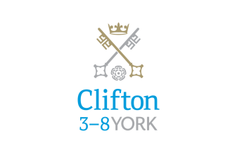

Clifton School and Nursery

Clifton School and Nursery, for day girls and boys aged rising 3 to 8 years, has its own building with use of extensive play areas, sports hall and swimming pool. Under the leadership of the Head, teachers use the attractive buildings and play areas to maximum advantage, teaching a broad and balanced curriculum which gives a wide variety of experiences, and emphasises the importance of basic skills. The curriculum is based on the National Curriculum and Primary Strategy, but goes far beyond this, both within the school day and during the wide range of co-curricular activities and visits outside of School.

Clifton enjoys separateness, a clear identity and its own House system. It allows smooth academic progression and provides tailor-made approaches and facilities for each age group.
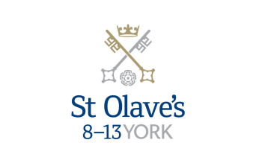

St Olave’s School

St Olave’s School (pronounced ‘olives’), for girls and boys aged 8 to 13 years, is adjacent to the main campus of St Peter’s and introduces boarding as an element of the School. Under the leadership of the Master, the teaching staff provide expertise in the 8 to 13 range, guaranteeing subject specialism to challenge and support every pupil.

The curriculum is wide and challenging with expert teaching from the earliest age. There are many opportunities for recreational and competitive sport with girls’ and boys’ teams enjoying success both regionally and nationally. There are numerous co-curricular activities to choose from on a weekly basis. Music plays a central role in school life, involving the full range of orchestral instruments.

Boarding is an integral element of the School and is accommodated in Wentworth, a boarding house on the main school campus.

St Olave’s has retained its own identity – a school within a school – giving all pupils a sense of pride and identity. It is recognised as a school in its own right, playing a vital role in the success of Clifton and St Peter’s.

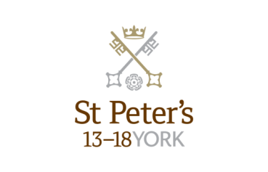

St Peter’s School

St Peter’s School, for children aged 13 to 18 years, is underpinned by academic rigour and challenge. Through outstanding teaching, first rate facilities, high expectations and sheer determination on the part of its pupils, St Peter’s achieves considerable success across a broad curriculum.

The four vibrant and successful boarding houses for boys and girls lend vitality to the pastoral life of the School. Inspiration from living in close proximity to a cultured and historic city adds further richness to the pupils’ lives. The Ofsted inspection of Boarding in December 2010 found the School’s provision to be Outstanding.

The School Chapel stands at the centre of the campus and regular services (three mornings a week) give pupils and staff the opportunity to reflect together on the spiritual values of the community and on the meaning and significance of what is happening locally, nationally and globally.

Music, Art and Drama are central to the cultural and academic depth of the School. The Sports programme is extensive, providing a wide range of choice for both girls and boys. Results are excellent, and St Peter’s pupils’ co-curricular achievements are considerable. The excellence of the teaching and facilities allows pupils to thrive.

The school’s website can be visited at www.stpetersyork.org.uk. The most recent inspection report is available on the ISI website.

About York

St Peter’s School is situated five minutes’ walk away from York’s compact city centre. York is one of the oldest and most beautiful cities in Europe, famous for its gothic Minster and winding medieval streets. York has won a number of tourist awards and further details are available on the Visit York website. York is regularly voted as one of the best places to live in the UK. Such is the size and layout of York, walking and cycling are ideal ways to get around, including taking in the famous sights of this historic city; an ancient Roman and Viking capital.

York is a central rail hub between Edinburgh, London and Manchester. The main railway station is only a 15 minute walk from the School. In addition it has a large variety of restaurants, pubs, theatres, cinemas, parks, museums and galleries, and life in York is always interesting, by day or by night.

Finding somewhere to live is also comparatively easy. York’s rental sector is in good health, though demand remains high. If you are trying to buy you will find York prices are around the national average.

York is a family friendly city. Attractions such as the Jorvik Viking Centre, the Barley Hall, the York Dungeons, the National Railway Museum and the York Chocolate Story are immensely popular with people of all ages.

The city lies in the Vale of York, a valley that runs north to south between the heathery North Yorkshire Moors to the east and the famous Yorkshire Dales to the west. Both areas offer an excellent escape for walkers, cyclists, climbers – indeed anyone with a love of fresh air and rolling countryside.

A guide to the City of York can be found at http://www.visityork.org/

Employee benefits

Our vision is to be a happy, thriving 3-18 co-educational day and boarding school community that combines a classical, high quality, all-round education with a forward-looking and exciting approach to learning.

Our staff are the key to our success. It is their expertise, enthusiasm and commitment that is reflected in our high standards and continued success. In return, we offer all our colleagues a competitive total reward package from day one of their employment with us.

Annual Leave

Teaching Staff – Teachers will normally be entitled to take as annual leave all school holidays except for such time as may be reasonably required to carry out additional duties during the school holidays. This includes staff INSET training. Public holidays occurring when the School is in session are working days.

Support Staff - Employees on all-year round contracts are entitled to a basic entitlement of 25 days paid annual leave each year plus public holidays (public holidays occurring when the School is in session are working days). Part-time or term time employees receive a pro-rata allowance of annual leave. This rises to 27 days after 5 years of service.

Childcare Vouchers

Eligible employees can join our Childcare Voucher Scheme that allows tax and National Insurance savings through a salary sacrifice arrangement. This scheme is available for employees with children up to fifteen years old (or sixteen years old for disabled children).
A salary sacrifice arrangement is an agreement between an employer and an employee to change the terms of the employment contract to reduce the employee’s entitlement to cash pay. This sacrifice of cash entitlement is in return for some form of non-cash benefit. Salary sacrifice is financially beneficial for the employee as tax and national insurance contributions are not paid on the non-cash benefit.

Cycle to Work Scheme

Eligible employees can join our Cycle to Work Scheme (also a salary sacrifice arrangement) that allows tax and National Insurance savings on the purchase of a bicycle (and related equipment).

Discounted school fees

A discount on school fees is offered to eligible staff for a maximum of two children at a time, if a place is available and entry requirements are met. The discount is offered for children at St Peter’s and St Olave’s Schools only.

For part-time staff the discount would be pro-rata based on the employee’s working hours.

Enhanced Maternity Pay
After one year’s continuous service with the School by the 11th week before the EWC, you will be entitled to receive enhanced maternity benefits as well as Statutory Maternity Pay (SMP).
You will receive the following benefits for a fixed period of 39 weeks:

First four weeks of absence Full pay

Following two weeks 90% of average weekly earnings

Following 12 weeks Half pay, plus Statutory Maternity Pay (SMP)

Following 21 weeks Statutory Maternity Pay (SMP)

Free School Lunches

Staff can enjoy a free meal during the lunch period in the School Dining Room. Lunch is provided on normal working days during term time. A selection of hot and cold food, beverages and sandwiches are available.

Parking
There is extensive free parking available to staff on the school site.

Pension

For teachers, their employment with the School is pensionable under the Teacher's Pension Scheme. Teachers are automatically enrolled when required by law. Both the teacher and the School will make the appropriate contributions based upon the teacher’s pensionable salary.

Eligible support staff are automatically enrolled into the St Peter’s School Pension Scheme. Those who do not meet the government criteria for eligibility will be given the option to join/opt in. The School pays a contribution of 12% of the monthly salary and the employee is required to pay 6%.

School Chapel

School Chapel is available to former pupils, staff and people connected the school for weddings, christenings and other appropriate events. Extensive grounds and gentle green lawns provide an excellent location for a marquee or champagne reception. The School is licensed for regulated entertainment and the Memorial Hall is ideal for evening functions.
Sick Pay

Where employees are unable to attend work due to sickness, there is a provision for sick pay. The amount of sick pay increases according to the employee’s length of service and current contract.
Sports Facilities

All staff can use the school sports facilities free of charge when they are not in use by the pupils. This includes a modern gym and swimming pool.

Training and Development

Our employees are encouraged to continually develop their skills and knowledge. Training and development opportunities may include gaining a professional qualification and other learning opportunities.

How to find us

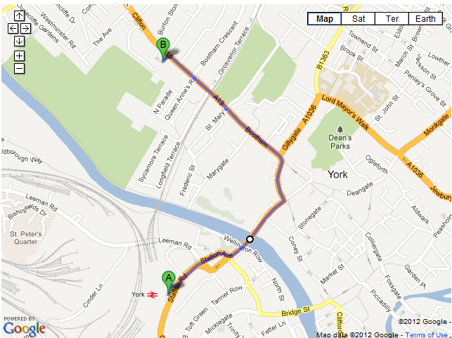
You can find St Peter’s School, York, at YO30 6AB.
The School (point B) is less than fifteen minutes on foot from York Railway Station (point A).

By car:

From York City Centre: Take the Thirsk Road (A19) at the Bootham Bar traffic lights. The school is 700m on the left, immediately after the footbridge.

From the A64: Take the Northern Ring Road (A1237). At the A19 roundabout turn towards the city centre. The school is two miles on the right, 300m after Clifton Green. Turn right into the school immediately before the footbridge that crosses the road.

Parking is available on site.

