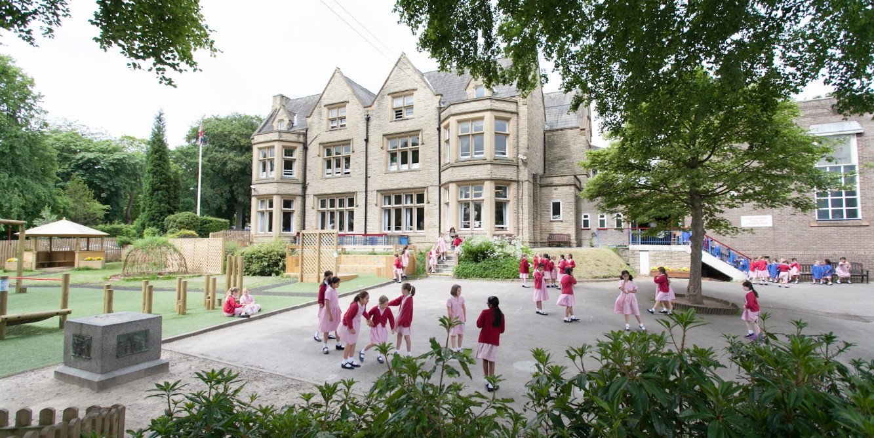
Welcome from the Headmistress

Thank you for your interest in Bowdon Prep School for Girls. This is an exciting time to join the team as we look to move our school to the next level.
Situated in a leafy suburb, just minutes from Altrincham town centre, Bowdon Preparatory School (BPS) is an established, independent day school for girls aged 3-11 years. BPS has an excellent reputation for academic achievement and prides itself on providing a happy, nurturing and stimulating environment for its pupils to thrive in. We enable each girl to grow in confidence and to acquire fundamental life skills in preparation for the move up to senior school.

Our Vision at Bowdon Prep School (BPS) is to empower girls to believe in themselves and to persevere and succeed in all that they do.
Life at Bowdon Prep is exciting. We believe that all pupils should have an education that motivates, supports and inspires them to be the very best that they can be and academic excellence is at the heart of our school. Our staff are academic specialists who are passionate about their subjects and put pastoral care at the heart of all they do. Our girls are ambitious and show real belief in themselves. They are determined and learn the value of perseverance.

With fantastic facilities, we provide an extensive range of opportunities to learn, explore and discover. I am incredibly proud of all our girls; they strive to do their very best as individuals. In all areas of school life, we want all of our girls not only to succeed – whatever their individual talents or abilities may be – but also to feel successful. You will find the sports teams are highly skilled and most competitive and an extensive range of opportunities for involvement in the creative and expressive arts ensures that the girls grow in confidence and self-esteem and perform with enthusiasm and passion. The girls go on to record highly impressive results in exams for entry into the senior schools, both within the Trafford grammar schools and in a wide variety of excellent independent schools; each year girls gain scholarships to Manchester High School for Girls and Alderley Edge School for Girls.

Our pupils leave us with not only strong friendships and a sense of responsibility to self and others but also many wonderful memories and a range of skills that will allow them to flourish in their senior school and beyond. I am incredibly privileged to be the Headmistress of Bowdon Preparatory School - it is exceptional place to learn.

If you would like to find out more about our school and the BPS community, please take the time to browse our website or if would like to arrange a visit please contact Gill Vasey, Head’s PA on 0161 9280678 or email headteacher@bowdonprep.org.uk

Mrs Helen Gee, Headmistress

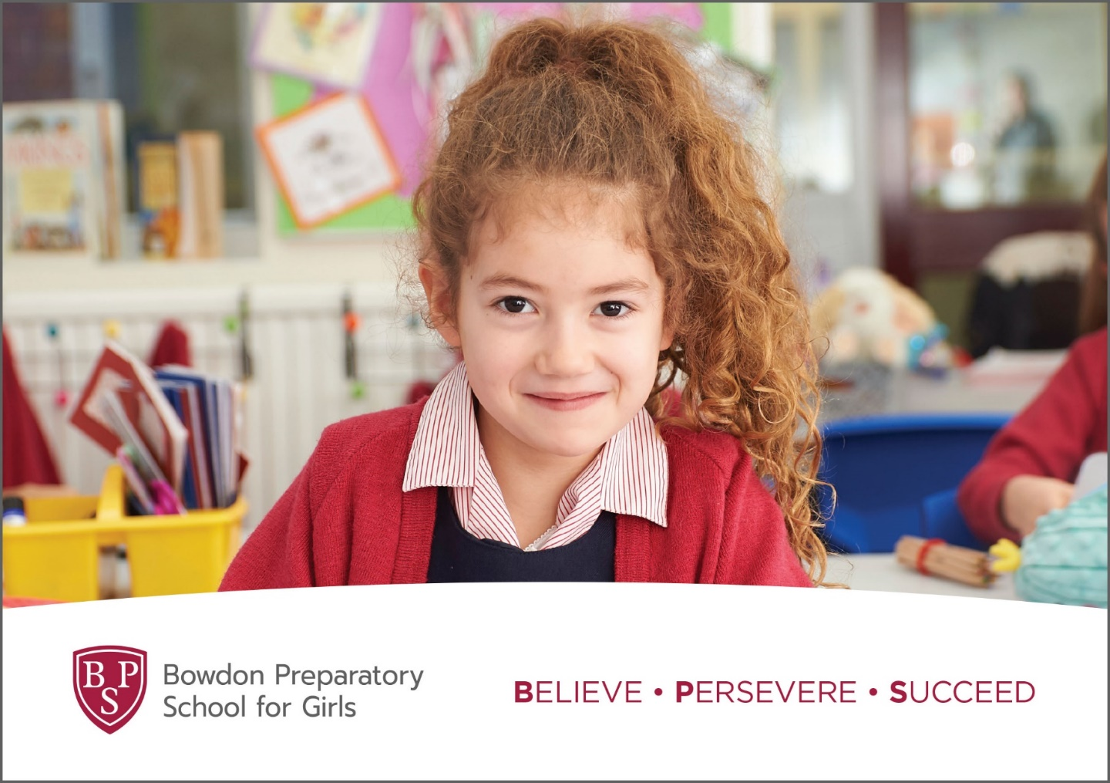
Teaching Assistant – Level 3
We are seeking to appoint an outstanding individual to fill the role of Teaching Assistant. This is an exceptional opportunity to join a thriving and happy prep school where pupils are at the forefront of all we do.
Full time
Fixed Term: Two Terms
with potential to extend/convert to permanent
Salary: £23,946 pa
The post-holder will work closely with teaching staff and the SENCo to support the needs of pupils.

Bowdon Preparatory School is committed to safeguarding and promoting the welfare of children, and young people, and expects all staff and volunteers to share this commitment. DBS Disclosure at Enhanced level will be required prior to any offer of employment.

Job Description
Respon

Assist in the educational and social development of pupils under the direction and guidance of the SENCo, class teachers

Support for Pupils
- Contribute to the planning and preparation of learning activities, supplement and extend work planned by the teacher to improve outcomes in clearly identifiable ways suitable for children’s interests and abilities for individual or groups of children.
- Contribute to the development, implementation and monitoring of Individual Education Plans.
- Monitor learners’ responses to activities and modify the approach accordingly.
- Monitor learners’ progress in order to provide focused support and feedback.
- Use ICT skills to advance learning.
- Demonstrate the positive values, attitudes and behaviour we expect from children.
- Establish fair, respectful, trusting, supportive and productive working relationships with pupils, acting as a role model and setting high expectations.
- Have high expectations of children with a commitment to help them fulfil their potential.
- Promote the inclusion and acceptance of all pupils within the classroom.
- Support pupils consistently whilst recognising and responding to their individual needs.
- Encourage pupils to interact and work co-operatively with others and engage all pupils in
- activities.
- Promote independence and employ strategies to recognise and reward achievement of self-reliance.
- Recognise and respect the contribution that parents and carers can make to the development and wellbeing of children.
- Teach classes, prepare lessons and cover periods of planned absences.
- Offer mentoring support and guidance for Year 6 peer mentors undertaking support roles with younger pupils.

Support for the Teacher
- Organise and manage appropriate learning environment and resources.
- Within an agreed system of supervision, plan challenging teaching and learning objectives to evaluate and adjust lessons/work plans as appropriate.
- Monitor and evaluate pupil responses to learning activities through a range of assessment and monitoring strategies against pre-determined learning objectives.
- Production of lesson plans, worksheet, plans etc.
- Record progress and achievement in lessons/activities systematically and providing evidence of range and level of progress and attainment.
- Provide objective and accurate feedback and reports as required on pupil achievement, progress and other matters, ensuring the availability of appropriate evidence.
- Work within an established discipline policy to anticipate and manage behaviour constructively, promoting self-control and independence.
- Supporting the role of parents in pupils’ learning and contribute to meetings with parents to provide constructive feedback on pupil progress/achievement etc.
- Administer and assess/mark tests and invigilate exams/tests.

Support for the Curriculum
- Deliver learning activities to pupils, adjusting activities according to pupil responses/needs.
- Prepare resources necessary for learning activities.
- Use ICT effectively to support learning activities and develop pupils’ competence and independence in its use.
- Select and prepare resources necessary to lead learning activities, taking account of pupils’ interests and language and cultural backgrounds.
- Advise on appropriate deployment and use of specialist aid/resources/equipment.

Support for the School
- Comply with and assist with the development of policies and procedures relating to child protection, health, safety and security, confidentiality and data protection, reporting concerns to an appropriate person.
- Be aware of and support difference and ensure all pupils have equal access to opportunities to learn and develop.
- Contribute to the overall ethos/work/aims of the school.
- Demonstrate a commitment to collaborative and cooperative working with colleagues and establish constructive relationships and communicate with the teacher, to support achievement and progress of pupils.
- Improve own knowledge and practice including responding to advice and feedback.
- Recognise own strengths and areas of specialist expertise and use these to lead, advise and support others.

Any other duties and responsibilities appropriate to the grade and role
All the above duties and responsibilities to be carried out in accordance with ISI Standards, BPS Policies, and current legislation with an emphasis on Customer Care, Equal Opportunities, Data Protection and Health and Safety.

Person Specification

Qualifications and Experience
- Level 3 or equivalent qualification in Supporting Learning
- Proven ability as an excellent classroom practitioner
- Ability to contribute to the co-curricular life of the school.
- Work effectively in a team
- Excellent standards of spoken and written English and maths

Professional Knowledge, Understanding and Skills
- What constitutes quality and high standards in learning and teaching
- High expectations of pupils.
- National Curriculum
- Effective organisational skills, ability to work flexibly and to prioritise
- Confident and competent user of ICT
- What constitutes appropriate and successful relationships with children
- Child protection in a primary school
- Respect for confidentiality of information

A strong commitment to:-
- Using a positive approach to promote learning excellent behaviour
- The personal welfare and safeguarding of children
- Support for an enriched curriculum through extra-curricular learning and educational visits
- Actively supporting school development
- Professional development
- What is important in our school

Personal Qualities
- Excellent interpersonal skills.
- Ability to foster and maintain successful relationships with parents
- Passionate about pupils’ learning and development
- Ability to act as role model for young people and display warmth, care and sensitivity in dealing with children
- Open minded, self-evaluative and adaptable to school developments and initiatives
- Cultural awareness and sensitivity
- Enthusiastic, flexible and good humoured.

