

|  |
| --- |
| **TEACHER OF MATHS** |

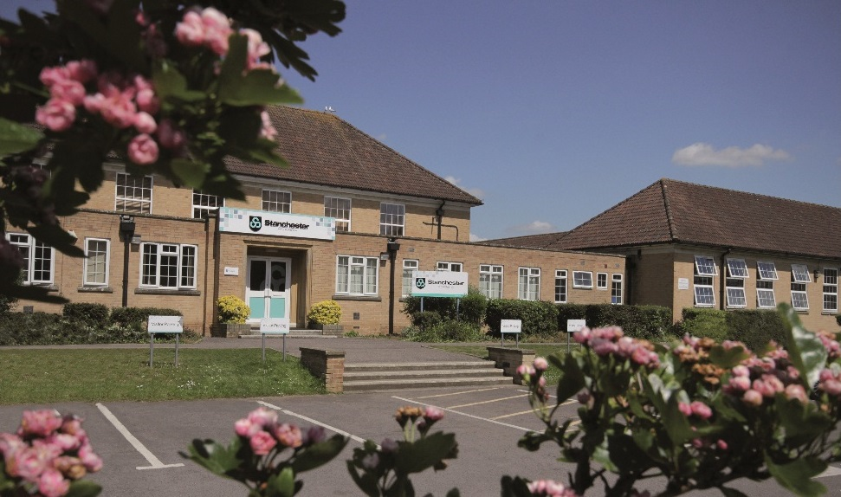

*Stanchester Academy  
Stoke-Sub-Hamdon  
Somerset  
TA14 6UG*

01935 823200

**Website:** [stanchester-academy.co.uk](http://stanchester-academy.co.uk/)

**Email:** [office@stanchester-academy.co.uk](mailto:office@stanchester.somerset.sch.uk)

**Principal:** Mrs Amy Joynes

**Recruitment Information Pack**

Contents

1. Letter from the Principal
2. Application Process
3. Information about the Department
4. 6Cs Information
5. Job Description
6. Person Specification
7. Benefits of working at Stanchester Academy



Dear Applicant

Thank you for expressing an interest in the post of **Teacher of Maths** at Stanchester Academy. This post is to cover a maternity leave vacancy and is part time (0.6 FTE) worked over 3 days commencing on 2 September 2019 at our Academy. Successful applicants should be able to teach Maths to Key Stage 4. Accompanying this letter is information about the Academy and the Department which we hope will provide you with everything you need to know to apply for the post. The Academy Website gives further details.

We are seeking to appoint an experienced, creative and inspiring teacher with energy and enthusiasm. We believe this is an outstanding opportunity to join a diverse and successful team that works hard to enthuse students and instil in them high standards.

The successful candidate will:

* have a real passion
* be able to build relationships quickly, with humility and empathy
* show respect to others – students, parents and colleagues – in order to get the best out of them
* be positive, optimistic, caring, kind and approachable
* be willing to be immersed in the life of a busy and successful Academy
* be able to inspire and motivate others, supporting a shared vision and direction for the Department
* use resources, intellect, creativity and innovation to be successful

At Stanchester Academy we aspire to be amongst the best, not just out of a healthy competitive spirit, but because it is our duty to foster and pursue this commitment for our learners and learning community.

We are proud to be an Academy known for a productive and welcoming atmosphere, valuing achievement but also strongly promoting personal development.  School should be a preparation for later life, and learning self-respect, consideration for others, and the consequences of our own actions, all helps develop a sense of duty, citizenship and belonging.

Stanchester Academy is a rural comprehensive school set in a stunning location in South Somerset, close to Yeovil and within a mile of the A303. We benefit from exceptionally good road and rail links to major cities in the UK. Stanchester Academy is an exciting Academy with aspirations that match the high expectations we have of our students. The professional development of our staff drives learning and has helped to create the “buzz for learning” that can be found in all classrooms. We are known also for our commitment to the personal development of the individual child. For us, self-respect, consideration for others pride and belief help to develop a sense of duty, citizenship and community.

In 2016 Ofsted judged the school as ‘*good*’ and identified the relentless focus on standards and expectations on being pivotal in our success. A recent externally commissioned quality assurance review found “leaders are steering the Academy confidently and strategically towards outstanding”.

The academy is frequently praised for its positive ethos where students feel valued and respected and where a healthy culture for learning exists across the school. GCSE results are also good; we have had some of the best results in Somerset in regards to student progress over the last two years. In 2018 11 subjects achieved over 70% 9-4 grades. In Maths, 71% of students achieved grade 9-4 or above in 2018, a pattern that has been maintained for the past four years.

We are looking for someone with high expectations, a love of their subject and able to inspire and enjoy the challenges of this role. You need to be a team player, who will go the extra mile to support students and want to continually develop and pick up the best ideas from around the world in Education. We have a great record for supporting and developing NQT’s, staff and leaders through our own highly valued CPD programme and links with training providers across the South West.

You are very welcome to visit us in advance of an application or to contact us to find out more.

Yours sincerely

Mrs Amy Joynes

Principal

**Application Process**

Governors & senior staff will meet to shortlist from **Wednesday 19 June 2019.** Interview candidates will be informed by telephone soon after.

If you have not heard by **Friday 21 June 2019**, please assume you have been unsuccessful on this occasion.

Interview Date: **Week Commencing: Monday 24 June 2019**

Completed applications should reach the school by **Wednesday 19 June** **2019** by **12noon** and should include:

* 1. fully completed TES on-line application form or Stanchester Academy application form (NB: CV’s are not required);
  2. a letter of application (no more than 2 sides of A4) outlining:
* Your approaches to student learning in Maths
* Additional areas to which you feel you could contribute in this thriving community school

We look forward to receiving your application by **12noon** on **Wednesday 19 June 2019**

Completed applications should be returned either via the TES portal or by post, marked ‘*Confidential*’ to Mrs Liz Joynes, HR Manager at Stanchester Academy, Stoke-sub-Hamdon, Somerset, TA14 6UG or by email to [LJoynes@educ.somerset.gov.uk](mailto:LJoynes@educ.somerset.gov.uk) or [office@stanchester-academy.co.uk](mailto:office@stanchester-academy.co.uk)

Should you wish to arrange a visit to view the Academy, please do not hesitate to contact Liz Joynes who will also be happy to arrange this.

Stanchester Academy has an absolute commitment to safeguarding and promoting the welfare of children. The Academy follows the national and Somerset policies and procedures for child protection and security and the interview will include questions about safeguarding children. Current and/or previous employers will be contacted through references as part of the verification process pre-appointment checks if the applicant is short listed. The successful applicant will be required to undertake an enhanced disclosure check with the Disclosure and Barring Service. Stanchester Academy is committed to equal opportunities and positively encourages applications from all sections of the community.

**Information about the Department**

Thank you for expressing an interest in the post of Teacher of a Maths at Stanchester Academy. Please find below some information regarding the post which we hope will answer some of the questions you may have.

**Maths Department**

**Curriculum Organisation**

Students receive eight lessons of one hour every fortnight in Years 7, 8 and 9 and nine lessons a fortnight in Years 10 and 11. There is a level of setting in every year group but it becomes more formalised in the later years as students prepare for the appropriate tiered exam, either Higher or Foundation.

We currently use Edexel for our GCSE examinations. Students achieve their KS3 curriculum requirements in Years 7 and 8 and formally start their GCSE studies in Year 9. The schemes of work, in all five years, can be seen as building blocks towards their GCSE goals. Consistent with the National Curriculum students are not only working towards their GCSE exams but they are also building a confidence and enjoyment in using Maths as life skills. Key priorities are embedded in the way we organise our scheme of work and deliver our lessons:

* Fluent in the fundamental skills of Maths
* Reason mathematically
* Solve problems

**Accommodation**

The Maths Department are located all together in a series of classrooms in one of the teaching blocks. We have access to a range of ICT suites and these are an integral part of the way we teach and in the way students can access Home Learning and revision materials. The team work closely together in creating and sharing resources and supporting the Department’s role within the school and the school as a whole.

**Developments**

Our aim is to be an outstanding Department within the school and further afield. We have a good track record of results that show an improving trend. We want to build on this every year by continuing to strengthen an already capable and committed team. There is a wealth of development opportunity in-house for both improving subject knowledge and enhancing classroom practice.

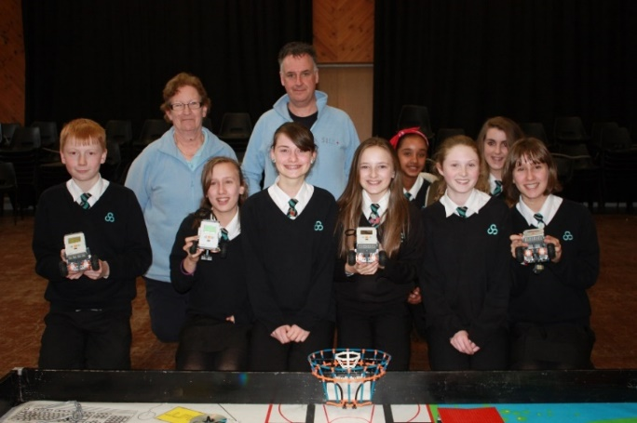



**Character Development**

**at**

**Stanchester Academy**



**Commitment**

**Creative**

The ethos and culture at Stanchester Academy has personal development at its core. Using the 6Cs our aim is to nurture and develop the characteristics that will help students to become well rounded people and equip them with the skills for lifelong success.

Good character has been identified as the foundation for improved attainment, better behaviour and increased employability, but most importantly, flourishing societies and as such we have committed to developing this within our students.

The 6Cs program is based on research conducted by the Jubilee Centre for Character and Virtues. All research reports can be found on the Centre’s website at www.jubileecentre.ac.uk

**Critical**

**Caring**

**Challenge**

**Collaboration**

**Job Description for a Classroom Teacher**

Accountable to: Curriculum Leader

|  |  |
| --- | --- |
| **Area** | **Accountability Statement** |
| Teaching and Learning | * Planning and preparing courses and lessons * Teaching, according to their educational needs, the students assigned, including the setting and marking of work to be carried out by the student in school and elsewhere |
| Assessment Recording and Reporting | * Assessing, recording and reporting on the development, progress and attainment of students * Providing or contributing to oral and written assessments, reports and references relating to individual students and groups of students |
| Students’ Personal Development | * Providing guidance and advice to students on educational and social matters and on their further education and future careers, including information about sources of more expert advice on specific questions * Take on the role of Form Tutor * Making relevant records and reports |
| Liaison | * Communicating and consulting with the parents of students * Communicating and co-operating with persons or bodies outside the school * Participating in meetings arranged for any of the purposes described above |
| Performance Management | * Participating in arrangements for the review of the teacher’s own performance and that of other teachers |
| Monitoring, evaluation and CPD | * Reviewing from time to time the methods of teaching and programmes of work * Participating in arrangements for further training and professional development * Act on advice and feedback given and be open to support |
| Educational methods | * Advising and co-operating with other teachers on the preparation and development of courses of study, teaching materials, teaching programmes, methods of teaching and assessment and pastoral arrangements |
| Discipline, Health and Safety | * Maintaining good order and discipline among students and safeguarding their health and safety both when they are authorised to be on the school premises and when they are engaged in authorised school activities elsewhere |
| Staff Meetings | * Participating in meetings at the school which relate to the curriculum or the administration or organisation of the school including pastoral arrangements |
| Cover | * Cover for absent colleagues, rarely and in circumstances that are not foreseeable |
| External Examinations | * Participating in arrangements for preparing students for external examinations, assessing students for the purposes of such examinations and recording and reporting such assessments * Participating in arrangements for students presentation for, and conducting, such examinations |
| Leadership and Management  (if appropriate) | * Contributing to the selection for appointment and professional development of other teachers and support staff, including the induction and assessment of new teachers * Assist the Principal in carrying out threshold assessments of other teachers for whom there is management responsibility * Co-ordinating or managing the work of other staff; and taking part in the review, development and management of activities relating to the curriculum, organisation and pastoral functions of the school |
| Administration | * Participating in administrative and organisational tasks related to the duties described above, including: * The direction or supervision of persons providing support in the classroom * Attending assemblies * Registering the attendance of students * Supervising students during duties before, during or after school sessions. |

**Person Specification**

**Standard Scale Teacher**

We are seeking a highly skilled colleague who will be dynamic and committed to the department and the school.

The qualities, skills and experience we are looking for include:

* Qualified Teacher Status.
* Strong Evidence of CPD.
* Detailed knowledge of the specialist subject curriculum for Key Stage 3 and Key Stage 4.
* Excellent teaching skills.
* Ability to teach the specialist subject to Key Stage 3 and Key Stage 4.
* Good ICT skills.
* Ability to improve attainment and achievement.
* Ability to work well in a team.
* Ability to plan and organise own workload.
* Ability to work effectively under pressure.
* Excellent decision-making skills.
* Excellent inter-personal skills.
* Excellent communication and presentation skills.
* Commitment to the wider life of the school.
* Good health and attendance record.

**Benefits of Working at Stanchester Academy**

|  |
| --- |
| **High Quality Professional Development** |
| * INSET Programme with personalised pathways |
| * New staff/PGCE induction programme with Mentor |
| * In-house Middle leader training programme |
| * M Level Accredited NQT induction programme |
| * M Level Accredited 2nd year teacher programme |
| * All teaching staff take part in observations during a Hub review each year |
| * Opportunities to run workshops for staff in school and within teaching partnerships |
| * Encouragement of individual action research through appraisal |
| * Opportunities to mentor/coach student teachers on ITT |
| * Annual Teach Meet |
| * Established Reading Group |
| **Support for Teaching** |
| * Investment in resources, facilities and the environment |
| * Outstanding ICT infrastructure including Wi-Fi, resources |
| * Strong departmental support structure |
| * IPad sets available for Teaching and Learning activities |
| * Timetabling ensures specialist teach in their subject areas and there are rarely any split classes |
| * Designated support for reprographics, trip management, student behavioural support, SEND needs |
| * Dedicated team of school learning supervisors |
| **Links with other Schools** |
| * Mid Somerset Consortium |
| * Taunton Teaching Alliance |
| * South West Teaching Alliance |
| * Whole Education |
| **Health and Well-being** |
| * Free Annual Flu Jab |
| * Our own specialist HR Manager |
| * Membership of Care-first providing free welfare counselling, free Occupational Health consultations |
| * Long service recognition with one day off per year after 10 years and 2 days off per year after 20 years’ service |
| **Supporting Families** |
| * Supportive to colleagues for time off during periods of family illness/crisis |
| * Supportive of requests where possible to attend graduations, special family events and house moves |

|  |
| --- |
| **Practicalities – Little extra touches** |
| * Free refreshments of coffee, tea, milk etc. at each CPD Event |
| * Quality free seated lunch provided on INSET Days |
| * Learning Lunches for Reading Group and Teaching and Learning Group |
| * Afternoon meal provided before evening events |
| * Food allowance whenever on duty (£2.20 per day) |
| * Water dispenser in main staff room |
| * Generous business travel allowance |
| * Free on-site parking |
| **Strong Staff Community** |
| * Staff Work Room with PC’s and Printer |
| * Large main staff room – we hold 2 weekly whole staff briefings |
| * Amazing involvement in charity events, national days, productions, including volunteer stewarding at Glastonbury |
| * Annual Community Festival organised and hosted by the school |
| * Duke of Edinburgh / Ten Tors |
| * PTFA Events |
| * Department social events |

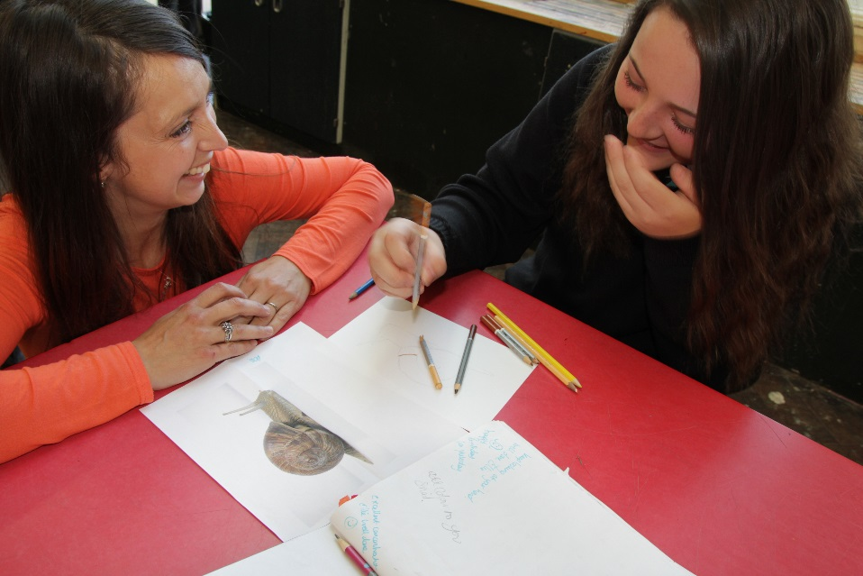

**Welcome to Stanchester Academy**