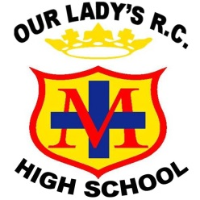
TEACHER OF SCIENCE
Start date: Easter/September 2020
Salary: M1 – UP3 (possible TLR dependent upon experience and expertise)
Contract term: Permanent. Contract type: Full Time

We are seeking to appoint an enthusiastic and highly motivated Teacher of Science. The right candidate will be an exceptional practitioner with a commitment to academic excellence and inspiring a love of Science in young people. They will play a pivotal role in securing the very best outcomes for the faculty.
We offer a vibrant and diverse community with students who are highly motivated and take responsibility for their learning. The building is modern and the staff are friendly, and committed to ensuring student success.
Our Lady’s is a heavily oversubscribed successful Catholic school with a “Good” judgement from Ofsted and an excellent reputation across the Diocese of Salford. We strive for academic excellence whilst also offering students a vast array of enrichment opportunities to help them discover and nurture their talents. We pride ourselves on meeting the needs of each individual and ensuring positive outcomes for young people of all abilities. The successful candidate will benefit from:
- A supportive and nurturing working environment that provides high quality, professional, developmental experiences and opportunities for career progression.
- Joining a team of nine highly skilled individuals, who consistently deliver high quality lessons.
Prospective candidates are encouraged to visit the school to witness our vibrant community. To arrange an informal visit contact Sally Royle (PA to Headteacher) on 0161 507 9670 or s.royle@olsc.manchester.sch.uk
On behalf of our students, thank you for your interest in our school
Closing date: Monday 24th February at 9.00am. Interviews are anticipated for Thursday 27th February.

