

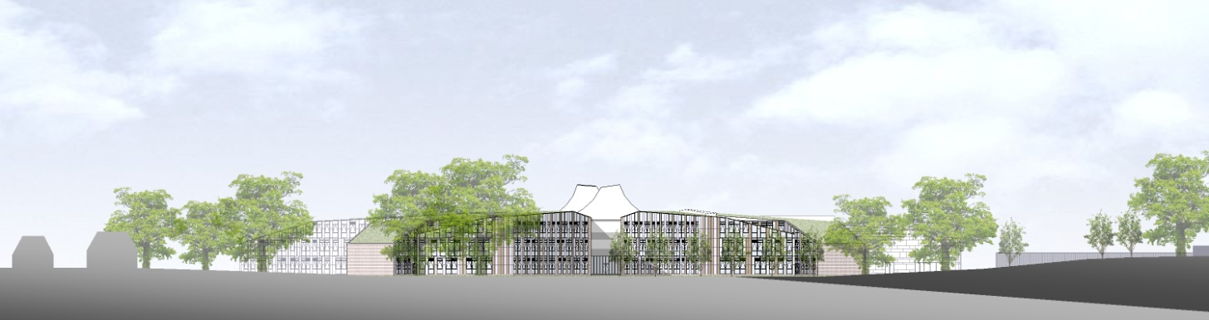

**ST BARTHOLOMEW’S SCHOOL**

**TEACHING ASSISTANT**

**(Personalised Learning Team)**

**PART-TIME, PERMANENT**



**Andover Road**

**Newbury**

**Berkshire**

**RG14 6JP**

**Tel: 01635 521255**

**Email:** [**recruitment@stbarts.co.uk**](mailto:recruitment@stbarts.co.uk)

**Website:** [**www.stbarts.co.uk**](http://www.stbarts.co.uk)

**The Faculties**

St Bart’s has a Personalised Learning team which includes learning support for students who are statemented or have an Education, Health & Care Plan and appear on the Special Needs Register.

Teaching Assistants (TAs) are deployed either to work within Personalised Learning or another faculty to support an individual student in lessons across the school.

**The Post**

* We are seeking to appoint a Teaching Assistant to start on 4 January 2022 on a permanent basis.
* The position is part-time, 29 hours and 40 minutes per week, term time plus 5 training days.
* The days and hours of work are Monday to Thursday 8.40am to 3.10pm and Friday 8.40am to 2.50pm.

**The Salary**

* The successful candidate will be paid in accordance with the national APT&C scale, point 2-3 (currently £18198.00 to £18562.00 per annum full-time equivalent). This equates to a starting salary of £12453.85 gross per annum or £9.43 per hour. Staff will be appointed to the start point of the advertised scale unless there is a specific experience reason for the Headteacher to agree an alternative point within the range.
* All leave must be taken during school holidays. Your annual salary will be calculated to include payment for your leave entitlement. Your annual salary will therefore be 44.5 weeks pay, to be paid in 12 equal monthly amounts.

**How to Apply**

Full post details, an application form and instructions on how to upload your completed application are available via the Jobs & Training / Job Opportunities section on the School’s website:

[**www.stbarts.co.uk**](http://www.stbarts.co.uk)

(Please note that curriculum vitae and covering letters cannot be accepted)

Successful candidates will be subject to a DBS enhanced check along with other relevant employment checks.

## Closing date: Sunday 5 December 2021

Thank you for considering St Bartholomew’s School, we look forward to hearing from you.