Sandown Park, Tunbridge Wells, Kent
TN2 4PY
Telephone: 01892 534377
Fax: 01892 516203
e-mail: hr@skinnerskentacademy.org.uk
web page: www.skinnerskentacademy.org.uk
APPOINTMENT OF
COVER SUPERVISOR

to commence from September 2019
earlier start date is available

Closing date 8 July 2019

Please follow application instructions included in this pack



Message from the Executive Principal

Thank you for your interest in The Skinners’ Kent Academy.

The Academy opened on September 1st 2009. It is an independent, non fee-paying, mixed, all ability school, funded by the DfE and supported fully by its lead sponsor The Skinners’ School, a grammar school for boys and the Skinners’ Company.

The Skinners’ Kent Academy is founded on the principles of a culture of high standards and high aspirations, a culture of active participation, an emotionally rich learning environment and an inclusive environment where every child is known and every learner supported.

The main aim of the Academy is to provide the highest quality of education for students, in Year 7 to Year 11 and the Sixth Form. However, the Academy is more than a new type of school. The Academy aims to raise and reflect aspirations within the local community and provide education, social and economic benefits for all.

The Academy moved into a state of the art new building in April 2013. This 21st century building provides outstanding facilities, not only for the Academy’s students but also for the wider community. The Academy continues to expand rapidly and has been oversubscribed in Year 7 since 2014. In September 2015 The Skinners’ Kent Primary School opened, initially at a temporary site within the Academy grounds, and has since relocated to the new site at Knights Wood as the newest member of The Skinners’ family of Schools.

We aim to find and develop everything that is exceptional in each child and inspire them to flourish within a framework of high expectations. We motivate our students to achieve of their very best, to fly high, and to set course on the brightest of futures. If you have similar aspirations for young people and want to work within a dynamic learning environment in which the highest standards are demanded and expected at all times, then we would really be very interested in receiving an application from you.

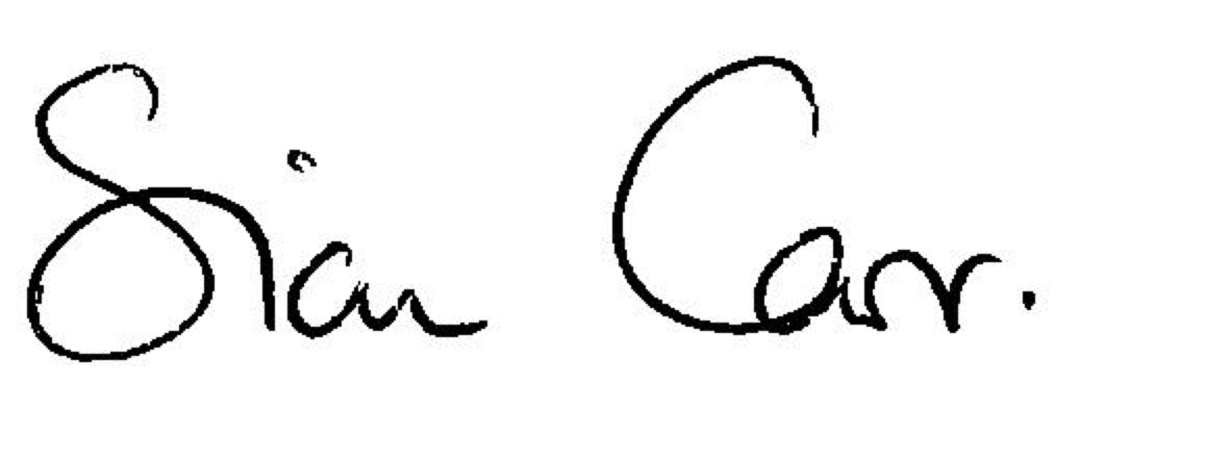
Mrs Sian Carr
Executive Principal

COVER SUPERVISOR

We are looking for highly motivated individuals to join the Academy to support the teaching and learning and raise standards and expectations of our students.

The successful candidate will be required to cover lessons, having sole charge for classes, when classroom teachers are absent covering a range of subjects and different year groups at short notice. This individual should be hardworking, creative, energetic and be or have the potential to be an excellent classroom practitioner. Within this role they would have the capacity to help us establish a vibrant learning environment and a culture of enthusiasm for learning. Their professionalism and dedication will enable our students to achieve more than they believe possible.

The Position
Working across all Faculties, the post of Cover Supervisor is permanent, term time only 39 weeks (including INSET days) and part time. The hours for this post are 30 hours per week, Monday – Friday 8.30am – 3.15pm (one day, currently Tuesdays, to 4.30pm with a 25 minute unpaid morning break and a 30 minute unpaid lunch break).

APPLICATION PROCEDURE - Please include the following in your application:

- Complete an application form including appendix 1.
- A letter explaining how your experience and qualifications equip you for this role. Please refer to the role profile.

If you are short-listed, references will be requested following 8 July 2019
Interviews will take place, at the latest, following 8 July 2019

We reserve the right to interview and appoint in advance of the deadline for this post so early applications are advised.

Due to postal and administrative costs only short listed candidates will be contacted further.

Job Profile


POST: Cover Supervisor

SALARY: Kent Scheme Band 5 – point 14-17 (£18,057-£19,863 Full time) – Pro rata will apply

RESPONSIBLE TO: HR Manager

RESPONSIBLE FOR: Covering lessons for absent staff as required by the Academy, applying policy and ethos across the Academy

WORKING PATTERN: 30 hours per week, Term time only (39 weeks) inclusive of INSETs

KEY RELATIONSHIPS: HR Manager; Administration Team; Academy Leadership Team; Heads of Faculty and Subject; Head of Junior/Senior House; Assistant Heads of House; All Academy Staff

- Job Purpose

  - To look after classes of students in the Academy and conduct pre-planned lessons for absent teachers, providing guidance, advice and classroom management.

- Key responsibilities

2.1 To supervise work that has been set in accordance with the Academy Trust Cover for Absence policy
2.2 To manage the behaviour of students whilst they are undertaking this work to ensure a
constructive environment
2.3 To respond to any questions from students about process and procedures
2.4 To deal with any immediate problems or emergencies according to the Academy Trust’s policies and procedures.
2.5 To collect any completed work after the lesson and returning it to the appropriate teacher.
2.6 To report back as appropriate using the Academy’s agreed referral procedures on the behaviour of students during the class, and any issues arising.
2.7 To maintain Academy classroom practice and expectations to ensure a consistent approach.
2.8 In the absence of cover duties to be deployed by SEN team to support in lessons

Appendix (a) shows day today responsibilities – see below

3 Additional duties

3.1. Attend team meetings and staff meetings as required
3.2 Maintain confidentiality inside and outside the workplace
3.3 Understand and apply Academy Trust policies
3.4 Undertake any reasonable additional responsibilities requested at any time by the Academy Trust leadership team

This job profile is subject to review to complement the Academy Trust’s Performance Management Framework.

Name and signature of employee
Date
Name and signature of Performance Reviewer
Date

Person Specification: Cover Supervisor

You should demonstrate that you meet the following criteria:

1 Education, training and qualifications
1.1 Evidence of good literacy and numeracy skills through any accredited qualification/s

2. Knowledge and experience
2.1 Good knowledge of teaching and learning best practice is desirable
2.2 Understanding of the ways in which young people learn and how to support their learning is desirable
2.3 Good knowledge and understanding of organisational administrative procedures
2.4 Evidence of understanding of IT systems
2.5 A strong understanding of and commitment to the Academy Trust vision
2.6 Evidence of having developed and sustained effective relationships with young people
2.7 Evidence of an understanding and commitment to child protection and safeguarding matters.

3 Essential skills and abilities
3.1 Excellent communication skills, including impeccable command of spoken and written English.
3.2 Excellent administrative and organisational skills, including the ability to multi-task, perform under pressure and deal with competing priorities
3.3 High degree of computer literacy
3.4 High degree of numeracy and strong analytical skills
3.5 Ability to work both as part of a team and independently

4 Personal qualities

4.1 Commitment to high educational, professional and personal standards.
4.2 Understanding of the importance of maintaining confidentiality.
4.3 A flexible approach to work, including a sense of humour.
4.4 Commitment to equal opportunities and valuing diversity.

Appendix (a)

ROLE OF A COVER SUPERVISOR COVERING A LESSON FOR AN ABSENT TEACHER

- Behaviour management of the class. From lining up outside the classroom, in the classroom and when the students leave at the end of the session.
- Monitor behaviour at all times, use the correct procedures when dealing with bad behaviour.
- The classroom needs to be an environment where all students can learn and work.
- Upholding the Academy rules in the classroom. Re enforcing Academy rules.
- Delivering the cover work to the best of your ability so the students can access the task set by their teacher. Being confident to adapt the work set, if required.
- Write up on the whiteboard instructions to re enforce task set. Be clear with instructions and expectations.
- Make sure students have their books/resources to use.
- Be proactive with resources, such as looking for video links that could help with the task set.
- Make sure every student is on task and working to the best of their ability.
- Reward the class and students for good attitude, good behaviour and working to the best of their ability.
- Make sure all resources are collected at the end of the lesson, put back in the correct place, the IWB switched off and the classroom is left tidy.
- Work is collected when required.
- Feedback to the teacher you are covering or head of subject .Feedback, what went well and what did not. The behavior of the class should also re reported, with achievement and sanctions issued.
- Relay any worries about a student to relevant staff – Tutor, AHOH, HOH, SEND

Appendix 1



To be completed and returned to:

HR Department
The Skinners’ Kent Academy
Sandown Park
Tunbridge Wells
Kent TN2 4PY

Name |  | Daytime Telephone No
Address |  | Evening Telephone No
Post Applied for

COVER SUPERVISOR
Email address
Current Position (i.e. School and Post) |  | Current Point on MPS or salary
QTS (if applicable)  Yes/no |  | National Insurance No.
Number of Days Absent during the last year (if more than 5 days, please give reasons)

Are there any health problems that you would like to bring to our attention? (if yes please give details) All successful applicants are subject to Occupational Health Screening.
Removed to comply with 2010 Equality Act. Please note, for jobs involving working with children or vulnerable adults, the statutory regulations require us to ascertain whether the physical and mental fitness of persons appointed to such roles is at an appropriate level prior to any confirmation of appointment

Signature |  |  | Date

