KENT COLLEGE

______________________________________________________
INDEPENDENT DAY AND BOARDING SCHOOL FOR GIRLS 3-18

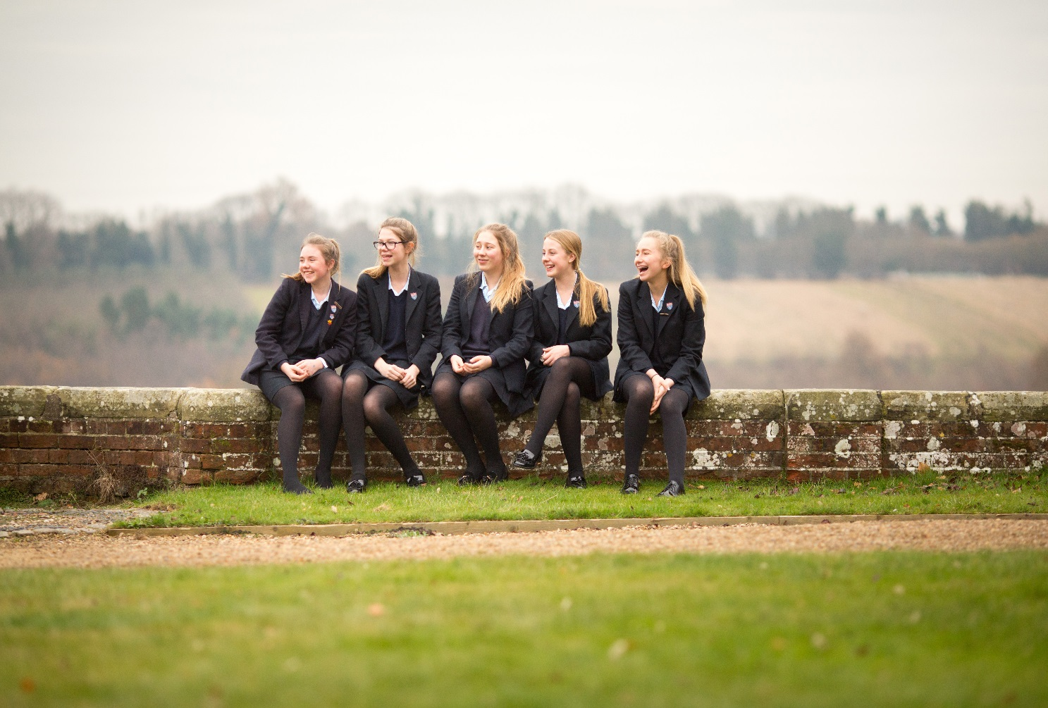

KENT COLLEGE PEMBURY

Assistant Housemistress
September 2017 or January 2018

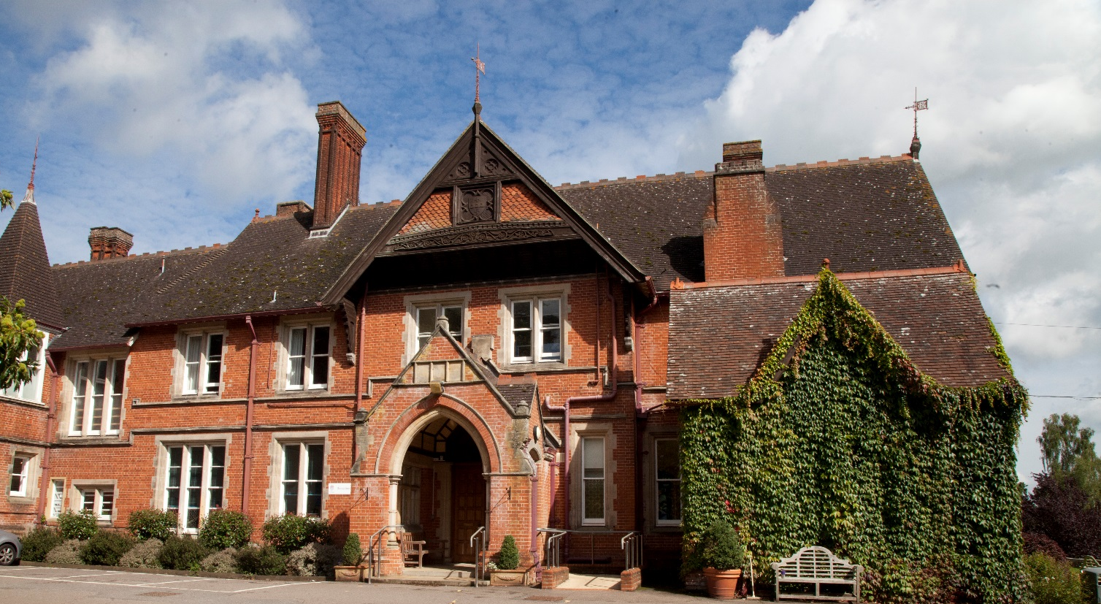

Background
Founded in Folkestone in 1886, Kent College is an independent day and boarding school for girls, with a Senior School (ages 11-18) and Preparatory School (ages 3-11) sharing the same site, facilities and some specialist staff. The school is one of a group of ten schools under the control of the Methodist Independent Schools Trust. The school has a resident Chaplain who leads the Christian worship in the school.

Since 1939, Kent College has been located on 75 acres of beautiful countryside in Pembury, near Tunbridge Wells. The school campus comprises an elegant Victorian manor house and purpose-built modern facilities, including boarding houses, a music centre, science building, sports hall, A level study centre, and an indoor, heated swimming pool. The school is committed to a continuous programme of development and the resources are excellent. IT provision is first-rate, including the number of interactive white boards, laptops and data projectors. In 2008 a new science wing was opened, providing inspirational science laboratories, and recent boarding refurbishment includes an extension of ICT facilities to individual study areas. The Countess of Wessex Theatre reopened in 2012 following extensive refurbishment and an iconic Library and Arts Centre opened in spring 2013. Our additional Sports Hall is now complete and was opened in October 2015.

The Senior School
The current roll in the Senior School is approximately 450 and attracts girls from all over the world. Entry at eleven and thirteen is by the school’s own entrance test and the school accepts quite a wide range of academic ability, with approximately half of our KS3 intake within the top 25% of the national ability range. Kent College offers a choice of 25 GCSE subjects, with group sizes usually between three and eighteen. Top students will be aiming for ten A and A* grades at GCSE, less academic students may take eight GCSE subjects. In summer 2015, 97% of GCSE grades awarded were A*-C and the school’s value added was around 8 grades for each girl’s set of results, based on predictions at KS3 baseline data. Excellence was seen in core subjects such as English, Modern Foreign Languages and Science, with 95% all English grades awarded A* - B. The school is in a highly competitive area with girls’ grammar schools, strong comprehensives and many independent schools locally.

Students are also accepted for entry at 16+ and there are approximately 125 girls studying for A-level courses. At A-level there were 92% A*-C grades and 50% A*-A Grades. The 26 subjects are mostly of the more traditional type with class sizes at 16+ normally ranging between three and 12. Scholarships to the Senior School are offered at 11+, 13+, 16+ and means-tested bursaries are available.

Extra-curricular Activities (ECAs)
Kent College places a strong emphasis on extra-curricular activities and has a flexible and innovative lunchtime and evening programme of prep and activity sessions. Boarders can choose when they do their prep and day girls choose whether to do homework at home or at school. All girls participate in extra-curricular activities and are encouraged to plan the use of their time so that they follow a balanced programme of academic work and extra-curricular activities. The pastoral care in the school is very strong and all staff are highly involved in PSHCE and general pastoral matters. All teaching staff are required to be involved in at least one ECA and most do more than this, as both subject and general ECA are available.

Inspection
The school underwent a full integrated inspection by the Independent Schools Inspectorate in December 2015 and was found to be excellent in all areas. The report together with other information about Kent College can be found on our website at www.kent-college.co.uk

Benefits
Kent College Pembury employs over 200 people in both academic and support staff positions. Highly skilled, dedicated and passionate staff are the driving force behind our ‘Excellent’ school.

We are delighted to welcome applications from candidates who share our core values and who are able to contribute to our continued future success. We recruit staff of the highest calibre who will inspire, support and challenge the girls, and fellow colleagues, to achieve their full potential. Whatever your role, you will benefit from a being part of a large staff community with opportunities for professional development.

We believe in rewarding our staff and offer a complete range of employee benefits including:

- Reduced school fees
- Childcare voucher scheme
- Free meals during working hours
- Free eye tests
- Subsidised Flu Vaccinations
- Free onsite parking
- On-going training and development
- Use swimming pool and fitness suite (at allocated times)

Boarding Houses
Boarding at Kent College is a central part of the school’s life and ethos. We are very fortunate to have such a close-knit boarding community at the heart of our school and believe that the family atmosphere present in the boarding houses has an extremely positive effect on all of the girls and staff there.

There are two boarding houses at Kent College organised to meet the needs of different age groups. Each house provides modern facilities with spacious bedrooms, cosy common rooms with TVs and videos, and bathrooms with private shower units.

The junior boarding house ‘Hawkwell and Hargreaves’ is home to all boarders in Year 9 and below, run by a Housemistress and Assistant Housemistress and House Tutor.

Our younger boarders flourish in the cosy atmosphere where they receive the individual care and attention they need. Every effort is made to make the girls feel at home.

Year 9 boarders enjoy having their own facilities in the pre-teen ages. The colourful common room provides a haven where they can watch their favourite TV programmes together, prepare a tasty snack at their kitchen unit, make use of the computers and, of course, relax.

The senior boarding house ‘James and Osborn’ is home to all boarders in Year 10 and above, run by a Housemistress, Assistant Housemistress, and House Tutor.

The Modern, purpose-built facilities of in James and Osborn house accommodate a mix of ages from 14 to 18 years. The hub of activity is often in the kitchens or common room, which welcome impromptu gatherings whilst drinks and snacks are prepared or a game of pool played. The house has two TV rooms, laundering facilities and a computer room.

The newly refurbished dorms in James and Osborn provide excellent individual study units and each girl has internet access for her laptop. This facility links her to the school system and thus allows her to pursue her studies in the privacy of her room. Final year A-level students usually have single rooms.

Private Study and Extra-curricular activities
A member of the teaching staff acts as Activity Co-ordinator to oversee the school’s very busy programme and the Senior Housemistress co-ordinates the boarders’ weekend activities. All girls are expected to participate and contribute to the school community and girls participate in music, drama, art, sport, clubs, and societies.

Weekends provide opportunities for additional events that cannot be fitted into the busy curriculum. There are trips out of school and visiting teachers join Kent College staff to lead workshops in drama, dance, cookery and craftwork. Some senior girls join the Duke of Edinburgh Award Scheme, and weekends are a time for expedition training and overnight camps. There are regular Saturday morning matches and, on Saturday evenings, there are some social events with other schools but these need developing. Most activities are open to boarders and daygirls, and daygirls may join in weekend events.

All boarders are expected to attend the once-weekly evening prayers in school, and full boarders the Sunday service, which is often held in the fine ancient church of St. Peter next to the school. The school’s resident Chaplain leads boarders’ prayers each Thursday evening.

The Post
We are seeking an Assistant Housemistress for our junior boarding house with both full and flexi boarding places for girls in years 4-9. Some experience within a school boarding environment is preferred as is a genuine interest in the welfare and development of students. There will be some opportunity to be involved in the wider school activities but this is not expected to be a teaching position. The hours will be 40 hrs per week.

Comfortable, self-contained accommodation within the boarding house is provided.

We are looking for a person with energy and an empathy with young people. They will need to have a sense of humour, work well in a team and be able to deal calmly and efficiently with a variety of tasks.

The school is a Methodist foundation, and staff should be in full sympathy with the Christian ethos of the school, though it is not necessary to be a Methodist. There is also a high degree of contact with parents, often via phone and email, and the Assistant Housemistress needs to have high levels of communication skills.

Part of this role may be to escort girls to and from medical or dental appointments and to act as an additional member of staff to accompany boarders’ weekend activities.

It is likely that this non-teaching post would appeal to someone who has had boarding, residential, or nursing experience. The successful candidate will be supported in professional development and may wish to work towards the Boarding Schools Association Certificate of Professional Practice for House staff if not already qualified. This is a permanent post, not a “GAP” type position.

Salary
The salary will be discussed at interview and will be dependent on previous experience. There is an optional contributory pension scheme available to all non-teaching staff.

Application process
The completed application form, including the names and addresses of two referees, cv and a letter of application should be sent to Headmistress, Ms Julie Lodrick, Kent College, Old Church Road, Pembury, Tunbridge Wells, Kent TN2 4AX by letter, fax (01892 820232) or email (hr@kentcollege.kent.sch.uk)

Closing date: Monday 26 June 2017 by Midday

References will be taken up prior to interview. One of the referees should normally be the applicant’s current or most recent employer. The post requires the highest level of clearance through the Disclosure and Barring Service (DBS).

Kent College is committed to safeguarding and promoting the welfare of children. Appointees must be prepared to undergo child protection screening Child Protection and welfare are taken very seriously at Kent College, with guidelines on confidentiality and staff-pupil relationship procedures well-publicised to staff.

All gaps of employment are to be accounted for and rigorously investigated. Referees are contacted to ensure the validity of the reference. Testimonials are not acceptable in place of confidential references.

