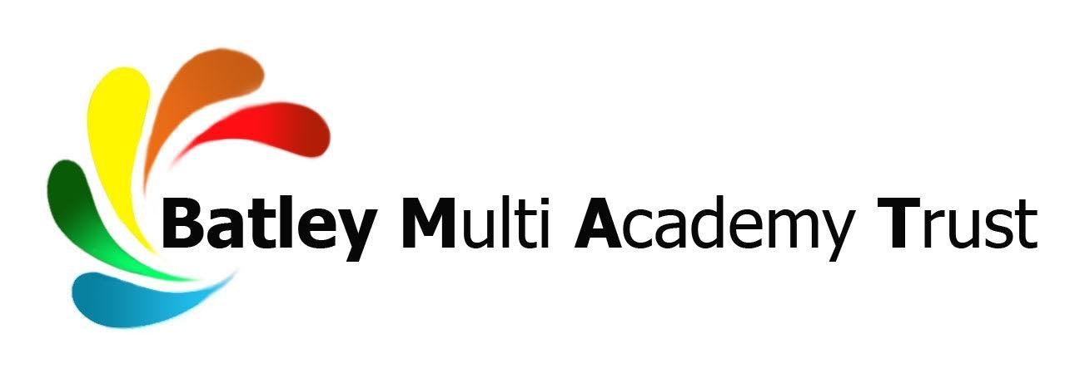
TEACHER OF ENGLISH
NQT/MPS/UPS
Full time
Permanent
To commence September 2019 or earlier if available

Upper Batley High School is a dynamic, innovative and forward thinking learning community. We are proud that our focus is on educating ‘Tomorrow’s Successful Men’ and we are specialists in the education of boys. We are looking for a forward thinking individual to join our team on our journey to outstanding.

Our GCSE results are improving rapidly and in 2013 we were in the ‘Top 100 Most Improved’ schools in the UK. In 2014 we were in the ‘Top 50% of Schools in the UK for Value Added’ and in 2015 we were graded as a ‘Good’ school by Ofsted. Ofsted said our learners are making rapid progress and ‘the school is a harmonious community in which to learn’. In 2016 we were identified as a Beacon School due to the excellent progress we make with our disadvantaged learners (Northern Powerhouse Report 2016) and in 2017 we achieved both the PSHCE Charter mark and the Careers Quality Standard award. In 2018 we achieved a record number of 7, 8 and 9 grades (the highest possible GCSE grades).

Our 11-16 school is multi-cultural and located close to the town centre, within easy access of the motorway network. Our work is focused on developing the unique potential of every individual whilst working towards becoming an outstanding educational organisation. We are a vibrant, rich and exciting learning community with unique and inspiring opportunities inside and outside the classroom.

We are part of the Batley Multi Academy Trust, whose sole purpose is to provide an outstanding education through our family of schools. Batley Multi Academy Trust currently comprises Batley Girls’ High School, Upper Batley High School, Healey Junior, Infant and Nursery School and Field Lane Junior, Infant and Nursery School.

We are seeking to appoint an innovative Teacher of English to join our successful and hardworking team. The successful applicant will be learner centered and a collaborative practitioner. The post offers excellent opportunities for a committed teacher with good knowledge of the GCSE syllabi to teach English Language and Literature at KS3 and KS4.

If you are a highly effective classroom teacher with excellent communication skills and are keen to make a difference to the progress and aspirations of our learners, then we would welcome your application.

In return we can offer:
- A firm commitment to your professional development with a structured programme of CPD
- A supportive team of exceptional staff and school leaders to ensure success in the role
- Excellent facilities with highly motivated learners, keen to learn and engage in lessons
- Leadership development opportunities and a bespoke development programme

This is an excellent opportunity to join a supportive forward thinking school who in return for your commitment and hard work will support you to achieve your own career goals and aspirations.

Please apply by completing a Batley Multi Academy Trust application form, available at www.ubhs.co.uk or by contacting our Human Resources department on 01924 350081/recruitment@batleymultiacademytrust.co.uk, for consideration by our selection panel. Please also include a letter of application, no more than two sides of A4 (minimum font size 11), outlining why you would like to apply for this role and what skills, qualities and attributes you will bring.

Closing date for applications is 12 noon on Tuesday 23 April 2019
Interviews will be held week commencing Monday 29 April 2019

Batley Multi Academy Trust is committed to safeguarding and promoting the welfare of children and young people and expects all staff and volunteers to share this commitment. The post is subject to an Enhanced Disclosure and Barring Service check for Regulated Activity.

Batley Multi Academy Trust is an equal opportunities employer and welcomes applications from all sections of the community.

