L3 Learning Support Assistant (formerly Learning Mentor)
Closing Date: Wednesday 5 June 2024 at 12.00noon
Interview Date: Week Commencing 10 June 2024 or Sooner depending on candidate
Responsible to: | Head of Learning Zone / SENDCO  Working under the direct instruction of Teaching Staff, Assistant SENDCO –operational and/or Additional Educational Needs Manager
Responsible for: | Support and guidance for LSA’s (and the supervision of these staff where appropriate)
Salary: | Band E+ Actual Salary £21,507 to £23,799 (FTE Salary £24,702 to £27,334) depending on experience
Working hours: | 37 hours per week, Monday to Friday, Monday to Thursday – 8am – 4pm; Fridays, 8am – 3.30pm term time at 192 days, Permanent.

Oakwood High School is an over-subscribed 11-16 High School with a strong emphasis on respect for all; we are a ‘well led’, ‘good’ school where ‘pupils enjoy attending’ and ‘the vast majority of parents would recommend’.

We are looking to appoint a well-qualified candidate to join an enthusiastic, supportive and successful school as a Learning Mentor.

- You will be working under the direction of Assistant SENCO and Additional Educational Needs Manager to implement agreed work with individuals and groups, in and out of the classroom.
- Successful candidate will support pupils with a range of difficulties to enable them experience the broad and balanced curriculum, which is their right.
- In particular, successful candidate will be required to work with pupils who need emotional support and nurture to empower them to access the curriculum.
- A successful candidate would also deliver bespoke pastoral support for pupils to overcome barriers, which may include social, emotional and mental health needs.

The successful candidate will be truly committed to supporting the pupils to progress and achieve, have high aspirations for pupil’s success, contribute to ongoing planning with imaginative and dynamic ideas and the success of the school in its move to outstanding.

To enhance pupils’ learning and create independence, all pupils and staff are provided with a chrome book.

We Offer:
- A supportive and successful school where staff work in a way that encourages a positive work environment that is solution focused and proactive for all.
- A school with a way of working that encourages a positive work environment that is solution focused and proactive for all.
- And a positive working environment, we care about our pupils, and we care about our staff, all of whom know and appreciate that. The successful candidate will have the opportunity to be part of this, contributing to this culture and developing it further.

Applicants are required to apply via our online application form which is available on our website: https://www.inspiretrust.uk/vacancies/
PLEASE NOTE we operate Safer Recruitment and we do
not accept CVs or CV attachments, all applicants must complete an application form in full.
Inspire Learning Trust is committed to safeguarding and promoting the welfare of children and young people and expects all staff, other workers, and volunteers to share this commitment. The Trust is an equal opportunities employer, and we undertake to make any reasonable adjustments to a job or workplace to counteract any disadvantages a disabled person may face.

Our safer recruitment processes include online media searches which will form our due diligence checks pre interview. Employees will be subject to a comprehensive vetting process including references from current and previous employers, right to work in the UK, an enhanced DBS check and a further check against the appropriate barred list.
All candidates are expected to read the Trust’s Safeguarding Policy accessible via our website: https://www.inspiretrust.uk/page-template/statutory-documents/

Why work for us?
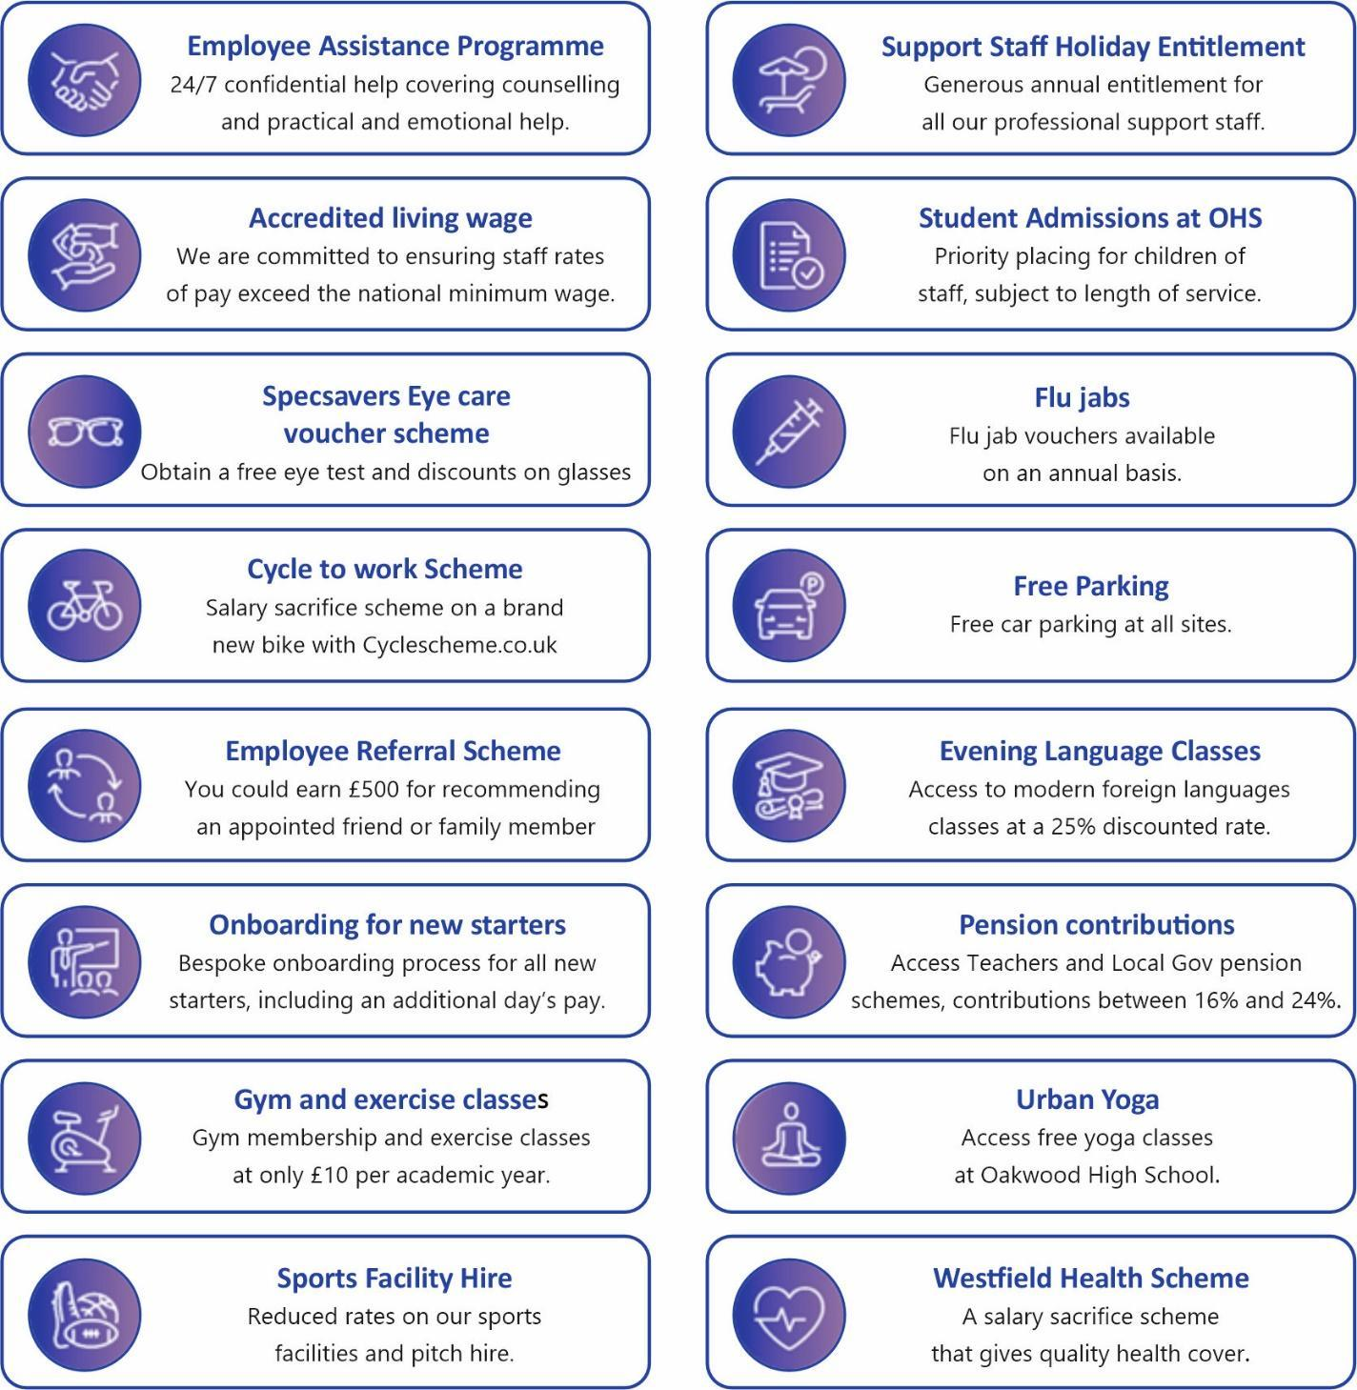

Job Description and Person Specification
Main Purpose of Job
To work under the guidance of the SENDCO, Assistant SENDCO and AENM to implement agreed work programmes with individuals / groups both within and out of the classroom. In particular candidates will be required to work with pupils who need support and nurture to empower them to access the curriculum.
All post holders at Oakwood High School and the Trust are required to work at their designated level to support the implementation of all policies and procedures to achieve key targets. These targets are reviewed annually and adapted to meet the needs of our pupils.
The post holder will be a key member of the team in the Academy and will work positively and proactively.
The post holder will work in collaboration with a range of staff across the Academy in the discharge of their duties and will at all times work within and contribute to the legal, regulatory and policy frameworks of the Academy and wider Trust.

Excellent standards of behaviour, respect and learning depend upon the 'tone' set by all members of the Trust community. We build upon our strengths – together!
For the purposes of this Job Description and Person Specification, Trust is Inspire Learning Trust and all Academies working within the Trust. All duties outlined below are the responsibility of the post holder who will be accountable for delivery. Where there is specific connectivity with another post, or the lead responsibility for an activity lies with another member of staff, this is stated and will be expanded on in the Service Framework and Development plan where appropriate.

Role Specific Duties and Responsibilities of the Post
(including Leadership, Accountabilities and Operational Activities).
A = Accountability (which means being responsible for something to somebody)
L = Leadership (guide, direct and influence the outcomes of)
O = Operational (day-to-day management and control of these activities)
 | 1. | Support for pupils | A | L | O
 | 1.1 | Use specialist (Curricular / Learning) skills / training / experience to support pupils. |  |  | ✔
 | 1.2 | Assist with the development and implementation of Pupil Support Plans. | ✔ |  | ✔
 | 1.3 | Establish productive working relationships with pupils, acting as a role model and setting high expectations. | ✔ |  | ✔
 | 1.4 | Promote the inclusion and acceptance of all pupils within the classroom. |  |  | ✔
 | 1.5 | Support pupils consistently whilst recognising and responding to their individual needs. | ✔ |  | ✔
 | 1.6 | Encourage pupils to interact and work cooperatively with others and engage all pupils in activities. |  |  | ✔
 | 1.7 | Promote independence and employ strategies to recognise and reward achievement of self-reliance. |  |  | ✔
 | 1.8 | Provide feedback to pupils in relation to progress and achievement. |  |  | ✔
 | 1.9 | Deliver intervention strategies to support pupil progress with regards to their emotional health and wellbeing. | ✔ |  | ✔
 | 1.10 | Use suitable systems (SIMS/Go4Schools) and liaise with Attendance and relevant staff to identify pupils with persistent low attendance or under-achievement. | ✔ |  | ✔
 | 1.11 | Monitor attendance and attainment to identify pupils at risk of becoming NEET. | ✔ |  | ✔
 | 1.12 | Work as a learning mentor to provide pastoral support around emotional health and wellbeing and academic issues. |  |  | ✔
 | 2. | Support for the Curriculum | A | L | O
 | 2.1 | Implement agreed learning activities/teaching programmes, adjusting activities according to pupil responses/needs. | ✔ |  | ✔
 | 2.2 | Implement local and national learning strategies, e.g., Literacy, Numeracy, KS3, Early Years and make effective use of opportunities provided by other learning activities to support the development of relevant skills. | ✔ |  | ✔
 | 2.3 | Support the use of ICT in learning activities and develop pupils’ competence and independence in its use. | ✔ |  | ✔
 | 2.4 | Help pupils to access learning activities through specialist support. | ✔ |  | ✔
 | 2.5 | Determine the need for, prepare and maintain general and specialist equipment and resources. | ✔ |  | ✔
 | 3. |  | A | L | O
 | 3.1 | Work with the Teacher to establish an appropriate learning environment. | ✔ |  | ✔
 | 3.2 | Work with the Teacher in lesson planning, evaluating and adjusting lesson / work plans as appropriate. | ✔ | ✔ | ✔
 | 3.3 | Monitor and evaluate pupils’ responses to learning activities through observation and planned recording of achievements against pre-determined learning activities. | ✔ |  | ✔
 | 3.4 | Provide objective and accurate feedback and reports, as required, to the SENCO, on pupil achievement, progress and other matters, ensuring the availability of appropriate evidence. | ✔ |  | ✔
 | 3.5 | Be responsible for keeping and updating records, as agreed with the SENCO, contributing to reviews of systems / records as requested. | ✔ |  | ✔
 | 3.6 | Undertake marking of pupils’ work and accurately record achievement / progress. | ✔ |  | ✔
 | 3.7 | Promote positive values, attitudes and good pupil behaviour, dealing promptly with conflict and incidents in line with school policy and encourage pupils to take responsibility for their own behaviour. | ✔ | ✔ | ✔
 | 3.8 | Liaise sensitively and effectively with Parents / Carers as agreed with the SENCO within your role / responsibility and participate in feedback sessions / meetings with Parents / Carers. | ✔ |  | ✔
 | 3.9 | Administer and assess routine assessments and invigilate exams / tests. | ✔ | ✔ | ✔
 | 3.10 | Provide general clerical / administrative support, e.g., administer coursework, produce resources for agreed activities, etc. | ✔
4. |  | Generic Duties and Responsibilities
4.1 |  | Comply with all Trust policies and procedures and work in accordance with the Code of Conduct for Staff.
4.2 |  | Break-time, dinner and after school duties (on a rota basis).
4.3 |  | All employees will be asked to work at their level on pupil/student interventions to meet the needs and targets of the Trust. For support staff this will include Basic First Aid (training will be provided).
4.4 |  | Be aware of and support differences and ensure all pupils, students and staff have equal access to opportunities to learn and develop.
4.5 |  | Participate and contribute to Talent Development and Service Frameworks and other plans.
4.6 |  | All employees will undertake regular and routine continuing professional development (including attendance and contribution to internal / external Training, Networking, Updating and other such events) to ensure that they develop and recognise their own strengths and areas of expertise and use these to achieve and support others and the aims of the Trust.
4.7 |  | Be aware of and comply with policies and procedures relating to safeguarding, health, safety and security, confidentiality and data protection, reporting all concerns to an appropriate person in accordance with policy.
4.8 |  | Contribute positively to the overall ethos / aims of the Trust including participation in appropriate networks and projects.
4.9 |  | Establish constructive relationships and communicate with others (inside and external to the Trust).
4.10 |  | Organise and support school/college and Trust events as requested.
4.11 |  | Any other reasonable and appropriate duties as directed by Trust or school/college Senior Staff.
4.12 |  | All staff are required to work in a way that encourages a positive work environment that is solution focused and proactive for all. As a senior support staff holder, you will support, mentor and act as a role model for all staff.

Person Specification
The Trust is committed to safeguarding and promoting the welfare of children and young people, and expects all staff, other workers and volunteers to share this commitment.
Key to abbreviations: MoA Method of Assessment, AF Application Form, R References, I Interview, CQ Certificate of Qualification, OT Occupational Testing, DBS Disclosure and Barring Service Check.
1. | Qualifications and Experience | Essential | MoA
1.1 | Teamwork, working with young people in a relevant capacity; including supporting withdrawal groups and whole class groups. | ✔ | AF
1.2 | Understanding of classroom roles and responsibilities and your own position within these. | Desirable | AF
1.3 | Ability to relate well to children and adults and an understanding of learning and development. | ✔ | AF
1.4 | A degree in a relevant subject. | Desirable | AF / CQ
1.5 | Evidence the use of specialist skills to support pupils who have additional needs with regards to SEMH difficulties. | Desirable | AF / CQ
1.6 | GCSE A*-C or 9 - 4 in Mathematics, English (and preferably Science) or equivalent. | ✔ | AF
1.7 | NVQ 3 Teaching Assistants or an appropriate L3 qualification or evidence of experience of successfully using relevant strategies to support pupils with learning difficulties. | Desirable | AF
1.8 | ICT skills including Microsoft/ google packages at an appropriate level. | ✔ | AF / CQ
1.9 | Working knowledge of relevant policies/ codes of practice/legislation. | Desirable | AF
2. | Support for Teaching and Learning | Essential | MoA
2.1 | Interest in practical/creative teaching support | ✔ | I / R
2.2 | Knowledge of educational developments. | Desirable | I
2.3 | Ability to organise and supervise the work of pupils so as to ensure that they make good progress. | ✔ | AF / I / R
2.4 | Evidence of ability to communicate with a range of adults and pupils. | ✔ | AF / I/R
2.5 | Experience of using IT to support learning. | ✔ | AF / I/R
2.6 | Ability to use Go4Schools. | Desirable | AF/I
3. | Personal Qualities | Essential | MoA
3.1 | Conscientious, honest and reliable | ✔ | I / R
3.2 | Able to make carefully considered decisions and assess risk. | ✔ | I / R
3.3 | Ability to work on own initiative. | ✔ | R
3.4 | Ability to communicate with a range of adults and pupils. | ✔ | I / R
3.5 | A commitment to self-improvement. | ✔ | AF / I
3.6 | Capacity to motivate, inspire and challenge pupils, self and others. | ✔ | I / R
3.7 | Ability to establish and maintain good relationships with a range of adults and pupils. | ✔ | I / R
3.8 | Inclusive. | ✔ | AF / I / R
3.9 | An understanding of and commitment to equal opportunities issues both within the workplace and the community in general. | ✔ | I
3.10 | A commitment to safeguarding and promoting the welfare of children, young people and vulnerable adults | ✔ | I
4. | 4. Mandatory Requirements | Essential |  | MoA
4.1 | A satisfactory DBS check at an enhanced level is a condition of employment with Inspire Learning Trust. | ✔ |  | AF / I / R
4.2 | Education posts are exempt from the Rehabilitation of Offenders Act, 1974; all current  convictions, cautions and bindovers must be declared on the application form or provided in  a sealed envelope addressed to the Headteacher. The 2013 amendments to the Act allow  that minor spent convictions, cautions and bindovers do not need to be declared. | ✔ |  | AF / R
4.3 | References that confirm suitability to work in an educational setting, reference must be  provided from current/most recent employer. References will not be accepted from  members of candidate's families or acting purely as a friend. | ✔ |  | AF / R
4.4 | A commitment to safeguarding and promoting the welfare of children, young people and vulnerable adults. | ✔ |  | I / R
45. | 5. Physical Requirements | Essential | MoA
5.1 | Health and physical capacity for the role. | ✔ | AF / I / R
5.2 | A good attendance record in current employment (not including absences resulting from disability). | ✔ | R

6. | Effective Behaviours
The Trust looks for evidence from all candidates of effective behaviours which we value and have found to be consistent with high performance. Part of our selection process will be to assess whether candidates can demonstrate that they have exhibited these behaviours in their current or previous employment, education, voluntary or other activity. Candidates are advised to read the following carefully and provide examples of these in the 'Information in Support of the Application' section of the application form. Candidates should be prepared to discuss these in the interview process.
6.1 | Seeing the Bigger Picture: Understand what your responsibilities are and how these contribute to the priorities of your team. Consider the varied impact your work could have on individuals with different needs and from other backgrounds. Gather information from both inside and outside of the Trust to inform your area of work.
6.2 | Changing and Improving: Review ways of working and suggest improvements, including how to make full use of new digital technologies. Learn new procedures and help colleagues to do the same. Query any issues that arise from changes in a suitable way. Respond in an effective and appropriate manner when emergencies arise.
6.3 | Making Effective Decisions: Use guidance, analyse relevant information and ask colleagues for input to support decision making. Identify and deal with any errors or gaps in information before making a decision. Consider the diverse needs of those affected by decisions and how it will impact them. Provide advice and feedback to support others in making accurate decisions. Ask others to clarify decisions when confused and query any issues that arise constructively..
6.4 | Leadership: Show enthusiasm for your work and take personal accountability for your role. Demonstrate responsibility for your own objectives. Act in a fair, inclusive and respectful way when dealing with others. Be considerate and understanding of other people’s points of view. Understand and support the objectives of the wider team. Demonstrate consideration of the wider consequences of own actions.
6.5 | Communicating and Influencing: Put forward your views in a clear, constructive and considerate manner. Use an appropriate method of communication for each person such as an email, telephone call or face-to-face, taking into consideration their individual needs. Use plain and simple language, being careful to check written work for errors. Consider the impact of language used on different groups of stakeholders. Remain honest and truthful when explaining opinions. Listen and ask questions to ensure your understanding.
6.6 | Working Together: Proactively contribute to the work of the whole team and remain open to taking on new and different roles. Get to know your colleagues and build supportive relationships. Listen to alternative perspectives and needs, responding sensitively and checking understanding where necessary. Ask for help when needed and support others when the opportunity arises. Be aware of the need to consider your own wellbeing and that of your colleagues. Understand that bullying, harassment and discrimination are unacceptable.
6.7 | Developing Staff and Others: Identify gaps in your skills and knowledge and make plans of how to develop these. Take time to achieve development objectives. Listen to and act on feedback from colleagues to find areas you can develop. Share knowledge and skills learnt with colleagues to contribute to the learning and development of the whole team.
6.8 | Managing a Quality Service: Gain a clear understanding of pupil/student needs. Plan, organise and manage your own time to deliver a high-quality education to pupils/students. Act to prevent problems by identifying issues, reporting them and providing solutions. Keep colleagues up to date with progress.
6.9 | Delivering at Pace: Always work with focus and pace to get the job done on time and to a high standard. Follow the relevant Trust policies and procedures. Use own knowledge and expertise to organise work. Keep focused on delivery and take responsibility for the quality of work produced. Keep a consistent level of personal performance. Keep managers and stakeholders updated on how work is progressing.

This specification has been prepared in accordance with the requirements of the Trust's Equal Opportunities in Employment Policy. We undertake to consider any 'reasonable adjustments' to a job or workplace to counteract any disadvantages a disabled person may have.
Inspire Learning Trust is committed to providing a safe, secure and supportive environment for all members of staff to support their wellbeing, built from effective relationships. As part of our Staff Wellbeing Strategy, we have contracted with the Education Support Partnership, and they provide us with an Employee Assistance Programme to support all staff on a range of issues. We will continue to work with our staff body to improve and ensure that we remain a really good place to work. Our commitment to our pay and conditions is demonstrated by the Trust being recognised as an Accredited Living Wage employer.


Inspire Learning Trust is committed to… Educational Social Responsibility
We are committed to a value led educational provision.

Inspire Learning Trust is an organisation driven by a desire to provide a truly outstanding and inspirational educational experience for all its pupils and students. Underpinning this aspiration, is an equal commitment to being a wonderful place to work and a valued and impactful community asset.
Since its journey began a decade ago, Inspire Learning Trust has worked tirelessly to develop a strong ethos. Together, within this multi academy trust, we will work to inspire learners to achieve, for today, for tomorrow and into the future.
Through a process of engagement and collaboration, Inspire Learning Trust has further developed this ethos, by encouraging each establishment to define their specific purpose in the development of the young people they support:
- Inspiring lives, creating possibilities, shaping futures - Sitwell Junior School
- Inspired to achieve - Oakwood High School
- A tradition of achievement - a future of opportunity - Thomas Rotherham College
- Everyone succeeds - Winterhill School
Underpinning this ethos, Inspire Learning Trust has embedded a set of common values that are believed in and shared, by the trusts, staff, pupils, students and trustees, these are;
Respect, Responsibility, Resourcefulness, Resilience, Reflection, Risk taking and Relationships

