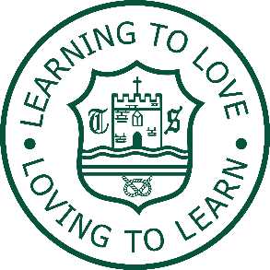

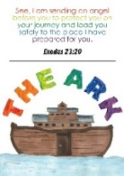
0.5 FTE Class Teacher for KS2

St Michael’s CE (A) Primary School
Teachers’ Pay Spine
Job Ref: EC3822023
Required for 1st September 2023 for a year.
St Michael’s CE (A) Primary School is committed to safeguarding and promoting the welfare of children and young people and expects all staff and volunteers to share this commitment. This post requires an Enhanced Disclosure and Barring Service (DBS) check and appointment will be subject to a satisfactory clearance.

We are seeking an outstanding Teacher to work in our caring and forward-looking school who:
- Is an inspiring and talented practitioner, passionate about standards and determined to make a genuine difference
- Has the ability and creativity to design, organise and deliver high quality learning experiences that motivate and inspire pupils and improve their attainment and progress
- Has excellent numeracy and literacy skills
- Is excited and motivated by new challenges
- Works effectively both independently and as part of a team
- Has been assessed as good or outstanding in the last 12 months
- Has experience teaching in KS2

The position is a fixed-term contract.

A visit to the school can be arranged by contacting Mrs Harty on 01902 558845.

CLOSING DATE: Wednesday 21st June 2023 at 12 noon

To apply, call the School on 01902 558845, visit www.wolverhampton.gov.uk/jobs or
e-mail: stmichaelsceprimaryschool@wolverhampton.gov.uk

