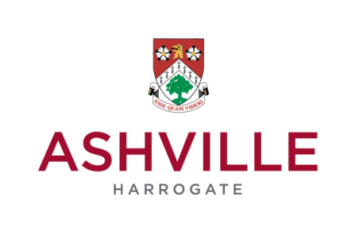

**Deputy Head Academic**

**Ashville College Preparatory School**

**April or September 2017**

Ashville College, Harrogate, is seeking to appoint an outstanding Deputy Head who will support the Head of the Preparatory School in the development of teaching and learning for pupils in the Prep School, as the current management structures of the Junior School and Pre-Prep schools merge. The role will be responsible to the Prep School Head for the standards of achievement and attainment from Years 1 to 6 and will assume responsibility for leading and managing Subject Leaders throughout the Prep School and will oversee transition from Early Years into year 1 with the Head of EYFS and from Year 6 into the Senior School with the Deputy Head Academic. The post holder will be jointly responsible with the Deputy Head Pastoral for the day-to-day running of the Prep School, ensuring that all areas are appropriately staffed, duties carried out and children supervised.

The successful candidate will be an experienced primary practitioner who has the energy, vision, communication and organisational skills to lead by example, maintaining high standards in classroom management, teaching and learning, computer literacy, pastoral care, discipline and time management.

Applicants will also be able to identify with and support the College’s Methodist values, which promote the ethos of every pupil being of equal value and that all individual pupils should strive to become the ‘best version of themselves.’

Founded in 1877, Ashville College is an HMC co-educational 3-18 boarding and day school of 868 pupils located on the outskirts of Harrogate in a 64 acre campus.  Ashville College is associated to the Methodist Independent Schools’ Trust (MIST).

**Deadline for applications is Tuesday 29th November by 12 noon.**

**We expect interviews will be held in the weeks beginning 5th and 12th December.**

Please return your completed application form together with a two page letter of application, addressed to the Headmaster of Ashville College, detailing your relevant experience, outlining why you have applied and suggesting how you would approach the role and what you would seek to achieve. Please also include a full CV.

Mrs Alison Paterson, HR Manager

Ashville College, Harrogate, North Yorkshire, HG2 9JP

or via email to [recruitment@ashville.co.uk](mailto:recruitment@ashville.co.uk)

Ashville College, Harrogate is committed to providing a safe environment for its pupils and staff. Applicants for this post will be required to provide proof of identity at interview if called, and the successful applicant will be required to undergo an enhanced DBS check before starting work.