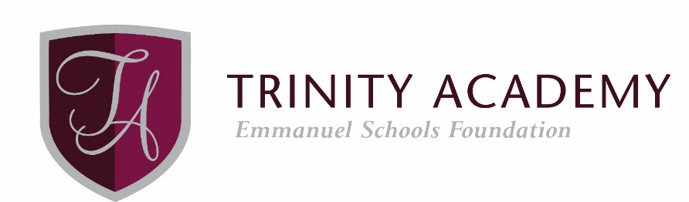

Role Profile
Cover Supervisor

Cover Supervisors work under the guidance of teaching staff and within an agreed system of supervision. They implement work programmes with individuals/groups, in or out of the classroom, including the supervision of whole classes during the short-term absence of teachers.

Cover Supervisors are responsible to the Cover and Reporting Manager for:

- Supervising students as they carry out work left by teachers in accordance with Academy policy
- Helping to prepare the learning environment and the materials needed for the lesson
- Assisting with the management of student behaviour to ensure a constructive working environment
- Responding to students’ questions regarding the work that has been set,
- Collecting any work completed after the lesson and returning it to an agreed person or place
- leaving the room in good order at the end of the lesson
- Supervising the orderly entry and departure of students in accordance with Academy policy
- Recording and reporting attendance at lessons in accordance with Academy policy
- Helping with examination invigilation under the supervision of the examinations officer
- Using the Academy's agreed referral procedures, as required, to report back on the behaviour of students during the class and any other issues arising
- Dealing with any immediate problems or emergencies according to the Academy's policies and procedures
- Following Academy policies and procedures, especially those relating to child protection and health and safety
- Respecting confidential issues linked to home/students/teachers/school work and keeping confidences as appropriate.

