

St Joseph's Catholic Primary School

June 2018

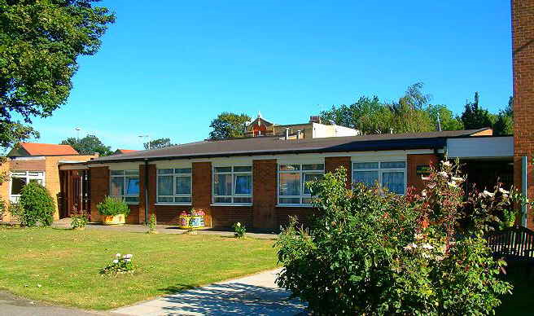
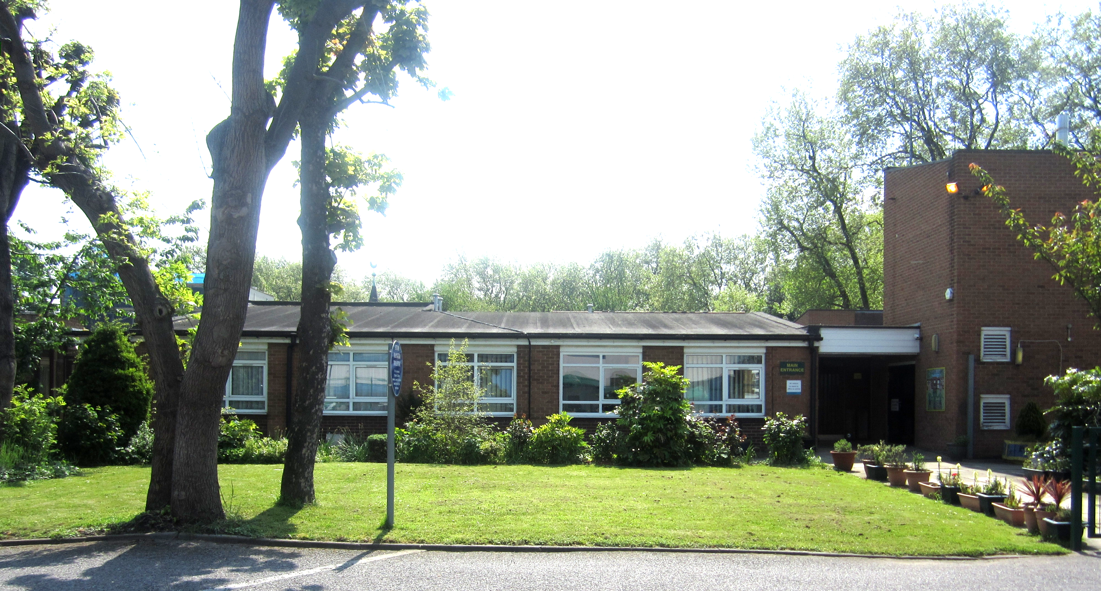

“This is an outstanding school. Pupils are eager to learn, and behave exceptionally well. They consider the feelings of others and are protective of one another. They feel extremely safe in school and are kept safe.”
Ofsted Report – June 2012

INTRODUCTION

Dear Parents,

Welcome to St Joseph's School.

This brochure has been produced to give you an insight into the way in which our school is organised and functions.

By the very fact that parents send their children to our school, we understand that they wish them to be instructed in the Roman Catholic faith and to benefit from a Christian education.

If the teachers are to succeed in what they do, your child will need every encouragement and practical example from home.

In our school, we strive to provide a happy, family atmosphere and a secure environment, so that the children will develop spiritually, morally, intellectually and socially. We all endeavour to treat each child as an individual, recognising his/her personal needs, aptitudes and abilities.

We hope that your child will benefit in every way from the education received here in St Joseph's School, and we encourage you all to come and get to know us, the staff, so that we can work together for the best interests of your child.

Yours sincerely,

Mrs Clare Garofalo
Headteacher

MISSION STATEMENT
St Joseph's school in partnership with the Parishes of St Peter's Rotherhithe and St Gertrude’s, South Bermondsey, provides a Catholic, Christian community, where each one can be helped and nurtured in the growth of their faith. Parents and carers will be supported actively and positively in their role as first educators of their children.

We seek to share with each other the richness of our Catholic faith and provide a safe, happy and caring environment, where we all grow in the love of God and each other with Jesus Christ as our model.

We aim to work together to:

Provide excellence in education, together with parents, staff, governors, the parishes the community and the wider world, so that our children reach their potential in all areas of development.

We also aim to:

- inspire a love of learning in our children
- encourage them to have enquiring minds
- involve the children to promote a sense of responsibility for their own learning
- develop in them a sense of their own self-esteem and self-worth
- celebrate our many different cultures and work to deepen our understanding of and respect for other faiths
- encourage them to participate actively in their local parish life
- Prepare our children for the challenge of leading a Christian life, so that they will become good and honest citizens in today’s world.

ETHOS & VALUES

At St Joseph's we cultivate a family atmosphere within a Christian ethos where Christ's messages and the Gospel values are lived out, and where we aim to help the children to achieve their full potential.

So, the few rules we have are made for the SAFETY, HEALTH and HAPPINESS of the School Community.

We RESPECT and CARE for EACH OTHER and OTHERS PROPERTY, THEREFORE

- WE LISTEN POLITELY.
- WE SPEAK TO EACH OTHER IN A QUIET VOICE.
- WE SAY PLEASE and THANK YOU
- WE TRY TO HELP and SHARE WITH OTHERS.

On a child's entry to the school, parents will be given a copy of the Home/School Agreement. This should be signed by the Headteacher and parent and will then be put on record.

St Joseph’s Catholic Primary School
Gomm Rd, Lower Road,
Rotherhithe,
SE16 2TY
Tel: 020 7237 4036
Fax: 020 7231 5191

Age range: 3 - 11 years

Headteacher: Mrs Garofalo

Deputy Headteacher: Mr David Weston

Chair of Governing Body: Fr Graham Preston

All the information in this booklet is correct at the time of preparing this booklet in June 2017. There is no guarantee however, that the facts will remain unchanged for the entire year or in subsequent years.

SCHOOL HOURS

Nursery 8.50 - 11.50 a.m 12.20 - 3.20 p.m

Infants 9.00 - 12.10 a.m 1.15 - 3.15 p.m

Juniors 9.00 - 12.15 a.m 1.15 - 3.15 p.m

St Joseph's School is a Roman Catholic Voluntary Aided Primary School. The school manages its own budget and the Governing Body are completely responsible for the running and maintenance costs of the building, the appointment of all staff, teaching and support and admissions.

THE SCHOOL DAY

25 hours per week = 5 hours per day.

The minimum requirement of teaching time

Infants 21 hours per week
Juniors 23½ hours per week

A list of holiday dates is distributed annually. Permission must be asked of the Headteacher to take your children on holiday during term time. This is not encouraged as
it is disruptive to their education.

ADMISSIONS CRITERIA – see Appendix 1

VISITORS

Parents are welcome at any time but IT IS IMPORTANT that they present themselves to the Premises Officer or School Administration Officer in the first instance. An appointment is required to speak to the Headteacher - this saves time for both you and the Head and prevents you being disappointed. An appointment is also required to speak to the Class Teacher. It is important that teachers are not disturbed while the children are in their care.

CAR PARK

Parents / carers are not allowed to drive into or park in the school grounds when bringing or collecting the children because of the lack of parking space and the hazard to the children.

PARKING

Some parents/carers park their cars dangerously outside our school. This could cause an accident. Please choose to park in an alternative location to ensure the safety of our pupils.

SCHOOL GATES

In the morning before 9.15am, entry and exit from the building is through the gate in the junior playground only.

In the evening, when you collect your child, entry and exit is again by the junior gate. Please do not cross the car park.

After 9.15am and before 2.55pm (i.e. when the junior gate is locked for safety) please enter and exit the premises via the automatic gates. Please take extreme caution crossing the car park.

COMPLAINTS PROCEDURE

Most concerns can usually be settled amicably through discussion with the headteacher. However a complaints procedure is available if any matters are not resolved.

SECONDARY TRANSFER

Children transfer from the primary school at the end of year 6, (aged 11). Parents are informed at the beginning of the child's last year in the primary school of all that concerns them and their child with regard to the Transfer Procedure for the current year. The Secondary Schools to which our children usually transfer are:

St Michael's, Bermondsey (Mixed Comprehensive)

St Thomas the Apostle, Nunhead (Boys only)

St Ursula's, Greenwich (Girls only)

Notre Dame, Southwark (Girls only)

Bacons College (Mixed)

City of London Academy (Mixed)

THE NATIONAL CURRICULUM

The school offers to all children admitted to the school.

- Religious Education

- The National Curriculum.

The key stages of education at Primary Level are:

Foundation Stage: Nursery and Reception
(The early learning goals set out what is expected for most
children by the end of this stage and prepares them for school.)

The curriculum for the Foundation Stage should underpin all future learning by supporting, fostering, promoting and developing children’s:

personal, social and emotional wellbeing;
positive attitudes and dispositions towards their learning;
social skills;
attention skills and persistence;
language and communication;
reading and writing

Key Stage 1: Yrs 1 & 2
Key Stage 2: Yrs 3 - 6

The National Curriculum is described as:
- an important element of the school curriculum;
- defining the values and purposes underpinning the school curriculum;
- outlining the two main aims of the school curriculum:

Our Aims and Objectives
Our main aim is to provide a broad and balanced curriculum, through well planned and organised cross-curricular activities, in a Catholic Christian setting, where the staff accompany the children on their faith journey, and where the Gospel values are seen to be lived out by all.
We aim:
- to teach the children to develop lively, enquiring minds and the
knowledge and skills needed to understand the world in which they live;

- to encourage a respect for all religious and moral values, cultures
and customs of other races, religions and ways of life;

- to help the children to become independent workers and thinkers,
which enables them to acquire self-discipline, and become responsible
persons;

- to provide every child with equal access to all areas of the curriculum,
regardless of race or gender.

- to provide opportunities for all pupils to learn and achieve; to promote a broad and balanced curriculum which "promotes the spiritual, moral, cultural, mental and physical development of pupils at the school and of society and prepares pupils for the opportunities, responsibilities and experiences of adult life". (Education Reform Act 1988).

The Core Subjects of the National Curriculum are:

Mathematics Science RE informs all areas of the curriculum

English I.C.T

The Foundation Subjects are:

History Geography Music

Design & Technology Physical Education. Art

Personal, Social and Health Education Citizenship

For each subject and for each key stage, programmes of study set out what pupils should
be taught.

Assessment
This is an on-going process, but formal assessment determined by testing will take place at 7 & 11 years of age to determine how pupils achievement relates to the Attainment Targets. The children in Reception class are assessed in the seven areas of learning at the end of the year through the Foundation Stage Profile.
This tells us where the child is at and helps us plan the curriculum. Curriculum records are kept on each child. These are a formal record of the child's academic achievements, skills and class progress in school. They are passed on to the next teacher at the end of each school year, and to the Secondary School at the end of Yr.6.

REPORTING TO PARENTS

At the end of each year parents will be given a written report. In the Autumn and Spring Terms, parents will have opportunities to discuss their child's progress with the teacher concerned.

OPEN EVENINGS

Open Evenings are special times when all parents are urged to come to see their children's work and to talk to the teachers about their child's development. This is an important opportunity to show your child that you care. Children are always greatly encouraged by their parent’s interest. Open evenings are held once a term.

RELIGIOUS EDUCATION

Religious Education is at the heart of all that we do in our school and informs the whole curriculum. Therefore, we try, through teaching and example, to impart Gospel values in every aspect of school life and to respect the dignity and rights of each individual in relationship to the school and wider community.

The R.E Programme for England and Wales, "Come and See", is used throughout the school from Nursery to Year 6. This provides a sound Doctrinal and Scriptural basis for the teaching of Religion in the school. We also develop the children’s spiritual and moral education using the themes from the programme.

Parents are the first and most important teachers of their children. The preparation for the Sacraments therefore takes place in the Parishes with the co-operation of the parents. The school supports this preparation through the on-going work done in the “Come and See” programme.

Mass is celebrated in school on Holidays of Obligation and other special feasts. Children attend assembly each day in the hall or in their class. Each class has an opportunity of preparing an assembly for the whole school and parents at various times throughout the year.
We celebrate the feast of St Joseph with a whole school Mass and there is a special leavers Mass for those children transferring to Secondary school.
There are special liturgies at Christmas and Easter.
Junior Children take part in a “Prayer service around the cross” every Wednesday.
They also receive the Wednesday Word. This is a scheme which encourages parents and children to pray together.
We emphasise the importance of the partnership between parents, Parish and school in the development of the faith life of each child and we teach R.E. in a way that respects the uniqueness of each one and his/her personal relationship with God. As a Roman Catholic school we see R.E as an essential and vital part of the school curriculum, underlying every part of this and school life.

SEX EDUCATION

Sex Education is taught in a very sensitive way and with regard to the Catholic faith. However, parents do have the right to withdraw their children from this part of the curriculum if they wish.

PROFESSIONAL DEVELOPMENT

Teachers and support staff attend regular training courses as the need arises.

SPECIAL EDUCATIONAL NEEDS
See Appendix 2

HOMEWORK
Our Homework guidelines are as follows:

Reception
- Reading every night (10min)
- 1 piece of Phonics per week
- 1 piece of Maths per week

Year 1
- Reading every night (10min)
- Spellings
- Number bonds to 10
- 1 piece of phonics per week
- 1 piece of English per week
- 1 piece of Maths per week
- Creative topic once a year

Year 2
- Reading every night (15min)
- Spellings
- Time Tables x2, x5, x10
- Number bonds to 20
- 1 piece of English per week
- 1 piece of Maths per week
- Creative Topic twice a year

Year 3
- Reading every night (30 min)
- Spellings
- Tables x 3, x 4, x8
- Number bonds to 20
- 1 piece of English per week
- 1 piece of Maths per week
- Creative Topic once a term

Year 4
- Reading every night (30 min)
- Spellings
- Tables (all up to 12 x 12)
- Number bonds to 100
- 1 piece of English per week
- 1 piece of Maths per week
- Creative Topic every half term

Year 5
- Reading every night (30 min)
- Spellings
- Tables(all up to 12 x 12)
- Number bonds to 100
- 2 pieces of English per week
- 2 pieces of Maths per week
- Creative Topic every half term

Year 6
- Reading every night (30 min)
- Spellings
- Learn tables (all up to 12 x 12)
- Number bonds to 100
- 1 piece of English every night
- 1 piece of Maths every night
- Creative Topic every half term

EXTRA CURRICULAR ACTIVITIES

As these activities frequently change, please see our website for more details.

EQUAL OPPORTUNITIES

Part of our school philosophy is to respect each child in their uniqueness and individuality and to try to inculcate in each one a sense of value and self-worth. This forms the basis of our attitude and approach to the promotion and implementation of equal opportunities throughout our school across the curriculum and in relationships with children and parents. Aware of children with special educational needs, we try to provide each girl and boy from different ethnic groups and social backgrounds with equal opportunities in every area of the curriculum.

From time to time we seek advice from the school's Educational Psychologist or the school nurse on the best way to help children with physical or learning difficulties. Before doing this we would discuss the problems with the parents.

BULLYING

Bullying, including racism and homophobia in any form is unacceptable, and incidents will be dealt with immediately.
(See school policy)

FRIENDS OF THE SCHOOL

This group of people work hard to fund raise for the school in order to help finance school trips, Christmas activities etc. It can be an enjoyable involvement in preparing and planning events and in getting to know other parents.

Any interested parents should enquire at the school.

HOSPITAL/DENTAL APPOINTMENTS

If you have to collect your child from school for a dental or hospital appointment, please let us know in advance. When you arrive to collect your child, please see the School Administration Officer who will know where to find him/her.

In Reception class, the school Dentist examines the children’s teeth once within the year. If treatment is needed, you will be asked whether you would like to make an appointment with the school Dentist or with your own Dentist. You do not need to come to the dental inspection although you will be told about it

ASTHMA, CONVULSIONS, FITS

The school should be notified if your child is asthmatic, or has convulsions, fits or any other medical conditions that we need to know about.

ASTHMA

If your child has Asthma, he/she must provide us with the medicine clearly labelled. It will be kept in a safe place in the classroom. You are responsible for ensuring the inhaler is in date.

EPI PENS
If your child has a prescribed EPI Pen, please ensure you provide us with 2 if the event that one does not work during an anaphylactic shock. EPI pens are stored in the main office. It is the parents responsibility to ensure they are in date with the child’s name clearly labelled. Staff are trained annually to administer an EPI pen,

MEDICINES & HEALTH

- Medicine can be administered in school by school staff. Although, we will only accept medicines that have been prescribed by a doctor, nurse or pharmacist for the child (name and date). All medicines should always be provided in the original container and include the prescriber`s instructions for administration.

- Parents may come to school to administer medicines.

- In the event of your child becoming sick during the day, we will contact you using the phone numbers you provide us with at the beginning of the school year. If you give us a mobile number please ensure that it is switched on.

SCHOOL MEALS

There are two dinner sittings (1) Infants (2) Juniors. Children are allowed to bring a packed lunch if parents wish. This has to be put in writing to the school and if children wish to change back to having dinners again this is only allowed at the beginning of a term or half-term and another letter to the school is needed.

The children are well supervised during their break times. There are 3 Senior Midday Supervisors and 6 Midday Supervisors who support the Head and Teaching Staff.

TOYS, TRADING CARDS, JEWELLERY & MONEY

Please do not let your child bring toys, cards, money, or mobile phones to school. The school will not take responsibility for loss or damage. Jewellery is not allowed except for small ear studs. No Jewellery can be worn for PE.

HEALTHY EATING

Please do not send sweets, other snacks or drinks to school for break times.
Children are given a piece of fruit each day. The Nursery children also have milk.
Children should bring a bottle of water to school which they will have access to at certain times of the day.
If your child has a packed lunch it must not contain sweets or fizzy drinks

HEALTHY BIRTHDAY CELEBRATIONS

We understand that children love to celebrate their birthday. To mark the special occasion, children can come to school wearing their own clothes. This ensures the whole school community knows it is their special day; it takes little organisation for parents; it is not unhealthy and it is completely free! We do not permit sugary treats, cakes or party bags.

SCHOOL UNIFORM

Skirt, pinafore/trousers | girls | Mid Grey
Trousers | boys & girls | Mid grey (no jeans, cords or track suits)
Sweatshirt/Cardigan | girls & boys | Green with the school logo available from School Trends
Blouse | girls | White
Shirt | boys | White
Socks | girls & boys | Mid Grey or White
Shoes | girls & boys | Sensible plain black, flat shoes (no high heels - no sling backs, flip flops or boots. School shoes should be all black, no higher than the ankle with no patterns, logos or white/coloured laces)
Summer Dresses | girls | White & Green Gingham dress.
P.E. Kit | girls & boys | Yellow polo shirt with school logo and green shorts

PLEASE MAKE SURE THAT YOUR CHILD’S CLOTHING AND P.E. KIT ARE CLEARLY MARKED WITH THEIR NAME.

HAIRSTYLES

No extreme hairstyles are allowed. Just as we expect children to dress appropriately for school, we also expect them to adopt a suitable, age appropriate hairstyle. We consider extreme styles to be: hair colouring, tramlines, shaven heads, logos or patterns. Hair which is long enough, should be tied back with discreet hairbands or accessories in keeping with the school uniform.

FREE SCHOOL MEALS

Parents on Job Seekers Allowance Income based, Income Support, or Child Tax Credit (not working tax credit)

Even though London Borough of Southwark now provide free school meals, it is still important for you to bring this documentation to the school office. This allows the school to claim money from the council for resources.

ABSENCES

Please send a note when your child is away from school, ring the Administration Officer or come and tell us otherwise your child will be registered as being absent without authorisation. A verbal message from a child re: absence or lateness is not acceptable. Holidays during term times are discouraged.

ATTENDANCE

The attendance figure for the school year 2015/2016 is

Absences 2.7 % (97.3%)

ACCESS TO OUR SCHOOL

Our school being a one storey open plan building would be accessible for pupils with mobility difficulties. There is a pathway into the building through the main door which would facilitate wheelchairs and ramps into each classroom.

WAYS OF HELPING YOUR CHILD

- Sleep please make sure that your child gets to bed at a
reasonable hour;

- Attendance unless your child is ill, please make sure your child attends
school regularly. Odd days /long periods of time do effect
children’s progress

- Punctuality unless your child is ill, please make sure he or she
comes to school on time every day. Please ensure
that your child arrives in time for school at 9.00a.m
and is collected punctually at 3.15p.m;

- Independence dressing and undressing, eating with a knife and fork
without help makes your child more confident at
coping with school. Please encourage them to do things
for themselves even if it takes a little longer at first;

Being responsible for their own belongings and clothing.

CHARGING AND REMISSIONS POLICY

Procedure School Trips

- Letter sent to parents/guardians inviting voluntary contributions for the cost of the trip.
- Any child whose parents cannot afford to pay will be included in the trip.
- However, if too many children do not pay, the trip will have to be cancelled as the school has not got the resources to fund more than a few children from each class.

SCHOOL TEACHERS

Mrs Clare Garofalo Headteacher

Mr David Weston Deputy Headteacher

Mrs Helen Preston

Mrs Sophie Fisher Special Educational Needs Co-ordinator

Miss Sian Clarke

Mr Jacob Boulton

Mrs Samantha Buksin

Mrs Rosanne Bartley

Miss Lauren Ridley

Miss Edyta Ropiak

Miss Rachael Downing

Mr Steve Noonan

Parents will be notified of their class teacher in a class letter before the end of term.

LIST OF GOVERNORS

Mrs Emma Cleveland Foundation Governor
c/o St Joseph’s School

Mrs Denise Hatch Foundation Governor
c/o St Joseph’s School

Mrs Stephanie Bailey Foundation Governor
c/o St Joseph’s School

Mr Steve Noonan Staff/ Governor
c/o St Joseph’s School

Father Graham Preston Chairperson/ Foundation Governor
St Peter’s Church

Mr Michael Jagodzinski Parent Governor

Mr Charles Osunkunle Parent Governor

Mrs Clare Garofalo Headteacher/Governor
St Joseph’s School

Mrs Malgorzata Hallewell Foundation Governor
c/o St Joseph’s School

Mr Brian Parsons Foundation Governor
c/o St Joseph’s School

Margaret Bruce (Clerk)
Governor Development Services
Southwark Council Children’s Services
PO BOX 64529
SE1P 5LX

Anthony Petrilli LEA Governor
c/o St Joseph's School

Fr Francis Lynch Vice Chairperson/ Foundation Governor
St Gertrude`s Church

All our governors are available to serve on all committees as required.

ST JOSEPH`S CATHOLIC PRIMARY SCHOOL

ADMISSIONS POLICY

AND

SPECIAL EDUCATIONAL NEEDS POLICY

Please see our website for more details.

