The Grammar School at Leeds  Deputy Head of Biology | 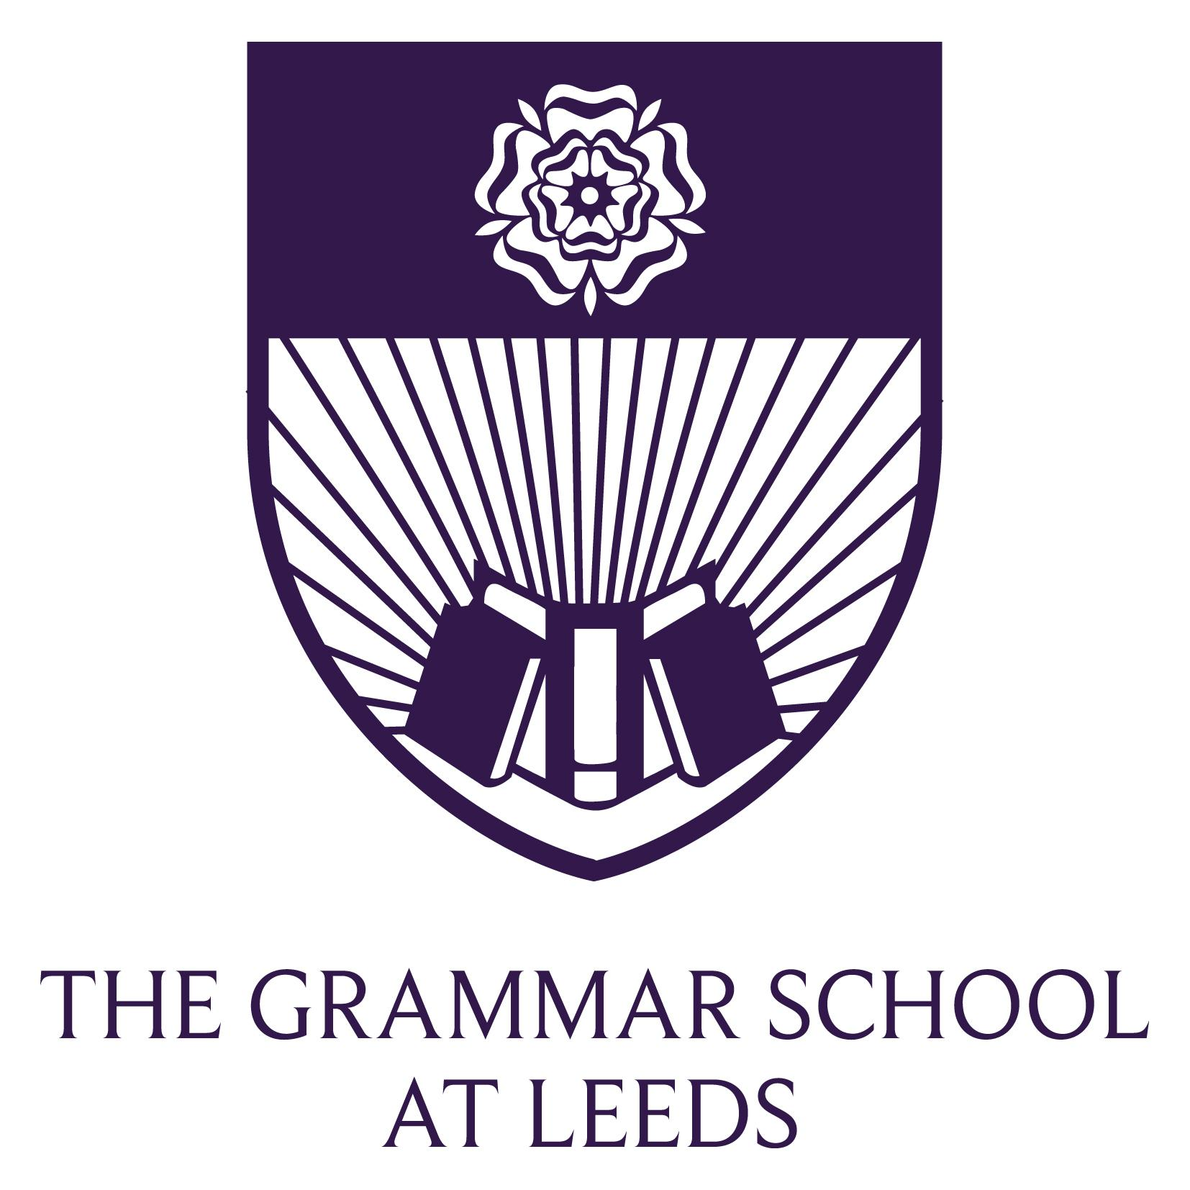
We are seeking a talented and dynamic Deputy Head of Biology to join this successful department from September 2017.
The Grammar School at Leeds (GSAL) is a co-educational independent school with over 2,000 pupils between the ages of three and 18. The senior and junior schools are located at Alwoodley Gates adjacent to open countryside on the northern edge of Leeds, and the nursery and pre-prep (up to year 2) at Rose Court in Headingley.

The school started life as Leeds Grammar School (LGS) in 1552, and today is the UK’s largest independent school following its merger with Leeds Girls’ High School in 2008. The school at Alwoodley Gates was purpose-built for LGS, which relocated from the city centre in 1997, and was later extended and improved to accommodate the merged school.

Under the ‘diamond model’ structure, children learn in single sex classes from ages 11 to 16, while benefiting from shared form time and extra-curricular activities. All senior school staff are expected to teach both boys’ and girls’ classes. Class, set and form sizes are usually between 16 and 22, and attention to detail and the best interests of the pupil assume a high priority. The school is academically selective, with consistently excellent examination results. Independence from the National Curriculum provides flexibility and a breadth of academic experience for pupils, who can develop their individual interests and strengths in order to make informed choices at GCSE. Sixth form students have a choice of nearly 30 A Level subjects, and the option to undertake the Extended Project Qualification.

Superb learning resources and facilities support the school’s academic offering as well as a wide range of extracurricular activities. The departmental teaching areas are complemented by year group common rooms, including an excellent Sixth Form Centre. Junior School and Rose Court each have their own libraries, sports halls and facilities for science, music, art/design, dance and food technology.

We place academic achievement at the heart of an all-round education, providing personal development and learning beyond the classroom through a wide range of extracurricular activities. Sport, music and drama, scouts, CCF, Duke of Edinburgh and debating are all impressive, with a strong record of success in national competitions. A lively house system encourages a high level of pupil participation, whether by experienced competitors or those having a go at something new.

The school promotes a strong sense of integrity, courtesy and social responsibility. Staff and students throughout the school are active in charitable work locally and internationally, while all sixth form students undertake voluntary service. Senior School provides religious assemblies for five different faiths.

Our success depends upon committed, professional, passionate and well-qualified staff, strongly focused upon excellence in the classroom and contributions to the wider life of the school. Staff are rewarded with a good degree of autonomy in their teaching, outstanding resources, freedom from government edict and an attractive benefits package. Many staff enjoy good career progression within the school; CPD is well-funded and there are many opportunities for leadership within the school, through curricular development, pastoral roles, the house system, or leading extracurricular development. The school is friendly, fun and supportive, while retaining high expectations.

Leeds is a thriving city which has benefited from a period of sustained economic expansion. Diverse and friendly, with a wide range of cultural, social, sporting and leisure activities the city has something for everyone. With all the benefits of a modern city and Yorkshire’s beautiful countryside on the doorstep, residents really can enjoy the best of both worlds.
www.gsal.org.uk

The Science Faculty
The Science Faculty, headed by Dr Mike Dearden, is very strong and has an outstanding academic record at GCSE, A level and with Oxbridge entrance. Within Science, Biology, Chemistry and Physics operate as three separate disciplines headed by Dr Lynne Gilbert, Dr Ruth Boddy and Mr Tom Rogerson respectively. Each department is large enough to have a Deputy Head of Department, a technical Team Leader and a General Science Technician.

In Year 7, the pupils begin to study the three separate sciences undertaking courses in Biology, Chemistry and Physics. The study of the separate disciplines continues through Year 8 to Year 11 when all pupils are entered for a double award in Science (Edexcel International GCSE Science (Double Award)). Biology, Chemistry and Physics are all offered at A level. The Science teaching facilities are among the finest available in any school in the country at this time and the Faculty is generously resourced. The vast majority of teaching in each Department is by subject specialists
The Biology Department

The Biology Department has eight academic staff and extends to eight laboratories, preparation room, greenhouse and staff offices. It enjoys outstanding technical support from two dedicated full-time technical staff. The department is lively and innovative, with a high profile, large numbers of sixth form students (over 120 A level students) and a reputation for excellence. A wide variety of practical work features strongly in all courses and ICT is used extensively, both in teaching and for administration. Biology has a well-developed school intranet site, aimed at use both in and out of class and the development of new technologies to support the work of the department is an on-going process. The department has considerable experience of providing mentoring for ITT students and actively supports continuing professional development.
The Post
We are seeking an enthusiastic and innovative Deputy Head of Department who is willing to play their role in the department and in school to the full; an individual who is committed to the teaching of Biology at all levels and who is willing to develop present aspects of the curriculum and to further enhance the department’s standing. The successful candidate will have strong classroom management skills and will be expected to play a full part in this busy Department. Colleagues have the opportunity to participate in the wide range of extra-curricular activities available within the school and to support the House system.

The post is a permanent one from September 2017 and we are seeking a good honours graduate with a teaching qualification, who is able to teach Biology throughout the school. The post could be seen as a career move to a challenging academic environment but equally might suit someone seeking a first move.
If you have any further questions about the department or the school you are welcome to contact the Head of Department, Dr Lynne Gilbert ALG@gsal.org.uk or the Deputy Head (Academic), Dr Debbie Danks DCD@gsal.org.uk
Benefits
The salary is constructed from a combination of National Spine points and GSAL supplements to reflect the commitment that is expected from all staff. There are also additional supplements available for participation in the wide range of extracurricular activities offered.
GSAL has a number of generous non- contractual benefits including discounted school fee rates for children; discounted staff lunch, discounts with a range of retailers, salary sacrifice schemes - childcare vouchers and cycle to work scheme.
To apply
The completed application form should be sent to Mrs Elaine Green elaine.green@gsal.org.uk to arrive no later than 9am on Monday 6 March 2017. Interviews will take place on Thursday 9 March 2017.
In addition to formal interviews there will also be an opportunity for short-listed candidates to see around the School and meet members of the department. Part of the interview procedure will be to teach a lesson and details will be made available with the call to interview. All short listed candidates will be provided with lesson briefs.
We may, occasionally, use Skype interviews to assist with the early stages of our selection processes.
In accordance with the school’s Child Protection policy, all staff are responsible for promoting and safeguarding the welfare of children and young people for whom they are responsible and/or with whom they come into contact. All applicants must be willing to undergo child protection screening appropriate to the post, including checks with past employers and the Disclosure and Barring Service.
Thank you for the interest you have shown in the school.
Job Description

The Grammar School at Leeds

Job Title: Deputy Head of Biology

Responsible to: Head of Department and through him/her to the Deputy Head (Academic)

Main Purpose of Job:
To support the Head of Department in monitoring, evaluating and improving the quality of teaching and learning in Biology.
Main Responsibilities/Accountabilities:
• To deputise for the Head of Department as required.
• To be curriculum leader for one Key Stage as decided in conjunction with the Head of Department.
• To produce and develop relevant schemes of work, especially for the designated Key Stage.
• To produce, coordinate and revise internal assessments, especially for the designated Key Stage.
• To assist the Head of Department in promoting good behaviour and a positive ethos among pupils, and in particular to give a clear lead on discipline and effective use of rewards and sanctions as applicable to the designated Key Stage
• To assist the Head of Department in implementing the school system of performance review within the department, including meeting with teachers to discuss their performance, progress and continuing professional development needs.
• To assist the Head of Department in the observation of colleagues at work and encourage the evaluation and sharing of good practice.
• To assist the Head of Department in ensuring that a suitably wide range and variety of different resources, teaching, and learning experiences are explicitly embedded in all of the department’s schemes of work; and to promote the sharing and development of good practice across the department.
• To coordinate all matters related to special needs provision within the department, including liaison with the Gifted and Talented Coordinator and the Special Needs Coordinator.
• To represent the department at some meetings, as required by the Head of Department or the Deputy Head (Academic).
• To promote commitment to a culture of self-improvement within the department.
• To take a role in having difficult conversations with students, parents and colleagues.
• To meet with parents when required.
In addition to the above there are duties and responsibilities set out in the job description for a general teacher and a form tutor. (Please see attached)
General:
• This job description does not define in detail all responsibilities, and the responsibilities and activities in the job description may be varied to meet the changing demands of the School at the reasonable direction of the Principal.
• All staff employed by The Grammar School at Leeds are expected to take responsibility for promoting and safeguarding the welfare of children and young persons for whom they are responsible for or with whom they come into contact.
• All staff should be aware of their responsibilities under the School’s Health & Safety Policy and implement it as appropriate.

Person Specification

Job Title: | Deputy Head of Biology, Senior School
Location: | The Grammar School at Leeds, Alwoodley Gates
Summary of Duties and Responsibilities: | To support the Head of Department in monitoring, evaluating and improving the quality of teaching and learning in Biology.

Applicants should ideally possess:

Qualifications & Attainments
- Strong A levels and a good degree in Biology or an appropriately related subject
- A PGCE or equivalent

Experience & Knowledge
- Excellent subject knowledge.
- Excellent pedagogical knowledge, including up-to-date knowledge of educational practice and thinking.
- The ability to support the HoD with the leading of teaching of biology across the Senior School age range. (11-18)
- The ability to set high standards in the classroom whilst having a good rapport with the students.
- The ability to set, mark and report on students’ work on a regular basis so that effective feedback is given.
- The ability to contribute effectively to pastoral life at GSAL.
- The ability to contribute effectively to GSAL’s co-curricular classes and activities.
- A good level of familiarity with IT, and its successful application to teaching and learning.

Skills & Qualities
- The skills and qualities expected of an excellent classroom practitioner.
- The ability to support the HoD in progressing the department through new ideas, and the ability to motivate staff to embrace these.
- The ability to assess and review course content and teaching methods in their area of responsibility, and to modify where necessary.
- The ability to inspire and positively support other teachers in the department.
- A willingness to observe and report as necessary on the performance of students, the department, and departmental staff.
- The ability to relate to and empathise with pupils, and to develop trusting and respectful relationships with them.
- A desire to stretch and support all students through careful lesson preparation and a willingness to offer extension classes and revision sessions.
- The ability to communicate effectively, orally and in writing, to a range of audiences, excellent planning and organizational skills with the ability to prioritise demanding tasks.

Values & Ethos
- A commitment to self-improvement as a leader and teacher.
- A commitment to achieving the highest academic standards in order to ensure that all pupils and staff reach their full potential.
- A commitment to an involvement in pastoral responsibilities and co-curricular activities.
- A willingness to lead and to participate fully in the Faculty’s programme of trips and events.
- A willingness to contribute to the corporate life of the school.
- A supportive understanding of the ethos of independent education.

Job Description

The Grammar School at Leeds

Job Title: Teacher of Biology

Main Purpose of Job:
- To communicate enthusiasm for the subject, to teach to a high standard of professionalism and to encourage students to be actively involved with their learning.
- To use a variety of activities to encourage students to take a wide interest in the subject and to enhance their understanding.
- To establish good working relationships with groups and individual students and to motivate through praise and encouragement.

Main Responsibilities/Accountabilities:
Planning
- To plan and deliver courses, schemes of work and individual lessons appropriate to the needs, interests, experience and existing knowledge of students in assigned groups and in accordance with departmental syllabuses, schemes of work and examination requirements.
- To share resources with other colleagues.
- To maintain an attractive and stimulating classroom environment.
Setting and supervising work
- To teach classes, groups or individuals and to set tasks to be undertaken at school and elsewhere.
- To set regular homework in accordance with school policy.
- To set work for classes in the event of absence from school.
Assessing, recording and reporting
- To mark and assess students’ class work and homework thoroughly and constructively in accordance with departmental guidelines and school policy.
- To set and mark examination papers and tests as required by the Head of Department.
- To record marks and assessments in accordance with school and departmental policy.
- To provide or contribute to oral and written assessments, reports and references, both at school and elsewhere, relating to the attainment, progress, development and learning of individual students and of groups of students.
Discipline and relationships
- To maintain good order, discipline and respect for others amongst students.
- To implement the schools’ academic expectations policy.
- To promote the school’s values and rules.
- To safeguard health and safety.
- To develop relationships amongst students conducive to optimum learning.

Communication with Parents and prospective parents
- To build and maintain co-operative relationships with parents and to communicate with them on students’ learning and progress, drawing attention to skills and talents as well as areas for improvement and difficulties.
- To attend parent consultation evenings and other meetings with parents as required and to provide parents with information about a student’s effort, attitude, performance and prospects.
- To attend Speech Night and other presentation evenings.
- To attend open evenings/days as required.
Professional Development
- To keep up to date with new developments in the subject and current educational thinking and practice.
- To evaluate and review one’s own teaching methods, materials, and schemes of work, and to make changes as appropriate.
- To participate in the School’s programme of professional review as agreed with the Head of Department and the Head.
Departmental
- To build and maintain co-operative relationships with colleagues and Assistants.
- To share in the responsibilities for administering the department.
- To attend departmental meetings and contribute to the discussion of policies, planning, implementation and evaluation of the work of the department.
- To be willing to take part in and organise trips (local visits and abroad)
- To safeguard the fabric and furniture of the school and to investigate, deal with and report any instances of damage.
Corporate Life
- To participate fully in the corporate and pastoral life of the school by attending assemblies, acting as a form tutor, acting as a house tutor, attending a variety of other events and carrying out general supervision duties as required, as well as contributing to some extra-curricular activities.
- To take part in whole school reviews of policy and aims and in the formulation of guidelines as required.
- To attend staff meetings.
General:
- Any other assistance as may be reasonably required from time to time by the Principal or other senior manager in order to facilitate the efficient running of the school.
- This job description does not define in detail all responsibilities and the responsibilities and activities in the job description may be varied to meet the changing demands of the school at the reasonable direction of the Principal.
- All staff employed by The Grammar School at Leeds are expected to take responsibility for promoting and safeguarding the welfare of children and young persons for whom they are responsible or with whom they come into contact.
- All staff should be aware of the School’s Health & Safety Policy and implement it as appropriate.

Person Specification

Job Title: Teacher of Biology, Senior School

Location: The Grammar School at Leeds, Alwoodley Gates

Summary of Duties and To contribute to the teaching of Biology in Senior School.
Responsibilities: To contribute to pastoral responsibilities and co-curricular activities.

Applicants should ideally possess:

Qualifications & Attainments

- Strong A levels and a good degree in Biology or an appropriately related subject.
- A PGCE or equivalent

Experience & Knowledge

- Excellent subject knowledge
- The ability to teach across the Senior School age range (11-18)
- The ability to set high standards in the classroom whilst having a good rapport with the students
- The ability to set, mark and report on students’ work on a regular basis so that effective feedback is given
- A familiarity with ICT and its application in teaching and learning in Biology
- The ability to contribute effectively to pastoral life at GSAL
- The ability to contribute effectively to GSAL’s co-curricular classes and activities
- Up to date knowledge of educational practice and issues

Skills & Qualities

- The skills and qualities expected of an excellent classroom practitioner
- A genuine enthusiasm for the subject as well as the ability to convey this to the students
- A desire to stretch and support all students through careful lesson preparation and a willingness to offer extension classes and revision sessions
- The ability to relate to and empathise with pupils, and to develop trusting and respectful relationships with them
- A positive approach and a willingness to share ideas and work as part of a team
- The ability to communicate effectively, orally and in writing, to a range of audiences
- A high level of organisational and planning skills with the ability to investigate, solve problems and make decisions
- An open mind that is receptive to new ideas, approaches and challenges

Values & Ethos

- A commitment to achieving the highest academic standards to ensure all pupils reach their full potential
- A willingness to participate fully in the Department’s programme of trips and events
- A willingness to promote Biology in and out of the classroom
- A willingness to consider and reflect upon one’s teaching methods, with a commitment to learning and continuing professional development.
- A commitment to an involvement in pastoral responsibilities and co-curricular activities
- A willingness to contribute to the corporate life of the school
- A supportive understanding of the ethos of independent education

Important information – please read:
Application Form

- Applications will only be accepted from candidates completing the GSAL Application Form in full. CVs will not be accepted in substitution for such forms.

- Candidates should be aware that all posts in the school involve some degree of responsibility for safeguarding children, although the extent of that responsibility will vary according to the nature of the post. Please see job description for the post. Accordingly this post is exempt from the Rehabilitation of Offenders Act 1974 and therefore all convictions, cautions and bind-overs, including those regarded as “spent” must be declared.

- Where appropriate the successful applicant will be required to complete a Disclosure from the Disclosure and Barring Service at the appropriate level for the post.

- We will seek references on shortlisted candidates and may approach previous employers for information to verify particular experience or qualifications, before interview.

- If you are currently working with children, current employer will be asked about disciplinary offences, including disciplinary offences relating to children or young persons (whether the disciplinary sanction is current or time expired), and whether you have been the subject of any child protection allegations or concerns and, if so, the outcome of any enquiry or disciplinary procedure. If you are not working with children but have done so in the past, that previous employer will be asked about those issues. Where neither your current nor previous employment has involved working with children, your current employer will still be asked about your suitability to work with children, although it may, where appropriate, answer not applicable if your duties have not brought you into contact with children or young persons.

- You should be aware that provision of false information is an offence and could result in the application being rejected or summary dismissal if the applicant has been selected, and possible referral to the police and/or DfE Children’s Safeguarding Operation Unit.

Invitation to Interview

- If you are invited to interview this will be conducted in person and the areas which it will explore will include suitability to work with children.

- All candidates invited to interview must bring documents confirming any educational and professional qualifications that are necessary or relevant for the post (eg the original or certified copy of certificates, diplomas etc). Where originals or certified copies are not available for the successful candidate, written confirmation of the relevant qualifications must be obtained from the awarding body.

- All candidates invited to interview must also bring with them:
- a current driving licence including a photograph or a passport or a full birth certificate
- a utility bill or financial statement showing the candidate’s current name and address
- where appropriate any documentation evidencing a change of name

Please note that originals of the above are necessary. Photocopies or certified copies are not sufficient.

Conditional Offer of Appointment: Pre-Appointment Checks

Any offer to a successful candidate will be conditional upon:
- receipt of at least two satisfactory references (if these have not already been received)
- verification of identity and qualifications
- a check at DfE List 99 and the Protection of Children Act List as appropriate
- a satisfactory DBS Disclosure
- verification of professional status such as GTC registration, QTS Status (where require), NPQH
- (for teaching posts) verification of successful completion of statutory induction period (applies to those who obtained QTS after 7 May 1999) + Prohibition check
- where the successful candidate has worked or been resident overseas in the previous five years, such checks and confirmations as the school may require in accordance with statutory guidance
- verification of medical fitness in accordance with DfE Circular 4/99 Physical and Mental Fitness to Teach of Teachers and Entrants to Initial Teacher Training
- satisfactory completion of the probationary period
- Possible Disqualification by Association declaration

Warning

Where a candidate is:
- found to be on DfE list 99 or the Protection of Children Act List, or the DBS disclosure shows s/he has been disqualified from working with children by a Court or
- found to have provided false information in, or in support of, his application or
- the subject of serious expressions of concern as to his/her suitability to work with children
The facts will be reported to the Police and/or the DfE Children’s Safeguarding Operation Unit.

