Appointment of
Teacher of Mathematics
September 2020
Closing date: 12 noon 20 January 2020
Interview date: w/c 27 January 2020

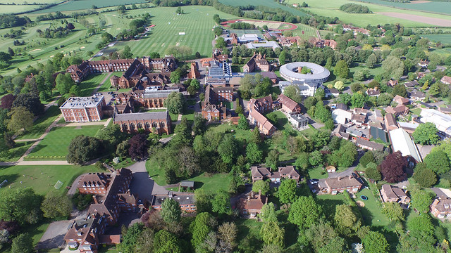

Radley College, Abingdon, Oxon, OX14 2HR
01235 543000
www.radley.org.uk/about-radley/employment

Culture and Background
_______________________________________________

Radley College is an independent boarding school of 690 boys situated five miles south of Oxford. Founded in 1847, the vision was to offer a different education from that offered by most Victorian public schools. A strong emphasis was to be put on the aesthetic and the beauty of the estate and the buildings contribute significantly to the atmosphere. Selective, but not ruthlessly so, the College is proud of its academic achievements both in and beyond the classroom. We care about results in all areas of College life – we believe very much in the pursuit of excellence and have high expectations of ourselves and the boys – but care even more about the development of the character of each Radleian: culturally, emotionally and spiritually.
The hallmark of Radley remains its warmth, generosity and kindness. It is an extraordinarily busy and vibrant place: everyone in Common Room is expected to be fully involved in a wide variety of activities outside the classroom as well as in the pastoral side of the school. Further information about the school may be found on our website.
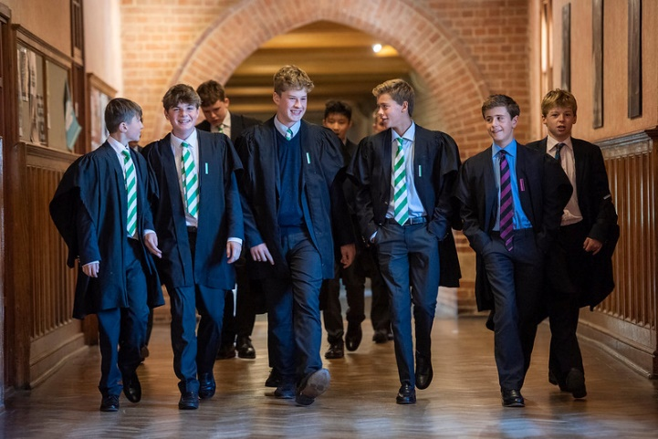

The Department
_______________________________________________
Following the appointment of David Cox as Head of Maths at Eastbourne College, we have an excellent opportunity for a full time teacher of Mathematics to join us from September 2020. Mathematics is extremely strong at Radley. Single Maths is always the most popular choice at A Level, and, currently, Further Maths is the second most popular choice. This year we are running five Further Maths sets in the Lower Sixth, and three in the Upper Sixth. The Maths Department consistently produces some of the best results in the College. At IGCSE (EDEXCEL) we run a policy of accelerated entry with about half the students sitting IGCSE at least one year early. In fact the top set will sit IGCSE five terms early and then go on to sit AS level at the end of the Fifth Form. Others used to sit the OCR freestanding qualification in Additional Maths, but this year we are experimenting with the AQA level 2 qualification in Further Maths. This is a time of challenge and transition, and we are still feeling our way. At Single Maths we fortunately avoided the EDEXCEL muddle, and were pleased to have moved to OCR. We stuck with EDEXCEL for Further Maths, preparing all candidates for CP1, CP2, FS1 and FM1, with the top sets also sitting FM2 and some STEP. This year we are dropping FS1 in favour of FP1.

The strength of the department is that we are a very strong team. At this time of change we pool ideas, make collective decisions, and move forwards together. It will take another year or two before things settle down. But the talent of the group is reflected by how many senior posts around the country are taken by teachers who honed their skills in the Radley Maths Department. As well as Eastbourne, the Heads of Maths at St Edward’s Oxford, The Leys School Cambridge, and Shiplake all came through the department. The current Director of Teaching and Innovation at Wycombe Abbey started at Radley before moving on to Head of Maths at Highgate; the current Deputy Head at Stockport stepped from Radley to Head of Maths at Hampton before his current post. And the current Director of Studies at St Albans High School for Girls progressed from Radley to Head of Maths at Oundle. So we could continue... The Radley Maths Department has a strong reputation for launching talented teachers on their journeys.
The ability to inspire school pupils through a demonstrable love for the subject is essential, as is a willingness to work within a highly motivated, professional and dedicated team. A commitment to maintaining the exceptionally high standards of the department is vital. Radley boys are interested and motivated, so high expectations are essential for them to achieve the full extent of their potential, often beyond their own expectations.
An experienced teacher seeking a move into a strong department will find that there is plenty of opportunity for responsibility and career development. We have also had much success in inducting colleagues who are new to the profession. Thus we also welcome applications from those who are just finishing their studies. Such appointees would start on a reduced teaching load, and would be closely monitored and supported by the Head of Department.

So what are we looking for? Well, as with all good teachers, enthusiasm for the subject is paramount. We would also expect the successful applicant to be good at Maths! As a boarding school, we are looking for someone who is prepared to throw themselves wholeheartedly into the life of the College. Radley is a community and those who get most out of it – whether as boys or as teachers – are those who are prepared to embrace the breadth of the education that Radley offers.

The department is well housed in a modern, light building, and each teacher has their own classroom. Every room has its own computer and projector, and we are starting to experiment with tablets, and I-pads as teaching and learning tools. There is always the flexibility for a teacher to develop his or her own style and run with initiatives. We just want them to do a good job and to enjoy themselves.

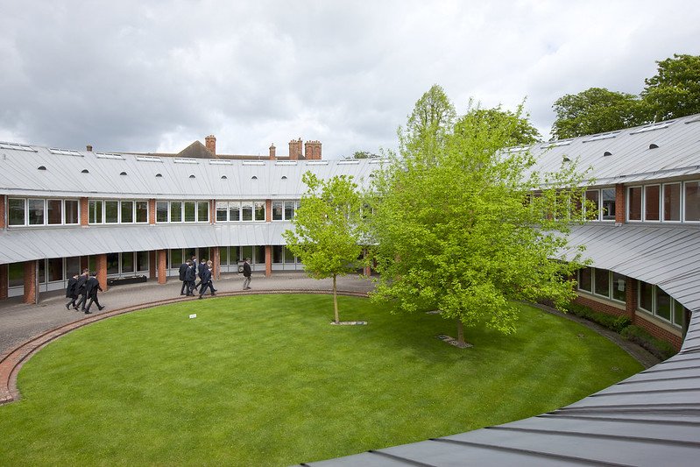
The department is strong at Oxbridge and a number of our best mathematicians go on to Oxford or Cambridge. One member of the department also teaches one afternoon per week in the University. One of the things that really marks us out is the Maths Society. This meets two or three times a term and most meetings are ‘home grown’, so each teacher can research an area of Maths and present it as a talk to the department and the senior boys. This seems to stimulate interest and provide material for discussion – and add to the feeling that we are surrounded by people who like doing sums! There is a real buzz about the department.

A typical load for a fully experienced teacher will be two Lower School sets and four A level classes. For someone new to the profession it will be less. Two teachers share single Maths classes and Further Maths is split three ways.

Safeguarding
_______________________________________________

Radley College is committed to safeguarding and promoting the welfare of its pupils and expects all employees to share this commitment. Employees must, at all times, have regard to the need to safeguard and promote the welfare of children in line with the provisions of the Children Act 2004 (as amended) and Keeping Children Safe in Education (as amended) and be fully aware of, and understand, the duties and responsibilities that apply to their role in relation to these requirements. All employees must attend appropriate training in accordance with College and local Safeguarding Board stipulations. Applicants must be willing to undergo child protection screening appropriate to the post, including checks with past employers and the Disclosure and Barring Service. A disclosure, at the enhanced level, will be requested from the successful applicant but a criminal record will not necessarily be a bar to obtaining this position. S/he will also be required to produce original evidence of qualifications as well as evidence of the right to work in the UK.

Staff Benefits
_______________________________________________

The College has its own generous salary scale and the majority of staff are accommodated on, or a few minutes’ walk away, from the campus. Families are very much part of Radley and the wider benefits are considerable: from the use of superb facilities to the hospitable and inclusive atmosphere which characterises the College community.

How to Apply
_______________________________________________

Applications must be submitted on the official application form which can be downloaded from our website and sent, together with a covering letter explaining your reasons for applying, to The Warden, Radley College, Abingdon, Oxfordshire OX14 2HR or by e-mail to applications@radley.org.uk. If you have questions or would like to discuss the vacancy please email the Head of Department, Garry Wiseman on gw.wiseman@radley.org.uk The closing date for applications is 12 noon Monday 20 January 2020.

SELECTION PROCESS

If shortlisted, you will be invited for interview during the week commencing 27 January. Your interview visit will involve a brief session with our Human Resources department, in order to undertake a number of identity checks. A list of valid identity documents will be sent to you prior to your interview.

In the event of not being successful, please be assured that all copies of identification will be destroyed.

