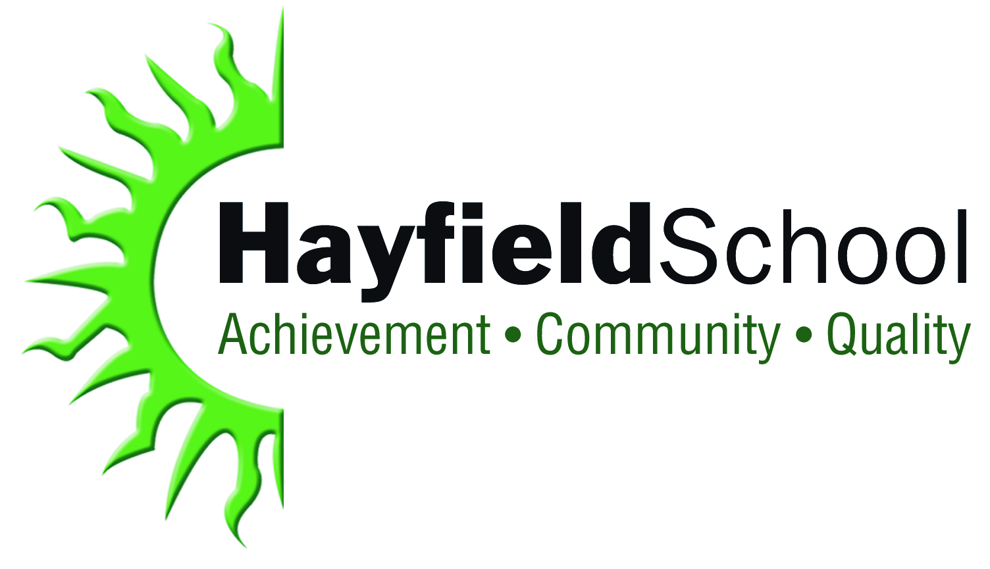

Director of Modern Foreign Languages

Recruitment Information Pack

The Hayfield School, Hurst Lane, Auckley, Doncaster DN9 3HG
Tel: 01302 770589 Fax: 01302 770179
E-mail: office@thehayfieldschool.co.uk Website: www.hayfieldschool.co.uk

Headteacher: Lisa Fox

April 2017

Dear Applicant

Post: Director of Modern Foreign Languages MPS/UPS TLR 9378 (Flexibility and/or R and R for a suitably experienced candidate with a proven track record)

Thank you for your enquiry requesting further details and an application form for the post of Director of Modern Foreign Languages at The Hayfield School. This is an exciting time to join the school and a real opportunity to shape the future of the Modern Foreign Languages Department.

We are looking to appoint a highly experienced Modern Foreign Languages teacher with a “can do” approach and a willingness to go the extra mile. Strong communication skills and emotional intelligence are essential, together with resilience and an ability to work collaboratively. The right person may not be a Head of Department at present but will certainly be on the cusp of it, having a proven track record in leadership within a Modern Foreign Languages Department and the potential to succeed at Middle Leadership. The right person will also fully understand that the leadership of a core subject comes with great pressure but the successful applicant will be fully supported and developed. The successful applicant will have the opportunity to build, shape and develop provision across all Key Stages within the department with a strong focus on teaching and learning to secure outstanding student outcomes.

The Hayfield School provides an extremely positive, high quality and enjoyable learning experience and aims to inspire students to achieve their very best. There is a strong track record of securing high standards of achievement but we refuse to rest on our laurels, always striving to become even better.

Everyone within the school community places great importance on the development of the whole person whether this is a student or a member of staff. The school has a strong ethos and there is a sense of pride among staff and students for the quality of their work together. Leaders at all levels are ambitious and continuously focus on securing improvement. The effective sharing of best practice and high quality CPD opportunities underpin the school’s vision, that we are all part of the learning community. You will be joining an ambitious and innovative school, so we are looking for a highly skilled member of staff who can secure positive outcomes for our learners and the staff they will be leading.

The Hayfield School is committed to safeguarding and promoting the welfare of children and young people and expects all staff and volunteers to share this commitment. The successful applicant will be required to undertake an enhanced criminal record check by the DBS.

If you believe that The Hayfield School can provide the challenges and opportunities you are looking for then please complete an application form online via the TES website. If you would like an informal discussion with the Headteacher or require further information about the role or the opportunity to visit prior to applying please do not hesitate to contact Paula Kynman, HR Manager, pky@thehayfieldschool.co.uk.

Yours faithfully
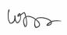
Lisa Fox
Headteacher

The Application Process
Please complete an online application via the TES website.
Applicants should return a completed application form along with a supporting letter of no more than 2 sides of A4 outlining:
- an explanation of how your skills and experience would make you an exceptional candidate for the post of “Director of Modern Foreign Languages” at The Hayfield School.

Closing Date: Monday 24th April 2017 at 9.00 am
Interviews: Thursday 27th April 2017
Queries
If you would like an informal conversation with Lisa Fox, the Headteacher, or if you have any queries on any aspect of the application process or need additional information please contact Mrs P Kynman, HR Manager, on 01302 770589 or e-mail pky@thehayfieldschool.co.uk.

