Higher Level Teaching Assistant (HLTA) – Supporting and delivering learning

Person specification.

1. Experience

1.1 Experience working with children of relevant age in a learning environment

2. Qualifications/Training

2.1 Meet Higher Level Teaching Assistant standards or equivalent qualification or experience
2.2 Excellent numeracy/literacy skills – equivalent to NVQ Level 2 in English and Maths

2.3 Training in relevant learning strategies e.g. literacy

2.4 Specialist skills/training in curriculum or learning area e.g. bi-lingual, sign language, ICT

3. Knowledge, Skills and Abilities

3.1 Can use ICT effectively to support learning

3.2 Full working knowledge of relevant polices/codes of practice/legislation

3.3 Working knowledge and experience of implementing national/foundation stage curriculum and other relevant learning programmes/strategies

3.4 Good understanding of child development and learning processes

3.5 Understanding of statutory frameworks relating to teaching

3.6 Ability to organise, lead and motivate a team

3.7 Constantly improve own practice/knowledge through self-evaluation and learning from others

3.8 Ability to relate well to children and adults

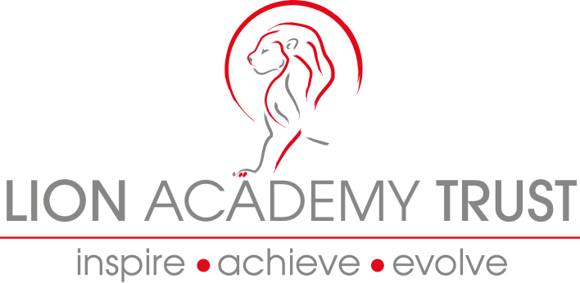
3.9 Work constructively as part of a team, understanding classroom roles and responsibilities and your own position within these

