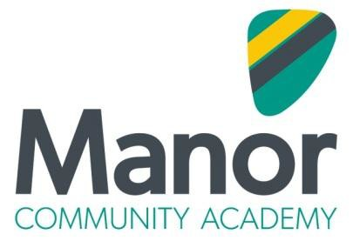

Manor Staff Charter

All staff at Manor Community Academy are committed to the values and ethos of the academy. To promote and maintain these values and ethos staff:

• Actively promote and contribute to the inclusion of all students
• Plan learning experiences which are of a high standard and are tailored to the individual needs of all students
• Demonstrate commitment to the progress and attainment of all students
• Recognise and act upon their role in ensuring the wellbeing, welfare and safety of all students
• Support and promote extra-curricular experiences
• Guide and nurture the social and personal development of students and encourage and reward active citizenship
• Maintain a culture of positivity which celebrates achievement
• Promote a culture of resolution and understanding

To support and enhance the promotion of the academy’s values and ethos, there is a commitment to:

• Promote a professional and collegiate culture amongst all staff
• Provide relevant and appropriate continued professional development and career stage support
• Ensure that effective coaching and mentoring networks are able to support all staff across the academy
• Provide opportunities for action research, project based learning and engagement in academy wide and Trust wide initiatives
• Support and nurture a professional culture of distributed leadership and empowered autonomy
• Recognise and celebrate staff commitment to the academy and its continued improvement

