LINCOLN

Lincoln is a beautiful, fast developing city in the heart of the East Midlands. Lincoln is recognised as one of the world’s great historic cities, attracting hundreds of thousands of visitors each year from all over the world.

With its medieval castle and one of the finest cathedrals in Europe, Lincoln is steeped in history. In 2015 the city was central to the national and international celebrations marking 800 years since the sealing of the Magna Carta.
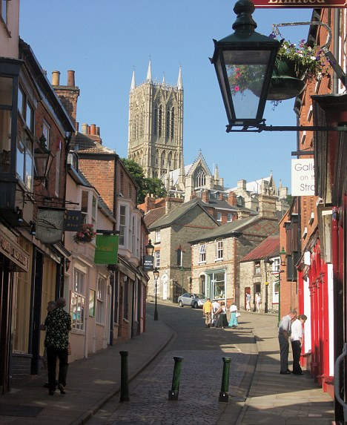

Lincolnshire was named third in the top 20 hottest holiday
Destinations of 2015. Lincoln’s famous cobbled Steep Hill was
Named one of the prettiest streets in Britain by the Daily
Telegraph, having previously been named Britain’s Best Street
2012 by the Academy of Urbanism.

In addition to the historic Quarter of the city, the Brayford Pool area offers a variety of restaurants, cafés and pubs situated next to the picturesque marina in the heart of the thriving city centre, just a few minutes walk from the High Street where there is a wealth of shops, restaurants and entertainment opportunities.

Lincoln is well connected with easy access to Nottingham, Leicester, Hull, Sheffield, Leeds and the A1. There are regular train services to London from Lincoln station and from Newark Northgate which is on the main London to Edinburgh line. In addition, the Lincolnshire Wolds and the delights of the East Coast are both easily accessible.

The establishment of the University of Lincoln has led to many more cultural and entertainment opportunities over the last ten years. There are many live music venues, regular concerts and the Drill Hall along with the Theatre Royal and the Engine Shed host a variety of play, talks and events. Lincoln also plays host to several annual internationally attended events, including the Victorian Christmas Market, the Steam Punk Festival, Comedy Festival, the Lincolnshire Show and many more.

