
ST FAITH’S
CHURCH OF ENGLAND PRIMARY SCHOOL







ADMIN DETAILS
Closing Date for applications:
Wednesday 24th May 2017 at 4:00pm
Interviews: Friday 26th May 2017
Visits: Contact on 020 8874 2653

ST FAITH’S
CHURCH OF ENGLAND PRIMARY SCHOOL
Alma Road, Wandsworth, SW18 1AE

St. Faith’s CE School is a small 1FE school housed in a beautiful, modern building, around twenty years old on the site of the old Victorian school built over 100 years ago. Since 2006 we have continued to develop and improve both the buildings and grounds to create a wonderful learning space for the children. It is fifteen minutes walk from the River Thames and Wandsworth Bridge, in the centre of the cobbled streets of Wandsworth Old Town. The school is a 2 minute walk from Wandsworth Town Station. We are also directly off the A205 (the South Circular). All classrooms open on to a terrace used as a play area. The school also has a play frame on a grassed area and two big hard surface play grounds. The Foundation Stage has its own separate play area.
There is a strong focus on developing a stimulating, light and spacious learning environment, both inside the building and in the grounds.

THE STAFF

The current staffing structure: Headteacher
Deputy Head
Assistant Headteacher
KS2 leader / KS1 leader

These posts make up the Senior Leadership Team

There are 8 class teachers. We also have a full time PPA release teacher and a floating teacher to support the children's learning in the junior classes. In addition there are 12 classroom assistants who work in school supporting work in classrooms and in the Early Years Unit [Nursery and Reception]. There are specialist teachers for French, PE and Art.

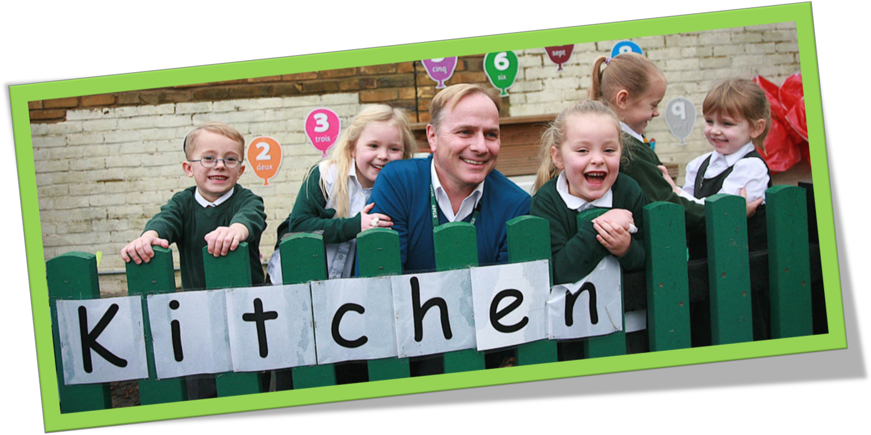

CHILDREN
The school roll is rising and currently 210. As well as children from the immediate residential area of the school (The Tonsleys), many children live in local council estates in the Southside Centre or on East Hill. Some travel from further afield in Tooting and Battersea.
The school is single form entry. The children are grouped in horizontal age classes and are taught mostly through mixed ability teaching.

High standards of behaviour are expected from all pupils and mutual respect and acceptance of one’s neighbour is encouraged. A weekly Family Worship time provides an opportunity for both individual pupils and their classes to share achievements received and acknowledgement for their efforts. We welcome up to 50 parents each week to the Friday worship. There is a welcoming atmosphere of openness in which pupils, parents and staff alike can promote the development of a creative working environment.

THE GOVERNORS
The Governing body consists of the Headteacher, 8 foundation Governors appointed by Southwark Diocesan Board of Education, the deanery synod and the parish council, and 6 representative Governors appointed by the London Borough of Wandsworth or by parents and staff. Senior Teachers often attend as observers.

The Governors are an integral part of the school community and links with the staff and children are encouraged. Each class has ‘adopted’ a Governor who visits the class, perhaps working with children, and generally seeks to arrive at an informed understanding about the school context. There are governors linked to particular areas of the School Development Plan.

THE PARISH
The Headteacher has worked successfully over the past eleven years to develop and support the Christian ethos of the school and develop links with the local area. Parents attend Worship each Friday morning. The school celebrates Harvest, Christmas and Easter at St Anne’s Church and Fr Gordon is a regular visitor at school.

PARENTAL INVOLVEMENT
Parents are kept informed of all events in school through the school newsletter published weekly, the website and text messaging. Parents are welcome at the school and are encouraged to help out in class, on school trips and for swimming. All parents that volunteer in the school are DBS cleared. The school is always looking for new opportunities to strengthen links with parents. There is a PTA that is very active in organising and running additional activities and fund raising events. Staff are available at the end of every day for informal chats with parents but they are encouraged to make appointments to discuss more important matters.

SAFEGUARDING
At St Faith’s we are committed to safeguarding and promoting the welfare of children and expect all staff and volunteers to share this commitment. The Child Protection, Safeguarding, and Safer Recruitment policies are on the school website for you to read.

We would ask applicants to note the following information:
- Applicants must complete the Wandsworth application form.
- When writing the statement in support of your application, please ensure that you have addressed all the points in the selection criteria in the order given. You must clearly demonstrate how you meet each of these criteria. Please give personal examples of your experience and skills to support the points.
- It is important to remember that your application form and personal statement is the basis upon which you are selected for interview.
- To further our commitment to safeguarding we will ask candidates to address any discrepancies, anomalies or gaps in their application form.
- Please provide email addresses and all telephone contact numbers for all your referees we will need to make immediate contact after shortlisting.

We look forward to hearing from you and welcoming you to St Faith’s CE School.








