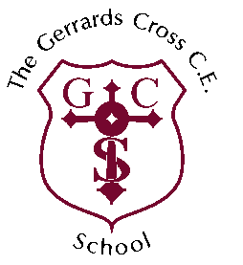
THE GERRARDS CROSS CE SCHOOL

CLASSTEACHER - Person Specification

Qualifications and training:
Essential | - Qualified teacher status  - Degree or equivalent  - Commitment to continuing professional development
Teaching:
Essential | - Excellent classroom practitioner  - Commitment to ensure that all children have access to effective, engaging and inspiring teaching and learning  - Commitment to raising achievement for all children through a broad, balanced and creative curriculum  - Ability to plan, organise and manage the teaching and learning of a class  - An understanding of an effective learning environment and the ability to create one for children of all abilities  - Ability to use ICT confidently and effectively to enhance learning  - Ability to assess the progress of children and differentiate effectively  - High standards and expectations for all in work and behaviour  - Ability to develop positive relationships with pupils, colleagues, parents and governors and to work well as part of a team  - Commitment to providing equal opportunities for all children in both curriculum and pastoral care  - Sympathy towards the ethos of a Church of England school.
Professional skills and attributes:
Essential | - Excellent communication and interpersonal skills  - Willingness to listen and be responsive to advice and support  - Commitment to an ethos of high standards, personal fulfilment and academic success  - Ability to be a team player  - Ability to plan time effectively, manage workload and meet deadlines
Personal qualities:
Essential | - Personal integrity, warmth and sensitivity  - Personal confidence  - Ability to relate well to others and to build positive relationships  - Flexibility and open mindedness,  - Enthusiasm and sense of humour

