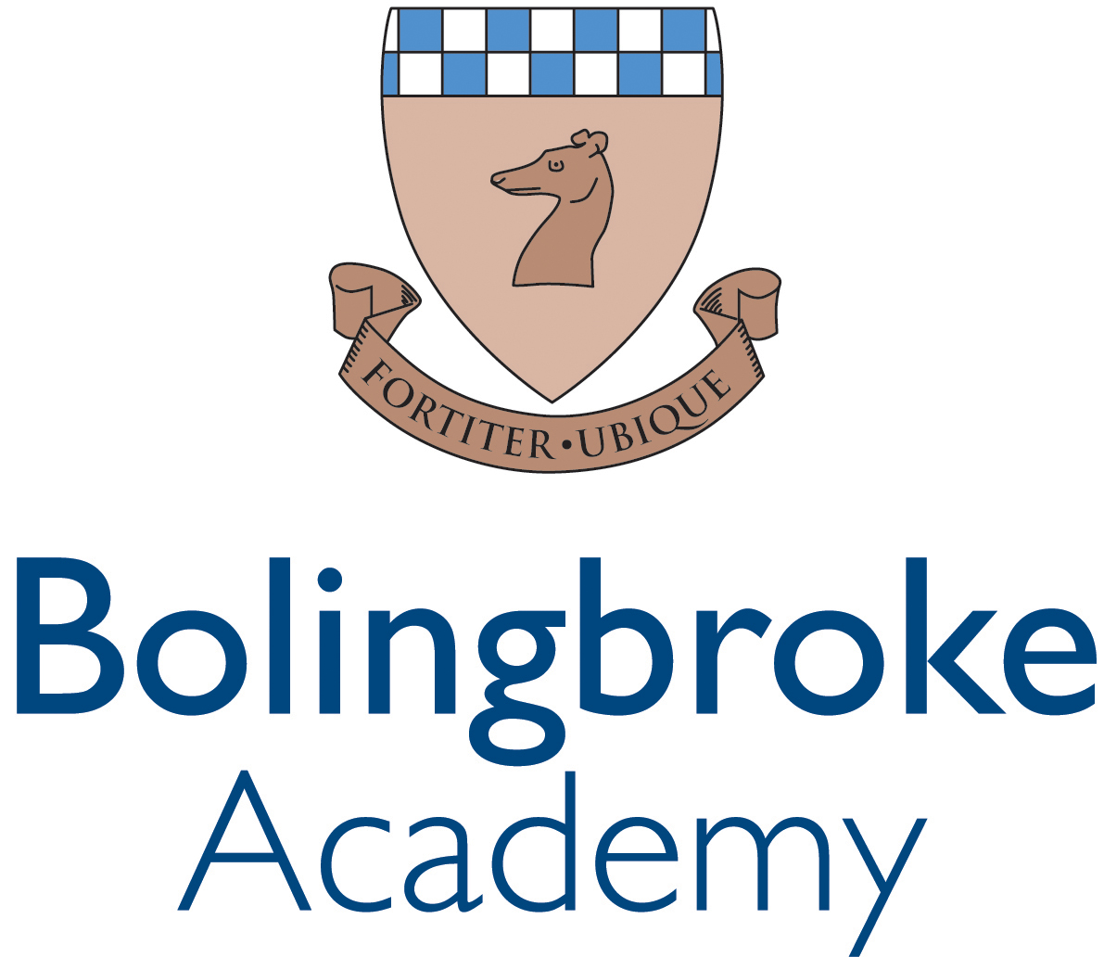
Teacher of Science

This is an exciting opportunity for a Teacher of Science to join our growing academy.

Bolingbroke Academy, a secondary school for 11-18 year olds, welcomed its first Year 7 pupils in September 2012, with another 120 pupils joining every year until the school is fully subscribed in 2018. Bolingbroke Academy provides a first class learning environment based on outstanding teaching, great relationships and excellent facilities. This is an exciting time in our school’s development as we await our first GCSE results and prepare for our first Sixth Form cohort in September 2017.

We are looking to recruit a motivated and inspiring Teacher of Science to join our successful Science department from September 2017. The successful applicant will be a strong and engaging teacher who will join a team of teachers committed to delivering outstanding teaching and learning that supports all pupils to achieve their full potential. This role would equally suit a strong NQT or an experienced practitioner.

Our ideal candidate will:
- be QTS qualified by the start date;
- be passionate about their subject and a committed team player;
- be able to teach Science at Key Stages 3 and 4 (Key Stage 5 would be advantageous);
- be able to motivate and inspire pupils;
- have the resolve to make a real difference to the lives of Bolingbroke Academy’s pupils;
- be committed to Bolingbroke Academy’s ethos of high expectations.

In return we offer the opportunity to:
- teach within a growing academy;
- join a network of ARK schools and gain access to an exclusive range of benefits, including reduced gym membership and a comprehensive CPD provision.

Please apply at https://goo.gl/q9vM3A by 11am on Thursday 22nd June 2017.

Applications are reviewed on an ongoing basis, therefore early application is advised. Strong candidates may be invited to interview prior to role’s closing date.

For any queries relating to your application, please contact the recruitment team on recruitment@arkonline.org or 020 3116 6345.

Location: Wandsworth, London
Start date: September 2017
Deadline: 11am on Thursday 22nd June 2017
Interviews: To be held week commencing 26th June 2017
Salary: Ark MPS (£28,799 - £39,195) or UPS (£44,261 - £47,998) (Inner London), depending on experience

Ark value diversity and are committed to safeguarding and promoting child welfare. The successful candidate will be subject to an enhanced DBS check and any other relevant employment checks.

Job Description: Teacher of Science
Reports to: Head of Science and/or Lead Chemistry/Physics Teacher
Start date: September 2017
Salary: Ark MPS (£28,799 - £39,195) or UPS (£44,261 - £47,998) (Inner London), depending on experience

The Role
- Deliver outstanding teaching and learning of Science thereby enabling pupils to achieve excellent results.
- Help design an engaging and challenging curriculum that inspires pupils to appreciate Science and its application.
- Help secure outstanding pupil progress in Science,
- To collaborate effectively with other members of the department to secure outstanding practice.

Key Responsibilities
- Plan and prepare effective teaching modules and lessons using the academy templates.
- Teach engaging and effective lessons that motivate, inspire and improve pupil attainment.
- Use regular assessments to set targets for pupils, monitor pupil progress and respond accordingly to the results of such monitoring.
- To produce and/or contribute to oral and written assessments, reports and references relating to individual and groups of pupils.
- Ensure that all students achieve at chronological age level or, if well below level, make significant and continuing progress towards achieving at level.
- Maintain regular and productive communication with parents, to report on progress, sanctions and rewards and all other communications.
- Direct and supervise support staff assigned to lessons.
- Implement and adhere to the academy’s behaviour management policy, ensuring the health and well-being of pupils is maintained at all times.
- Participate in preparing pupils for external examinations.
- Keep abreast of developments in the subject area at each Key Stage.
- Mark, assess and provide feedback in line with best practice and academy policy at all times.
- Assist with a range of enrichment and extension activities, as well as departmental trips and visits.
- Work effectively with the Science team to ensure that the quality of the Teaching and Learning in Science remains at its highest level.
- Assist in the induction of new staff as appropriate.

Academy Culture
- Support the academy’s values and ethos by contributing to the development and implementation of policies practices and procedures.

- Help create a strong academy community, characterised by consistent, orderly behaviour and caring, respectful relationships.
- Help develop a school/department culture and ethos that is utterly committed to achievement.
- Help maintain discipline across the whole academy.
- Be active in issues of pupil welfare and support.
- Run at least one extra-curricular activity weekly.
- Be committed to equality of opportunity and the safeguarding and welfare of all pupils.

Other
- Undertake, and when required deliver or be part of, appraisals and relevant professional development.
- Perform additional duties and tasks required for the effective operation of the school and as directed by the Head of Department or Principal.

Person Specification: Teacher of Science

Qualification Criteria
- Appropriate degree.
- Qualified to teach and work in the UK.

Skills and Attributes

- A commitment to teaching Science at Key Stages 3-5.
- Excellent classroom teacher, or potential to be one, with the ability to reflect on lessons and continually improve own practice.
- The ability to understand and interpret pupil data to drive lesson planning and pupil attainment.
- The ability to plan and prepare engaging and differentiated lessons.
- Up to date knowledge of the curriculum area.
- Effective and systematic behaviour management, with clear boundaries, sanctions, praise and rewards.
- The ability to work as part of an effective team.
- Genuine passion and a belief in the potential of every pupil.
- Strong communication, planning and organisational skills.
- Vision aligned with ARK’s high aspirations, high expectations of self and others.
- A motivation to continually improve standards and achieve excellence.
- Commitment to regular and on-going professional development and training to establish outstanding classroom practice.

Other
- Commitment to equality of opportunity and the safeguarding and welfare of all pupils.
- Willingness to undertake training.
- This post is subject to an enhanced Disclosure & Barring Service check.

Ark is committed to safeguarding and promoting the welfare of children and young people in our academies. In order to meet this responsibility, we follow a rigorous selection process. This process is outlined here, but can be provided in more detail if requested. All successful candidates will be subject to an enhanced Disclosure and Barring Service check.

