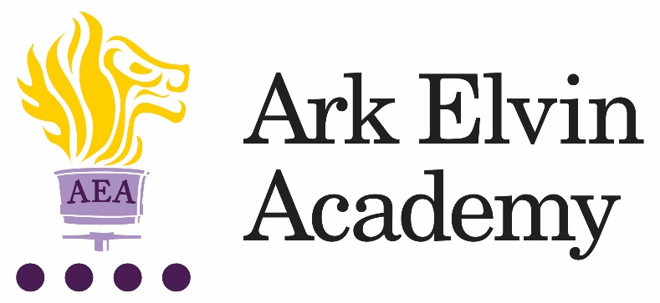

English Teacher

At Ark Elvin Academy we are working hard to give all our pupils an excellent education and are looking for committed teachers and support staff to join us at this exciting stage in our school improvement journey. We are a large, non-selective secondary school in the London Borough of Brent, with excellent transport links to central London. We are committed to ensuring teachers can focus on teaching and have the opportunity to refine and develop their practice in the classroom and develop their leadership skills. Our new building works are underway and will be ready in December 2017, follow this link to find out more about our new building.
In recruiting for the English Teacher role we are seeking the following from applicants:
- A degree in English and good A levels, or the equivalent.
- A commitment to our school improvement process
- A growth mindset
- High standards of professionalism
- Courteousness
- Record of high quality teaching
You will become a part of a close knit professional community of enthusiastic teachers and benefit from guidance and support of experts from the Ark network, one of the country’s top performing school groups.
We encourage and welcome you to visit our school; to arrange a visit, please contact Venessa George on v.george@arkelvinacademy.org or 020 8902 6362.
For any technical queries about submitting your application, please contact the recruitment team on 0203 116 6345 or recruitment@arkonline.org
To apply for the role, go to https://goo.gl/UaRHxE and complete the online application by 11am, Friday 23rd June 2017.
Closing Date: 11am, Friday 23rd June 2017.
Location Brent, London
Start date: September 2017
Salary: Ark MPS/UPS (Inner London) £28,799 - £47,998 (depending on experience)

Ark is committed to safeguarding children; successful candidates will be subject to an enhanced DBS

Job Description: English Teacher
Reporting to: Head of English
Key responsibilities:
- To plan, resource and deliver lessons and sequences of lessons to the highest standard, thereby ensuring meaningful learning takes place and pupils make rapid and sustained progress
- To develop one’s own teaching practice to a level of advanced proficiency
- To fully implement all academy routines and techniques for creating a culture of high expectations
- To contribute to the enrichment, extra-curricular and raising aspirations programmes
- To provide daily pastoral tutoring to a form group
- To contribute to the effective daily working of the academy.
Outcomes and Activities:
Teaching and Learning
- With direction from the Head of Department and within the context of the academy’s curriculum and schemes of work, to plan and prepare effective teaching schemes and lessons
- To teach engaging and effective lessons that motivate, inspire and improve pupil attainment
- To use regular assessments to set targets for pupils, monitor pupil progress and respond accordingly to the results of such monitoring
- To produce/contribute to oral and written assessments, reports and references relating to individual and groups of pupils
- To develop plans and processes for the classroom with measurable results and evaluate those results to make improvements in pupil achievement
- To ensure that all pupils achieve at least expected progress and the majority of pupils make more than expected progress
- To maintain regular and productive communication with pupils, parents and carers, to report on progress, sanctions and rewards and all other communications
- To provide or contribute to oral and written assessments, reports and references relating to individual pupils and groups of pupils
- To direct and supervise support staff assigned to lessons and when required participate in related recruitment and selection activities
- To implement and adhere to the academies behaviour management policy, ensuring the health and well-being of pupils is maintained at all times
- To participate in preparing pupils for external examinations.
Academy Culture
- To support the academy’s values and ethos by contributing to the development and implementation of policies, practices and procedures
- To help create a strong academy community, characterised by consistent, orderly behaviour and caring, respectful relationships
- To help develop a school/department culture and ethos that is utterly committed to achievement and good discipline
- To be alert and active on issues relating to pupil welfare and child protection
- To support and work in collaboration with colleagues and other professionals in and beyond the school, covering lessons and providing other support as required.
Other
- To undertake , and when required, deliver or be part of the appraisal system and relevant training and professional development
- To undertake, within reason, other various responsibilities as directed by the Head of Department or Principal.

Person Specification: English Teacher
Qualification Criteria
- Qualified to at least degree level in English
- Qualified to teach and work in the UK

Experience
- Evidence of being, or having the potential to be, an outstanding teacher of the subject.

Knowledge
- Up to date knowledge in the curriculum area
- An understanding of what an outstanding education looks like in the classroom
- An understanding of the strategies needed to establish consistently high expectations

Behaviours
Leadership
- Effective team worker
- High expectations for accountability and consistency
- Vision aligned with Ark’s high aspirations, high expectations of self and others
- Genuine passion and a belief in the potential of every pupil
- Motivation to continually improve standards and achieve excellence
- Effective listening skills that lead to a strong understanding of others
- Commitment to the safeguarding and welfare of all pupils.
Teaching and Learning
- Excellent classroom teacher, or potential to be one, with the ability to reflect on lessons and continually improve their own practice
- Effective and systematic behaviour management, with clear boundaries, sanctions, praise and rewards
- Thinks strategically about classroom practice and tailoring lessons to pupils' needs
- Understands and interprets complex pupil data to drive lesson planning and pupil attainment
- Good communication, planning and organisational skills
- Demonstrates resilience, motivation and commitment to driving up standards of achievement
- Acts as a role model to staff and pupils
- Commitment to regular and on-going professional development and training to establish outstanding classroom practice.
Other
- Commitment to equality of opportunity and the safeguarding and welfare of all pupils
- Willingness to undertake training
- This post is subject to an enhanced Disclosure & Barring Service check.

Ark is committed to safeguarding and promoting the welfare of children and young people in our academies. In order to meet this responsibility, we follow a rigorous selection process. This process is outlined here, but can be provided in more detail if requested. All successful candidates will be subject to an enhanced Disclosure and Barring Service check.

