ST THOMAS A BECKET CHURCH OF ENGLAND
VOLUNTARY AIDED PRIMARY SCHOOL

‘A small school with a big heart’

Headteacher Application Pack

August 2017

WELCOME FROM THE CHAIR OF GOVERNORS

Dear Applicant,

On behalf of the Governing Body, I should like to thank you for your interest in the post of Headteacher of St Thomas à Becket Church of England Voluntary Aided Primary School.

The School has a strong family atmosphere with 70 pupils on roll which includes our nursery. Our numbers are stable.

Pupils are pleasant, very well behaved and confident, whilst the parents are very proud to be associated with our school and respectful of the considerable professional expertise of the staff. The Governing Body is supportive; Wiltshire County is a large, proactive, positive Local Authority, rich in expertise and the Diocese is also a supportive advocate.

As Head of a Church of England school, it is expected the successful candidate will embrace a positive, Christian ethos in all aspects of school life and will lead Christian Collective Worship. It is also important the successful candidate has the enthusiasm, can-do flexibility and interpersonal skills that are needed in a small school.

Standards at St Thomas à Becket Primary School are high and the school is widely acknowledged to be very successful within the local area, by Ofsted and SIAMs, both of which rated us as Good in 2016. There is, however, plenty of scope for further development and the successful candidate will find the school a most rewarding place in which to work.

Whether or not you decide to apply for this post, I should like to thank you for your interest and to wish you well in your career.

Yours sincerely

Gillian Murray
Chair of Governors

INTRODUCTION

St Thomas à Becket Church of England (Aided) Primary School is located in the village of Tilshead which sits in a delightful rural location in the heart of Salisbury Plain in Wiltshire.

The School was founded in 1874. According to our Trust Deed, the school came into being as “a school for the education of poor persons of and in the parish of Tilshead and Chitterne in religious and useful knowledge”.

Our school is a small but vibrant community. The boys and girls are great. There are three classes - Choughs, Kestrels and Skylarks and we also have Robins, our nursery. The school currently has 70 pupils on the roll ranging from 2-11 years in age. We have low numbers of SEND and Pupil Premium children. Children aged over 11 years from Tilshead have been going to secondary education at nearby Market Lavington.

St Thomas à Becket School employs a great team and standards are high.

We are proud of our academic achievement. In 2016, Ofsted and SIAMS rated us overall as Good. However, neither the governing body nor the staff team are complacent and recognise there is always scope for further development particularly in the current climate of transformational educational change.

We currently run a small number of after-school clubs, for which parents are charged a small fee. The clubs vary throughout the year and to date have included cookery, sports, archaeology, WII and design technology activities.

The school footprint itself is relatively small. Classrooms are split across 2 buildings and there is a separate Nursery. There is a separate office for the Headteacher, a Reception/Administration Office and a communal staff room. The pupils do have the use of a small playing field and playground, and there is a separate sports field which the school leases.

Our parents are supportive with an active PTA.

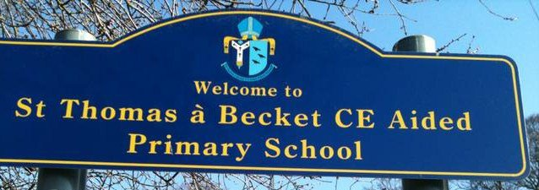
LOCAL AREA

Tilshead is a rural village situated 15.3 miles north of the city of Salisbury in Wiltshire. The village benefits from being in the beautiful country side in the heart of Salisbury Plain, approximately midway between the villages of Shrewton and Market Lavington and 5.3 miles from Stonehenge, a world heritage site. The area is a popular location for those working in the bigger towns surrounding the area, and for those serving in the British Army.
The main road is the A360 which runs through the centre of the village. The nearest train stations (Warminster, Westbury, Pewsey and Salisbury) are all within 30 minutes travelling time and operated by Great Western Railway providing direct links to London as well as allowing you to venture across Wiltshire into Wales and Oxfordshire.
Local amenities include St Thomas à Becket Church which is situated next door to the school, a petrol station with convenience store, a village hall and a public house. However, a short car or bus journey can take you to Salisbury, Devizes, Bath and many other local Wiltshire towns.

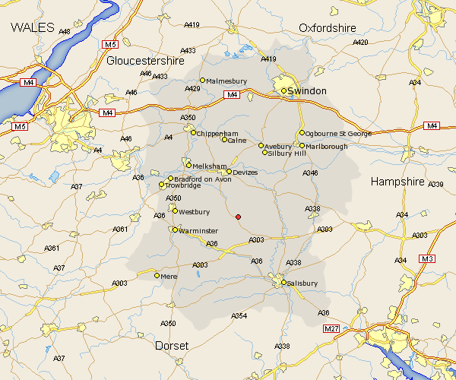

SCHOOL ETHOS AND VALUES

We value our school as a source of knowledge and skills.

We aim:

- to provide a welcoming and purposeful environment in which children can learn in an enthusiastic and secure atmosphere;

- to deliver a rich and diverse curriculum to best develop pupils’ intellectual, physical and aesthetic abilities;

- to instil in children, the highest expectations of effort, behaviour and achievement.

Each person is valued for their individual abilities and respected for the unique contributions they make.

We aim:

- to generate and develop confidence and self-esteem in each child;

- to engender an inquisitive nature and an intrinsic desire to learn throughout life;

- to offer every child equal access to the curriculum and the full range of school activities;

- to ensure the staff feel valued and supported.

We value our close links with the Church.

We aim:

- to stimulate children to become spiritually aware and to
develop moral values;

- to provide pastoral care and embody a Christian ethos that values and respects other faiths.

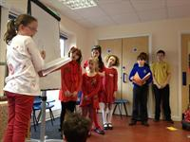
We value our role in the community.

We aim:

- to promote responsible citizenship, and an awareness of community needs, and the contribution we can make to society;

- to celebrate cultural diversity, value the opinions of others and foster tolerance;

- to encourage teamwork and co-operation through learning opportunities.
ABOUT THE SCHOOL

Below you will find some useful links which further information about the school.
Ofsted: Good (inspection date 22 June 2016)
A link to the report can be found here: https://reports.ofsted.gov.uk/inspection-reports/find-inspection-report/provider/ELS/126416
SIAMS: Outstanding (inspection date 9 June 2016)
A link to the report can be found here:
https://www.churchofengland.org/pdf/schoolreports/2015_2016/Salisbury_St%20Thomas%20a%20Becket_09.06.16_126416.pdf
SATs results (2016)
A link to the report can be found here:
https://www.compare-school-performance.service.gov.uk/school/126416
Staffing:

4 x Teaching staff including the Headteacher (2 full-time and a job-share). The Headteacher is required to teach for 0.4FTE of their time.

4 x Teaching Assistants

MDSAS x 2 (one is a Teaching Assistant and we have a volunteer on Fridays)
1 x Admin / Finance Officer
1 x supervisor for the After-School Clubs – these are run if sufficient interest and is not regular afterschool care
Catering and cleaning services are outsourced
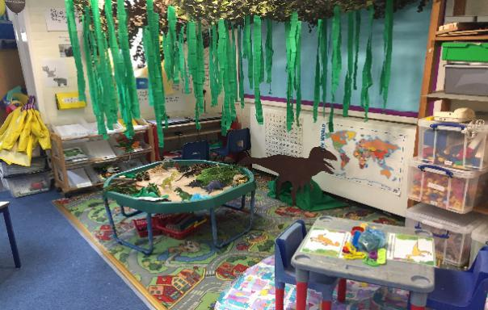
THE SUCCESSFUL APPLICANT

This vacancy has arisen due the current Head moving on to pastures new as part of her career progression. She has very successfully been in post for six years and with the school for thirteen. The school has valued her tenure and is keen to recruit a Headteacher who will also leave a long-term legacy.

Whilst every school feels they are ‘special’, this is a deeply held belief at St Thomas à Becket by the staff, children, parents and governors.  An active parent body contributes with dedication and passion to all school activities and sets high standards for the school.  The changes in funding have impacted the school and the school is currently exploring new funding avenues. | 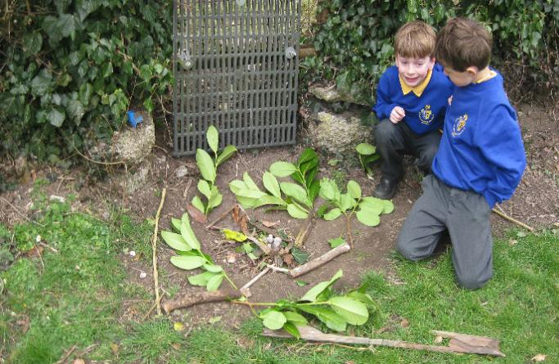
The successful candidate will need to lead the school through these situations and challenges, and plan for its sustainable future, whilst also embodying the school’s values and leading in a manner which is in keeping with them.

Job Description

This job description is subject to the general conditions of service for a Headteacher as set out in the current School Teachers’ Pay and Conditions document.

This post includes a requirement for the jobholder to teach (0.4FTE).

Responsible to: Governing Body, Wiltshire Local Authority and the Diocese of Salisbury.

Responsible for: All staff, pupils and visitors to the school
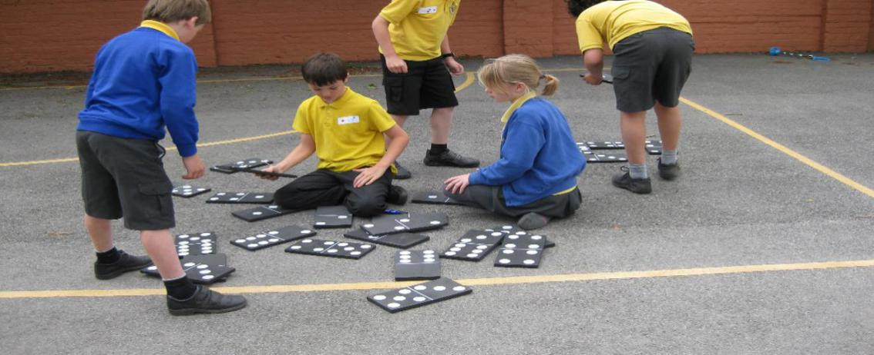
THE SUCCESSFUL APPLICANT

Duties and Responsibilities

Strategic direction and development of the school

The Headteacher will:

- promote the Christian ethos of the school in keeping with its religious character and to work in partnership with the church at Parish and Diocesan level

- work with the governing body to develop a strategic view for the school in its community and analyse and plan, for the future needs and further development and sustainability of the school

- provide vision and direction to secure effective teaching, successful learning and achievement by pupils and sustained improvement in their spiritual, moral, cultural and physical development to prepare them for the opportunities, responsibilities and experiences of later life

- enable the governing body to challenge and support the school effectively so weaknesses are tackled decisively and statutory responsibilities are met, by providing timely, relevant information on:
- progress against School Development Plan
- pupil attainment, progress, achievement and quality of teaching and learning
- action arising from any recent audits
- child safeguarding, bullying, exclusions, and attendance
- such other matters as the governing body needs to be informed about in order to be effective
- propose a balanced budget that meets the needs and addresses the priorities within the School Development Plan

- ensure creativity, continuous improvement and the use of appropriate technologies to achieve excellence and a broad curriculum, equipping pupils well for their next stage of education and moving towards achievement of Outstanding

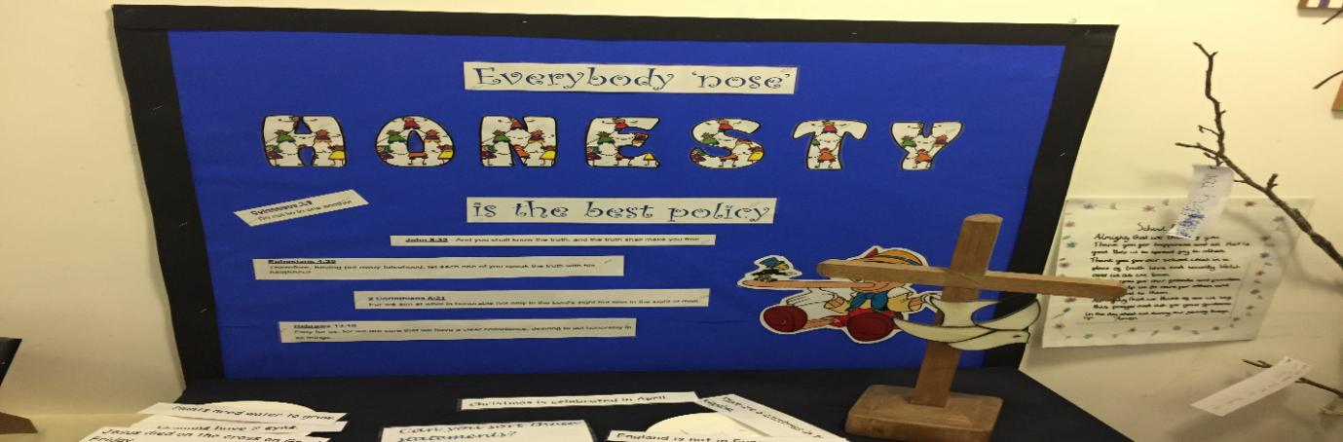
THE SUCCESSFUL APPLICANT

- plan, allocate, support and evaluate the work undertaken by all staff ensuring clear and appropriate delegation of tasks and devolution of responsibilities

- work closely with the team to ensure the smooth running of the school

- put in place effective means of communication with staff that provides them with the information needed to support them in carrying out their duties effectively

- implement and sustain effective systems for the management of staff performance

- be responsible for leading the staff performance appraisal process ensuring it is balanced and robust

Leading and Managing the School

The Headteacher will:

- be able to balance excellent management with a teaching commitment (0.4FTE).  - work with governors and colleagues to recruit staff of the highest quality  - deploy and develop all staff effectively to maintain the highest quality of education  - manage and organise the premises efficiently and effectively to ensure they meet the needs of the curriculum and health and safety regulations  - undertake responsibilities as defined in the school’s Health and Safety Policy and/or the LA’s Health and Safety Policy  - ensure appropriate risk assessments are undertaken before sanctioning and participating in any potentially hazardous activity  - Apply a ‘Can-do’ approach to resolving local issues | 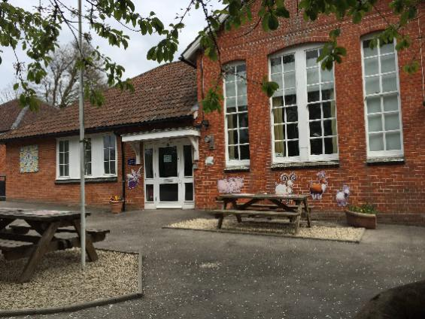
 | 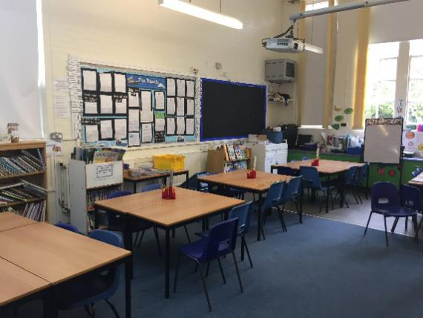
THE SUCCESSFUL APPLICANT

Accountability

The Headteacher will:

- provide information, objective advice and support to the governing body to enable it to meet its responsibilities for securing effective teaching and learning and improved standards of achievement and for achieving efficiency and value for money

- attend meetings and report to the governing body on the discharge of the Headteacher’s functions and the affairs of the school

- continue to develop a school in which all governors and staff recognise they are accountable for its success

- ensure parents are well informed about the curriculum, attainment and progress and about the contribution they can make to achieving the school’s targets

Community

The Headteacher will:

- be the external face of the school to our community, ensuring good communication between the school and everyone with whom we work  - build a school culture and curriculum which nurtures relationships with the community through effective communication  - maintain an outward-looking perspective through creating learning experiences for pupils with the wider community, locally, nationally and internationally | 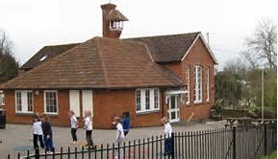

THE SUCCESSFUL APPLICANT

Safeguarding children and safer recruitment

This school is committed to safeguarding and promoting the welfare of children and young people as required under the Education Act 2002 and expects all staff and volunteers to share this commitment. The Headteacher plays the lead role in this within the school and the Headteacher post is subject to enhanced CRB disclosure.

The Headteacher will ensure:

- the policies and procedures relating to safeguarding and safer recruitment are adopted by the Governing Body and are fully implemented and followed by all staff

- sufficient resources and time are allocated to enable the designated person and other staff to discharge their responsibilities in relation to safeguarding, including taking part in strategy discussions and other inter-agency meetings, and contributing to the assessment of children

- all staff and volunteers feel able to raise concerns about poor and unsafe practice in regard to children and that such concerns are addressed sensitively and effectively in a timely manner in accordance with agreed whistle-blowing policies

Personal Specification

The following is a summary of some of the main attributes the Governing Body would wish to see in the successful candidate for Headteacher. Generic Qualifications, knowledge, experience, skills and qualities needed to fulfil this role are set out in the ‘National Standards for Headteachers’ (DfES/0083/2004) to which candidates should refer. It is downloadable from www.teachnet.gov.uk/publications

Qualifications and Training

- Qualified Teacher status

- Existing Head or Readiness for Headship (NPQH or evidence of equivalent level of learning achieved through senior leadership role within a school.

- Successful teaching experience in the primary phase.

- Recent and relevant in-service professional development and training including Safeguarding.

- Ability to support, maintain and develop the Christian ethos of the school.
THE SUCCESSFUL APPLICANT

Experience, Knowledge and Skills

You will be required to evidence:

- Your suitability to work with children and the ability to protect them and promote their welfare.

- Experience of successful school leadership in a senior role including evidence of bringing about school improvement.

- Experience of using whole school self-evaluation (e.g. lesson observations, work scrutinies, data analysis) to raise standards and bring about school improvement.

- Awareness and understanding of the current Ofsted and SIAMs processes and framework

- Understanding of the Headteacher’s responsibilities and accountability to pupils, governors, parents, LA, Diocese and the wider community.

- Your ability to develop a curriculum which promotes pupils’ spiritual, moral, social, cultural, academic creative and physical development and well-being.

- Your ability to build effective relationships with all members of the school community, leading by example and coaching others to bring about improvements.

- Your ability to articulate and communicate a strategic vision for the future development and sustainability of St Thomas à Becket Voluntary Aided Primary School as a distinctive and effective church school and a commitment to upholding and developing its values.

- Successful experience of using performance management along with the professional development of all staff to bring about school improvement.

- You have the confidence and ability to lead collective worship appropriate to the category of the school (1944 Education Act).

- Successful experience of setting and managing budgets to support sustainability and school improvement.

- Ability to secure good, transparent governance working with the Governing Body

- An understanding of how to develop an inclusive school.

- Evidence of partnership working.
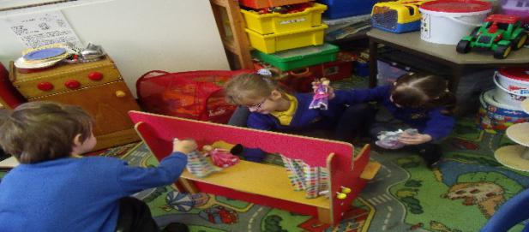
THE SUCCESSFUL APPLICANT

Personal Attributes

You will demonstrate a number of personal attributes we see as critical to the success of the role:

- Commitment to lead our school community with pride, passion and energy, demonstrating strong Christian values and a wide-ranging view of the Headteacher role that extends beyond the school.

- The ability to inspire trust and commitment from the whole school community

- A love of education at grass roots level.

- Puts quality of education at the heart of decision making.

Ability to create, inspire and promote a culture of high achievement for all.

- Recognise fallibility in self and others and see it as a learning opportunity, mistakes are to be recognised as inevitable.

- Demonstrate commitment to own CPD as well as that of others.

- Have a sense of humour.

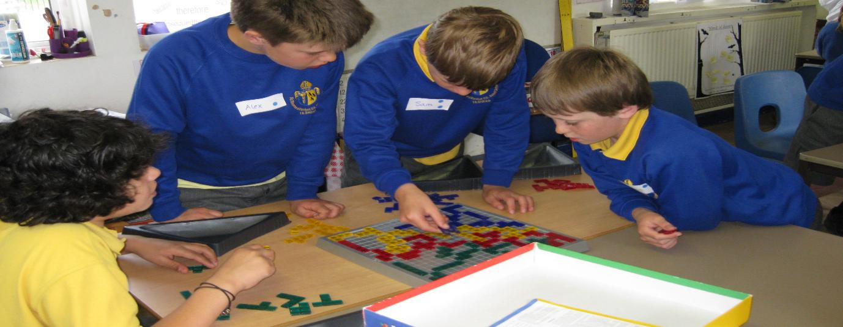

JOB ADVERTISEMENT

Headteacher
Salary: L6 - L12 / Start Date: January 2018

AN EXCITING OPPORTUNITY IN A TIME OF CHANGE!
The Governing Body of St Thomas à Becket Church of England (Aided) Primary School is seeking to appoint a special person to lead our friendly and successful village school from January 2018.
This is an exciting opportunity for an existing or aspiring head teacher to build on the strengths of the school. We are seeking an inspiring, motivated and dedicated leader who is passionate about teaching, learning and developing the full potential of our children.
In 2016, Ofsted described us as ‘a very small school, with a big heart’ and rated us as Good overall. We were also rated Good in our SIAMS Inspection. We are very proud of these achievements. We are equally proud of our outstanding staff and enthusiastic, active parents who all contribute to create a vibrant inclusive community where every child is nurtured in a caring Christian environment to meet their full potential.
The school is located in the village of Tilshead which sits in a delightful rural location in the heart of Salisbury Plain in Wiltshire.

We are looking for an inspirational Headteacher to lead our vision and build on the exceptional work that has already been done, to take St Thomas à Becket Primary School onwards to Outstanding and to develop greater sustainability for the future. You will be able to demonstrate resilience, creativity and passion, and you will be positively supported by governors, staff, and parents, to empower our children to become independent, resilient, lifelong learners.
The school offers a caring, family environment with small classes whilst providing an excellent education for all our children. We currently have 70 children on roll, aged from 2 - 11 years. Our nursery has been part of the school since 2015 and aids the children in their transition into primary school.
The St Thomas à Becket Primary School family is a wonderful mix of children and parents from the local area, so as our new Headteacher you will continue to prioritise our caring and inclusive ethos, strongly underpinned by our Christian values. The school has very strong community links, and a close partnership with the St Thomas à Becket Church community, which we expect to be maintained.
St Thomas à Becket Primary School is an active member of the Emanuel Collaborative Partnership, a group of 6 local schools, which is working together to create a positive impact on the member schools through sharing of best practice and resources.

JOB ADVERTISEMENT

We are searching for an individual who will:

- Bring vision, leadership and strategic direction for the continued improvement of our Church school.

- Be innovative and creative, seeking novel solutions to achieve outstanding outcomes.

- Relish the challenges in leading a small rural school.

In return, we can offer you:
- A shared passion for our school and its journey into the future.

- Children and adults who are brimming with enthusiasm; confident, ready and willing to share in their learning.

- The uniqueness of a vibrant village community which actively supports our school.

Application and Selection Process
School visits
Visits to the school are encouraged and can be arranged post 1 September 2017 by contacting Mrs Fran Langston, Administration and Finance Officer:
Telephone:- 01980 620435
Email:- admin@st-thomas-a-becket.wilts.sch.uk

Information:
Please see the Candidate Information Pack for full details.
For more information about the school please visit our school website:
http://www.st-thomas-a-becket.wilts.sch.uk/

JOB ADVERTISEMENT

Safeguarding
The school is committed to safeguarding and promoting the welfare of children and expects all staff and volunteers to share this commitment. We will ensure that all our recruitment and selection practices reflect this commitment. This post is subject to an enhanced Disclosure and Barring Service (DRB) check. Reference checks will also be performed prior to interview.

Deadline:
Closing date for applications: Midday on Wednesday, 20 September 2017.

Shortlisting:
Shortlisting will take place on Tuesday, 26 September 2017. Shortlisted candidates will be informed of the range of activities that will form the selection process in advance of their interview.

Interviews:
Interviews will take place on Wednesday, 11 October 2017

Additional Contact Information:
Mrs Gillian Murray, Chair of Governors, email: gmurray@st-thomas-a-becket.wilts.sch.uk

