

Principal:
Astrea Academy Sheffield
Recruitment Pack

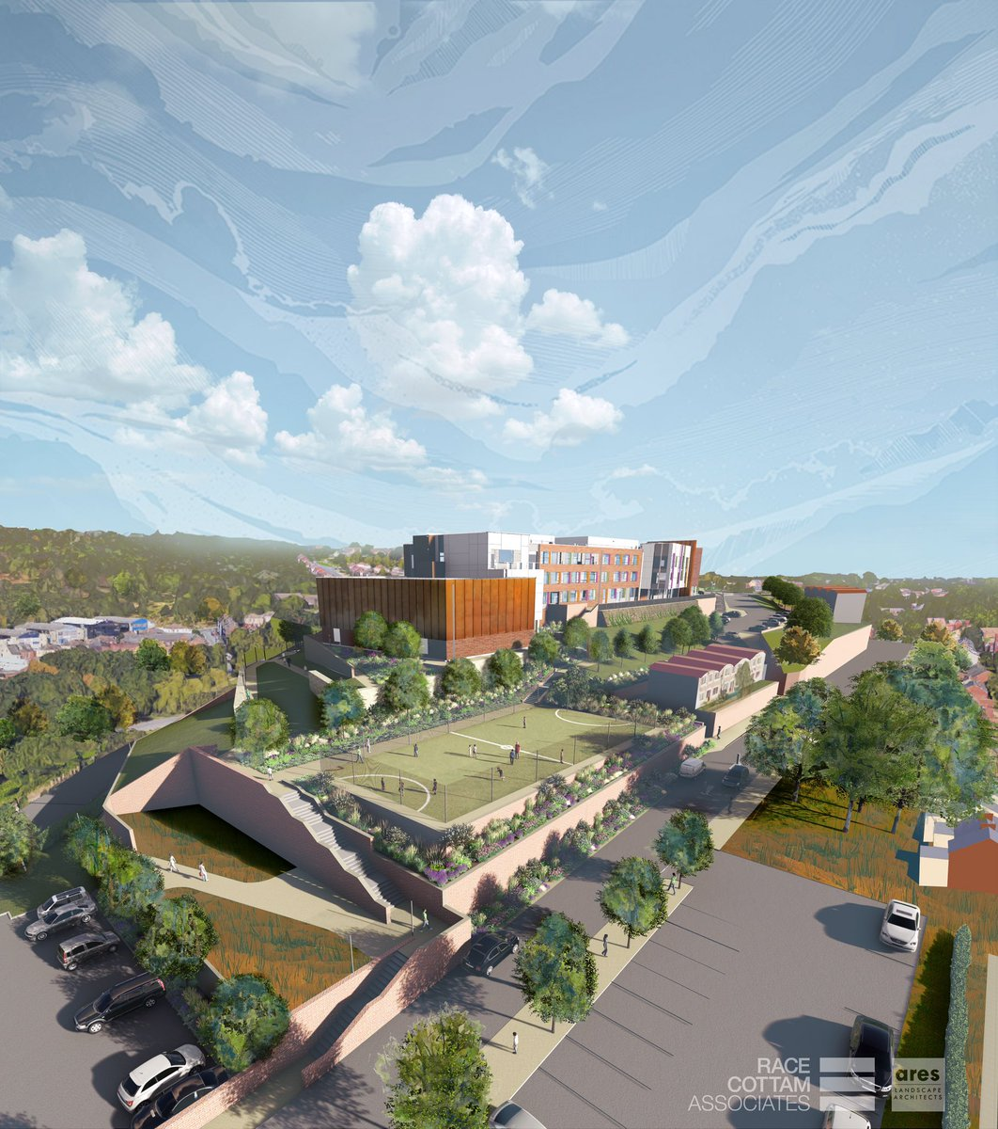

Artists impression aerial view of the new Astrea Academy building in Burngreave, Sheffield

Contents

- Welcome Letter – Libby Nicholas, CEO Astrea Academy Trust
- Astrea Academy Sheffield: Context and Further Information
- Astrea Academy Trust: Ethos and Family
- Job Description
- Person Specification
- Child Safeguarding Policy
- Explanatory Notes
- How do I apply?

Welcome Letter

Dear Candidate,
Thank you for your interest in this role within the Astrea Academy Trust.
This is a hugely exciting time for our family of academies. The Trust has been recognised by the Department for Education as being well placed to raise standards and achieve excellence for pupils in a growing number of academies. We are presented with a rare opportunity to make a real difference to the lives and life chances of so many primary and secondary school children – many of whom haven’t previously received the educational opportunities they deserve.
The Trust currently has academies based across South Yorkshire and Cambridgeshire, including academies at various stages of development. As a Trust, we are clear about the importance of achieving long term sustainability for our academies. Our vision is to enable individual academies to flourish with real autonomy, whilst also ensuring a strong ethos of support and collaboration across our Academies.
Employees within Astrea belong to a community of professionals, and benefit from a wide range of networks and development opportunities across the Trust. The Trust provides a strong culture of collaboration and support, together with high expectations for staff and pupils alike.
Those we recruit can demonstrate that they share our values, are highly motivated to work with colleagues within and beyond their academy to continuously develop their skills and pursue professional excellence, and are committed to providing the highest standards of teaching for all children. If that is you then we would be delighted to receive your application.

Libby Nicholas
Chief Executive, Astrea Academy Trust



Astrea Academy Sheffield
This is an incredibly exciting time to be joining Astrea Academy Trust as the Principal of our brand new all-through Academy in Sheffield.
In September 2018 Astrea Academy Sheffield will open. Located in Burngreave, the all-through academy will provide a fantastic education for pupils in the local area from the age of 2-18. The academy will grow with its community and will reach capacity within four years of opening. When all year groups are filled, the academy will accommodate, educate and oversee the personal development of all its pupils including Nursery and Reception. There will be a two-form entry throughout the primary phase and five-form entry throughout the secondary phase. There will also be a sixth form providing further education as a bridge to University and employment for all of our students.
At Astrea Academy Sheffield our mission is this:
- As young adults, pupils will leave with the necessary dispositions, character and academic qualifications to live a life full of choice and opportunity.
- A broad and balanced curriculum based on knowledge, skills and experiences will enrich pupils’ lives, build cultural capital and instil a love of learning. Students will be able to apply their learning to real world contexts and problems, creating solutions in collaboration with others.
- Pupils will learn to value family, community and the environment. They will make a positive contribution to the life of the Academy and those around them. Pupils will become resilient learners who are motivated to take responsibility for their learning, health, well-being and happiness.
- Pupils will have high expectations of themselves, a culture of craftsmanship and a drive for excellence. They will understand the scope of possibilities that lie ahead of them and what is required to achieve their ambitions with the confidence and belief to make them a reality.

CURRICULUM PRINCIPLES
Astrea Academy Trust academies have a curriculum that is values-led, which engages, motivates, and inspires pupils and which gives them the opportunity to translate learning into real and relevant skills application. The Astrea curriculum prepares pupils for life and work and enables them to achieve their potential both academically and creatively.
At Astrea Academy Sheffield, our curriculum will be the purpose of our school. The curriculum is everything that we want our pupils to know and to understand. It includes learning about discrete subject disciplines such as the sciences, humanities and the arts and how these disciplines relate to one another. Our curriculum is also what we want pupils to achieve, the opportunities we offer them and the experiences we believe all pupils are entitled to.

An Inclusive Education
At every stage from the age of 2, to the age of 18, we will ensure an inclusive and fully supportive approach to ensure we meet the needs of all students, including those who are, or have been looked after, those with special educational needs and disabilities and those who are able and/or gifted.
We believe that every child and young person matters and all pupils have a common entitlement to a broad and balanced curriculum integrated in to all aspects of Academy life. We ensure that pupils of all abilities have the opportunity to flourish. We welcome students of all abilities and from all backgrounds; our teachers will take the time to get to know and understand every individual. Whether they are doing very well, are struggling in an area of learning or need extra emotional or pastoral support, we will always work to meet their needs. It will be crucial to identify a special educational need as early as possible and quickly implement strategies that support learning to promote achievement and attainment in all pupils.
The Astrea Experience
Unique experiences are an important part of going to school. At Astrea Academy Sheffield we work hard to plan and create these opportunities. Not simply because they are exciting and valuable life experiences, but because experiences build the characteristics we want pupils to have and appreciate the world and how it works. All pupils should have the opportunity to represent the school in competitions, perform on stage, visit the theatre a foreign country and experience the best the arts, humanities and science have to offer. Whilst at the school all pupils will have the opportunity to:
- Camp in a field or a forest
- Visit a foreign country
- Do an adventurous activity
- Take part in the Astrea Olympics
- Display artwork in a public space
- Climb a mountain
- Run an enterprise
- Learn to play a musical instrument
- Cook a meal for the family
- Participate in a debate in an iconic building
- Perform in an Astrea concert
High Aspirations for All
At Astrea Academy Sheffield we will have the highest aspirations for our pupils and our teachers. With dedication, hard work and belief there is nothing that cannot be achieved. We will set high expectations for the behaviour of all pupils and believe that excellent behaviour is a foundation of a successful academy where people respect one another and fulfil their role within a learning community. This extends from the way they wear their uniform to the way they interact with peers and teachers. As pupils progress through the school, they will take on additional responsibilities and from Key Stage 4 have the opportunity to fulfil leadership roles across the school.
Industry and Community Partnerships
Our curriculum is designed to provide opportunities for pupils to work closely with local businesses and organisations. This will include opportunities for pupils to visit and work in the local area, complete projects linked to a variety of industries and gain industry specific qualifications along the way leading to training and employment. Each term pupils will work on a ‘Big Problem’ themed day to complete a common task. The purpose of these days is to engage pupils in some of the problems and issues facing society, apply the knowledge and skills they have developed across the term and manage an extended task in a real-world context. Our partnerships with the local community will be a focus of these days and create further opportunities to deliver the school’s careers education and experiences programme.
Enrichment
From the age of 9, pupils will take part in enrichment activities during period 6 and period 7 on a Wednesday afternoon. The academy will offer an extensive range of opportunities for all pupils to opt into which will include sport, art, debating, crafts and additional languages. These opportunities will be born out of the interests, hobbies and expertise of academy employees, Sixth Form students and the expertise and skills in the local community. The academy will also offer a wide range of extra-curricular opportunities and clubs throughout the school year.
Assessment and Reporting
We aim to involve our parents/carers in all aspects of school life; to keep them fully informed of school events, and of their child’s progress. We do this through parent discussions, reading records, weekly newsletters, and our parent forums. We will also hold weekly coffee meetings for parent & carers in which the Principal and members of the leadership team meet with parents. More formal contact is made during our termly parent/carer consultation evenings, when parents/carers are given the opportunity to discuss their child’s progress with the class teacher; additional contact will be offered for students with SEND, according to need. An annual written report is sent home during the final Summer Term. It is expected that all pupils will be present at these consultations. Parents/carers are also encouraged to contribute to the life of the school by becoming a parent helper and/or school governor.

Additional information on Astrea Academy Sheffield
Visit our dedicated website for the Academy http://www.astreasheffield.org/.
For updates regarding the ongoing developments at Astrea Academy Sheffield, career opportunities and live updates, follow the school on Twitter @AstreaAcadSheff
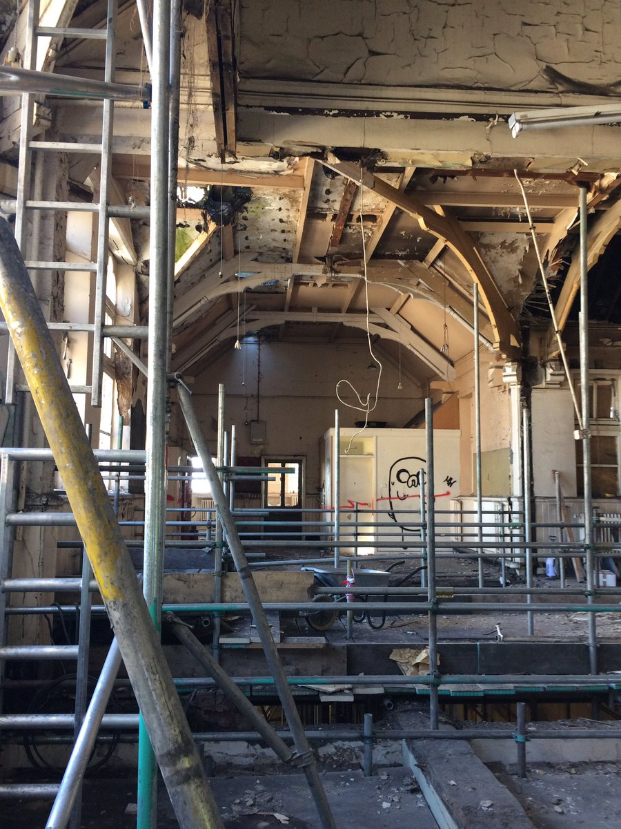

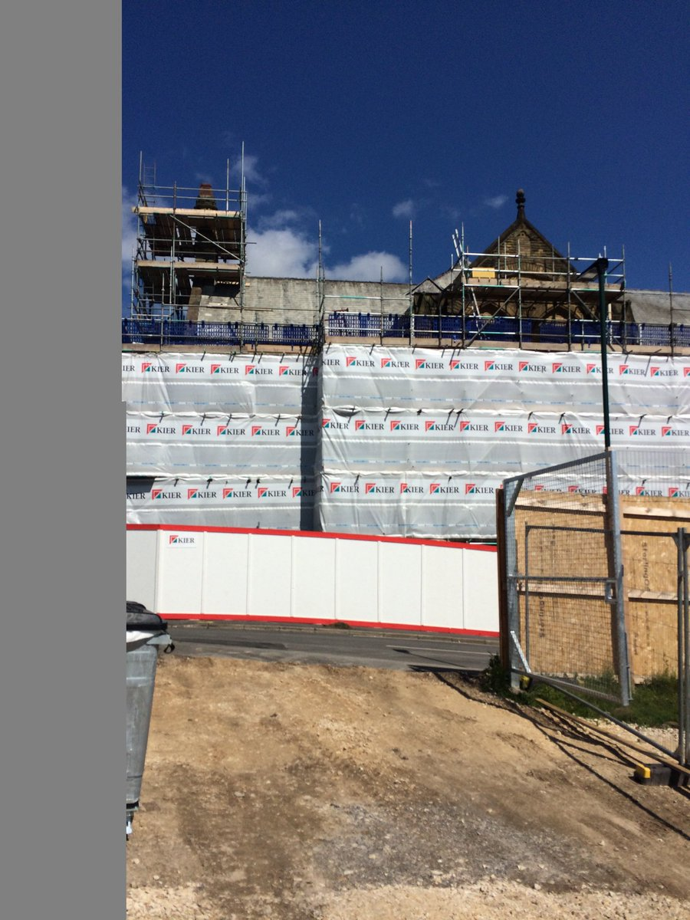

Photographs of the development in building works across the new Astrea Academy, Sheffield

Astrea Academy Trust

We value all-round development of the individual, through arts, sports, leadership opportunities, enrichment and community. This is encapsulated in the skills, qualities and personalities we foster in our pupils.
The Astrea Academy Trust logo communicates the values collaboration, development and aspiration. The three figures are coming together in the shape of a tree, which represents growth, whilst the tallest figure Astrea reaches upwards, towards a star, which is above and beyond the highest branch of the tree.
Academies, staff and children within the Trust benefit from a strong ethos of support and collaboration across the Astrea family. Teachers within Astrea belong to a national community of professionals, and benefit from a wide range of networks and development opportunities across the Trust.
Astrea benefits from the involvement of leading educationalists, including our Professional Adviser Professor John West-Burnham, and strong links to prestigious institutions such as the Institute of Education.

Astrea Academy Trust Ethos

The work of the Astrea Academy Trust is underpinned by five core Value Partners, which are equally applicable to pupils, staff and the work of the Trust itself.

Each pair of Value Partners is accompanied by a call for action in the form of a hashtag, which is used in verbal, digital and hard copy communications.

The Value Partners can be used as a measure of individual, school and Trust progress and as a guide to inform the direction of change.

Responsibility and Leadership
Individuals in the Astrea community are accountable for their own decisions and actions and are supported by strong leaders, while trailblazers are encouraged to develop skills and talents in others. The Trust has a strong commitment to developing and nurturing our own leaders. #4equity

Enjoyment and Innovation
We know that everyone learns best when they enjoy what they do and can follow their innate desire to achieve. Astrea pushes boundaries so that pioneering ideas are tried and tested so that our academies remain leaders in the advancement of teaching and learning methods. #go4it

Aspiration and Development
Every member of the Astrea community, from the youngest pupil to the oldest member of staff, is encouraged to cultivate opportunities to grow. We achieve excellence by being inspired to become the best we can be. The progress and well-being of pupils is our top priority, at the centre of every decision. #Reach4thestars

Collaboration and Inclusion
Astrea honours and applauds the differences that make us unique whilst actively seeking and celebrating the common ground that binds us together as a strong community. We work together in a productive environment where dynamic ideas are shared in partnership, so that every member of the community may thrive #all4one

Honesty and Integrity
We are honest and open. Astrea decisions and responses are grounded in time-honoured moral principles that remain constant in the face of challenges and change #4good
You can learn more about the Values, and hear from staff and pupils across Astrea Academies, at our website: https://astreaacademytrust.org/

Astrea Academy Trust Family

Academies currently within Astrea Academy Trust:

- Byron Wood Academy, Sheffield
- Carrfield Primary Academy, Rotherham
- Castle Academy, Doncaster
- Cottenham Village Academy, Cambridgeshire
- Denaby Main Primary Academy, Doncaster
- Edenthorpe Hall Academy, Edenthorpe
- Gooseacre Primary Academy, Rotherham
- Greengate Lane Academy, Sheffield
- Hartley Brook Primary Academy, Sheffield
- Hatfield Primary Academy, Sheffield
- Hexthorpe Primary Academy, Doncaster
- Highgate Primary Academy, Rotherham
- Hillside Academy, Doncaster
- Kingfisher Primary Academy, Doncaster
- Lower Meadow Primary Academy, Sheffield
- The Centre School, Cambridgeshire
- The Hill Primary Academy, Rotherham
- Netherwood Academy, Barnsley

Job Description
Position: Principal
Salary: Leadership scale, negotiable
Reporting to: CEO and Executive Director of Education
Location: Astrea Academy Sheffield

Purpose of this role

Core Purpose
Astrea requires an inspirational leader who will be the catalyst for ensuring that the Astrea Academy Sheffield becomes a beacon for its community and students. There is a lot of exciting work to do before we officially open our doors in September 2018 and the new Principal will have an incredible opportunity to help us create and build an academy that is at the cutting edge of education during the planning and preparation stages.
Our new Principal will lead the academy on its journey from the beginning. Building and implementing effective structures and staffing to ensure that the nourishing curriculum is embedded along with the Astrea values in establishing an environment that is conducive to excellence in all areas. Not only will the Principal be expected to create this academy they will be pivotal in shaping the future for generations to come.
This is a truly unique opportunity to be involved from day one in the operational and strategic planning and preparation of the academy as well as implementing the standards that will drive home the improvements year on year.
The Astrea Academy Sheffield Principal will be accountable to the CEO and Executive Director of Education for ensuring the educational success across all phases of the new all-through academy. They will provide professional leadership and management of their academy and must establish a culture that promotes excellence, equality and high expectations of all pupils, whilst contributing to the success of all children within the Astrea family.

The Principal shall carry out the professional duties as described in the Astrea Teaching Standards and the School Teachers Pay and Conditions Document and would be expected to have considered these in relation to Astrea Academy Sheffield.

Responsibilities
- To lead and prepare the academy in all educational, facilities and operational areas ready for opening in September 2018;
- To develop and execute a recruitment strategy for the academy;
- To develop and execute the required financial and budget strategies for the academy;
- To further design and implement the entire school curriculum;
- To communicate the vision and expectations by becoming the public face of the academy to all internal and external stakeholders;
- The effective implementation and embedding of the agreed Astrea vision, teaching standards, principles and policies within the academy;
- Providing leadership across all aspects of the internal organisation, professional leadership, management and control of their academy;
- Creating a culture of constant improvement and being an inspirational leader, committed to the highest achievement for all in all areas of academy work;
- The Principal will have line management responsibilities for the Heads of the Primary and Secondary phases as well as Vice Principals/Assistant Principals and other appropriate staff within the academy.
Shaping the Future (Strategic Leadership)
- Work with the SLT and the Governing Body, and under the guidance of the CEO, and Executive Director of Education to develop the shared vision and strategic plan for the academy, which is responsive to the community it serves. At the core of this should be the educational and personal development of the pupils;
- Work with the CEO, and Executive Director of Education, Astrea Board, Governors, and staff to define and implement the academy’s vision and strategic direction so that it is understood and acted upon by all stakeholders;
- Create and implement the required staffing structures throughout the growth period of the academy and beyond;
- Work within the academy community to translate the vision into agreed objectives and operational plans, which will drive forward and sustain school improvement;
- Ensure the sustained raising of aspiration, achievement and attainment, is met through an inclusive, sustainable and innovative lifelong education environment;
- Ensure the academy achieves its performance targets;
- Demonstrate the vision and values of Astrea in everyday work and practice. Motivate and work with others to create a shared culture and positive climate;
- Promote the academy, and the Trust and develop effective and productive relationships with a wide range of stakeholders;
- Secure the commitment of parents and the wider community to the vision and direction of the academy and the Trust;
- Challenge, motivate and empower others to attain ambitious outcomes;
- Working with the CEO and Executive Director of Education to develop strategies for academy readiness in Early Years and a positive transition across Key stages and into both primary and secondary education for children and parents.

Leading Learning and Teaching
- Drive and inspire a passion for learning in every member of the academy community;
- Provide a model of outstanding practice to all staff in teaching and school leadership;
- Secure and sustain effective teaching and learning throughout the academy by ensuring sound strategies are in place for monitoring and evaluating the quality of teaching and standards of pupils’ achievement, using benchmarks and setting targets for rapid improvement of all children including those in vulnerable groups;
- Promote excellence in teaching and learning, ensuring a continuous and consistent focus on pupils’ achievement and development (whole-person as well as academic);
- Ensure that a high quality educational experience (as expressed through the Astrea mission statement, principles and innovations) is available for all children and young people;
- Create a positive culture of challenge, support and high expectations, in order to achieve the academy Strategic School Development Plan, raise standards and improve the quality of teaching;
- Ensure that teaching in all year groups is improving to outstanding;
- Ensure that all children make good progress including where there are barriers to learning, through clear, consistent and excellent systems and provision for all, actively promoting inclusion;
- Provide effective and appropriate pastoral support is available to children in the academy;
- Through robust and effective monitoring and evaluation, identify and act on areas of improvement in relation to the curriculum and assessment;
- Keep informed of developments within the National Curriculum and other relevant curriculum development sources, to ensure that the curriculum is rich, relevant and inspirational and contributes to outstanding educational and whole-person outcomes;
- Ensure creativity, innovation and the use of appropriate new technologies to achieve excellence;
- Develop an inclusive and supportive approach so that each academy is a place where all young people and the wider school community feel welcome.
Developing Self and Working with Others
- Treat everyone within the academy fairly and equitably;
- Develop a culture of personal responsibility that recognises both excellence and supports appropriate strategies to deal with under performance in accordance with Trust Appraisal and Capability policies and procedures;
- Ensure a high standard of professional development for all staff and for self, including attending all mandatory training events;
- To build a collaborative learning culture within the academy and actively engage with other academies within the MAT and the wider Astrea family to build effective learning communities;
- Work with all staff to build effective teams across the primary and secondary phases;
- Sustain their own enthusiasm and motivation and develop and sustain that of other staff;
- To ensure effective planning, allocation, support and evaluation of work undertaken by teams and individuals, ensuring clear delegation of tasks and devolution of responsibilities;
- Develop and maintain effective strategies and procedures for staff induction, professional development and appraisal as below;
- Effective and consistent implementation of the Astrea Appraisal Policy and other systems of quality assurance and professional development of teachers;
- Motivate and enable all staff to carry out their respective roles to the highest standard, through high quality continuing professional development based on assessment of needs and identified through the appraisal process;
- Develop and maintain respect across all stakeholders, inspiring individuals to contribute positively to shared ideas and plans for the academy, the MAT and the wider Astrea family;
- Under the direction of the CEO and Executive Director of Education, to develop capacity, through coaching and mentoring members of the SLT;
- Keep abreast of educational developments and best management practice in order to introduce appropriate innovation and contribute to joint practice development across the Trust.
Managing the Academy
- Produce and implement clear, evidence-based improvement plans and policies for the development of the academy across all phases and its facilities;
- Advise Astrea on the formulation of the annual budget in order that the academy secures its objectives;
- Receive and approve the academy budget in order to ensure that each academy meets its objectives;
- Manage the academy’s financial and human resources effectively and efficiently to achieve the school’s educational goals and priorities;
- Work with the SLT and Trust to recruit and retain staff of the highest quality, in line with trust policy and safer recruitment procedures; and in line with the growth programme of the academy during the initial four years;
- Work with the Trust and senior colleagues to deploy all staff effectively in order to improve the quality of education provided across all phases;
- Regularly monitor the budget for the academy and the use of resources;
- Manage and organise the academy environment efficiently and effectively to ensure that it meets the needs of the curriculum and health and safety regulations;
- Ensure that the allocation and use of accommodation within the academy provides a positive learning environment that promotes the highest achievement for all;
- Work with Astrea, SLT and School Business Manager to maximise the level of external funding that is attracted to support each academy’s development;
- Promote, embed, secure and monitor all agreed Astrea policies.
Securing Accountability
- Work with the Governing Body, and the Executive Board (providing information, objective advice and support) to enable both to meet their responsibilities;
- Ensure that individual staff accountabilities are clearly defined, understood and agreed and are subject to rigorous review and evaluation;
- To develop an academy ethos which will enable everyone to work collaboratively, share knowledge and understanding, celebrate success and accept responsibility for outcomes;
- Develop and present a coherent, understandable and accurate account of the academy’s performance to a range of audiences including governors, parents and carers;
- Reflect on personal contribution to academy achievements and take account of feedback from others.
Strengthening Community
- Build an academy culture and curriculum which takes account of the richness and diversity of the academy’s communities;
- Ensure learning experiences for pupils are linked into and integrated with the wider community both within the MAT and also within the Astrea community of academies;
- Create and maintain an effective partnership with parents and carers to support and improve pupils’ achievement and personal development;
- To seek opportunities to invite parents and carers, community figures, and those from the wider Astrea family, business or other organisations into the school to enhance and enrich the school and its value to the wider community.
Equal opportunities
- To take responsibility, appropriate to the post for tackling unlawful discrimination amongst all groups in line with the Equalities Act 2010.
Safeguarding children and Safer Recruitment
- To have due regard for safeguarding and promoting the welfare of children and young people and to follow all associated child protection and safeguarding policies as adopted by the academy, LGB, Executive Board and Astrea;
- Ensure that all policies and procedures adopted are fully implemented and followed by all staff;
- Ensure that sufficient resources and time are allocated to enable the designated person and other staff to discharge their responsibilities, including taking part in strategy discussions and other inter-agency meetings, and contributing to the assessment of children;
- All staff and volunteers feel able to raise concerns about poor or unsafe practice in regard to children, and such concerns are addressed sensitively and effectively in a timely manner in accordance with agreed whistle blowing practices.
Health and Safety
- To work in compliance with the academy’s Health and Safety policies and under the Health and Safety at Work Act (1974), ensuring the safety of all parties with whom contact is made, such as members of the public, in premises or sites controlled by the academy;
- To ensure compliance with procedures is observed at all times under the provision of safe systems of work through a safe and healthy environment and including such information, training, instruction and supervision as necessary to accomplish those goals.
Data Protection
- To ensure compliance with the Data Protection Act (1974) and the Freedom of Information Act (2000).

Person Specification
This part will allow you to understand who we are looking for within this role and the skills knowledge or experience that we would expect.

Knowledge/Qualifications and Experience | Essential | Desirable
Graduate with Qualified Teacher Status | *
NPQH (or equivalent) achieved or underway |  | *
Experience of developing a differentiated and creative curriculum to pupils with a diverse range of social, emotional, cultural, intellectual and physical needs | *
Ability to use a range of evidence, including performance data, to support, monitor, evaluate and improve aspects of school life, including challenging poor performance | *
Ability to engage the school community in the systematic and rigorous self-evaluation of the work of the school | *
Evidence of recent professional development that prepares for this post | *
Experience of monitoring and improving the quality of teaching and learning | *
Experience at Principal or Deputy Principal level | *
Experience of having led, or made a significant contribution to, the success of a school, through its leadership, pupil outcomes and ethos | *
Experience of supporting staff to optimise attainment and progress of pupils | *
Evidence of an ability to plan strategically, build and communicate a coherent vision in a range of compelling ways | *
Extensive experience of working with children with significant barriers to learning | *
Knowledge of legislation relating to managing a school including Equalities legislation | *
Experience of leadership in an all-through provision |  | *
Experience of developing and leading through the planning to implementation stages of a new academy |  | *
Skills and abilities and professional attributes

Proven ability to inspire, lead and participate actively in building and sustaining a learning community and network with others within and beyond the school | *
Experience of working across more than one academy |  | *
Understanding and ability to communicate and successfully implement strategies across all aspects of the school including accountability, learning, curriculum, administration and communication | *
Proven ability to deliver a collective vision and shared purpose across the academy and Astrea family | *
Outstanding Teacher | *
Experience of effectively managing the impact of change on organisations and individuals | *
The ability to deliver effective strategic financial planning, financial management including budgetary control and value for money | *
An understanding of and competent use of ICT including emerging technologies to aid and promote the quality of teaching, learning and administration | *
Excellent organisational skills | *
Well-developed interpersonal and communication skills and ability to use new and emerging technologies to secure impact | *
Clear understanding of the ethos and strategies required to establish consistently high standards in outcomes, progress, attitudes and behaviour | *
Able to meet national standards for Principals | *
Demonstrate a personal enthusiasm and commitment to leadership aimed at making a positive difference to children and young people and raising standards | *
Demonstrate personal and professional integrity, including modelling values and vision | *
Evidence of a commitment to safeguarding and promoting the welfare of children and young people | *
Commitment to promote and support the aims of Astrea | *

Child Safeguarding Policy

The Trust is committed to Safeguarding and Promoting the Welfare of all its students. Each student’s welfare is of paramount importance. We recognise that some children may be especially vulnerable to abuse e.g. those with Special Educational Needs, those living in adverse circumstances.

We recognise that children who are abused or neglected may find it difficult to develop a sense of self-worth and to view the world in a positive way. Whilst at the Academies, their behaviour may be challenging. We will always take a considered and sensitive approach in order that we can support all our students.

The Trust’s Child Safeguarding Policy applies to all adults, including volunteers, working in or on behalf of the Trust.

Everyone in the education service shares an objective to help keep children and young people safe by contributing to:
- Providing a safe environment for children and young people to learn in education settings; and
- Identifying children and young people who are suffering or likely to suffer significant harm, and taking appropriate action with the aim of making sure they are kept safe both at home and in the education setting’

Safeguarding Children and Safer Recruitment in Education DfES 2007

The Trust pays full regard to DfES guidance ‘Safeguarding Children and Safer Recruitment in Education’ Jan 2007. We ensure that all appropriate measures are applied in relation to everyone who works for the Trust who is likely to be perceived by the children as a safe and trustworthy adult including e.g. volunteers and staff employed by contractors. Safer recruitment practice includes scrutinising applicants, verifying identity and academic or vocational qualifications, obtaining professional and character references, checking previous employment history and ensuring that a candidate has the health and physical capacity for the job. It also includes undertaking interviews and an Enhanced DBS check.
Please visit http://Astrea.org.uk/about-us/statutory-documents/ for the full policy.

Explanatory Notes

Applications will only be accepted from candidates completing the Trust’s Application Form. Please complete ALL sections of the Application Form which are relevant to you as clearly and fully as possible. CVs will not be accepted in place of a completed Application Form.

Safeguarding Children and Young People

We are committed to safeguarding and promoting the welfare of children and young people. We expect all staff to share this commitment and to undergo appropriate checks, including an enhanced check.

- Candidates should be aware that all posts in Astrea Academy Trust involve some degree of responsibility for safeguarding children and young people, although the extent of that responsibility will vary depending on the nature of the post. Please see the job description enclosed in this Application Pack for further details.
- Accordingly, this post is exempt from the Rehabilitation of Offenders Act 1974 and therefore all convictions, cautions and bind-overs, including those regarded as “spent” must be declared.
- If you are currently working with children, on either a paid or voluntary basis, your current employer will be asked about disciplinary offence, including those related to children or young people (whether disciplinary sanction is current or time-expired), and whether you have been the subject of any child protection allegations or concerns and if so the outcome of any investigation or disciplinary proceedings. If you are not currently working with children, but have done in the past, that previous employer will be asked about these issues.
- Where neither your current or previous employment has involved working with children, your current employer will be asked about your suitability to work with children, although it may be answered not applicable where it is appropriate; if your duties have not brought you into contact with children or young people for instance.

Interview Process

After the closing date, short listing will be conducted by a Panel. You will be selected for interview entirely on the contents of your application form, so please read the Job Description and Person Specification carefully before you complete your form.

All candidates invited to interview must bring the following documents:

- Documentary evidence of right to work in the UK
- Documentary evidence of identity that will satisfy DBS requirements
- Documentary proof of current name and address
- Where appropriate any documentation evidencing change of name
- Documents confirming any educational or professional qualifications that are necessary or relevant for the post

Please note that originals of the above are necessary, photocopies or certified copies are not sufficient.

We will seek references on shortlisted candidates for Trust based positions and may approach previous employers for information to verify experience or qualifications before interview. Any relevant issues arising from references will be taken up at interview.

In addition to candidate’s ability to perform the duties of the post, the interview will also explore issues relating to safeguarding and promoting the welfare of children, including:

- Motivation to work with children and young people
- Ability to form and maintain appropriate relationships and personal boundaries with children and young people
- Emotional resilience in working with challenging behaviours
- Attitudes to use of authority and maintaining discipline

Conditional Offer: Pre-Employment Checks

Any offer to a successful candidate will be conditional upon:

- Verification of right to work in the UK
- Receipt of at least two satisfactory references (if these have not already been received)
- Verification of identity checks and qualifications
- Satisfactory Enhanced DBS Check
- Verification of professional status such as QTS Status, NPQH (where required)
- Satisfactory completion of a Health Assessment
- Satisfactory completion of the probationary period (where relevant)
- Where the successful candidate has worked, or been resident overseas in the previous five years, such checks and confirmations as may be required in accordance with statutory guidance

How can I Apply?
This is an exciting and very rewarding role and we look forward to receiving your application.

Please complete the Application Form which is available together with this document

Please send your completed Application Form to

Name: Ingrid Chambers
Position: Human Resources Assistant
Contact: ingrid.chambers@astreaacademytrust.org

The Application Process

The candidates selected for interview will be informed after shortlisting and full details of the interview programme will be provided. If you do not hear from us within 14 days of the closing date of this position, unfortunately you have been unsuccessful on this occasion.

