Wilberfoss Church of England (VC)
Primary School

Headteacher Recruitment Pack

Storking Lane, Wilberfoss, East Riding of Yorkshire, YO41 5ND Tel: 01759 380327
Email: wilberfoss.primary@eastriding.gov.uk Website: www.wilberfossprimary.co.uk


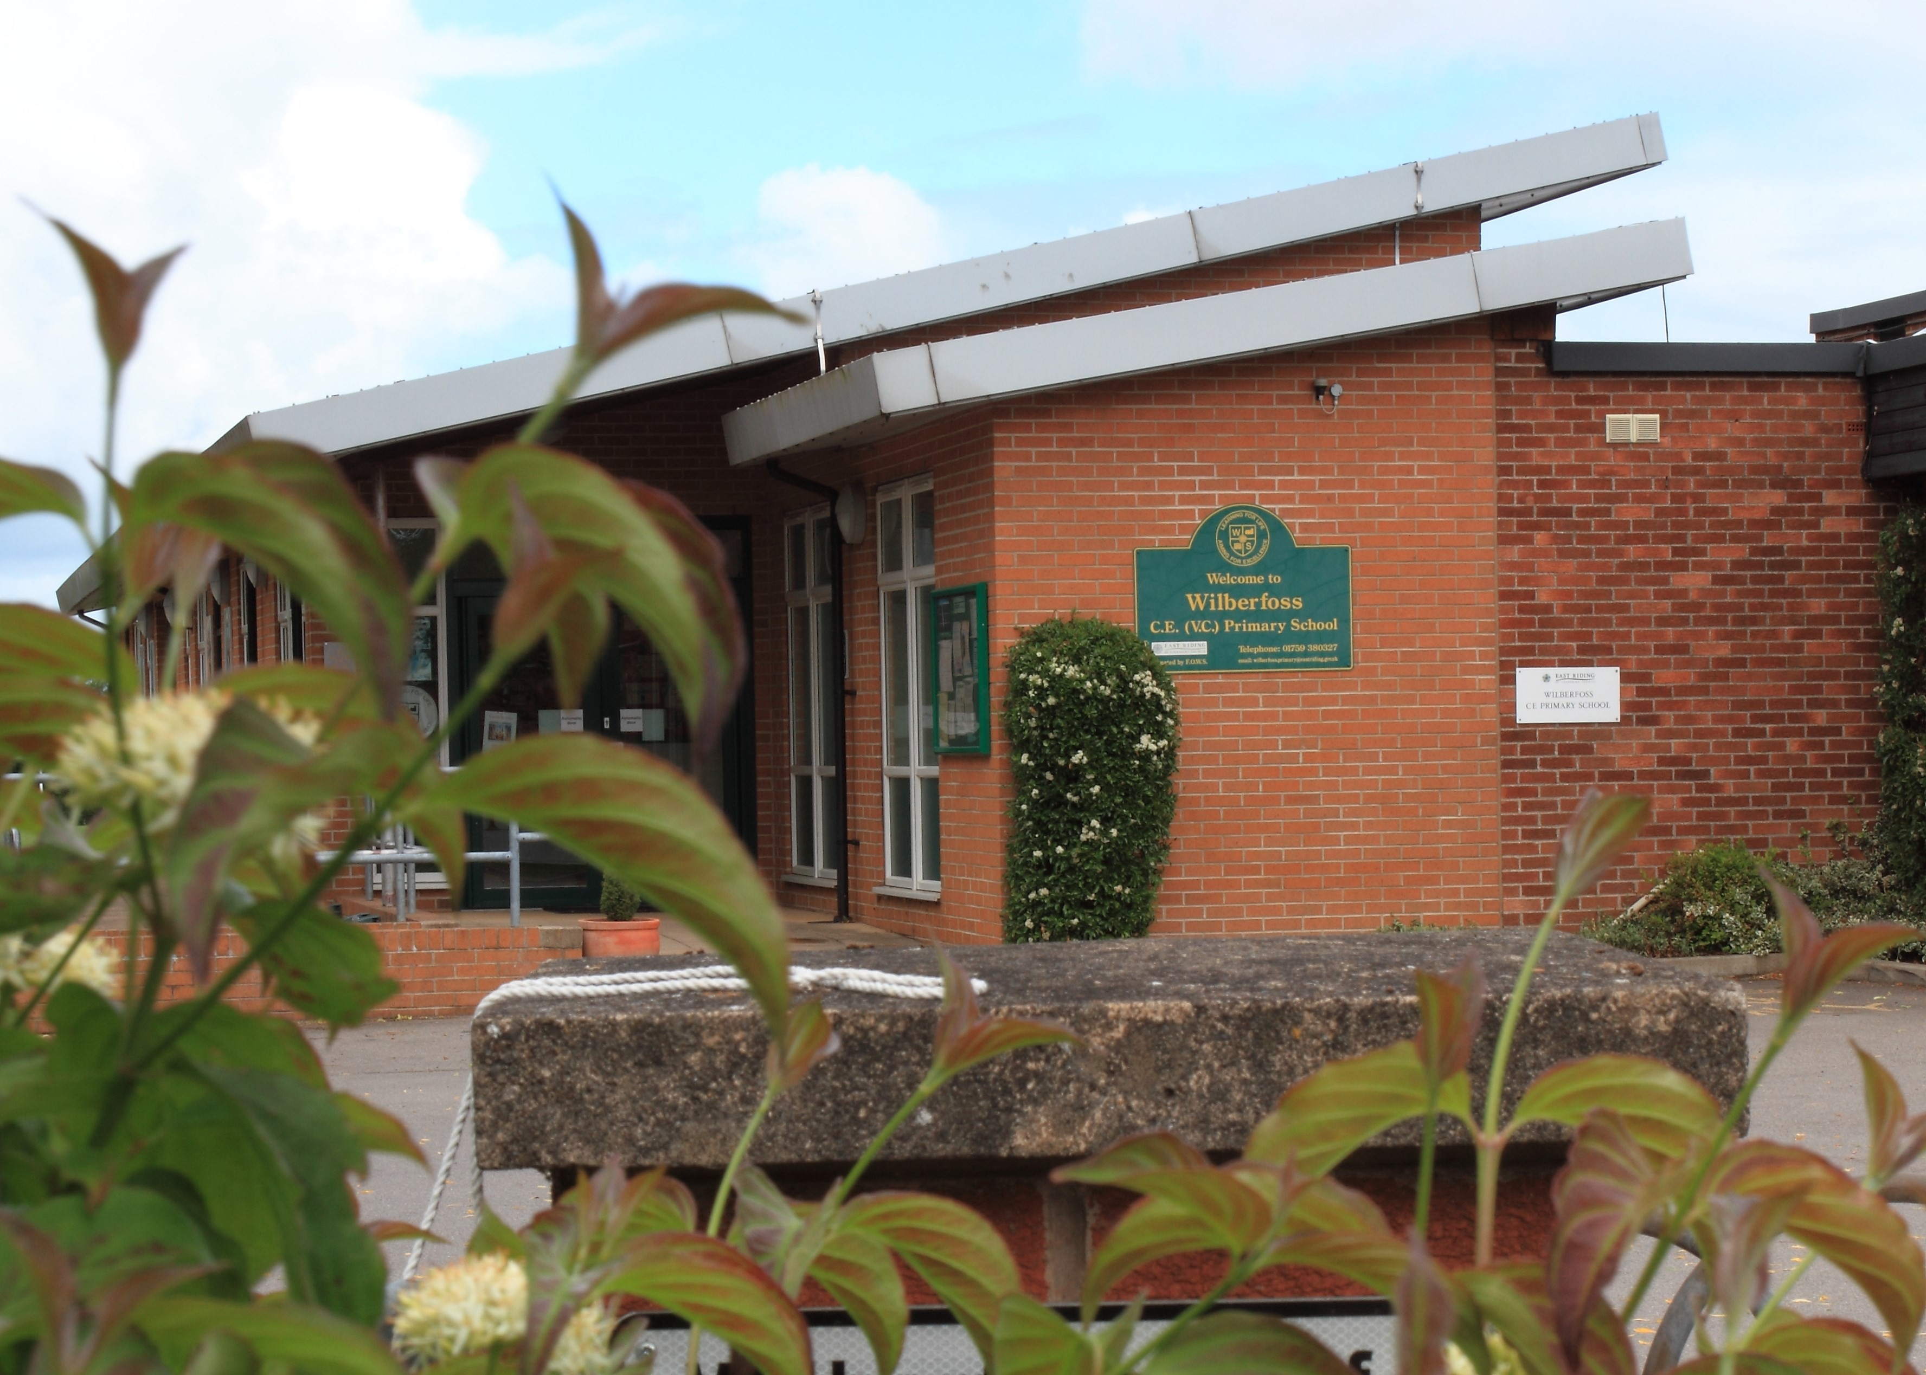

2

Contents

- Welcome from Chair of Governors
- Letter from School Council
- Letter from our Staff
- Our School
- Key Challenges & Priorities
- Welcome from our Priest in Charge
- Our Diocese
- Wilberfoss Village - the best of both worlds!
- Job Description
15. Person Specification
17. How to Apply

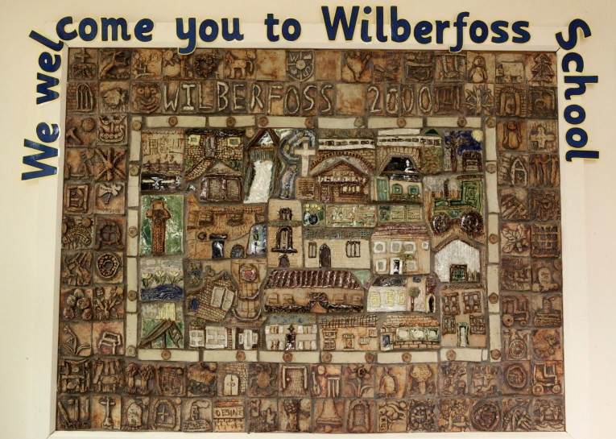
3

Welcome from the Chair of Governors

Thank you for showing an interest in the position of Headteacher at Wilberfoss Church of England Primary School. We are a voluntary controlled school located in a picturesque village on the edge of the Yorkshire Wolds and just 8 miles outside the historic and cultural City of York.

Our outgoing Headteacher has decided to retire after long service to our school and the local authority. As we say our good byes and close one chapter we look forward and start to think about the next set of challenges faced by our school, including the appointment of the Headteacher.

We started the recruitment process by asking pupils what attributes they wanted from their new Headteacher. We then went on to ask staff, parents and carers and our parent group “Friends of
Wilberfoss School”. There was much correlation and the essence of this feedback has been captured in the following pages. As you read through this recruitment pack we hope that you will recognise and identify with the attributes that we are seeking to enable us to take the school forward into its next chapter.

We were graded as GOOD at our last OFSTED in 2017 and SIAMS in 2014 however in alignment with our vision of “Learning for Life, Aiming for Excellence” we recognise that there is always room for improvement as reflected in the priorities within our School Improvement Plan. I am sure that you may see other challenges if you come and visit us and we would welcome your thoughts!

We are fortunate enough to have motivated, confident and well-mannered pupils who are keen to learn as well as a highly talented and dedicated team of teachers, teaching assistants, support staff, and volunteers who are passionate about making Wilberfoss Primary School the very best it can be.

We are therefore looking for a passionate and inspirational leader who is able to model outstanding teaching and has the vision and drive to lead our School through continuous improvement to ensure the very best outcomes for all of its pupils.

We are also seeking an outstanding communicator who can collaborate with all members of the school community: pupils, staff, governors, parents, Friends of Wilberfoss School, Church, the local authority, Diocese, neighbouring schools and other stakeholders.

We are also fortunate to have the support of the York Diocese and that of our Priest in Charge who has a wonderful relationship with the school. Our Governing Body is professional and supportive and will work together to support the head in their new role.

I have been a school governor at various schools over the last 30 years and have more recently taken on the role of Chair of Governors. Three of my children have attended the school and I speak from experience when I say it is an absolute pleasure to be involved with all members of the school community and to see our children being nurtured in all aspects of their education including their social and emotional development.
Thank you for your interest in our school, we look forward to receiving your application.
Lynda Hoyle
Chair of Governors
Wilberfoss C of E (VC) Primary School



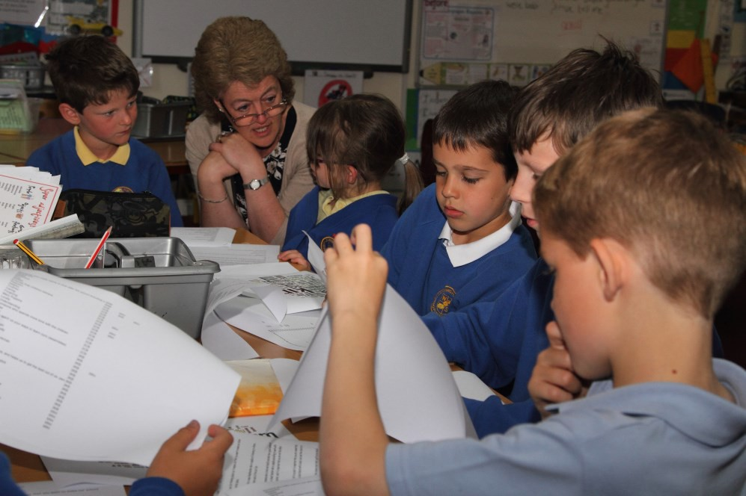
4

Letter from School Council

Dear Future Headteacher,

Thank you for thinking about us; it means a lot that you want to make our school an even better place.

We are looking for a new Headteacher who is capable of listening to others, including the teachers, and is firm but fair.

We would also like someone who is kind and helpful and who has a good sense of humour! We would like a Headteacher who is capable and willing to work with the children as their teacher, and it is important that you are not like Miss Trunchbull!

The Christian values mean a lot to us and it is important that you are committed to them like we are. We have a local church with a lovely vicar and the church is a big part of our school.

We have talked to children in all of the classes about what qualities we would like in a new Headteacher and we have created a “Wordle” from the feedback.

This is what is important to the School Council:
- Help us to stay healthy and safe;
- be fair and thoughtful;
- be respectful and not judgemental;
- be sympathetic and trustworthy, and
- you must like children!

You would be more than welcome to come and work with us if you wanted to; we are looking forward to it already!

Yours faithfully Natasha
Chairperson, Wilberfoss School Council



5

We asked the children what qualities they wanted from their new Headteacher. Here is what they said…….

6

A letter from our staff

A letter from our staff.

Thank you for your interest in the post of Headteacher for Wilberfoss School. In addition to the required qualifications, skills set and experience, we are looking for that special person who can inspire, support and encourage us as a staff team.

We are looking for a ‘people person’ who is warm, wise, fair and consistent, and who possesses both a sense of humour and of fun.

We seek a Headteacher who will listen as well as lead, and enable us to develop our full potential
- both as individuals and as a team. We need that special someone to be committed to working together with every staff member. We each have different skills, experience, passions and perspectives and enjoy being able to develop and share these for the benefit of the school.

We are also looking for someone with a special gift for communication at every level both within the school and with the wider community.

We obviously seek someone who can be strong and decisive. But we still need someone who cares and is kind, and knows how to say thank you and offer praise.

Last, but by no means least, we are looking for a leader who is motivated and excited about the idea of getting to know us all. Our school is looking for a Headteacher who feels at home everywhere in school: in the classrooms, offices, corridors, playgrounds and cloakrooms.

If you think you would like to apply for the post of Headteacher of Wilberfoss School, and you would relish the opportunity to lead our team, then please do apply and we look forward to having the chance to meet you.

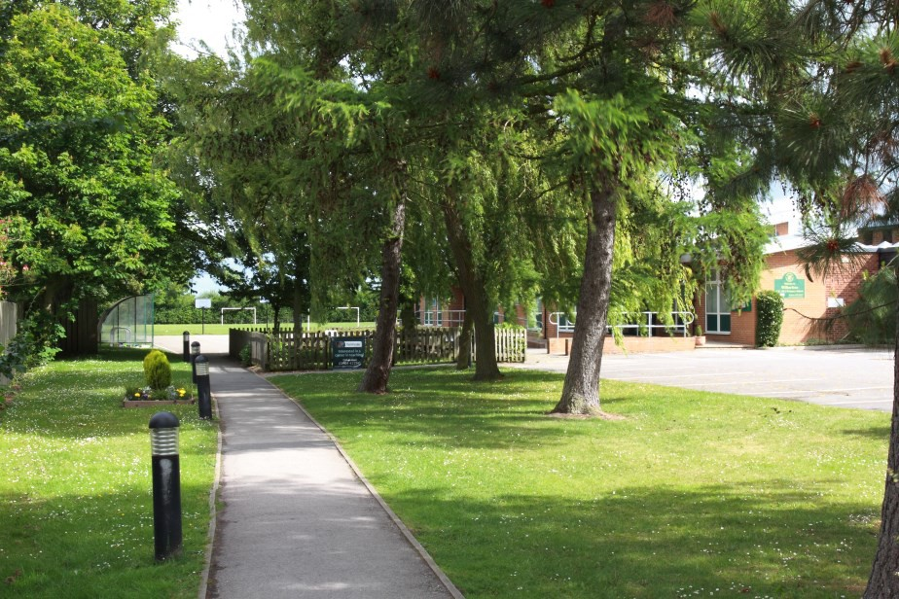
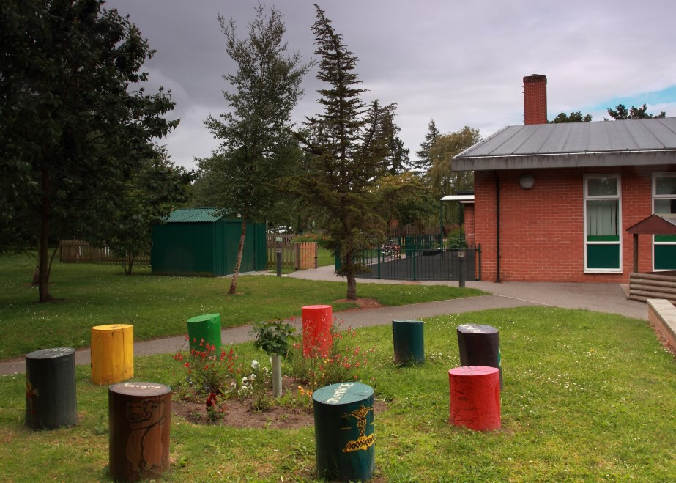

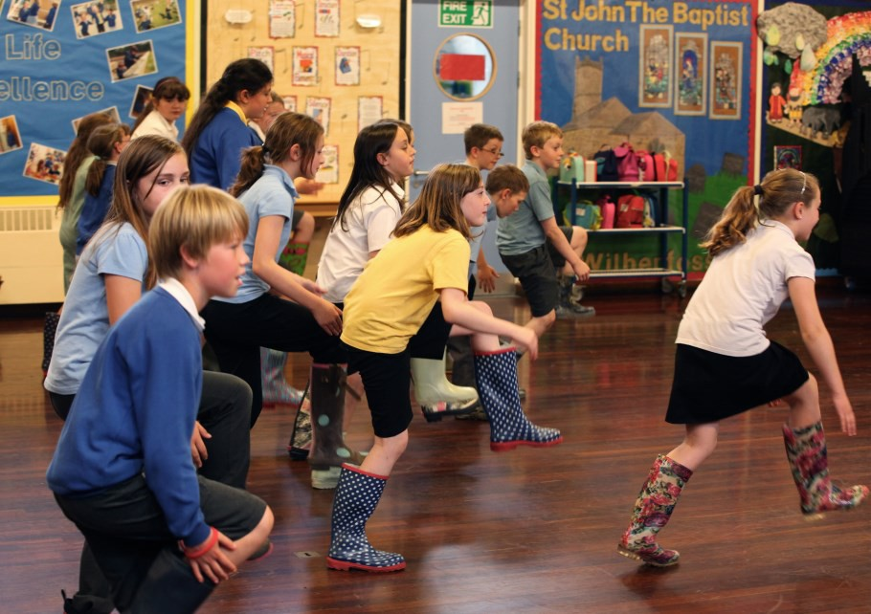

7

Our School

Our Christian Values: Service, Thankfulness, Friendship,
Perseverance, Truthfulness, Forgiveness.

Wilberfoss Primary School is a Church of England school at the heart of the community. There has been a school in Wilberfoss since the 1800’s, and the current school building opened in 1973. There are currently 241 pupils at the school. Our school’s philosophy is that all members of our learning community should “Learn for Life and Aim for Excellence.”
Our Vision
In our school, we aim for our children to grow in knowledge and understanding and to be happy, confident and caring people.
We will help them to achieve their potential, to make informed choices, to respect the beliefs and lifestyles of other people and to care for their environment, within a supportive Christian community.
In 2017 OFSTED said:

“This is a good school. It has a positive culture of caring for each other and strong relationships between adults and pupils.”
In 2014 SIAMS said:

“The vision of the school is explicit and particular to the school and rooted firmly in the distinctively Christian values that underpin school life for children and adults alike.”
The church and Rev Aysha St Giles play an important role in the life of the school.
The Governing Body are there to support, challenge and be a critical friend to the Headteacher and the school.
Friends of Wilberfoss School (FOWS), are a group of hard- working, fun-loving, committed parents and carers who help raise funds for school projects and trips.

Parents and carers are encouraged to help their children’s learning in partnership with the school, to help every child achieve their potential.
Alongside academic learning, we nurture the Spiritual, Moral, Social and Cultural development of the children, to help to form well- rounded individuals.
The children are:

“well mannered, considerate towards each other’s needs and highly respectful of all adults. The behaviour of all groups of pupils, including those pupils whose circumstances potentially make them vulnerable, is exemplary. In turn, the pupils’ spiritual, moral, social and cultural development is exceptional.”
“Spiritual development, as well as cultural and moral development, is excellent and a natural outcome of the school’s explicit Christian ethos.”

SIAMS May 2014.







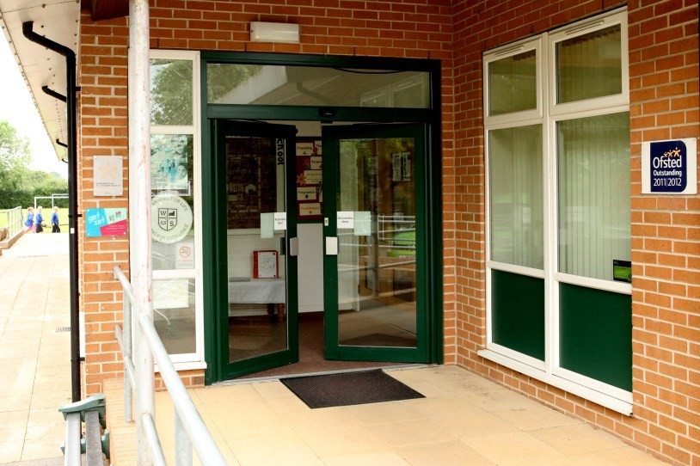



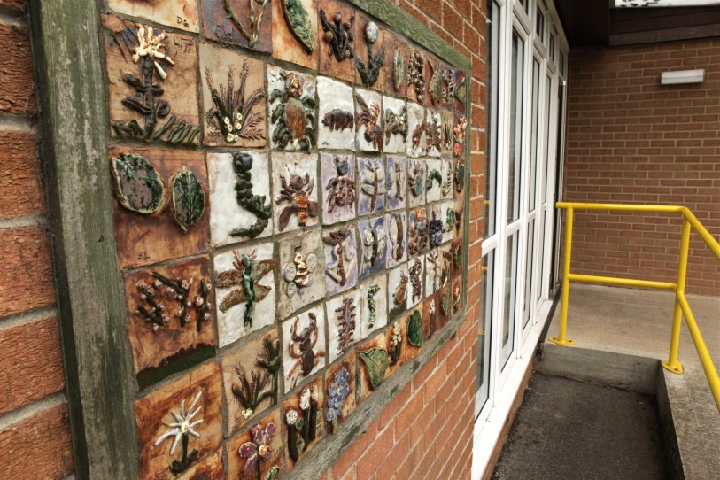
8

Priorities and Key Challenges

Priorities
Every year, the Headteacher, in consultation with the Governing Body and staff, sets the School Improvement Plan. The priorities for 2017/18 are linked to our Ofsted.

Improve teaching, learning and assessment in EYFS

Continue to improve outcomes in writing to ensure these are as
strong as those in reading and mathematics, particularly in KS2

Strengthen leadership and management by further developing
the role of middle leaders to improve the progression of skills
across the whole curriculum

Key Challenges
  - Maintain our standards as a good school and further enhance and improve these.
  - Continuation of support and professional development for all staff.
  - Continue to implement the new curriculum effectively and develop accurate, useable assessment protocols which support pupil learning.
  - Manage increased school admissions and pupil numbers.
  - Improve teaching, learning and assessment in EYFS
  - Continue to improve outcomes in writing.

9

Welcome from our Priest-in-charge

Thank you for considering the role of Headteacher for Wilberfoss C of E Primary School. The children know me as Revd Aysha and I am the half-time Priest-in-Charge of the parish.

Based at the Church of St John the Baptist (which is the only church in the village), we seek to serve as a focus for the whole community and welcome people of any and every tradition and denomination. We are a growing church and always have at least two services each Sunday. We also have special services each month suitable for families with young children and, for our young people and those newly confirmed, a more informal and interactive teaching Eucharist.

The Church and School have developed a good relationship and work together to strengthen the Christian ethos of the School and encourage visits and links with the Church. I take Collective Worship on a regular basis and enjoy spending time in the School. We also have a gentleman at church who knows a lot about the history of our lovely Grade 1 listed building and his talks and tours have proved very popular with the pupils.

Church and School have often shared a charitable focus, especially in Lent, and I have been delighted when ideas and projects have ‘cross-pollinated’ and we have been able to work together in fun and
imaginative ways. A good example of this came in the form of “Toilet Twinning” which we sponsored at Church and I felt able to talk about when I took Collective Worship one morning.

I do hope you will consider applying for the post here. I greatly look forward to working with a new Headteacher and you may be assured of my prayers, support and a commitment to work with you for the good of the school and the wider parish.

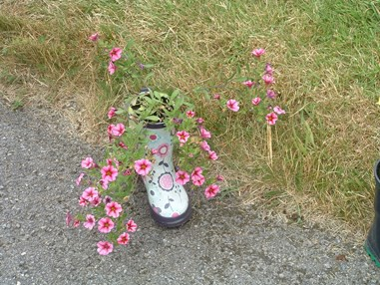
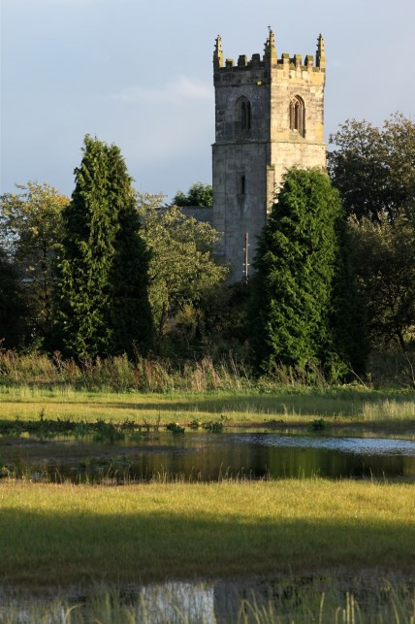
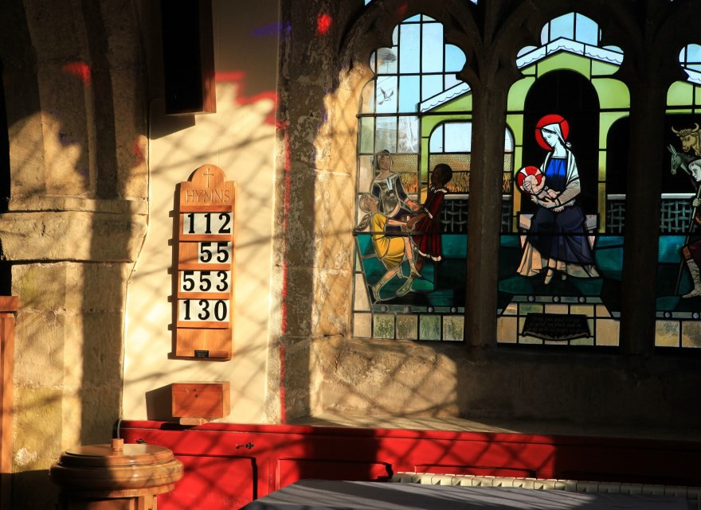

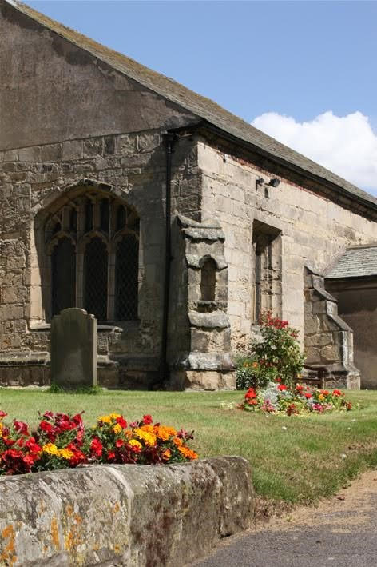

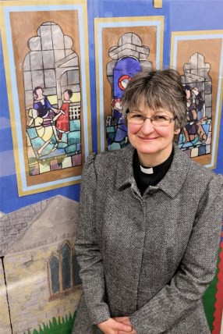
Every blessing Aysha

Wilberfoss School collected and planted lots of colourful boots to decorate our church path and give a wonderful sense of welcome to our Flower Festival.



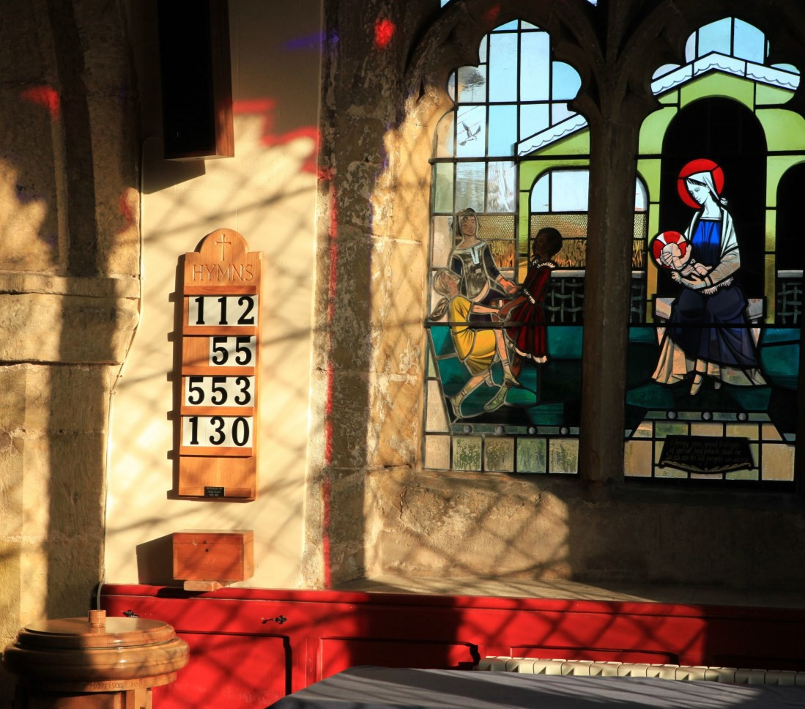
10

Our Diocese

York Diocesan Board of Education supports over 120 Church of England schools and academies in the area from the Humber to the Tees. We have a dedicated team of professionals who offer a wide range of expertise and can help schools access further assistance.

The Education team aims to:

- Be available as a ‘one-stop shop’ for pastoral and professional support;
- work with a range of agencies to promote school improvement;
- promote excellence and Christian distinctiveness;
- provide and facilitate professional development and governor training;
- help schools and academies network, collaborate together and share best practice;
- offer a Total Property Management scheme in association with DBE Services Ltd;
- guide schools on matters concerning trusts;
- work with schools exploring Academy conversion;
- advise in the appointment of staff, especially Headteachers;
- represent Church of England education to the wider church community and more widely to the public;
- maintain contact with local authorities and the Regional Schools Commissioners.

The Rt Revd Paul Ferguson, Bishop of Whitby and Chair of the Diocesan Board of Education, said:
“Our schools and academies are a vital part of the mission of the Church of England in the Diocese of York. Staff and governors are strongly committed to their communities, and in many cases the influence of church schools can only be described as transformative.
We strive to offer our young people the very best in every aspect of education, including encouraging them to mature spiritually and to understand how faith informs good relationships and responsible citizenship. We aim for our schools to be places where the love of God in Christ is truly reflected.
If these aims and values resonate with you, we hope that you will consider applying to come to Wilberfoss to lead our school into the next phase of its life.”

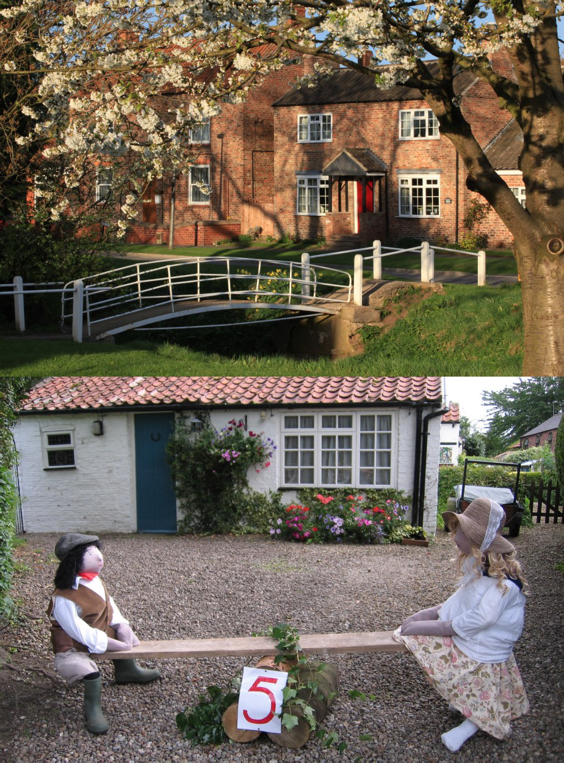

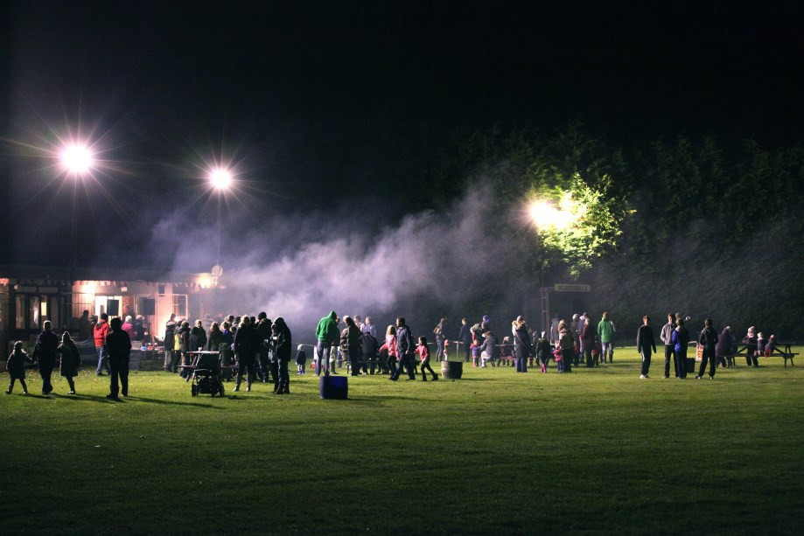

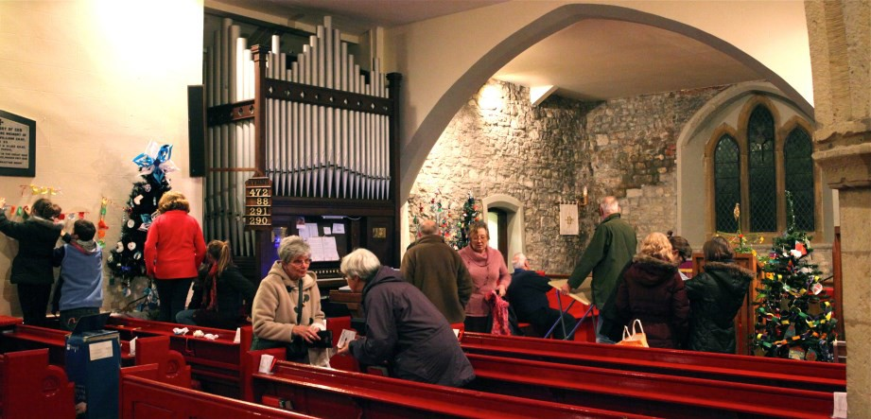

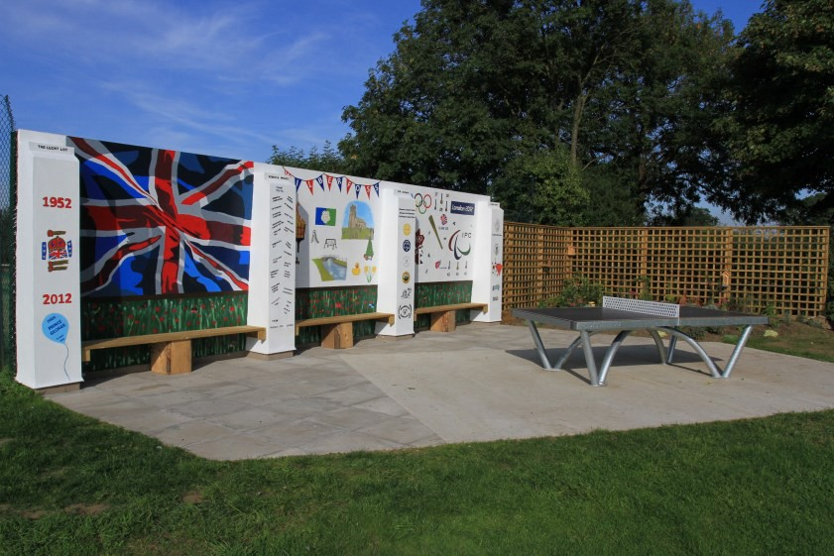
11

Wilberfoss Village - the best of both Worlds

Wilberfoss is a pretty village lying just 8 miles outside the beautiful and historic city of York. Whilst York offers a plethora of cultural, eating and entertainment options, the area also offers plenty for lovers of the outdoors as Wilberfoss sits on the edge of the Yorkshire Wolds, an area of magnificent, unspoiled scenery, beautiful market towns, outstanding country houses and a sweeping coastline. With a well connected road system it’s also possible to be in Leeds within 40 minutes and via rail from York, London is a mere 2 hours away.
Both the school and the grade 1 listed 15th century parish church of St John the Baptist are at the heart of the village and have forged close links within the community. Village life is vibrant with activities such as the annual duck race on the beck, Wilberfoss in Bloom, Wilberfoss Wildcats (the junior football team), Women of Wilberfoss (our WI) to name just a few. Pupils, parents and grandparents play a full role in all of these activities.
We also have a community centre, The Oddfellows Arms public house, local shop/post office, butcher, hairdresser, sports pavilion and playing fields, a playground and a private nursery next to the school.
All in all we think Wilberfoss is a great place to live and learn and we would be very happy to welcome you into our community.

12

Job Description
Post title: Headteacher
Salary range: Group 2: L14 – L 20
Responsible to: Governing Body, Local Authority and the Diocese of York

The Headteacher will take overall responsibility for the leadership, organisation, management and conduct of
Wilberfoss Church of England Voluntary Controlled Primary School in accordance with the school’s policies and in consultation with the Governing Body.

As a Church of England school, the Headteacher will maintain and encourage a strong Christian ethos ensuring that everyone is treated with equal respect and opportunity.

The Headteacher will work with the staff, governors, parents and carers, the Diocese and the Local Authority to foster a productive learning environment, which is inspiring, engaging and fulfilling for the whole school community, building upon the existing strong foundations to maintain and further improve all aspects of the school’s standards and quality.

The Headteacher will ensure the school is fully compliant with all current statutory requirements, local and national policies with particular reference to the guidance on safeguarding and the promotion of the wellbeing of children. Equality, safety, respect and a Christian ethos will underpin all aspects of the Headteacher’s work.

The Headteacher will be an outstanding teacher who is enthusiastic about their own continuing professional development and that of the staff. The Headteacher will be committed to developing the distinctiveness of the school and will welcome the support and training opportunities offered by the Diocese to support and develop their effective leadership of this church school.

Leadership, Strategic Direction and School Improvement

The Headteacher will confidently articulate, live out and promote the vision for the school rooted in distinctively Christian values and be committed to further developing the school’s ethos and educational vision towards:

- A fair and equitable environment that treats everyone with dignity and respect, developing a positive climate that motivates all members of the school community;
- continuing high standards in all aspects of school life, leading to excellence in the achievements and personal development of all pupils and staff;
- nurturing all children so that they reach their full potential;
- a drive for excellence in all aspects of school life ensuring outstanding teaching and successful learning;
- ensuring that the school’s successes are celebrated and communicated to the wider community to promote positivity;

The Headteacher will promote effective relationships with pupils, staff, governors, parents and carers, the local church, Friends of Wilberfoss School (FOWS), community, Local Authority, Diocese, other schools and other external bodies. The Headteacher will work closely with the staff and Governing Body, drawing on experience and best practice, to build a strong strategic direction that:

- drives and secures continuous improvement in the school environment and staff effectiveness;
- provides a rich and vibrant curriculum ensuring the school effectively meets statutory requirements and delivers a well-balanced education that will sustain a thirst for knowledge, understanding and a passion for learning throughout life;
- ensures that the school’s curriculum has a positive impact on the behaviour and learning of all pupils, contributing fully to their well-being and their social, moral, spiritual and cultural development;
- supports and leads the effective management of the school including financial planning, organisation and administration.

13

Job Description (continued)

Leadership, Strategic Direction and School Improvement

The Headteacher will lead by example – with integrity, creativity, resilience, and clarity – drawing on their own experience, proficiency and skills, and that of those around them to:
- Maintain a highly visible and approachable manner to all members of the school community;
- demonstrate positive relationships and attitudes to all individuals encountered through their work;
- ensure that all those involved in the school are committed and motivated to establish and achieve the school’s aims and objectives;
- model professional standards in all aspects of their work and demonstrate an effective work life balance, offering guidance for staff in the management of their workloads and creating a positive and supportive working environment;
- provide a safe, calm and well-ordered environment for all pupils and staff focused on safeguarding pupils and developing their exemplary behaviour in school and the wider society;
- ensure that arrangements for collective worship meet statutory requirements and promote understanding of the Christian faith and respect for other faiths and cultures;
- monitor, evaluate and review the effectiveness of the school, its priorities and policies in consultation with staff and the Governing Body;
- continue to develop and enhance collaborative working;
- inspire, develop and manage a highly effective team with enthusiasm and a continuous drive towards excellence;
- ensure all staff have distinct roles and responsibilities and are held to account;
- implement and sustain effective systems for management of staff performance and development, incorporating appraisal systems and targets;
- welcome strong governance and actively support the Governing Body to understand its role and deliver its functions effectively – in particular its functions to set school strategy and hold the Headteacher to account for pupil, staff and financial performance;
- embrace the guidance set out in the National Standards of Excellence for Headteachers (Department of Education, January 2015) with the aim of raising aspirations, securing high academic standards, empowering staff, and building public confidence in relation to Wilberfoss School.

Learning and Teaching

The Headteacher will:
- Create an environment that inspires outstanding teaching, effective learning, high standards of achievement, exemplary behaviour and a passion for learning;
- welcome opportunities to nurture curious minds within and beyond the classroom and develop creativity;
- be accountable for ensuring that all pupils make maximum progress across all areas of the curriculum;
- ensure parents and carers have a range of opportunities to be fully involved in their child's learning and the life of the school;
- ensure that effective teaching strategies are closely matched to the needs of each and every pupil;
- ensure equality of learning for all and inspire every child to be the best that they can be;
- spend time in the classroom, both to model and celebrate best practice;
- understand what outstanding teaching and learning looks, sounds and feels like and communicate this effectively;
- put in place effective strategies for continuous assessment, monitoring and evaluation of pupil learning and progress;

14

Job Description (continued)

The Headteacher will:
Pastoral Care
  - Develop positive relationships to create an ethos where children and families feel safe and nurtured as individuals;
  - create an ethos where every staff member feels valued, motivated, and supported to develop their own skills and subject knowledge and to support and encourage each other;
  - develop a fair, inclusive and equitable environment;
  - establish open and transparent systems and channels for communication.
  - create a culture where attitudes to learning are positive, leading to high engagement and a happy school environment;
  - implement effective safeguarding procedures that ensure the safe recruitment of all staff and the safety of all members of the school community with respect to e-safety, personal security and health and safety.
  - provide support, guidance and challenge for each member of staff so that they are able to give of their very best for the good of the whole school;
  - identify emerging talents, coaching current and aspiring leaders in a climate where excellence is standard, leading to appropriate delegation of leadership responsibilities and clear succession planning;
  - enhance the current and future value of teaching through high quality training and sustained professional and personal development for all staff.

15

Person Specification

Appointment criteria |  | Essential | Desirable | Measured by
 |  | Essential | Desirable | Application | Interview | Task | References
Qualifications and Training
1 | DfE recognised Qualified Teacher Status | X |  | X |  |  | X
2 | A relevant Honours degree or equivalent | X |  | X |  |  | X
3 | National Professional Qualification for Headteachers (NPQH) |  | X | X |  |  | X
4 | Evidence of recent continued professional development relating to leadership and management (curriculum planning, teaching and learning) | X |  | X |  |  | X
Characteristic Skills and Abilities
5 | Demonstrates excellent interpersonal skills with the ability to create good relationships and rapport across the school community. | X |  |  | X | X
6 | Has a clear understanding of the distinctive Christian characteristics, ethos and values of a Church of England primary school and how they underpin  all aspects of school life. | X |  | X | X | X
7 | Demonstrate experience of working in collaboration and/or partnership to develop positive relationships and achieve strategic objectives. | X |  | X | X
8 | Has high expectations and personal integrity with the ability to promote  and sustain the highest education, welfare and wellbeing of every child. | X |  | X | X | X
9 | Aspires to be an inspirational leader who demonstrates energy and ideas with enthusiasm. | X |  | X | X | X
10 | Recognised as an outstanding teacher with recent involvement in  strategic leadership in a primary school setting. | X |  | X | X | X | X
11 | Has proven experience in managing change and implementing new initiatives. | X |  | X | X |  | X
12 | Has a proven track record of contributing to successful school self-  evaluation and school improvement in raising standards. | X |  | X | X |  | X
13 | Has successful experience of effective strategic, financial and resource management to achieve educational priorities and ensure value for  money. |  | X | X |  |  | X

16

Person Specification

Appointment criteria |  | Essential | Desirable | Measured by
 |  | Essential | Desirable | Application | Interview | Task | References
Professional Experience and Knowledge
14 | Exhibits high quality organisational and time management skills. | X |  | X |  | X
15 | Is articulate and approachable with excellent interpersonal communication skills, both verbally and in writing. | X |  | X |  | X
16 | Presents a proven track record in inspiring, leading, empowering and  managing staff. |  | X | X | X |  | X
17 | Can demonstrate ability to lead and implement a strategic school development plan, based on robust and accurate self-evaluation. |  | X | X |  | X
18 | Is able to articulate a vision of exemplary school leadership, putting  continuous improvement and pupil outcomes at the core of fair and effective management. | X |  | X | X | X
19 | Can recognise high performance and address underperformance. | X |  | X | X
20 | Has knowledge and experience of effective safeguarding and child  protection procedures and will ensure that all members of the school community share that commitment. | X |  | X | X |  | X
21 | Shows commitment to and evidence of promoting diversity and equal opportunities within the school curriculum and employment practices. | X |  | X | X
22 | Has some experience in the recruitment, selection and induction of staff  and volunteers. |  | X | X
23 | Has an understanding and ability to use a range of IT systems as required. | X |  | X |  | X
24 | Demonstrate an understanding and willingness to apply the National Standards of Excellence for Headteachers (Department of Education, January 2015) in relation to primary school education. | X |  |  | X | X
Leading Teaching and Learning
25 | Is an outstanding, reflective practitioner, who can model highly effective teaching skills and has high expectations for pupils’ learning and achievement. | X |  | X | X |  | X
26 | Is experienced in national and wider curricular development. |  | X | X | X
27 | Can demonstrate successful experience of positive behaviour management and developing a pupil-focused inclusive and effective  learning environment. | X |  | X | X |  | X

17

How to apply

Deadline for Applications
Friday 6th October 2017 (Midnight)
Thank you for your interest in the vacancy for the headship at our school.
Candidates are welcome to make an informal visit to school prior to making an application. Please contact Nicky Lyons (SBM) in the school office to make arrangements 01759-380327

If you decide to apply for the post, please complete an online application form at www.recruiteastriding.co.uk, ensuring that you clearly detail how you meet all of the essential requirements in our employee specification. In addition, please outline your vision for primary education in the section of the application form headed ‘Supporting Statement’.

For your information, the recruitment timetable is detailed below:

- Online applications close at midnight on Friday 6th October 2017
- Shortlisting date Tuesday 10th October 2017
- Interview Day 1 Monday 23rd October 2017
- Interview Day 2 Tuesday 24th October 2017
- Governing board ratification meeting Tuesday 24th October 2017
- Appointment confirmed by LEA w/c 30th October 2017
- Contract Start Date 9th April 2018

If you are unable to submit an online application form, hard copies must be returned by the closing date:
Scan and email to recruitment.services@eastriding.gov.uk

By post to Recruitment Services, County Hall, Beverley, East Riding of Yorkshire, HU17 9BA

18

Wilberfoss School - “Learning for Life – Aiming for Excellence”

“kind, patient, understanding, strong, confident teachers ”

“The school sets high standards”

“A lovely village school with lots going on”

Parent & carer comments

“office.. well organised and readily answer
queries”
“Children respect teachers”




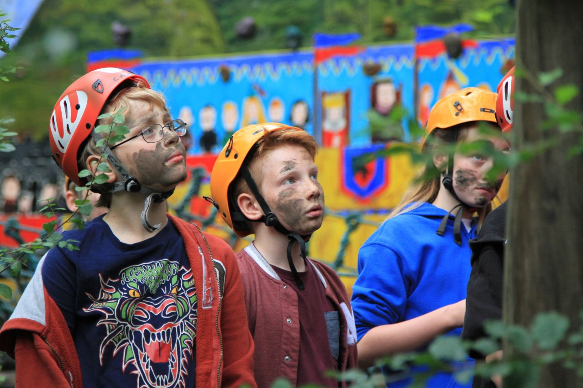







“What stands out for us as exceptional are the brilliant staff... and the way that they all work together as a cohesive team”

Wilberfoss Church of England (VC) Primary School 2017

