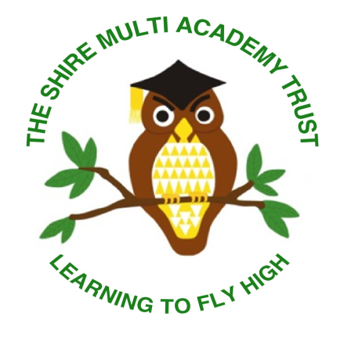
Information for Prospective Candidates.

Our Future
Education is ever changing, evolving to meet our ever changing society. Children need and deserve an education that is right for them.
At the Shire Multi Academy Trust our ethos is simple. We put children first; we provide them with opportunities and experiences via which they can excel creating a Trust-wide learning culture where children thrive.
The Trust recognises that our future lies in creating a collaboration of autonomous schools that meet the needs of all pupils, where academies will be actively encouraged to ensure that their operations meet the specific needs of the community to which they belong.
With these principles in mind the Shire Trust will:
- promote excellence for all pupils,

- actively encourage shared working, adopting common approaches where it is in the best interest of pupils,

- establish robust systems of accountability,

- delegate decision making to the individual academy, providing this proves effective,

- provide effective support and intervention in academies where required.

Our Vision
We believe in Leaders Leading. We believe in Teachers Teaching. We believe in Children Learning.
Our Trust aims for all its schools to collaborate sharing expertise and skills. We listen to, value and strategically utilise the experience and practice of all. We embrace each other’s strengths and openly support each other’s developments. Learning together makes us stronger.
Our Trust aims for inclusivity. We know that success in modern Britain depends upon respecting, understanding and celebrating difference. We welcome all. We endeavour to improve the lives and life chances for our children and their families. As a Trust we nurture, celebrate achievement and recognise success in order that all our children become confident citizens of the future.
As a Trust we innovate. In the fast paced world of education in the 21st century we welcome challenge and provide an environment that encourages staff reflection and debate about the way they teach. We want our schools to create a climate in which teachers are motivated and trusted to take risks, to be inventive, to ‘think out of the box’ in ways that suit the uniqueness of our schools.
Our Trust has a culture amongst all stakeholders that makes it unequivocally clear there are no excuses for children not achieving high standards in their learning and behaviour. Rigorous quality assurance is ensured through strong governance and a framework of accountability and responsibility by all.
‘Learning to fly high’ is our motto. Our children engage with exciting learning journeys that provide a wealth of experiences fostering future aspirations. From jumping in puddles to playing a tuned instrument we aspire to be the best that we can be.

The Role of Local Governing Bodies

The Local Governing Bodies provide support and challenge to Heads of School in ensuring every child makes good or better progress and that parents & carers are fully involved in their child’s education. The Local Governors are active in supporting our schools they have a variety of experiences and perspectives and come from a range of backgrounds. We value their expertise and input into making our academies successfully.

The Executive Leadership Group
The Trust operates an Executive Leadership Group (ELG). The ELG is chaired by the Executive Headteacher and is composed of the Finance Director, Director of Strategic Improvement, Director of School Improvement and the Heads of School. The goal is to support the development and underpin the collaborative intentions of the trust.
The ELG will meet on a regular basis to consider and advise on the business of the Trust and the improvement of all Academies and any cross-trust initiatives.

We hope that this information has given you an insight into our ethos, vision and how we work collaboratively across our schools. We look forward to your application if you feel you would like to join our team and make our vision a reality.

