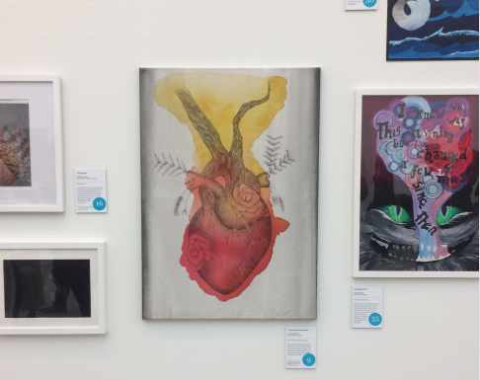

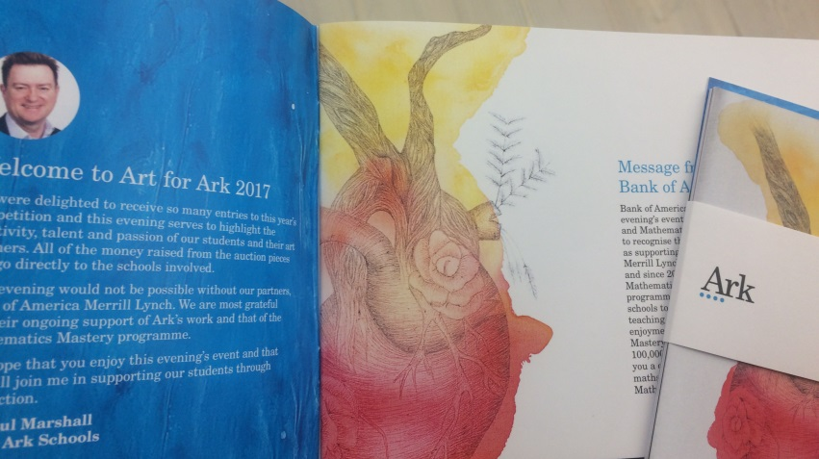



Teacher of Art

Candidate

information brief

**October 2017**

Dear candidate,

Thank you for taking the time to find out more about King Solomon Academy Secondary School in Westminster and the possibility of joining us. Included in this information pack is information about the academy, and the role of Teacher of Art.

The teacher of Art will teach art across the school. This will involve teaching across Key Stages, including Primary and teaching GCSE and A-level where pupils chose art as an option. We are committed to building on the excellent beginnings of art in the school and build passion and success for our pupils. The successful applicant will have experience of teaching Art to primary aged pupils.

This is a unique opportunity for a teacher to creatively drive forward a programme of artistic success. Our central London location offers opportunities for excellent partnerships with local galleries and other organisations. The successful candidate will have the relevant experience for leading art teaching, and the drive and enthusiasm to inspire pupils and teachers.

For further information about the role and the school and to apply please go <http://kingsolomonacademy.org/current-vacancies>**.**

The application deadline is by **11am** on **Wednesday 18th October 2017.**

For an informal conversation about the role, please contact Francesca Waters, Recruitment Manager at [recruitment@arkonline.org](mailto:recruitment@arkonline.org) and 0203 116 6345.

We wish you the best with your application.

Yours sincerely,



**Max Haimendorf**Principal

**Job Description: Teacher of Art (all-through)**

**Reports to:** Head of All-through Art

**Start date**: January 2018

**Salary**: Ark MPS/UPS (Inner London): £29,375 - £48,478 dependent on experience

**The Role**

To provide outstanding teaching and learning to ensure exceptional progress of their students.

**Key responsibilities**

* Prepare, deliver and assess learning to a high standard, ensuring great outcomes
* Lead in class and out of class projects which bring Art to life in the school
* Where teaching in primary allows it, create and deliver learning which incorporates Design Technology into Art projects
* Provide a nurturing classroom and school environment that helps students to develop as learners
* Helping to maintain/establish discipline across the whole academy
* Contribute to the effective working of the Academy

**Outcomes and activities**

**Teaching and Learning**

* To teach engaging and effective lessons that motivate, inspire and transform pupil attainment.
* With direction from appropriate curriculum leaders, assist in the creation and development of challenging and innovative schemes of work which are inspiring for learners and teachers alike.
* Use regular, measurable and significant assessments to monitor progress and set targets.
* Respond accordingly to the results of such monitoring.
* Ensure that all students achieve at chronological age level or, if well below level, make significant and continuing progress towards achieving at level.
* Maintain regular and productive communication with parents, to report on progress, sanctions and rewards and all other communications.
* To develop an exciting and motivating extra-curricular and enrichment offer including university links, trips and residentials.

**Academy Culture**

* Help create a strong academy community, characterised by consistent, orderly, caring and respectful relationships
* Help develop a small school culture and ethos that is utterly committed to achievement

**Other**

* Undertake other various responsibilities as directed by the Principal or their designate.

**Person Specification: Teacher of Art**

**Qualification criteria**

* Qualified to degree level and above
* Qualified to teach in the UK
* Right to work in the UK

**Experience**

* Experience of raising attainment in a challenging classroom environment
* Experience of teaching primary aged pupils and ideally secondary aged pupils Art
* Experience of continually improving the teaching and learning of their subject though schemes of work and extra-curricular activities etc.

**Skills and attributes**

We are looking for these skills and attributes or at the very least, a clear, demonstrable capacity to develop them:

**Leadership**

* Effective team worker and leader.
* High expectations for accountability and consistency.
* Vision aligned with KSA’s high aspirations, high expectations of self and others.
* Genuine passion and a belief in the potential of every student.
* Motivation to continually improve standards and achieve excellence.
* Commitment to the safeguarding and welfare of all pupils.

**Teaching and Learning**

* Creative, and highly skilled instrumentalist
* Excellent classroom practitioner.
* Effective and systematic behaviour management, with clear boundaries, sanctions, praise and rewards.
* Has good communication, planning and organisational skills.
* Demonstrates resilience, motivation and commitment to driving up standards of achievement.
* Commitment to regular and on-going professional development and training to establish outstanding classroom practice.

**Alignment with KSA vision**

* Relentless drive to do whatever it takes to ensure all students succeed.
* The belief that with the right environment more than 95% of our pupils are able to excel at University.
* The courage and conviction to make a difference.

**Alignment with KSA Art vision**

* The belief that through a coherent and rigorous primary art programme, excellence and aspiration will be achieved in our older pupils
* A belief that Art should be visible and celebrated in the life of our school.

**Communication skills**

* The ability to listen and communicate effectively.
* Empathy and the ability to understand the needs, aspirations and motivation of diverse individuals and groups.
* The ability to influence and motivate others.

**Problem solving**

* Identify, analyse and resolve problems and issues.
* Develop plans with concrete outcomes and effective solutions.
* Evaluate results and identify necessary actions.
* Make fact-based decisions.

**Resilience**

* Sustain energy, optimism and motivation in the face of pressure and setbacks.
* Stay calm in difficult situations and maintain clarity of vision.
* Be adaptable in the face of adversity.

**Results and learning orientation**

* Awareness of own strengths and limits.
* Commitment to ongoing improvement and learning.
* A passion for teaching subject.
* Focus on achieving challenging goals and results.
* Resourcefulness and flexibility in delivering outcomes.

**Other**

This post is subject to an enhanced Disclosure and Barring Service check.

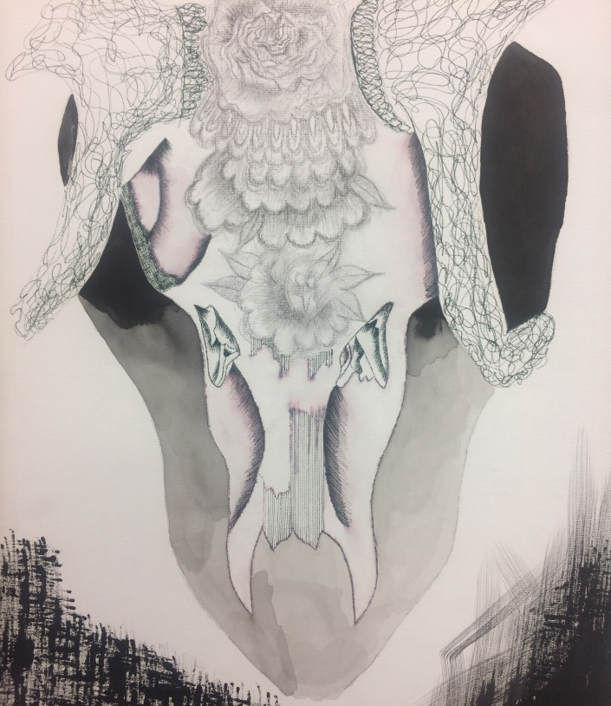

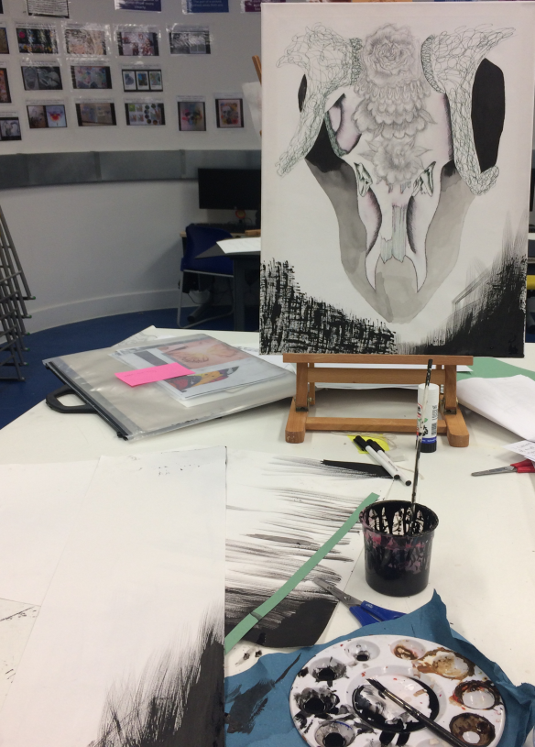

**Principal

Max Haimendorf graduated from Oxford and joined the first cohort of the Teach First programme, teaching Science in West London. Following work at Teach First central office he joined the consultants Oliver Wyman where he worked in finance strategy. Whilst there he wrote about the importance of small schools in Teach First’s first Policy Paper, Lessons from the Front. In 2008 he was appointed as Secondary Headteacher of King Solomon Academy, starting the Secondary part of the school in September 2009. He has now led KSA through two outstanding Ofsted inspections and to achieve the highest GCSE results in the country for a non-selective school in 2015. He became all-through Principal of KSA and Executive Principal of Ark Paddington Green Primary Academy in September 2016.

*“We are dedicated to doing whatever it takes to ensure each of our pupils has the chance to attend an academically rigorous university.”*

**Max Haimendorf, Principal**



**About Art at KSA**

The vision is to provide opportunities for students to create a wide variety of work with detailed explorations in mediums such as painting, drawing, printmaking and sculpture. Students will be introduced to relevant artists and art styles, students will learn to compare, analyze, evaluate and discuss their own work as well as the work of others. We take great pride in exhibiting our pupils’ work throughout the start artist wall, art work framed around the school and exhibitions.

We want to inspire pupils to learn the skills of great artists so that they can enjoy the process and outcomes of endeavour in art. In Key Stage 1, 2 and 3, this means giving pupils access and opportunity to develop their artistic skills and interests. In these early years we currently teach design technology through art, broadening our pupils understanding of designing, creating and manipulating materials.

We have now taught GCSE Art for several years and intend to launch A-level Art. With the support of the Head of Art, the successful candidate will have the opportunity to drive the expectations and strategy for the teaching and learning of art at our school.

**Curriculum allocation**

|  |  |
| --- | --- |
| **Year group** | **Allocated hours** |
| KS1 + 2 | 1 hour per week |
| KS3 | 1 hour per week |
| 10 | 3 hours per week |
| 11 | 3 hours per week |
| 12 | 6 hours per week |
| 13 | 6 hours per week |

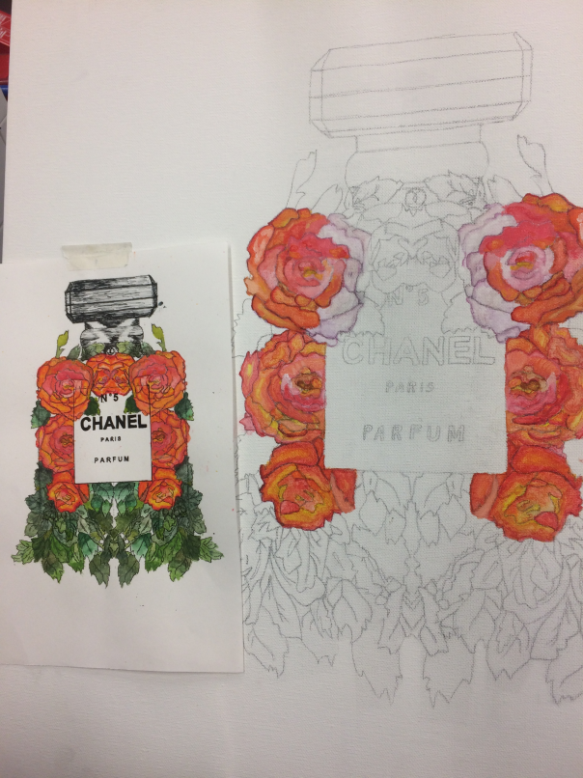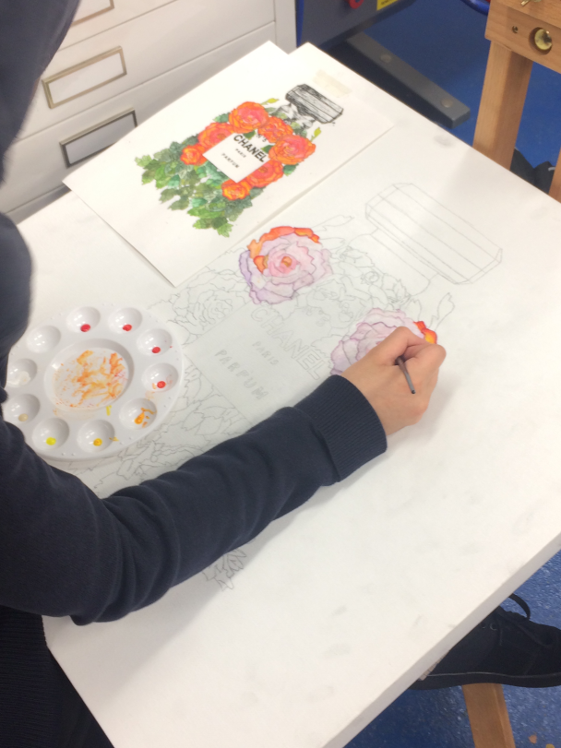

**MMiss Panayides, Head of Art**

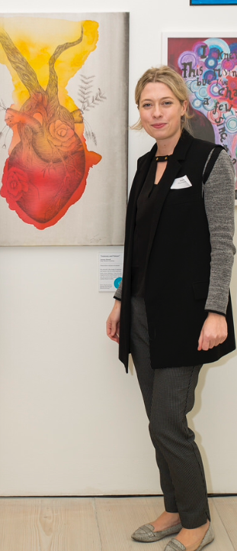

Ms Panayides was brought up in Cyprus and moved to the United Kingdom to pursue her passion in Art.

She graduated from the University of Reading with a BA in Fine Art before completing a PGCE.

Prior to joining KSA Ms Panayides was Head of department and Deputy Head of year in a school in Reading.

Ms Panayides leads all through Art at KSA. Art curriculum runs through Primary all the way to sixth form. Ms Panayides has created a curriculum that links all the skills needed to progress in all Art ready for GCSE.

In her spare time, she enjoys attending art exhibitions to keep up to date with current artists.

**Being part of the Ark network**

Ark is an international charity, transforming lives through education. We exist to make sure that every child, regardless of background, has access to a great education and real choices in life.

We know that great schools need great teachers, which is why we offer you the very best training and support at every stage of your career - from starting out as a trainee to running your own school.

Our highly-successful network of 34 schools educates over 20,000 students across Birmingham, Hastings, London and Portsmouth. They are achieving some of the best results in the country despite being largely in areas of historic academic underachievement.

Ark schools prioritise six key principles: high expectations; excellent teaching; exemplary behaviour; depth before breadth; more time for learning; knowing every child.

Ark invests significantly in a number of professional development programmes which complement academy level training:

* The Ark training menu: we have developed a bespoke training menu, which is accessible by all staff in the network offering a wide range of training modules to staff in all roles
* Network support: schools share CPD, allowing us to share best practice and role specific training across the network, facilitated by in-school and central staff
* Ark staff receive 10 training days each year rather than five.

***Ark runs a number of additional programmes, including:***

* Leading Impact for senior leadership development
* Lead Teachers, aimed at developing the skills of outstanding teachers to improve performance of other teachers
* Outstanding Teachers, aimed at good teachers aiming to improve and embed outstanding practice
* SEN training for new to role and established SENCos
* New Teacher induction

Ark is at the forefront of changing education society through education. We run Initial Teacher Training through School Direct and we co-founded the Future Leaders and Teaching Leaders development programmes.and offers teachers and support staff a comprehensive range of school-based first class professional development opportunities.

**Ark Safe Recruitment Procedure**

Ark is committed to safeguarding and promoting the welfare of children and young people in its academies. In order to meet this responsibility, its academies follow a rigorous selection process to discourage and screen out unsuitable applicants.

**Disclosure**

This post is classified as having substantial access to children, and appointment is subject to an enhanced police check of previous criminal convictions (DBS). Applicants are required, before appointment, to disclose any conviction, caution or binding over including ‘spent convictions’ under the Rehabilitation of Offenders Act 1974 (Exemptions) Order 1975. Non-disclosure may lead to termination of employment. However, disclosure of a criminal background will not necessarily debar individuals from employment – this will depend upon the nature of the offence(s) and when they occurred.

**Reference checking**

References from the previous and current employer will be taken up for shortlisted candidates, and where necessary employers may be contacted to gather further information.

**Probation**

All new staff will be subject to a probation period of six months (which may, in certain circumstances, be extended by up to 10 weeks). The probation period is a trial period, to enable the assessment of an employee’s suitability for the job for which they have been employed. It provides the academy with the opportunity to monitor and review the performance of new staff in relation to various areas, but also in terms of their commitment to safe guarding and relationships with pupils.