Science Department
The Science Department at Highams Park School is an accomplished and friendly department; it has 16 well qualified, highly motivated teachers who work well as a team in a highly supportive atmosphere.

The Science department consistently achieves very good results across all 3 key stages. Our success is largely due to having an established committed group of hardworking enthusiastic teachers who have high expectations of our students.

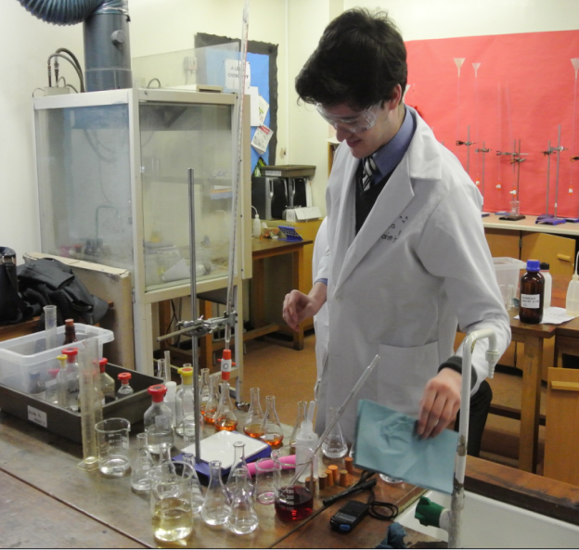
The department has the use of 9 laboratories, a science staff room, a dark room, a resource room and 4 prep rooms. All of the labs have recently undergone a complete refurbishment. We are supported by an efficient and highly skilled technical support team.

At Key Stage 3 students receive 3 one hour lessons for science out of the weekly 25-hour timetable. Our schemes of work are based on the National Curriculum, they follow closely the programmes of study as set out by QCA and they allow for progression in concepts across the Key Stage. The schemes of work are supported by a programme of regular formative and summative assessment.

At Key Stage 4 students will follow one of 2 routes determined by teachers based upon student performance during Key Stage 3 and teacher’s professional judgement as outlined below:

- Pupils study a Combined Science course which leads to students gaining two GCSEs in science.
- Pupils study three separate Science disciplines in Biology, Chemistry and Physics. Students achieve 3 GCSEs. (This route involves an additional lesson after school and additional homework).

Both courses are based on the same body of knowledge and have a similar emphasis on exploration and investigation. Our A*-C results are outstanding.

The school has large and vibrant sixth form. All 3 A-level sciences, Biology, Chemistry and Physics are popular options and students regularly proceed to study science subjects at higher education.
The science department provides an enjoyable, forward thinking and professionally supportive environment. Standards of achievement are very high and the department plays a key role in contributing to our very positive whole school ethos. We value every student as an individual and continually strive to meet the needs of each child.

We look forward to meeting potential candidates who are interested in joining the department and are willing to contribute to the future plans for developing the department further.

