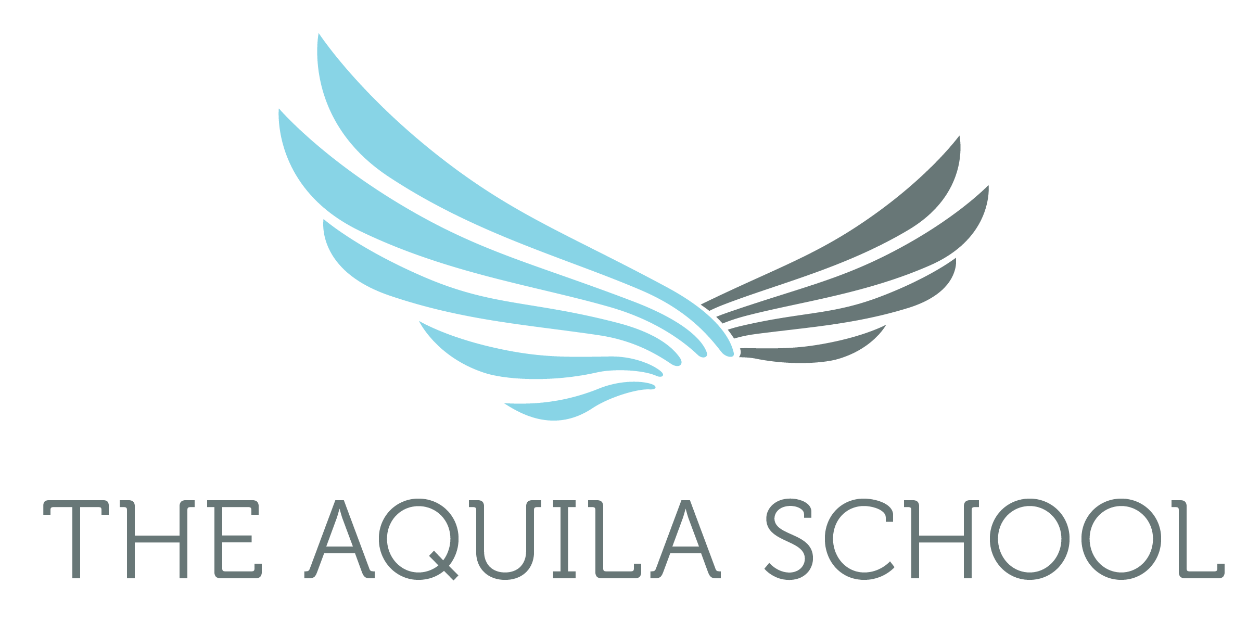
Primary class teachers, music, PE and swimming teachers
Description of the school:
The Aquila School will open in September 2018, initially with only primary children, eventually becoming a mixed 3-18 through school. The school is located in a residential area of Dubailand and will focus on providing children with amazing learning. The vision for the school is real learning for a real future, with an emphasis on inclusion, learner led activities and encouraging children to make choices about their own learning. Teachers should be skilled at ensuring that children are actively learning throughout each lesson. Design and technology will be a key feature of the curriculum.
The Aquila School will be the first new build school designed and managed by The International Schools Partnerships (ISP) a comparatively new and rapidly growing organisation with schools in Europe, the Middle East, Mexico and the USA.
As well as the exciting opportunity of working in a new school, staff will also receive a generous tax free salary, housing, annual flights, health insurance, free child places for dependent children, shipping at the beginning and end of contract and an end of service gratuity.
To apply please send a copy of your CV and a letter of application (maximum one side of A4) stating what you can offer a new school to principal@theaquilaschool.com by 14th November 2017. Initial skype interviews will take place before the end of this term.

Person Specification:
Essential | Desirable
Qualified teacher status recognised in the UK (for class teachers, PE and music teachers) OR a recognised qualification to teach Arabic, Islamic or Social Studies in the UAE  At least one years teaching experience post qualification  Ability to use initiative, be flexible, fun, proactive and positive  Ability to plan lessons which enable children to be independent, active learners and make as much progress as possible  Willingness to work above and beyond to contribute to the development of a learning community  Ability to form and maintain professional working relationships with all members of the school community | Experience working in a range of key stages  Experience working in an international school  Evidence of continuing professional development  Interest in a particular curriculum area

Job Description Teacher:
Key qualities:
- To be able to teach in an enjoyable, creative, and inclusive way, promoting independence, so that every child makes as much progress as possible
- To be able to develop positive working relationships with all members of the school community
- To be able to use initiative, be flexible, fun, proactive and positive

Core purposes:
- To be accountable for ensuring that children are inspired, motivated and equipped to make as much progress with their learning as possible through ‘real learning’
- To work collaboratively with colleagues and families
- To have a positive impact on the work of the school

Key duties include:
- To ensure children are safe and well cared for at all times
- To plan and deliver creative and engaging lessons, ensuring that children are actively learning throughout each lesson
- To ensure effective communication and direct the work of others, as appropriate
- To lead extra-curricular activities, participating and leading staff training and contributing to the establishment and development of the school community
- To comply with our agreed policies
- To actively engage with our school community e.g. through newsletters, informal dialogue, reporting, supporting school functions and contributing to community activities
- To actively participate in the performance management process of self and others

The Aquila School is committed to the safeguarding and welfare of our children and young people and expects all our staff to share this commitment. All posts are subject to appropriate checks and references prior to appointment.

