** Senior ICT Technician**

**Salary: Single Status Grade 8 £22,966 - £24,805**

**Full time permanent post**

Required January 2020

**INFORMATION FOR APPLICANTS**

**CONTENTS**

1. Letter from Headteacher
2. Job Description
3. Person Specification

January 2020

Dear Applicant

**Senior ICT Technician**

Thank you for your interest in this post.

We are St Catherine’s College – preparing students to stand shoulder to shoulder with their peers, locally, nationally and globally.

We are proud of our college, our talented and highly motivated staff and students. Our staff team work tirelessly to ensure that teaching is the best it can be and everyone has a role to play in this. We support each other and there is an open, friendly and collegiate atmosphere where new members of the team are welcomed and supported.

We are:

* An Investors in People Award School, which means that we invest heavily and value the development of all our staff
* An inclusive Church of England School with the benefits of links with The Diocese of Chichester and the opportunity to promote strong lasting values based on the Christian faith

Understandably this letter and our website only gives a flavour of the college. We therefore encourage visits for prospective candidates to see our college in action. We do understand however that visits are not always possible or practical and you would not be at a disadvantage if you are unable to visit the college.

**The Post**

We are looking to recruit a Senior IT Technician to provide IT support for both the curriculum and the administrative users throughout the College. The post holder will support the IT Manager with the development of the IT infrastructure and cloud resources available in the College.

Main tasks will include managing:

* AD, DNS, DHCP, Office 365 and Sharepoint online
* the smoothwall filtering system
* the Ruckus wifi system
* the network infrastructure in liaison with the IT Manager
* Support Windows, MacOS, iOS, Android
* The college servers, both physical and virtual
* Support teaching and learning by providing an on-call service to teaching staff throughout the day
* Provide advice, guidance and demonstrations to pupils and staff

The successful applicant will have previous experience of working in a senior IT role in a school; experience of learning advanced functionality with the key school software profiles and knowledge of Core IT technologies.

**We offer you**

**We know it’s a competitive market and are proud of what we can offer:**

* **Excellent career development opportunities**



* **A geographical location**, being situated near Sovereign Harbour, Eastbourne’s award winning Marina. It is part of several miles of beautiful coastline, including the South Downs National Park, the white cliffs of Beachy Head and 1066 country
* **A friendly**, supportive and caring staff team
* **CPD,** starts immediately upon employment
* **A fabulous staff room** with complimentary tea and coffee
* **A café** that serves at breakfast, break and lunch using freshly sourced ingredients
* **Local Government Pension Scheme**
* **Free Flu Vaccine**
* **Highly visible** supportive senior leaders
* **Great Students** – you can make a massive difference to them
* Did you know that buying a house in East Sussex can be cheaper than in many other counties in the UK.
* We are part of a growing trust, (Diocese of Chichester Academy Trust)

**Your Application**

Completed application forms and letters of application should be sent directly to the college addressed to Mrs S Windsor, Head of Personnel, SWindsor@stcatherines.college and arrive by no later than **noon on Monday 20 January 2020**.

Please use the standard application form, accompanied by a letter of application, which must be no more than two sides of A4. We are unable to consider CVs in place of application forms unless you are a person with a disability and a CV is the most convenient method of applying. In your letter of application you should clearly address the relevant sections of the Person Specification for this post and may find it helpful to use headings. We are committed to safeguarding and promoting the welfare of children and young people, successful applicants will need to undertake a DBS enhanced clearance.

I am conscious of the time and effort it takes to submit an application and am grateful for your interest. Shortlisted candidates should hear from us shortly after the closing date.

St Catherine’s is a thriving college with a bright future and a vibrant and collegiate atmosphere within which to work. I am keen that we appoint quality candidates to join what is, I believe, one of the best staff teams. If I can be of any assistance or provide any further information, please do not hesitate to contact me.

Yours faithfully



Solomon Berhane

Headteacher

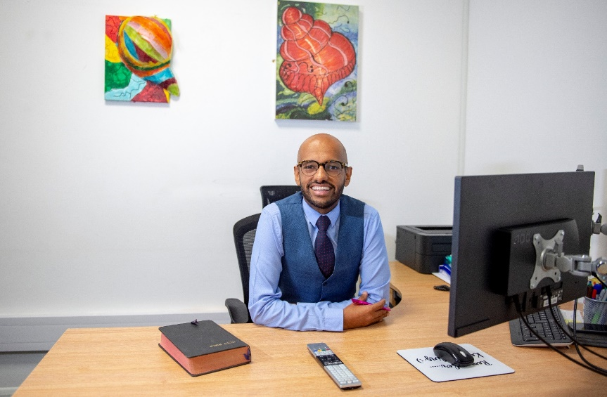

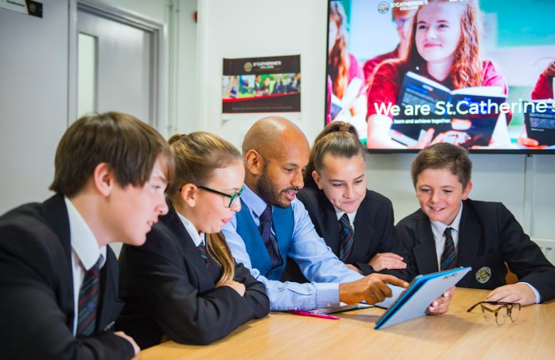

**Job Description**

Post: Senior IT Technician

Responsible to: IT Manager

Grade: Single Status Grade 8

Hours: 37 hours per week 52 weeks per year

**Main Purpose**

To provide IT support for both the curriculum and the administrative users throughout the College.

To support the IT Manager with the development of the IT infrastructure and cloud resources available in the College.

**Main Tasks**

**IT**

1. To manage AD, DNS, DHCP, Office 365 and Sharepoint online.
2. To manage the smoothwall filtering system.
3. To manage the Ruckus wifi system.
4. To manage and maintain the network infrastructure in liaison with the IT Manager.
5. To have the ability and passion to support Windows, MacOS, iOS, Android.
6. To manage the College servers, both physical and virtual.
7. To support teaching and learning by providing an on-call service to teaching staff throughout the day.
8. To provide advice, guidance and demonstrations to pupils and staff.
9. To keep up to date with new technology to ensure that St Catherine’s College has the most up to date IT systems available.
10. To actively support the school’s E-safety and Safeguarding Policy to ensure that our pupils, staff and network operate in a safe and secure manner.
11. To provide support to the IT Manager with purchasing software and hardware for the College. This will include gaining three quotes in order to achieve best value for money and is fit for purpose.
12. To assist the IT Manager in providing staff training.
13. To work alongside the IT Manager with the development of the IT system in school.
14. To work with the IT Manager to maintain the security of the local network and online presence.
15. To manage and maintain all system backups (network, servers, online resources and CCTV).
16. To work alongside the Data Manager to ensure that the MIS system is maintained, and updates are carried out efficiently.
17. To provide technical assistance for out of hours school events.
18. On rare occasions, be available ‘out of hours’ for emergency support to resolve issues remotely.
19. To manage and support the College’s mobile devices e.g. monitoring equipment loan system, daily set up of IT rooms and bookings.
20. To support the examinations department with IT technical support and set up.
21. To maintain the off-site PC’s, internet and phone system within our Motor Vehicle garage.
22. To install and maintain network cabling.
23. To install and maintain software within the College.
24. Review hardware specifications and plan upgrades.

**General**

1. To maintain the College phone system (including mobiles).
2. To maintain the College Asset Register.
3. To act as the College’s AV technician and to provide guidance to staff and pupils.
4. To develop the Reprographics facility and suggest areas for improvement to ensure an efficient, high quality and cost-effective print service is delivered to all stakeholders.
5. To install and maintain the digital CCTV system in the college.
6. To liaise with the Site Team to ensure that the PAT testing register is maintained.
7. To drive and develop your own CPD.
8. To work alongside the site team regarding school holiday projects.

**PERSON SPECIFICATION: SENIOR ICT TECHNICIAN**

|  |  |  |  |
| --- | --- | --- | --- |
| **Attributes** | **Essential** | Desirable | |
| Qualifications and training | * Suitable ICT qualifications * Good general education, with GCSEs or equivalent in English and Maths |  | |
| Experience | 🖹 Experience of IT services in a medium sized company / school  🖹 Experience of learning advanced functionality with the key school software profiles. | 🖹Experience of working in a senior IT role in a school  🖹Previous experience in a senior role | |
| Skills and Abilities | 🗣Ability to produce clear and well formatted documents   * Ability to work with tact and diplomacy and maintain confidentiality * 🗣 Able to communicate well, both in writing and orally   ✍ Able to manage time effectively and work to deadlines  🖹 Ability to perform reporting and analysis of help desk functions  ✍🗣Be reflective and proactive in seeking feedback to constantly improve practice  ✍🗣Initiative and ability to work without direct supervision, taking responsibility for tasks, prioritising and scheduling your own work |  | |
| Knowledge and Understanding | 🖹 Knowledge of school software profiles such as: Active Directory, Microsoft Office 365, SIMS, Booking systems. Follow-me-printing or similar systems. Sharepoint.  🖹 Understanding of the fundamentals of IT for IT infrastructure  🖹Knowledge of Core IT technologies including: Windows Server Suite. Configuring and supporting a hybrid operating system environment. Maintaining and Administering. | 🖹Previous line / project management knowledge. | |
| Values | * 🗣 Be broadly in sympathy with the aims and ethos of the School * A commitment to comprehensive education, equal opportunities and inclusion | 🗣 A practising Christian |
| Personal Qualities | ✍🗣 Approachable  ✍🗣High expectations of self and others   * Resilient, motivated and committed to achieving excellence * Is self-motivated and hard working * Possesses a sense of humour and the humility to admit mistakes * Shows imagination, vision and proactivity * Possesses an infectious enthusiasm, stamina and considerable energy * Ability to work under pressure to achieve, to have high expectations, lead by example and meet deadlines * Identify and undertake personal development opportunities and suggest personal development targets | 🖹 Excellent attendance record |

**Criterion assessed by:** 🖹 = application form; ✍ = letter of application; 🗣 = interview