French and Spanish Teacher, full time position
(Required for January or February 2020)

We are looking for an enthusiastic and dynamic teacher of French and Spanish with a good honours degree and excellent communication and interpersonal skills to join our successful MFL department in this high performing school.

The ability to teach French up to A level is essential as well as the ability to teach Spanish to GCSE level. This role would suit either a Newly Qualified Teacher or someone with more experience.

The successful candidate will work with the department in promoting a love of languages both inside and outside the classroom. A willingness to contribute to the extra-curricular life of the School is also a requirement.

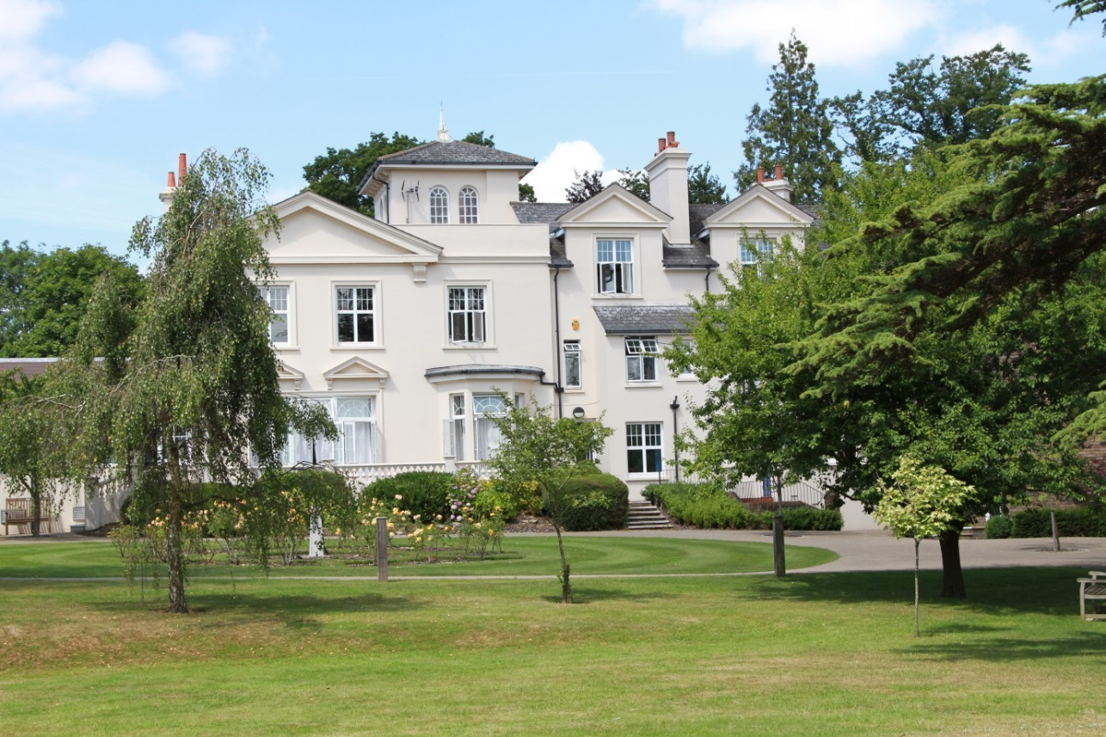

ABOUT THE SCHOOL

Location
The School is situated in a very pleasant thirteen-acre site in the conservation area of the town. Burgess Hill is a medium sized town with its own theatre, orchestra, cinema and leisure centre. Burgess Hill is approximately ten miles from Brighton and Lewes, fifteen miles from Crawley and fifty miles from the centre of London. It is well served with fast roads – the M23 and M25. The school is a three minute walk from the railway station.

Facilities
The School is a blend of Victorian buildings and ultra-modern facilities and there has been a steady development of the facilities.

Curriculum
The School offers a full range of GCSE and A level courses in preparation for university entrance.

Pastoral care
Our pastoral system is designed to encourage and support the development of each individual student from the moment she arrives in school until the time she leaves. We want to provide each student with the skills and confidence to help her to make the most of her time with us, at university and beyond. Implicit in the School aims is the expectation that every teacher will accept responsibility for the development in each pupil not only of the highest academic standards, but also of the confidence and self-esteem which comes from being valued as an individual within a community.

Co-curricular and extra-curricular activities
We believe that education is about giving young people the chance to be successful in as wide a range of areas as possible, and to feel a sense of pride in their achievements. Extra-curricular activities give each student wonderful opportunities to explore her own talents and develop her individual skills to her full potential. The successful applicant will be expected to work effectively as part of the languages team and play a full part in the wide range of co-curricular and extra-curricular activities with which the department is involved. They will be encouraged to draw on their own interests and expertise to assist the department in continuing to promote a positive image of languages throughout the school.

The Departments

Three modern languages are taught at Burgess Hill Girls: Spanish, French and German. All three are thriving and successful subjects and are well supported by both staff and students. The language departments are very well resourced.

Junior School
Girls in Years 3, 4, 5 and 6 learn French.

Lower School
Year 7 – All students study French, German, Spanish and Latin
Year 8 - Students opt to study either Spanish or German in addition to French and Latin

Upper School
Year 9 – All students take at least one MFL and/or Latin
All students are expected to continue their study of at least one modern foreign language to GCSE and have the option of taking the subject further to A level.

A lesson is 40 minutes and at present the lesson allocations are as follows:

Year 3 1 period of French
Year 4 1 period of French
Year 5 2 period of French
Year 6 2 periods of French
Year 7 3 periods of French, 2 periods of Latin, 1 period each of Spanish and German
Year 8 3 periods of French; 2 periods of Latin, 2 periods of either Spanish or German
Years 9-11 4 periods per week per language
L6 8 periods per week per language
U6 8 periods per week per language

We follow the AQA specifications for all languages.

At present, Modern Foreign Languages are taught by one part time Head of Spanish, one full-time Head of French and one full-time Head of German. In addition, we have one more full-time member of staff and language assistants for all three languages who help with oral work at KS4 and KS5.

The Spanish department has a language and cultural trip to Cadiz aimed at Years 9 to U6.

The French Department runs an immersion trip to the south of France in June, aimed at Years 10 to the L6.

The Role

We are looking for a full-time teacher of French and Spanish to join the team and assume the following responsibilities:

- Teach French up to A level and Spanish up to and including GCSE level.
- Marking, assessment and reporting of student progress and achievement.
- Promote the learning of French and Spanish by being involved in initiatives such as exchanges, theatre visits, Linguistic Olympiad and similar competitions, extra-curricular activities etc
- Contribute to the development of new specifications, schemes of work and departmental initiatives
- Participate in the development of ICT in language learning

REQUIREMENTS FOR THE POSITION

- An innovative, lively French and Spanish teacher who will be keen to teach throughout the Senior School.

- Good Honours degree.

- Enthusiasm for the teaching of languages.

- Use own interests and expertise to assist the department in continuing to stimulate a positive image of French and Spanish throughout the school.

- Willingness to participate in the wider life of the school.

- Newly qualified teachers will be considered as well as experienced teachers.

RECRUITMENT PROCESS

Candidates are required to submit an application form with supporting letter and details of two referees. One reference should be able to comment on the teaching skills of the candidate. References will be taken up prior to interview.

The closing date for applications is 5.00pm on Monday 30th September.

Short-listed candidates will be contacted by telephone and interviews will take place on Tuesday 8th October 2019.

Candidates who have not heard from the School by the end of October should presume that we will not be taking their application further.

Candidates will be required to teach a short lesson on a topic to be decided, complete a relevant task and attend an interview. They will also meet with key staff and be offered a tour of the School.

All appointments are made in accordance with our equal opportunities policy and applicants should let us know of any special needs they may have.

The School is committed to safeguarding and promoting the welfare of children and applicants must be willing to undergo child protection screening appropriate to the post, including checks with past employers and the Disclosure & Barring Service.

