SUPPORTING INFORMATION ABOUT TRINITY SCHOOL

Trinity School began in 1968 with the joining together of the Carlisle Grammar School, The Creighton School, and The Margaret Sewell School; we have just celebrated our 50th anniversary in 2018. We have a site which is right at the heart of the city of Carlisle. The old grammar school which houses our Sixth Form is a lovely building in red sandstone. The 11-16 school has benefited from an extensive rebuild and remodelling project. In September 2010 we opened the first phase which gave us state of the art Science, Technology and ICT rooms. September 2011 saw the opening of the second phase, with new Art, MFL, Humanities and SEN rooms and the third phase, a new entrance, was completed in April 2012. In April 2018 we opened a new sports hall, a superb facility for PE. We think we have a lovely school in which to work and we are delighted with what we have achieved.
Trinity School has just over 1600 students; this includes a Sixth Form of 250. This makes us one of the largest Church of England schools in the country. We gained academy status with effect from 1st September 2011 and are now a stand alone Church of England Academy. If you are worried that the school might be too big and impersonal for you, then don’t be: this is a very friendly school, which functions as a community, and as a series of smaller communities within the main school.
The pastoral system is run by the Heads of Years, each supported by a Year Group Tutor. Form tutors make sure that they know their forms well and monitor their progress through the year. Behaviour in the school is good, and our classrooms are pleasant, well ordered places.
Each department has its own area in the school, with its own facilities, but the central staffroom still works as the main meeting place for staff. We are not a quiet place: there are school plays, musicals and concerts; Graduation Evening takes place in Carlisle Cathedral; an Awards Evening in St Cuthbert’s Church; we have a wide range of sports and team games going on; the Duke of Edinburgh Award scheme is very popular and we have a programme of visits to the continent and further afield. Yet this is a place where the emphasis will always be on the quality of teaching and learning. We have high ambitions for all our students, and enjoy a very supportive relationship with parents, and with governors.

We aspire to being a place where Christian values are at the heart of what we do. We try to have simple policies and to value the contribution of every individual in the school. While we are a Church school, there is no requirement in our admissions policy for students that they must be churchgoers to come here. Similarly for staff – we like staff to be in sympathy with and supportive of the aims and ethos of a church school, but there are members of staff of many different persuasions working here.

The school is supported by the Diocese of Carlisle, and the Trust which oversees us as an Academy has the Bishop, the Dean and the Archdeacon on it, along with a member of the Diocesan Board of Finance and our Chair of Governors. They have our best interests at heart, as do the Governors themselves who support, encourage and celebrate the school.

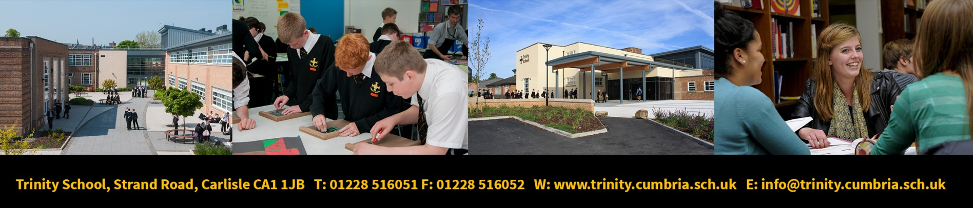
Please go to the Trinity school Website for further information about our school.

