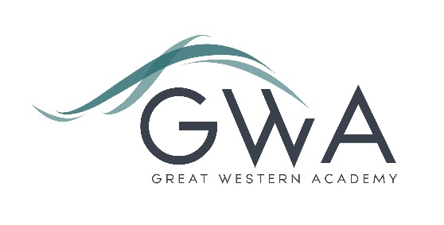

Information for Applicants

Classroom Teachers (Full-time or Part-time)
Great Western Academy opened in September 2018 in North Swindon with a full cohort in year 7 (PAN 150). The Academy will educate pupils from Years 7 to 13, with our first cohort of Sixth Form students starting in September 2019, likely to be around 100 students judging by applications received to date. Currently we plan to run 22 A-level subjects in our first year. We are heavily oversubscribed for year 7 entry in 2019.
As the school grows in future years there is an excellent opportunity for existing staff to shape and develop their role including potentially moving into leadership positions.
We welcome applications from those seeking a part-time role; please state this clearly in your application if so, otherwise it will be assumed you are applying for a full-time position.
An applicant’s briefing pack with full information about Great Western Academy and the role is available on the GWA website at www.gwacademy.co.uk/school-information/vacancies . If you have any questions prior to application you are very welcome to contact us.
Application process

Please complete the application form supplied and enclose a supporting letter, either in the space provided on the application form or as a separate document. The application form should be completed in full in black ink or type. A CV is not required and should not be submitted as part of the application.

Your supporting letter should be no more than 2 sides of A4 (with a font size no smaller than 11) and should enhance your application by providing further information, matched to the person specification, about your suitability for the post. This should include evidence of the impact on student outcomes you have made in your career to date.

Electronic applications should be returned via email to office@gwacademy.co.uk . Postal applications can be returned to:

Graham Davis
Principal, Great Western Academy
William Morris Way
Swindon
SN25 2PP

Closing Date: 9am Monday 25th February 2019
Interviews: Week beginning Monday 4th March 2019

The interview process will include observation of your teaching, and a variety of other tasks and activities.
Great Western Academy is committed to safeguarding and promoting the welfare of children, young people and vulnerable adults and we expect all staff to share this commitment and undergo appropriate checks. All posts within the Trust are therefore subject to an Enhanced DBS and barred list check.

References: References will be taken up prior to interview.

