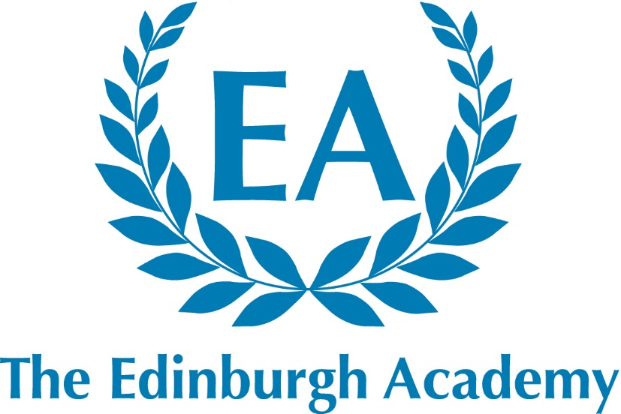

42 Henderson Row
Edinburgh
EH3 5BL

Fully co-educational

HMC
Independent Co-educational Day School

Senior School: 586 pupils aged 11 –18
Junior School: 388 pupils aged 5 –11
Nursery: 92 pupils aged 2 – 5

Head of Drama (Maternity Cover)
Start date April 2018

Information for Applicants
December 2017

The Edinburgh Academy

Introduction

The Edinburgh Academy is an academically selective, independent, co-educational day school for pupils aged 5-18 years with a reputation for being caring and friendly. It aims to provide co-educational excellence with a first-class all-round education to those of intellectual promise and academic potential, regardless of background, race or creed. The Edinburgh Academy aims to be forward-looking and progressive but also greatly values its long held traditions.

Although the School is not academically exclusive, the ability range of pupils is well above the national average. Great emphasis is placed on the pursuit of co-curricular interests alongside academic studies for all our pupils. The School has a strong reputation for individual attention and excellence in its pastoral care and co-curricular provision.

The School is oversubscribed at all entry points and this creates a competitive pressure on admissions places at the School.

School Background

The Edinburgh Academy is a fully co-educational school. The School consists of a Senior School containing about 560 pupils and a Junior School containing about 390 pupils, and a Nursery Department of around 100 pupils. The School is a member of HMC. The Edinburgh Academy moved to full co-education across the whole school in 2008. Previously girls were admitted only in the Sixth Form (S5 and S6).

The Junior and Senior Schools are on separate sites, both of which have spacious grounds and sports facilities including extensive playing fields, an all-weather sports area, and a large Sports Hall and Centre.

The School’s Place in Edinburgh

The School was founded in 1824 and has been regarded as a leading educational establishment within the City of Edinburgh and across Scotland ever since. Original Directors included the leading literary names of their age such as Sir Walter Scott. Robert Louis Stevenson and James Clerk Maxwell were also pupils at the School. More recent Former Pupils (Academicals or Accies) include: Nicky Campbell - radio and TV broadcaster; Guy Berryman - bass guitarist with Coldplay; Will Whitehorn – past President of Virgin Galactic - Space Tourism Company; Mike Blair - Scottish rugby; Dragon’s Den star, James Ingham.

The Senior School occupies a site in Henderson Row, less than a mile from Princes Street and at the northern limits of the Georgian ‘New Town’, of which it was designed to be a part. The buildings include an iconic school hall and the James Clerk Maxwell Science Centre, which was completed in November 2006. The playing fields are about half a mile from the main buildings – Raeburn Place (8 ½ acres) (shared with the Academicals - Former Pupils), New Field in Inverleith Place (20 acres) and a further five acres at the Junior School, also at Inverleith, with a 400 metre grass running track.

An investment programme in facilities of over £15m has in the last 5 years seen a new Juniors School library and classroom block, 2 floodlight all weather pitches, a Performing Arts Centre and a new sports pavilion. A bespoke climbing wall facility was officially opened in 2015. The School has further ambitious plans beyond this current phase of development which will see a wholescale redevelopment on our Senior School site over the coming decade.

The Edinburgh Academy is a highly regarded school within the local community, across Edinburgh and beyond. Staff and pupils take great pride in this reputation, and the commitment from all is evident in the continuing success and progress of the School.

The Edinburgh Academy is committed to sharing its facilities with the local community and has established a series of projects that provides the use of its estates and premises for the public good.

Further details about the School and its resources are given on the School website. www.edinburghacademy.org.uk

Classes and Assembly
7ths (S6) and 6ths (S5) classes are organised by tutor groups studying either Highers, Advanced Highers or GCE A-level. Across the Senior School no teaching group consists of more than 24 pupils and many are substantially smaller.

A School Assembly is held at 8.50am each morning, and is attended by the whole school. School Services for the whole school are held on several occasions during the session.

Exam Results

The Edinburgh Academy uses both English and Scottish examination boards. Nearly all subjects now present SQA National 5 and Advanced Higher examinations. Each year, a significant number of our 7ths (S6) have conditional places at very competitively sought universities on the basis of their Advanced Higher/A-level and Higher results.

Yearly academic results can be seen on the School website.

Games and Activities
At the Edinburgh Academy, sport offers opportunities at all levels. The PE curriculum is varied, encompassing a wide variety of team games and individual sports. The School runs teams in a large number of major and minor sports and encourages pupils to represent the School at one or more sports at any age group.

In Music, there are about 20 performing groups including orchestras, choirs, wind bands, a big band and several chamber groups.

In Drama there are usually three or four main productions each year. There is a fully active LAMDA qualification schedule in acting, reading for performance, mime, public speaking and Musical Theatre in place. This occurs at break time and lunchtimes. In addition the Drama and Music department liaise to produce an annual musical, with potential to increase this.

All pupils currently join the CCF or The Duke of Edinburgh’s Award in 4ths (S3).

All members of staff are expected to play a full part in supporting the co-curricular life of the School.

Head of Drama (and Theatre Production)
Job Description

A well-qualified Head of Drama (Maternity Cover) is required for April 2018 to be responsible for the leadership and management of the Drama Department in this co-educational day school.

Drama Department Details
Curriculum
In Geits (P7), pupils learn basic staging through practical and theoretical interpretation. Pupils in Term 2 are immersed in project work, (script) allowing pupils their first opportunity to specialize in any area of theatre that they wish. Third term pupils develop skills in makeup artistry, stage fighting and mime. In 2nds, (S1) pupils develop their improvisation skills further. Theory includes ground plans, staging, voice, movement and project work. Pupils in Geits/2nds Drama are expected to attend the theatre at least once a year. In 3rds (S2) pupils begin their curriculum further developing skills from a range of sources, from Ancient Greek theatre to Medieval Mystery Plays and Restoration Drama. Pupils are expected to attend at least one theatre production a year and complete an evaluation of performance. In 4ths (S3)–AH, pupils follow the SQA programme of National 5, Higher and Advanced Higher qualifications. Pupils are also presented for LAMDA examinations in acting, public speaking, reading for performance, mime and musical theatre.

Facilities
The main venue for large-scale theatrical productions within the School are held within the fully equipped and versatile Magnusson Theatre (seats 250). There is a full time theatre technician in place to support all curricular and co-curricular productions. Academic drama teaching, rehearsals and smaller-scale productions take place in the classroom upstairs or in the Magnusson Centre. There is a designated costume and properties area within the department. The classroom is used as a flexible makeup and green room, prior to productions. The School’s city centre location means that it is easy for groups to visit the professional theatre within the City of Edinburgh and the surrounding area.

The Post
We are looking to appoint a full-time Maternity Cover teacher, with experience of teaching across the full age and ability range. You would be expected to liaise with the Music department concerning Musical Theatre and the school musical. This is an excellent opportunity to undertake a teaching role in a vibrant Drama Department, in a highly successful school.

Duties and Responsibilities:
We welcome applications from well-qualified men and women who are graduates with relevant teaching qualifications. The successful candidate should be able to teach Drama from Geits (P7) up to Advanced Higher level. The candidate would also be expected to promote and oversee the teaching of dance within the School, working with the Edinburgh Dance Academy, who provide the external instruction.

Duties and responsibilities associated with all teachers at the Edinburgh Academy are:
- To plan, prepare and teach lessons to all assigned pupils according to their educational needs.
- To assess, record and report on the progress of the pupils within the guidelines written in the Staff Handbook.
- To engage with the wider School Curriculum in a manner which is consistent with the ethos of the School.
- To carry out such administrative and other routine tasks as are outlined in the Staff Handbook.
- To demonstrate a commitment to both individual professional development and to the developing curriculum in the School.
- To carry out any other duties and to assume any other responsibilities as the Rector shall from time-to-time reasonably request.
- To be conscious at all times of the importance of the external image of the School and to act in a professional and constructive manner with pupils, parents and external agencies.
- To play a full part in the co-curricular life of the School.

Short-listed candidates will be asked to plan and teach a lesson.
Reporting
The Head of Drama (Maternity Cover) will report to the Deputy Rector (Director of Studies) on all aspects of classroom management, timetabling, teaching and learning, reporting and pupil discipline.

Remuneration Package
The Edinburgh Academy pay scale shadows the national scale for teachers and promoted posts, but also offers a special supplement in recognition of the extra contributions made by teachers out with their classroom duties. This supplement is currently 8% addition to national scales. The terms and conditions may be discussed at interview.

Availability
The appointment is available from the start of the Summer Term (16th April 2018).

Applications
Applications are welcome from well-qualified graduates for this post of Head of Drama (Maternity Cover).

Further details are available from the Rector’s Office – 0131 624 4911 rectorsoffice@edinburghacademy.org.uk Candidates should complete all sections of the application form and send it to this email address.

Candidates are welcome, if they wish, to send a copy of their curriculum vitae, including full details of qualifications and experience, and/or a covering letter explaining why they think they are particularly suited to the role and how it may fit in with future aspirations. However, please note that this is entirely optional and the short listing for interview will be based on the application form. The appointment will be made without regard to gender or ethnic origin.

The closing date for application is Wednesday 10th January 2018.

Conditions of Appointment
The appointment will be subject to satisfactory references, verification of identity and proof of qualifications, and to a satisfactory medical screening.

Child Protection
The Edinburgh Academy is committed to safeguarding and promoting the welfare of children, and applicants must be willing to undergo child protection screening appropriate to the post, including checks with past employers and PVG Disclosure Scotland.

Equal Opportunities
The School is an Equal Opportunities employer, and welcomes applications for this post from appropriately qualified persons regardless of age, disability, gender, race or sexual orientation.

Barry Welsh
Rector
December 2017

