Friarage Community Primary
School
Recruitment Pack for
CLASS TEACHER WITH LEADERSHIP OF MATHEMATICS
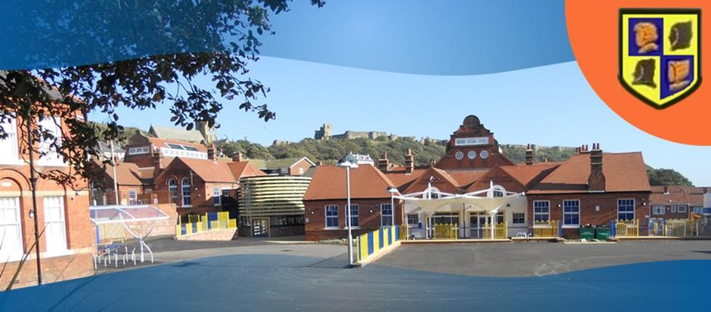

Friarage CP School
Friargate
Scarborough
YO11 1HS

Friarage Community Primary School
Friargate, Scarborough, YO11 1HS
Telephone: (01723) 374244
Fax: (01723) 507069
E-mail address: admin@friarage.n-yorks.sch.uk
WEB: www.friarage.n-yorks.sch.uk
Co-Head Teachers
Mrs R Blamires, Mrs C Cappleman
Assistant Head Teacher Mrs K Woodward-Hay
Dear applicant,

Thank you for considering applying to our school.
Founded in 1896, Friarage School has a strong history of serving its local community. The school is situated within the Castle Ward area of Scarborough.
We are proud to work with all our families to give our children the very best provision. We believe in developing the whole child so that they learn skills for life not just for primary school.
Our children deserve the very best both in learning and pastorally; we hope that you will want to join our supportive team and have the drive and commitment to face the rewards and challenges working in our school will present.
We look forward to hearing from you,
Yours sincerely,
Mrs Blamires, Mrs Cappleman
To apply for the post please telephone or email for application pack:

Friarage School 01723 374244 Email: jorrah@friarage.n-yorks.sch.uk
Closing date for applications: 12th December 2017
Shortlisting: 13th December 2017
Interviews will take place: 19th December 2017

Prospective candidates are welcome to visit the school
To book an appointment please contact the school office on 01723 374244
You can download an application pack and application form from our school website: http://www.friarage.n-yorks.sch.uk

Our Aims at Friarage School

Ofsted July 2014:
Pupils say “We are like one big family”

Friarage School is a family and a team where everyone is given the challenge and support to be the best they can possibly be in a safe, welcoming and positive environment.
Children and staff will work and play together developing skills so that we all become ambitious and reflective lifelong learners as well as being respectful and respected members of the community.
We are committed to Restorative Practice Principles to nurture respect for all in our school community.

We aim to:-

- Work in partnership with parents, carers and our community to build upon what each child already knows and develop their skills for future learning.

- To create a safe and stimulating environment where high quality learning takes place.

- Ensure that pupils, parents, staff, governors and visitors are welcomed into a warm friendly and thriving learning community.

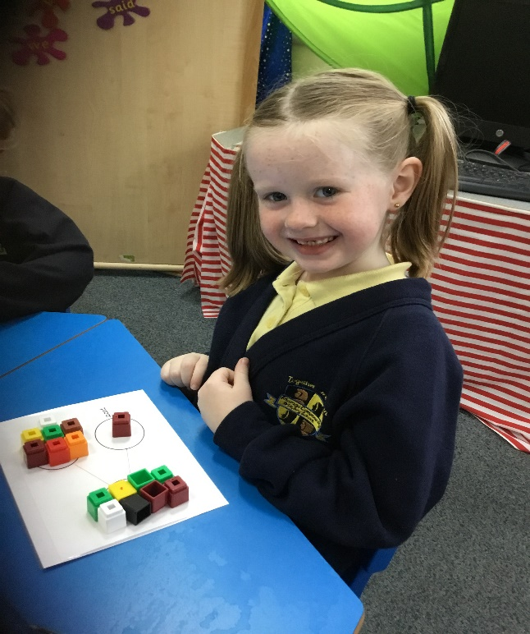

School Information

Friarage has 356 pupils on role including nursery.
We currently have over 50% of pupils entitled to free school meals - this is a general trend for the school.
In order to meet the needs of our busy working families the school offers a free Breakfast Club from 8.00am. Breakfast Club is an integral part of the school and ensures all pupils have the opportunity to start the day with a healthy meal.
School starts at 8.45am.
Year 1 morning session is from 8.45am until 11.45am
Year 1 afternoon session is from 12.45pm until 3.00pm.
Year 2 morning session is from 8.45am to 12 noon
Year 2 afternoon session is from 1.00 until 3.00pm
KS2 morning session is from 8.45am to 12pm, lunchtime is 12pm until 1pm.
KS2 afternoon session is from 1pm until 3.05pm.
We have two Nursery sessions each day; 8.45am until 11.45am or 11.45am until 2.45pm.
2017-2018 our school operates as follows:
Foundation - One nursery class and two reception classes.
KS1 - Two Y1 classes and two Y2 classes.
KS2 – 2 Year 3 classes, 2 Year 4 classes, 2 Year 5 classes and 2 Year 6 classes.
We believe this provides the best learning environment for the children, delivers the best value and efficient use of the resources available to us.
For further information about our school please follow the link to our school website www.friarage.n-yorks.sch.uk

JOB DESCRIPTION MAIN SCALE TEACHER

JOB TITLE: Teacher of KS1

GRADE: Main Pay Scale plus TLR1

RESPONSIBLE TO: Co-Head Teachers

JOB PURPOSE:

To carry out the professional duties of a teacher as set out in the relevant pages of the School Teacher’s Pay and Conditions document. In addition ‘a teacher employed as a teacher in the school will perform in accordance with any directions which may reasonably be assigned to them’.

To provide for the educational, social, moral, spiritual and cultural development of each of the children in your class and for maintaining high standards of teaching and learning, marking, monitoring and assessment and communication with parents/carers.

LEADERSHIP AND CO-ORDINATION
To assume the role of ‘subject’ consultant for colleagues.

To demonstrate, by practical example if appropriate, effective ways of organising the teaching within mathematics.

To inform parents/governors if/when required regarding current thought and practice in mathematics.

To assist the Head Teacher in ensuring the highest possible standards and quality of learning in mathematics using the school’s Teaching and Learning Policy as one means to achieve this.

KEY RESPONSIBILITIES:
Develop and maintain an up-to-date knowledge and understanding of the areas of teaching and pupil support for which post-holder is responsible.
Plan work to meet the learning needs of allocated pupils in a consistent and effective way.
Use appropriate teaching and classroom management strategies to motivate pupils and enable each to progress.
Monitor the progress of pupils for whom the post holder is responsible to, set expectations and give constructive feedback.
Maintain appropriate records to demonstrate progress made by pupils.
Participate fully in professional development activities to develop practice further, sharing the learning from these as appropriate.
Make an active contribution to the policies and aspirations of the school.
To fulfil all of the requirements and duties set out in the current Pay and Conditions Documents relating to the conditions of employment of teachers.
To fulfil all of the responsibilities and duties required by the School’s policies on teaching and learning.
To achieve any performance criteria or targets arising from the School’s Performance Management arrangements.
This job description will be reviewed annually.

SIGNED …………………………………………………… POST HOLDER

SIGNED …………………………………………………… HEADTEACHER

DATE ……………………………………………………

PERSON SPECIFICATION

JOB TITLE: TEACHER OF YEAR 1

GRADE: MPS/TLR 1

CRITERIA | ESSENTIAL | DESIRABLE | ASSESSMENT
Qualifications & Training  Degree | Y |  | 2
Experience  Experience of planning and delivering curriculum at relevant KS1 and/or subject(s)  Experience of teaching high quality phonics  Teaching a class with a widespread of ability including disadvantaged pupils  Experience of teaching in more than one school  Experience of teaching children with EAL.  Experience of teaching children with challenging behaviour  You will demonstrate the ability to accelerate progress and raise attainment | Y  Y  Y  Y  Y | Y  Y | 2  2  2  2, 4, 6  2 & 4  2, 4, 6  2 & 4
Skills & Knowledge  A thorough knowledge and understanding of all relevant aspects of the National Curriculum in relation to the post  The ability to lead mathematics across the school.  Knowledge or experience of teaching Maths No Problem.  Personal Qualities  The ability to inspire and motivate staff and pupils through your passion for mathematics.  Enthusiasm and commitment to the aims and objectives of the school  Good communication skills  Communicates effectively with children, parents and staff  Teaching to a high standard within a safe and stimulating learning environment  Works well within and contributes to the existing staff team  Understands and values the process of planning and monitoring and evaluation as an aid to raising standards  Effective organisational skills  Confident and an excellent user of ICT to support teaching and learning  Ability to take part/lead after school clubs  An understanding of safeguarding and child protection  Other Requirements  Motivation to work with children and young people  Ability to form and maintain appropriate relationships and personal boundaries with children and young people.  Emotional resilience in working with challenging behaviours; support the principles of Restorative Practice. | Y  Y  Y  Y  Y  Y  Y  Y  Y  Y  Y  Y  Y  Y | Y  Y  Y | 4  2,4  2,4  2  2,4,6  2,4,6  2,4,6  2,4,6  2,4  2,4  2,4  2,4  2,4  2,4  2,4  2,4  2,4
Equal opportunities
To assist in ensuring that NYCC’s equalities policies are considered within the school’s working practices in terms of both employment and service delivery

Assessment:
1. Test prior to shortlisting (i.e. all applicants) 4. Probing at interview
2. from application form 5. Documentary Evidence
- Test after shortlisting 6. OTHER (teaching a Lesson)

